MongoDB Assignment

Part 1 – Basics of MongoDB
- What is MongoDB and how is it different from relational databases?
MongoDB is a NoSQL, document-oriented database used to store and manage large volumes of unstructured or semi-structured data. Instead of using tables and rows like relational databases (RDBMS), MongoDB stores data in documents (similar to JSON objects) inside collections.
- In MongoDB, what are databases, collections, and documents?
Database : A container for collections in which each database has its own collections, indexes, and documents.
Collection : Collection is a group of documents inside a database like a table in relational database (SQL).
Documents : Documents is a basic unit of data in which data is stored in a json like format.
- What format does MongoDB use to store documents?
It uses JSON format to store data.
- List three different ways to install or use MongoDB.
1 Download and install MongoDB Community Server from the official MongoDB website.
2 Use MongoDB Atlas.
3 Run MongoDB with Docker.
- Which MongoDB tool provides a graphical interface?
The MongoDB Compass tool provides a graphical user interface (GUI) for MongoDB.
- How can you verify MongoDB installation using the terminal?
mongod --version

Part 2 – MongoDB Commands
- Write the command to show all databases.
show dbs or show databases
- How do you switch to or create a new database called mydb?
Command - use mydb
If mydb already exists → it switches to it.
If mydb doesn’t exist → it creates it only after you insert a document/collection.
- Write the command to create a collection called users.
db.createCollection("users")
If you insert a document into a collection that doesn’t exist, MongoDB will automatically create it as db.users.insertOne({ name: "Asmit", age: 22 })
- Insert one user with fields name, age, and city.
db.users.insertOne({ name: "Asmit", age: 22 })
- Insert multiple users at once.
db.users.insertMany({ name: "Asmit", age: 22 },{ name: "Tarun", age: 20 })
- Write the command to view all documents in the users collection.
db.users.find()
- Write the command to find a user named "Alice".
db.users.find({name:”Alice”})
- Write the command to find users with age > 25.
db.users.find({ age: { $gt: 25 } })

Part 3 – CRUD Operations
- Write a query to update one user’s city to "Berlin".
db.users.updateone({name:”Alice”}{$set:{city:”Berlin”})
- Write a query to update all users from "London" by adding a new field status: "active".
db.users.updateMany({city: "London"}, { $set: {status: "active"}}}
- Write a query to delete one user named "Alice".
db.users.deleteOne({name: "Alice" })
- Write a query to delete all users from "Paris".
db.users.deleteMany({city: "Alice"})

Part 4 – Query Operators & Projection
- Which operator is used to check if a value is greater than another?
$gt (greater than).
- Which operator is used to find documents where a value is not equal?
not equal ( $ne).
- Write a query to find users whose city is either "London" or "Paris".
db.users.find({ city: { $in: ["London", "Paris"] } })
- Write a query to find users from "London OR Berlin".
db.users.find({ city: { $in: ["London", "Berlin"] } })
Alternative:
db.users.find({$or: [{ city: "London" }, { city: "Berlin" }] })
- Write a query to show only name and city fields while hiding _id.
db.users.find( {}, { _id: 0, name: 1, city: 1 } )

Part 5 – Relations & Schema Design
- What does it mean when we say MongoDB is "schema-less"?
MongoDB does not enforce a fixed structure (schema) for documents in a collection.
- What is the difference between embedding and referencing in MongoDB schema design?
Referencing:
we store related data in separate documents and link them using an ObjectId or key.
Embedding:
we store related data inside the same document.
- Create an embedded document for a user with multiple orders.
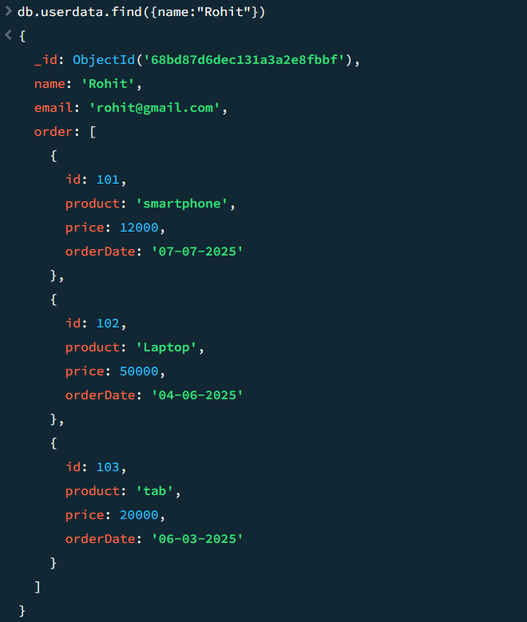
- Create a referenced schema for users and orders using ObjectId.
db.userdata.aggregate([
{ $lookup:{
from: "userorder",
localField: "_id",
foreignField: "userId",
as: "oops"
}}
])
- Which approach is better for small related data: embedding or referencing?
Embedding because all data is saved at one place and no need for lookups and it maintains simple structure.
- Why is schema design important even though MongoDB is schema-less?
it is important because it affect performance, Storage Efficiency, data consistency, scalability and maintainability.

Part 6 – Aggregation Framework
- What is aggregation in MongoDB and why is it more powerful than find()?
Aggregation in MongoDB is a data processing and transformation framework that allows you to perform complex operations like filtering, grouping, sorting, joining, and transforming data.it can also reshape the output.
- Write an aggregation query using $match to find only delivered orders.
db.userorder.aggregate([{$match:{status: "delivered"}}])
- Write an aggregation query using $project to show only customerName and total fields.
db.userorder.aggregate([{$project:{username:1,_id:0}}])
- Write an aggregation query using $group to calculate the total amount spent by each customer.
db.userorder.aggregate([{$group:{_id:"$product",total:{$sum:"$price"}}}])
- What does the $unwind stage do in aggregation?
$unwind stage is used to deconstruct an array field and each element of the array becomes a separate document in the pipeline.
- Write an aggregation query using $lookup to join orders with customers on customerId.
db.customers.aggregate({$lookup:{from:"orders",localField:"customerId",foreignField:"orderId",as:"customer_order"}})
- Write an aggregation query to find the top 2 highest orders using $sort and $limit.
db.userorder.aggregate([{$sort:{price:1}},{$limit:2}])

