Cody Bellec Homework 9 March 11, 2021

1) URL: https://github.com/Cody-Bellec/robotics-is-gonna-change-the-world

2) Tag: hw9

3) roslaunch homework9 homework9.launch

4) White 1:
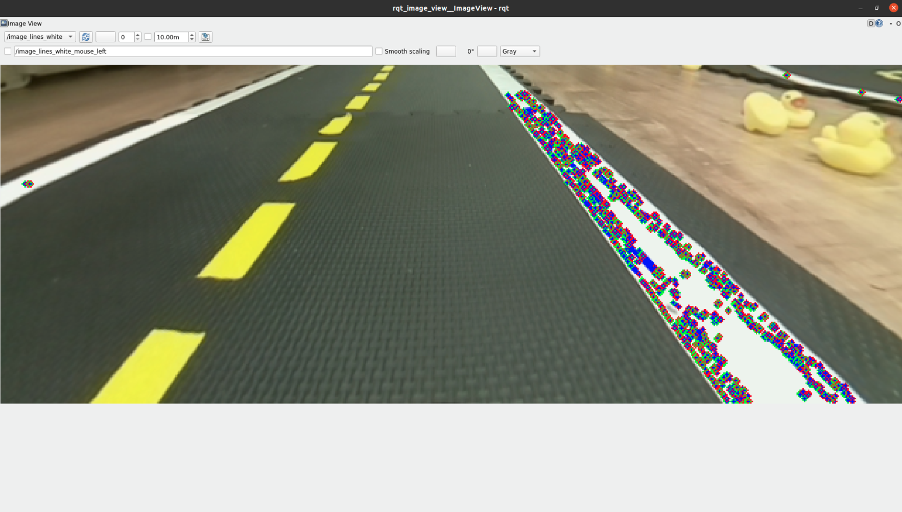
Yellow 1:
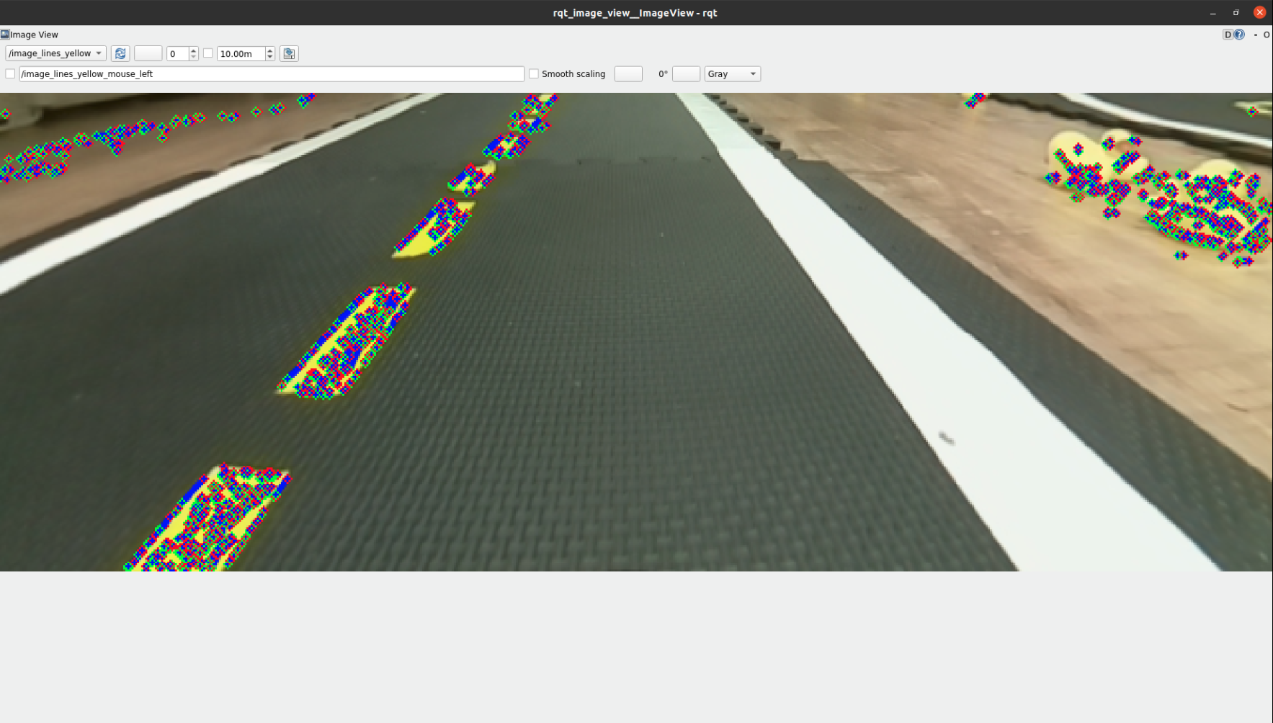

White 2:
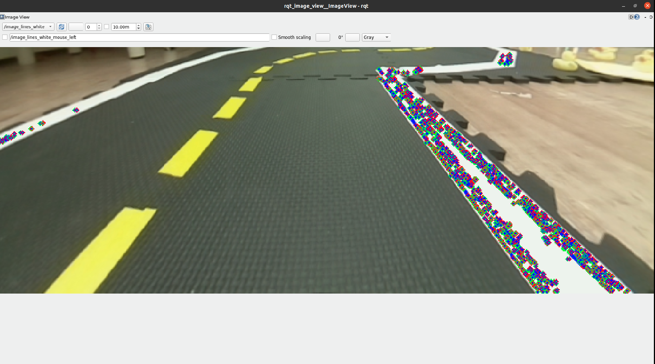
Yellow 2:
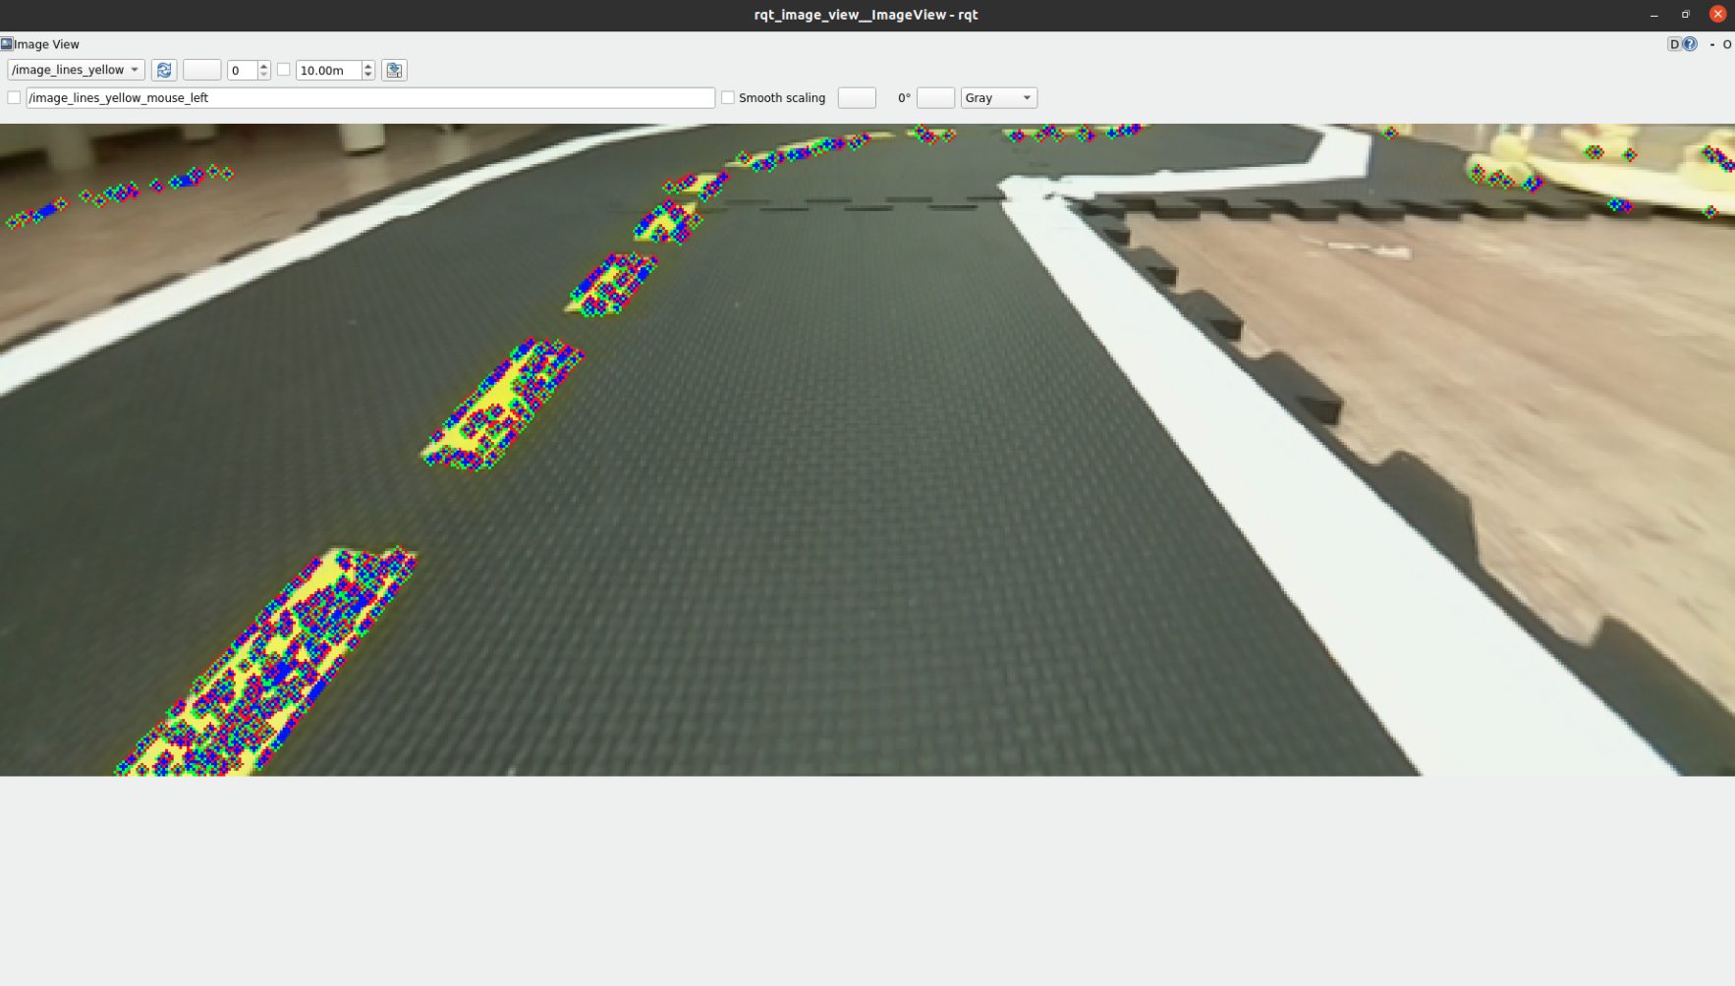

White 3:
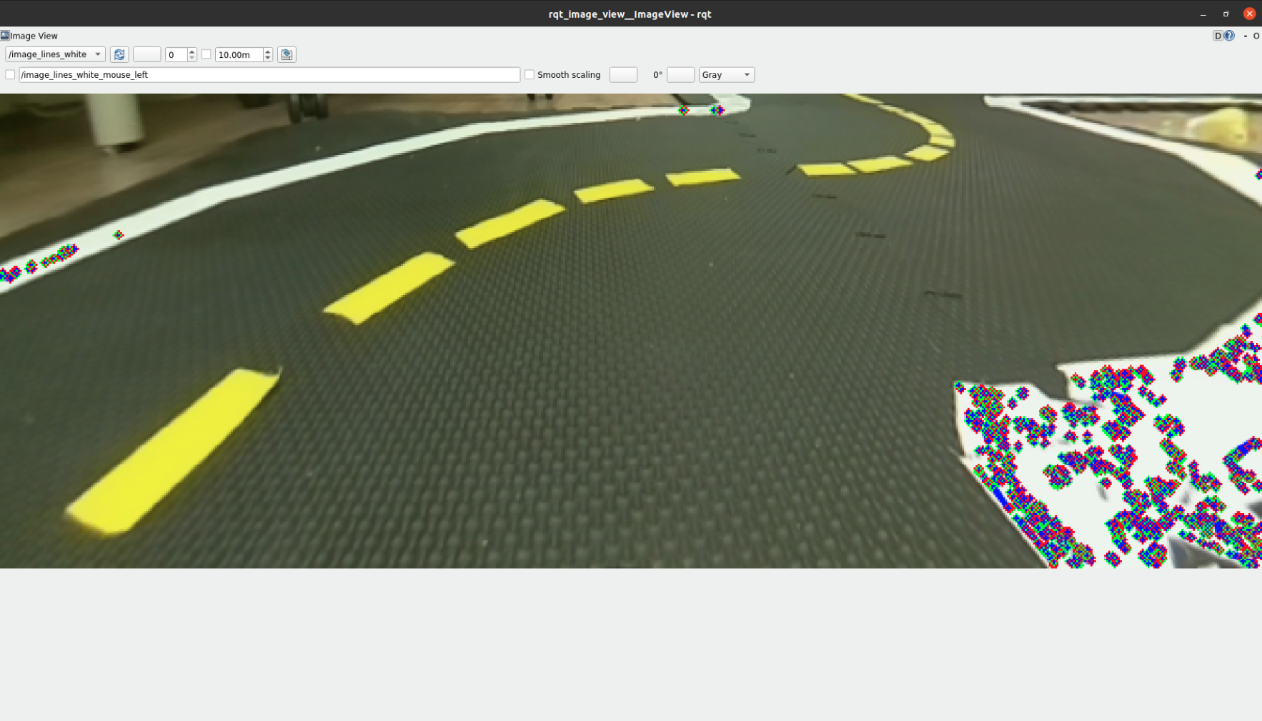
Yellow 3:
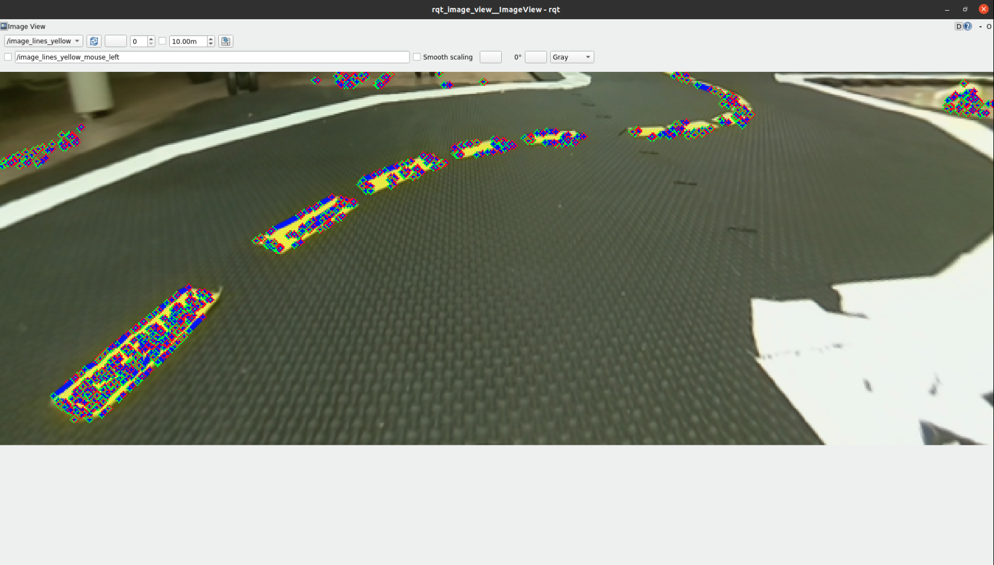

White 4:
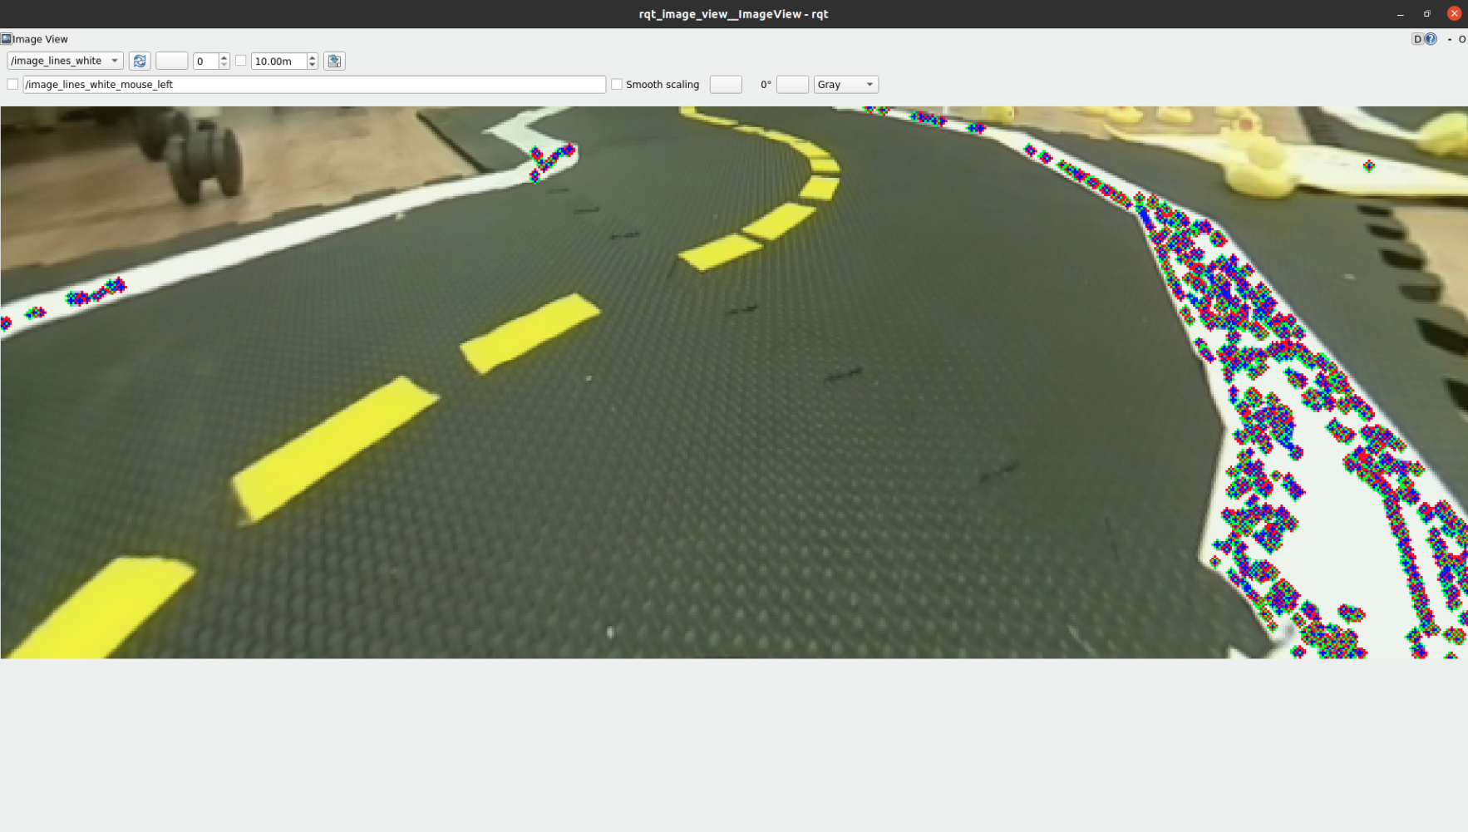
Yellow 4:
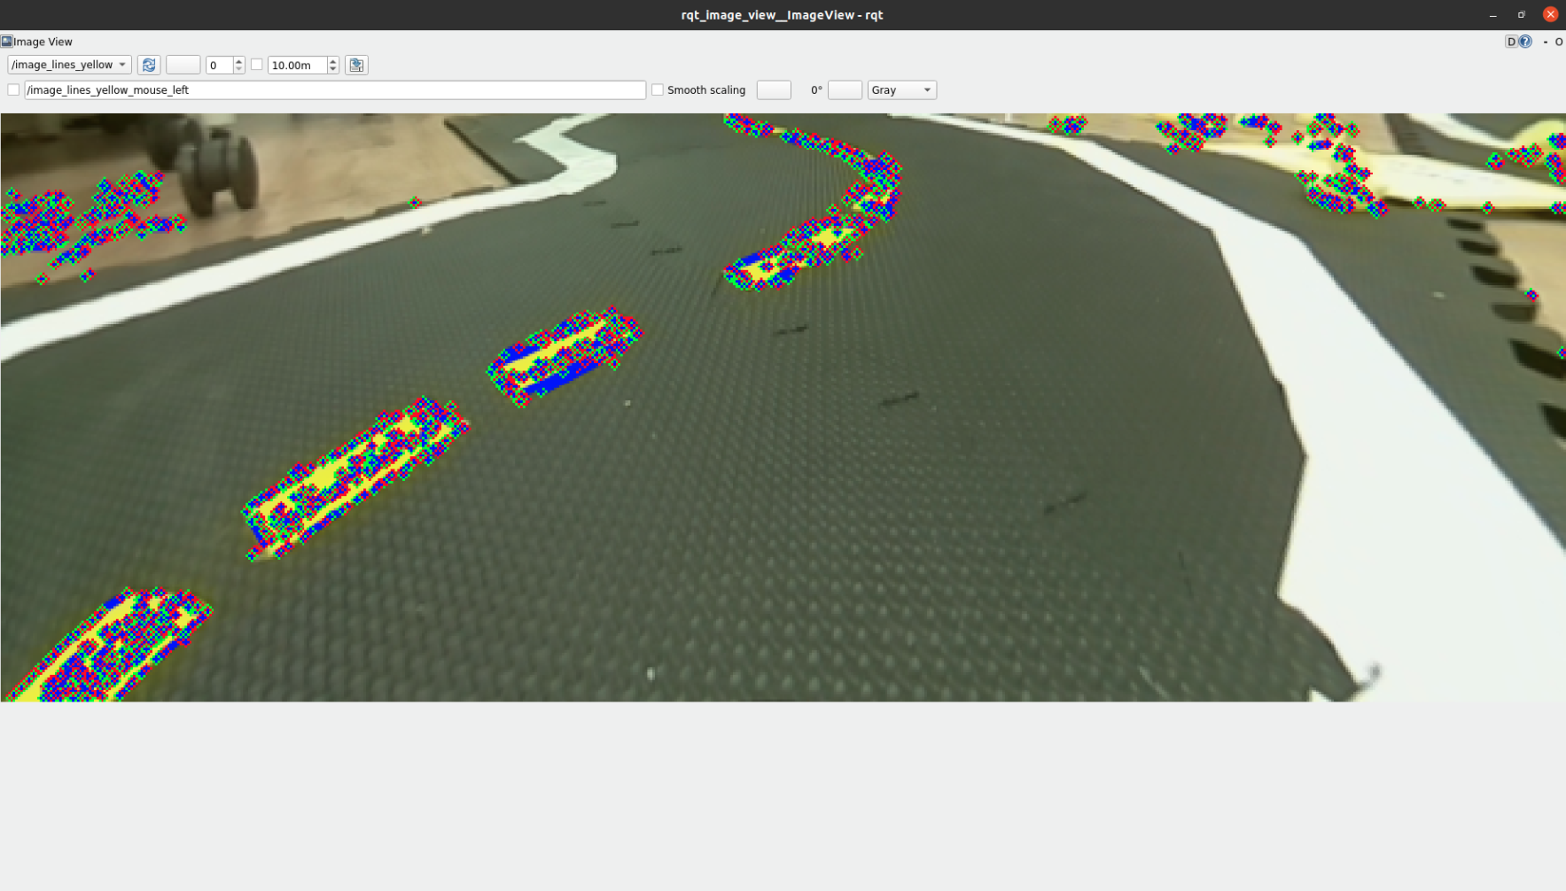

White 5:
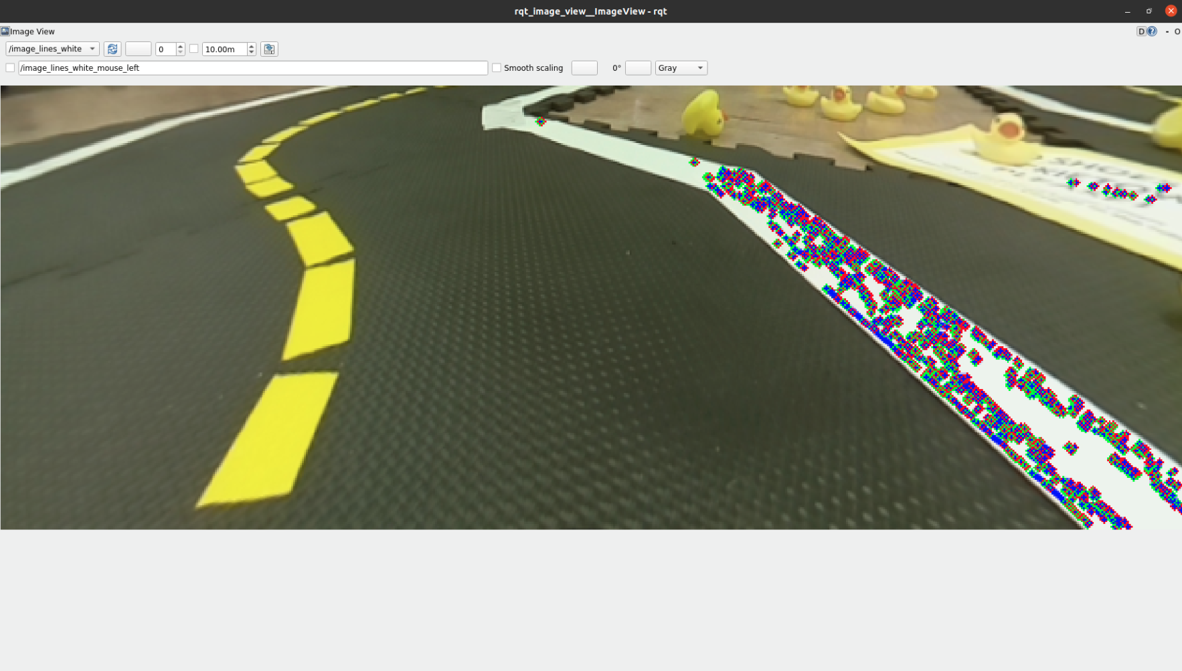
Yellow 5:


