Cody Bellec Homework 8

1) URL: https://github.com/Cody-Bellec/robotics-is-gonna-change-the-world

2) Tag: HomeWork8

3) Command: roslaunch homework8 homework8.launch

4) White 1:
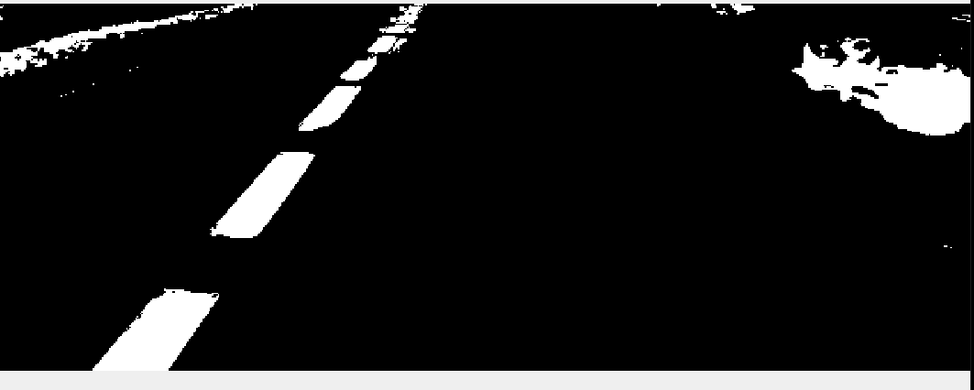
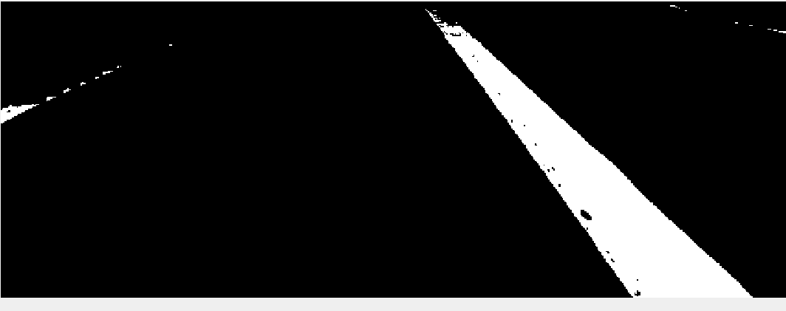
Yellow 1:
White 2:
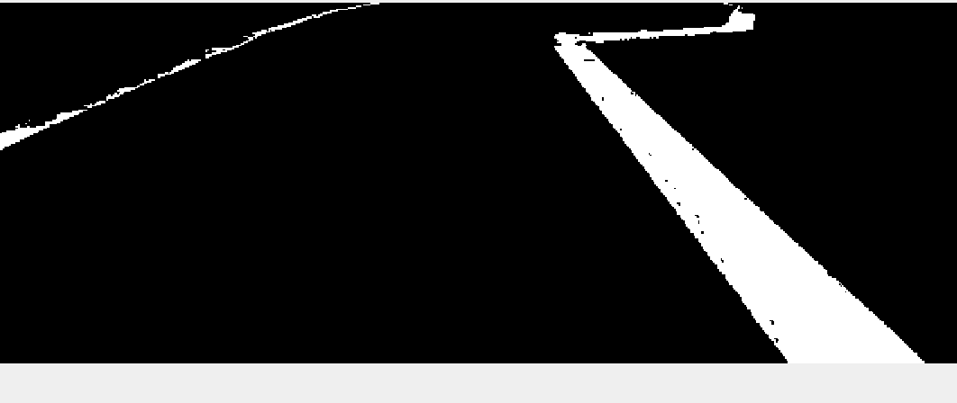
Yellow 2:

White 3:
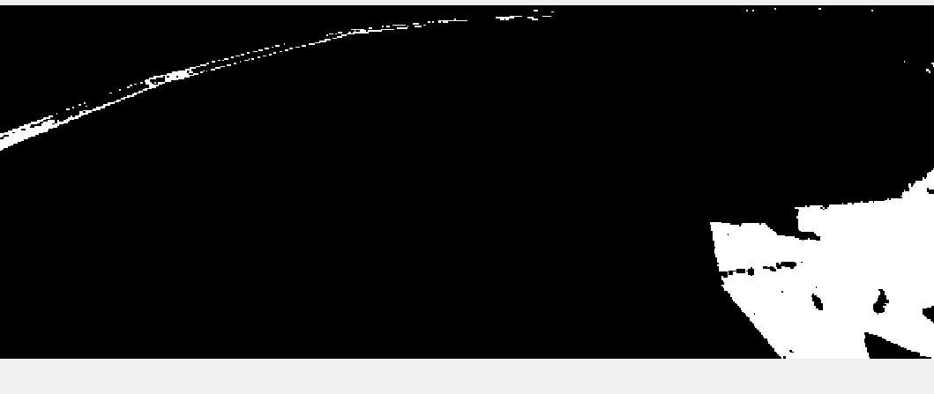
Yellow 3:
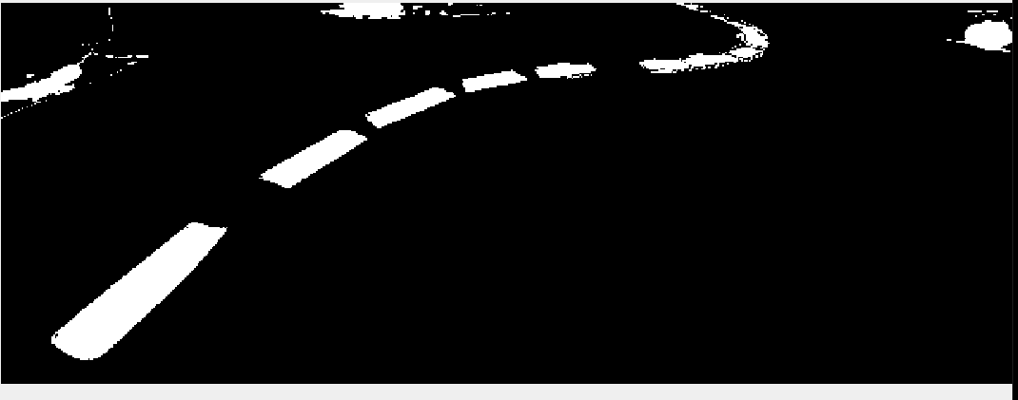
White 4:
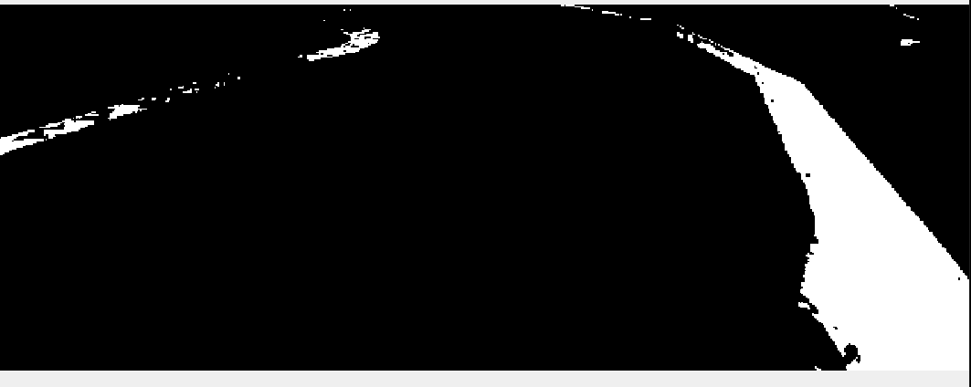
Yellow 4:
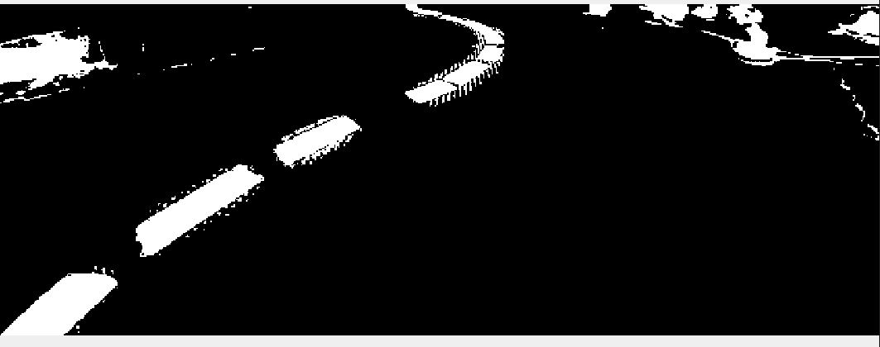
White 5:
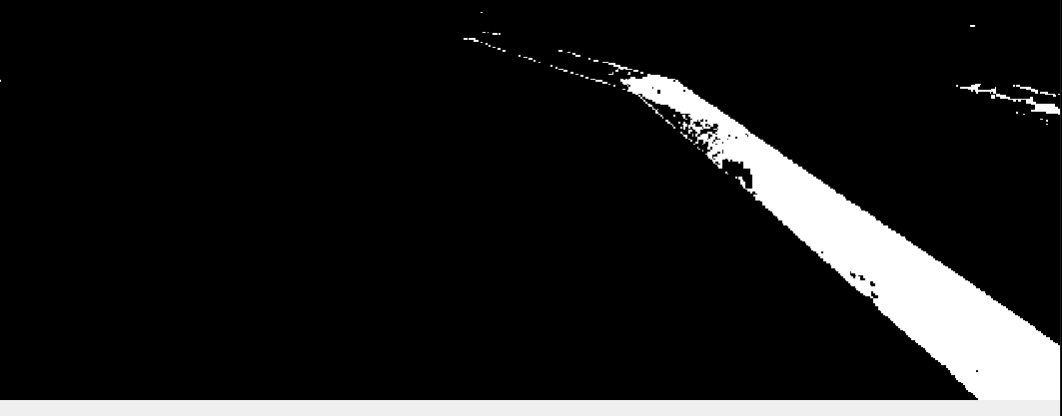
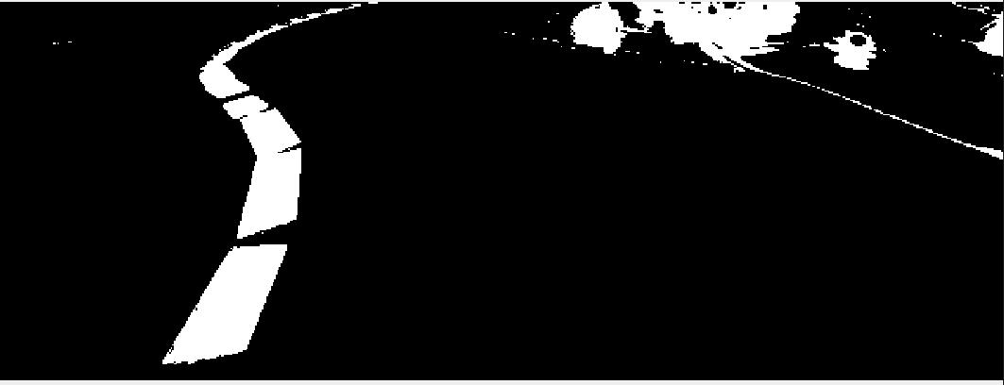
Yellow 5:

