姓 名：陈浩
学 号：2024220055
班 级：飞动242
实验内容：
题目1：使用turtle库中的turtle.fd()、turtle.seth()等函数在屏幕上绘制一个等边三角形。
算法：
- 让小海龟平行走一段距离
- 让小海龟旋转120度向前走和第一段等距离
- 让小海龟旋转120度再向前走等距离
1.1程序代码：
import turtle
turtle,fd(80)
turtle.seth(120)
turtle.fd(80)
turtle.seth(-120)
turtle.fd(80)
1.2调试错误：
错误1：Traceback (most recent call last):
File "C:/Users/Chen/Desktop/等边三角型.py", line 2, in <module>
turtle,fd(80)
NameError: name 'fd' is not defined
错误1的修改：将fd前面的”，”符号改为”.”
1.3正确代码：
import turtle
turtle.fd(80)
turtle.seth(120)
turtle.fd(80)
turtle.seth(-120)
turtle.fd(80)
1.4调试结果：
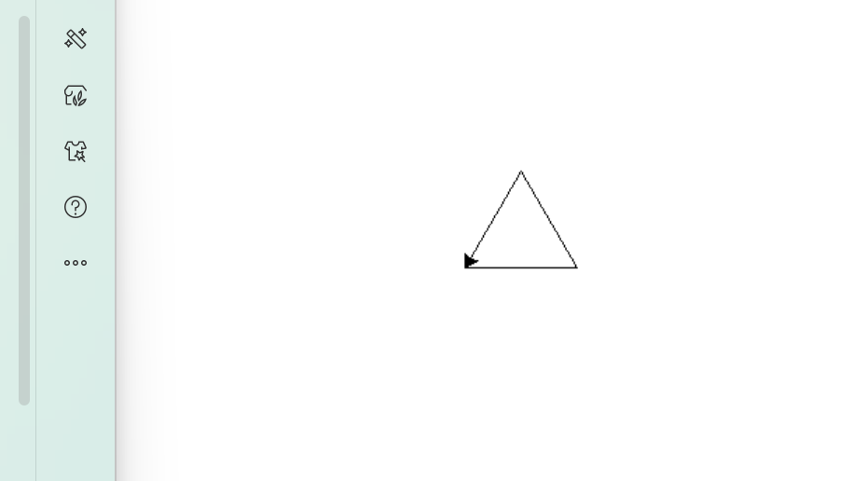

题目2：参考书上实例2.1代码，绘制一条5段蛇身的彩色蟒蛇，颜色自选。
算法：
- 先抬起画笔把画笔移后面一段距离
- 设置合适的画笔尺寸
- 设置想要的颜色
- 放下画笔
- 画第一段圆弧
- 后来每次改变颜色画圆弧五段即可
2.1程序代码：
import turtle
turtle.pendup()
turtle.fd(-250)
turtle.pensize(25)
turtle.pencolor(1,1,0)
turtle.seth(-40)
turtle.pendown()
turtle.circle(40,80)
turtle.circle(-40,80)
turtle.pencolor(1,0,0)
turtle.circle(40,80)
turtle.circle(-40,80)
turtle.pencolor(0,0,0)
turtle.circle(40,80)
turtle.circle(-40,80)
turtle.pencolor(0,1,1)
turtle.circle(40,80)
turtle.circle(-40,80)
turtle.pencolor(0,1,0)
turtle.circle(40,80/2)
turtle.fd(40)
turtle.circle(16,180)
turtle.fd(40 * 2/3)
2.2调试错误：
错误1：Traceback (most recent call last):
File "C:\Users\Chen\Desktop\蟒蛇.py", line 2, in <module>
turtle.pendup()
AttributeError: module 'turtle' has no attribute 'pendup'. Did you mean: 'penup'?
错误1的修改：”penup“打错成”pendup“了
2.3正确代码：
mport turtle
turtle.penup()
turtle.fd(-250)
turtle.pensize(25)
turtle.pencolor(1,1,0)
turtle.seth(-40)
turtle.pendown()
turtle.circle(40,80)
turtle.circle(-40,80)
turtle.pencolor(1,0,0)
turtle.circle(40,80)
turtle.circle(-40,80)
turtle.pencolor(0,0,0)
turtle.circle(40,80)
turtle.circle(-40,80)
turtle.pencolor(0,1,1)
turtle.circle(40,80)
turtle.circle(-40,80)
turtle.pencolor(0,1,0)
turtle.circle(40,80/2)
turtle.fd(40)
turtle.circle(16,180)
turtle.fd(40 * 2/3)
2.4调试结果：
