ESPNow

Overview:

ESPNow is a simple Wi-Fi based, connectionless, point to point communication protocol supported by a number of ESP devices (this document will focus on the ESP32). ESPNow uses mac addresses as the devices network interfaces and has support for a basic level of security through a simple encryption key system.

Advantages:

* Lightweight, does not use much system resources.
* Provides simple security through the CCMP method.
* Can be used in either station or softap mode (Although all devices must be using the same mode).
* Able to broadcast to all nearby devices (however the receivers must be configured to receive broadcast messages).

Limitations:

* Does not guarantee recipient received message, if that is required must create custom acknowledgment system.
* Each peer the device needs to communicate with must have their MAC address added to a whitelist in order to enable communication (max 20 devices at once). This can be avoided to some extent with the broadcast function.
* Can only send 250 bytes at a time.

Brief Setup Overview:

1. Initialise and start Wi-Fi module (do not need to give SSID info).
2. Initialise ESPNow (with esp_now_init). This is also a good time to set the send and receive call backs as well as the primary master key (with esp_now_register_send_cb, esp_now_register_recv_cb and esp_now_set_pmk respectably).
3. Add peers to the peer list (with esp_now_add_peer). Note peers must be in the same mode (station or softap), however they can have different channels.
4. Send data (with esp_now_send). The send call-back will be called once the send is complete (should wait till then before sending again). It will indicate success if the frame made it to the target device, however it does not guarantee the data made it to the application layer of the receiver. Note the device must be set to the same channel as the target device (can change channel with esp_wifi_set_channel).

Security:

ESPNow makes use of the CCMP method, as described by IEEE Std. 802.11-2012. This requires each device to have a master key and a local key for each device it connects to. All devices that intend to communicate must have the same master key. A local key can be set for each peer. Each device pair must ensure they use the same local key when configuring peer information for the other.

Range testing:

ESPNow appears to work well up until about 20m, at which packet dropping becomes noticeable. However, it was still able to send/receive packets up until 30m (potentially further).

Test 1 data:

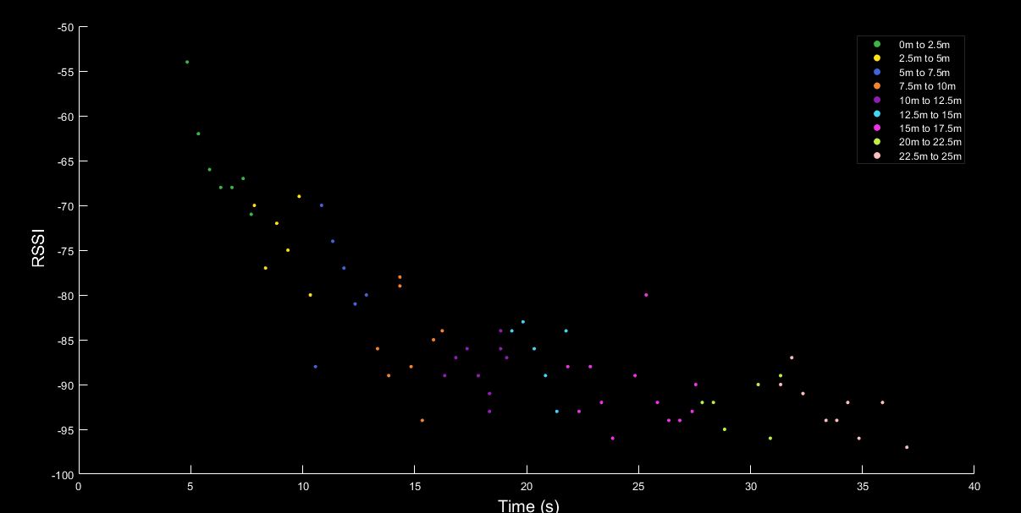

(No Packet loss)

Test 2 data:

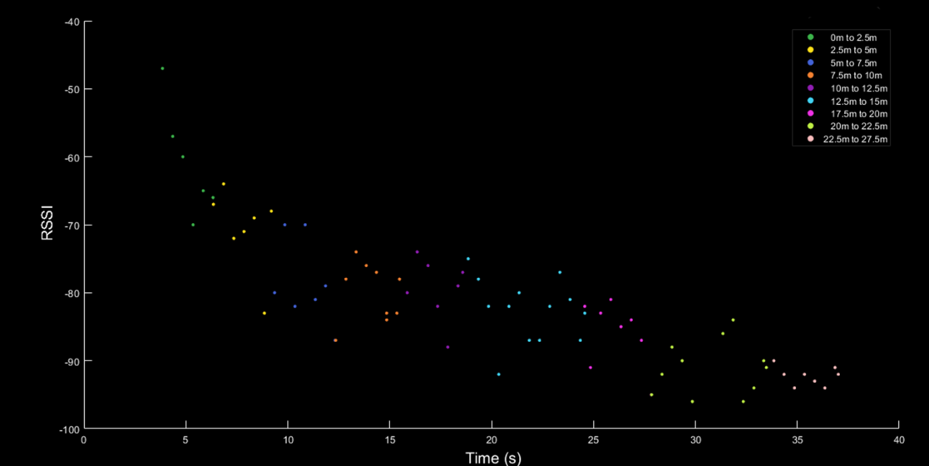

Packet Loss:

|  |  |  |  |  |  |  |  |  |  |
| --- | --- | --- | --- | --- | --- | --- | --- | --- | --- |
| Ranges(m) | 0 to 2.5 | 2.5 to 5 | 5 to 7.5 | 7.5to 10 | 10 to 12.5 | 12.5 to 15 | 17.5 to 20 | 20 to 22.5 | 22.5 to 27.5 |
| Packets Dropped (%) | 0% | 0% | 0% | 0% | 0% | 0% | 8.3% | 25% | 45.5% |

Test 3 data:

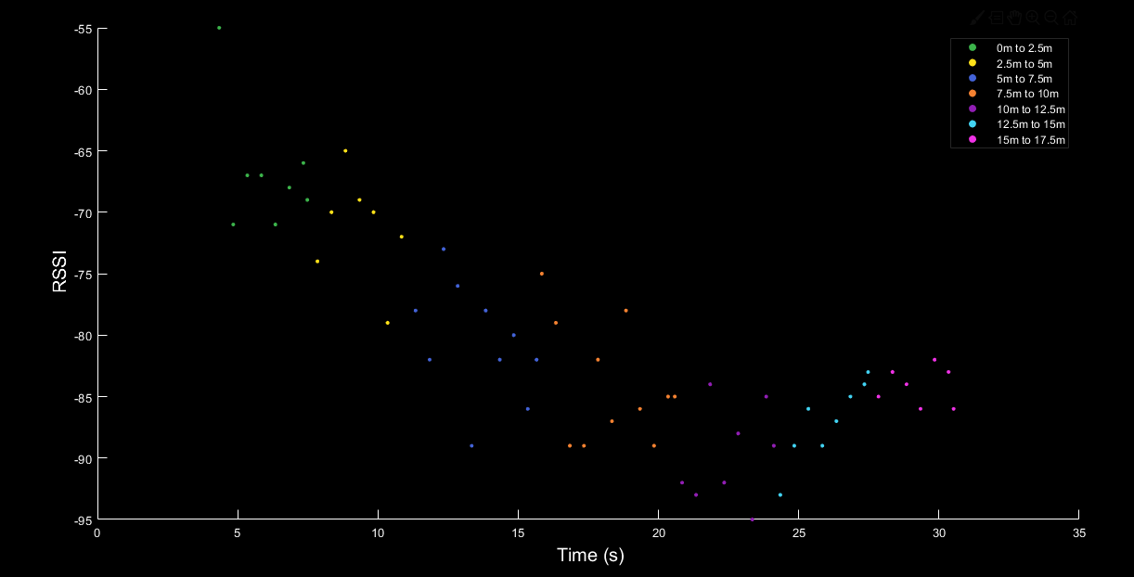

Packet Loss:

|  |  |  |  |  |  |  |  |
| --- | --- | --- | --- | --- | --- | --- | --- |
| Ranges(m) | 0 to 2.5 | 2.5 to 5 | 5 to 7.5 | 7.5to 10 | 10 to 12.5 | 12.5 to 15 | 15 to 17.5 |
| Packets Dropped (%) | 0% | 0% | 0% | 0% | 0% | 16.6% | 0% |