***You are not required to submit this exercise but do it in class and inform me after you have completed all tasks successfully. Those who are attending the live session via Zoom need to send this assignment to me before 12:30 , 31.10.2019 to get points for attendance.***

1. Create a database newdb.
2. Select newdb as your working database.
3. Create table named project_plan as below:

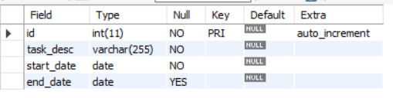

1. Create table named user_info as below:

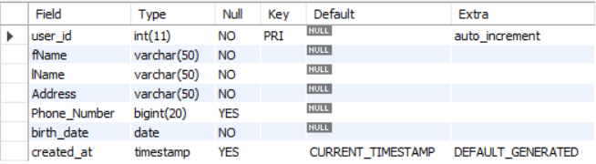

1. Insert 5 records as below into project_plan. Use describe statement to see column names and the data types so that it is easier to insert records.

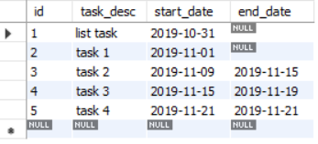

1. Verify that you have inserted records into the project_plan table by executing SELECT statement.
2. Insert 5 random records into user_info
3. Verify that you have inserted records into the user_info table by executing SELECT statement.
4. Open Lecture1.sql and learn SELECT statement in MySQL.