**Creating a CS:GO Server through Google Cloud**

Step 1: Creating the server 1

Step 2: Setting up server connections 3

Step 3: Setting up the server 6

Step 4: Starting the server 7

Step 5: Connecting to the server from Game 9

Step 6: Setting up administrators for your server 10

1. RCON Method: 10

2. Game mods method (Easier for admins after setting it up): 10

Step 7: Updating your server: 13

Step 8: Setting game to tickrate 128: 13

# **Step 1: Creating the server**

Go to [Google Cloud](https://cloud.google.com/), log in, and click "Get started for free".

Fill out any additional information, and begin your 90 day trial, with $300 credit.

When that is done, click on "Compute Engine" on the left sidebar (You may have to open the menu):

[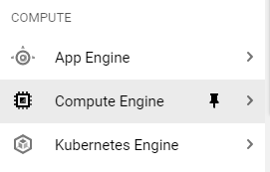](https://preview.redd.it/x9paro99l5961.png?width=271&format=png&auto=webp&v=enabled&s=4cc77a85906bacccd0ae3709d4bf1b36325109ad)

Select "Images" on the left-hand side, and search for ubuntu-2004

Select the best option as in the previous picture, then click on the three dots on the right side of the instance and **create instance** like in the picture below.

This will bring you to a setup screen for your server.

Name your server and select a region closest to where you will be playing from as in the picture below.

Then choose a machine configuration. Generally, 2 vCPU and 8 GB (e2-standard-2) will be enough for a practice server, while you may want to upgrade if you're planning on running 5v5s. [Pricing for each configuration](https://cloud.google.com/compute/all-pricing). The configuration in the picture below should be suitable for 5v5 competitive.

Scroll down to "boot disk", press "Change", and enter 50 for "Size (GB)" then click **SELECT**. Unless you plan on uploading a lot of files and configs, 50GB should be plenty for your server.

Click "**CREATE**", and your server should be created!

# **Step 2: Setting up server connections**

**Configuring the IP address**

Click on your server from the VM Instances page and bring up the server details.

Scroll down to Network Interfaces, and take note of the Primary Internal IP.

Scroll to the right side of the Network interfaces to find "**View details**" and click it.

Select “IP Addresses” on the left-hand side then click on “External IP addresses” on the top of the page.

Then scroll to the right of the IP’s list and click on “RESERVE”.

This will bring up a new window to reserve a static External IP address. Name your server and if you want, you can give it a description (not necessary unless you have many different IP’s reserved) and click “RESERVE” button.

This is your new static External IP address that you will need to connect to from inside the game. Write it down or copy/paste it later when you need to make a connection from the game to your server.



**Configuring the firewall to allow connections to the server**

Select "Firewall" on the left-hand side

Click "create firewall rule" at the top

Name your firewall rule

For "Targets", select "All instances in the network" (provided you don't have any other servers)

For "Source IPv4 ranges", enter [0.0.0.0/0](https://0.0.0.0/0) to allow any IP addresses to connect

Check "tcp", and enter 27015-27030,27036-27037

Check "udp", and enter 4380,27000-27031,27036

[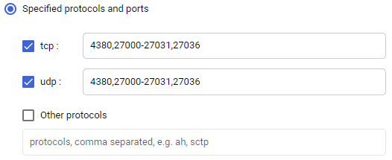](https://preview.redd.it/rvg2lw6fl5961.png?width=526&format=png&auto=webp&v=enabled&s=1fd62b1923373a56a0661e7ee7a7c56dcb68559d)

Click "CREATE" to create your firewall rule.

Return to your server page by selecting "Compute engine > VM instances" from the top-left menu.

**Step 3: Setting up the server**

Click on your server, and select "SSH" to open the terminal.



Wait for each of the following steps to complete before going onto the next. You will know when it is complete when the bottom of your terminal shows youremail@servername:~$

Paste the following into the terminal to update the repositories:

sudo -- sh -c 'dpkg --add-architecture i386; add-apt-repository multiverse; apt-get update; apt-get -y dist-upgrade'



Then press “Enter” on your keyboard and wait for the process to finish.

After that paste the following into the terminal and press “Enter” the same way as before to install linuxGSM:

wget -O linuxgsm.sh https://linuxgsm.sh && chmod +x linuxgsm.sh && bash linuxgsm.sh csgoserver

Type ./csgoserver install, and press "enter" when prompted to begin the installation. The server will begin installing the CS:GO server, along with any other dependencies. This process will take approximately 20 minutes.

After installation, you may be prompted for a game token. Leave the field blank for now, and press enter.

# **Step 4: Starting the server**

Go to [Steam Game Server Management](https://steamcommunity.com/dev/managegameservers), and create a new game token with app ID 730. Copy your new Game Login Token.

In the terminal, enter: nano start.sh to open a text editor



Paste the following into the file, and remember to replace [YOUR CODE] with your game token, and [YOUR IP] with the INTERNAL IP ADDRESS you noted earlier:

screen serverfiles/srcds_run -game csgo -usercon -strictportbind -ip [YOUR IP] -port 27015 +clientport 27005 +tv_port 27020 +sv_setsteamaccount [YOUR CODE] -tickrate 128 +map de_mirage +servercfgfile server.cfg -maxplayers_override 16 +mapgroup mg_active +game_type 0 +game_mode 1 +host_workshop_collection +workshop_start_map -authkey -nobreakpad

Press CTRL + S and CTRL + X to save and exit the text editor.

**NOTICE: In the above script the server “tickrate” is set to 128 (Which is better for the players to get a smoother better connection to the server), if you want to change it to the default 64, then you can delete the commanline “-tickrate 128” from the launch script you wrote in start.sh**

You will usually want to set up a password and RCON (remote connection) password for your server.

In the terminal, enter nano serverfiles/csgo/cfg/autoexec.cfg



Paste the following into the file (replace the passwords with your passwords):

hostname "CSGO Server"

rcon_password "YOUR_RCON_PASSWORD"

sv_password "SERVER_PASSWORD"

sv_cheats 0

sv_lan 0

exec banned_user.cfg

exec banned_ip.cfg

sv_minupdaterate 128

sv_mincmdrate 128

exec gamemode_competitive

Press CTRL + S and CTRL + X to save and exit.

At this point, your basic server is ready and you can start and connect to your server from the Game.

In the terminal, enter sh start.sh to start the CS:GO server.



Congrats! Your server is now up and running. You can shutdown the server by simply typing “quit” and pressing enter in the terminal.

**Step 5: Connecting to the server from Game**

Once you have Steam installed, you can add the server as a favorite in order to access it easily in the game.

Open steam and click on View -> Servers in the upper-left corner of your Steam window.

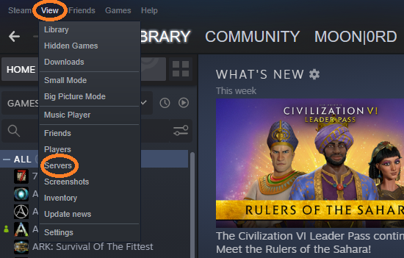

A new Servers list window will open and you will have to add your CS:GO server here by clicking on the “ADD SERVER” button and adding your static “EXTERNAL IP ADDRESS” that you reserved for your server, followed by “:27015” and click on “ADD THIS ADDRESS TO FAVORITES” button.

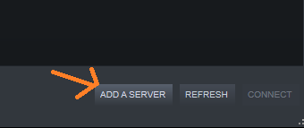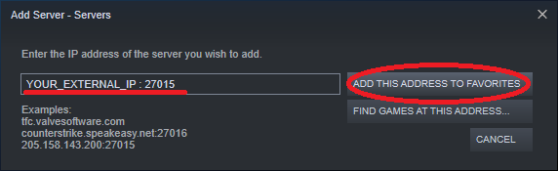

Now your server is added as a favorite and can be accessed from inside the game by clicking on it.

Start your CS:GO game from Steam

Once in game, click on Play CS:GO on the left side of your screen, then click on “OFFICIAL MATCHMAKING” and change it to “Community Server Browser”.

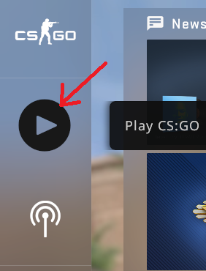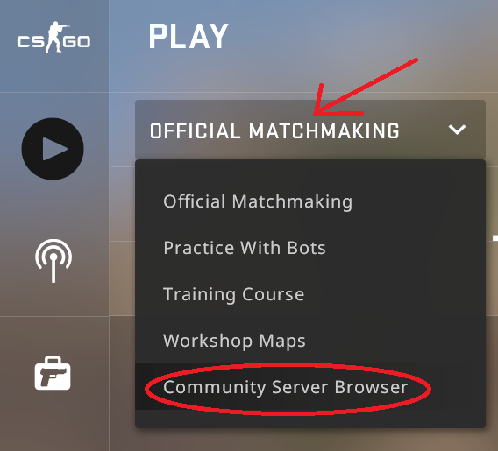

Now your favorite servers window popped up and you can select your server from there by clicking on it and then pressing connect in the bottom-right corner of the window.

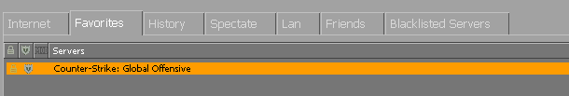



Now you are connected to your server and can play on it.

# **Step 6: Setting up administrators for your server**

Once you have your server running successfully you would want to be able to administrate the games plaid on it and for that you can either setup a list of administrators through installing 2 mods to your server or you can just use the RCON password that you have set up in the “autoexec.cfg” file.

1. **RCON Method:**

- inside the game, you will have to [unlock your developer console from the game settings](https://www.prosettings.com/csgo-enable-developer-console/)

- open your developer console and enter: rcon_password <your_rcon_password>

- now you can write commands in your developer console to shape the server as you wish, you can find long list of commands [here](https://www.tobyscs.com/csgo-console-commands/).

1. **Game mods method (Easier for admins after setting it up):**

- first you have to stop your server by typing “quit” in the terminal and pressing the “return” key.

- now we have to install 2 mods called metamod and sourcemod (IMPORTANT: we have to install them in this particular order 1. metamod 2. sourcemod)

- in your terminal type: “./csgoserver mods-install".



- a list of mods will appear after you hit enter and there we will type: “metamodsource” and hit enter.



- after it has finished the installation we have to type again: “./csgoserver mods-install" and hit enter, after the list appears type: “sourcemod” and hit enter.



- now the mods are installed and need to add admins to the configuration file of the mod. Type: ”nano serverfiles/csgo/addons/sourcemod/configs/admins_simple.ini” in the terminal.



- press the down arrow key on your keyboard until you reach the bottom of the page.

- here you will have to add the STEAM_ID of the players you wish to be administrators of your server. You can find their id’s at <https://steamid.io/> where you can search by their names for example or by loging in if you want to see your own id.

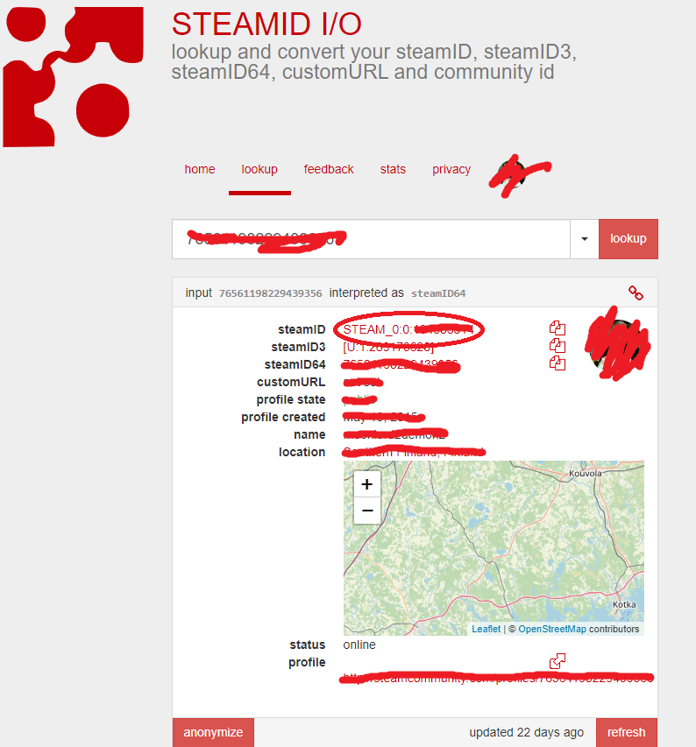

- copy the whole steamID including “STEAM_0:0” and copy it in your admins_simple.ini between brackets followed by space and “99:z”

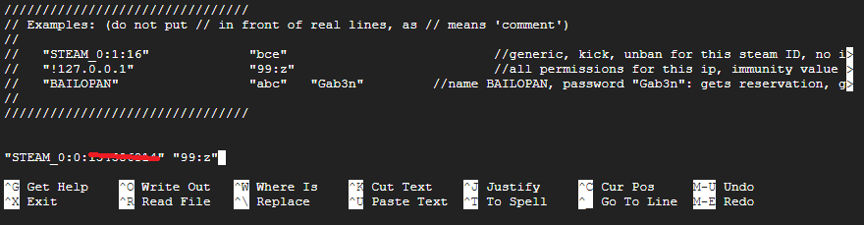

- now press CTRL + S and then CTRL + X

Now your admin is set to your server and you can start your server again and your game.

After you opened the game you can open your developer console and type: "bind p sm_admin” (NOTE: This is for binding the admin panel to your P key on your keyboard. You can change “p” to any key you wish) hit enter and exit the console.

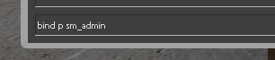

Now you can access the admin panel by simply pressing the key you bound it to (in this case P) and pressing the numbers indicated in the menu to administrate your server as you wish.

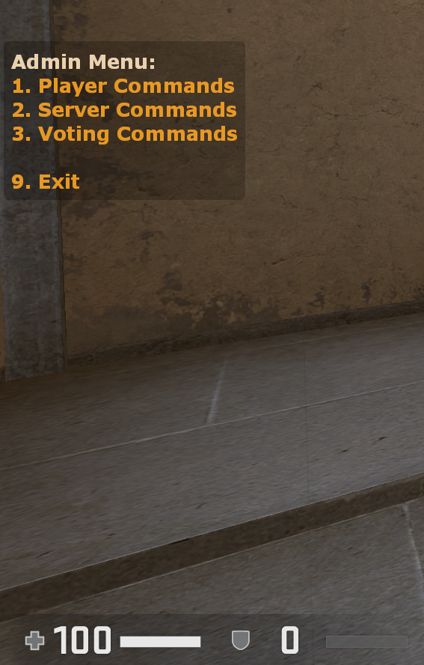

**Step 7: Updating your server:**

You will need to update the server whenever CS:GO is updated in order to play on it. To do so, simply enter “ ./csgoserver update “ into the terminal (Note: Your CS:GO server must not be running, make sure you shut it down before updating), hit enter and wait for the update to finish.



**Step 8: Setting game to tickrate 128:**

If the server is set up to tickrate 128, you will have to set your game client to that same tickrate in order to benefit from it. To do that you will go to your Steam library and locate your CS:GO game in the left side of the window, then right-click mouse button on your game and select Properties. This will bring up the game properties window, where you will have to select General on the left-hand side of the window(if not already selected by default), and scroll down to LAUNCH OPTIONS. Copy/Paste the folowing launch options there:

-novid -tickrate 128 +mat_queue_mode 2 +cl_forcepreload 1 -nojoy

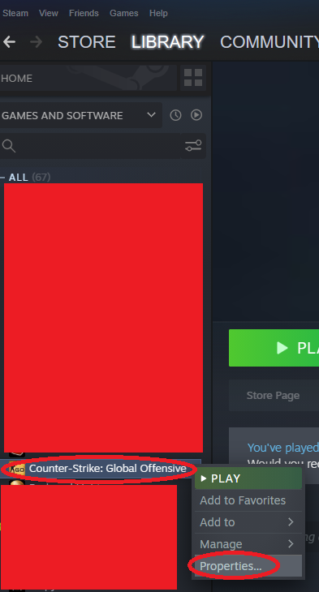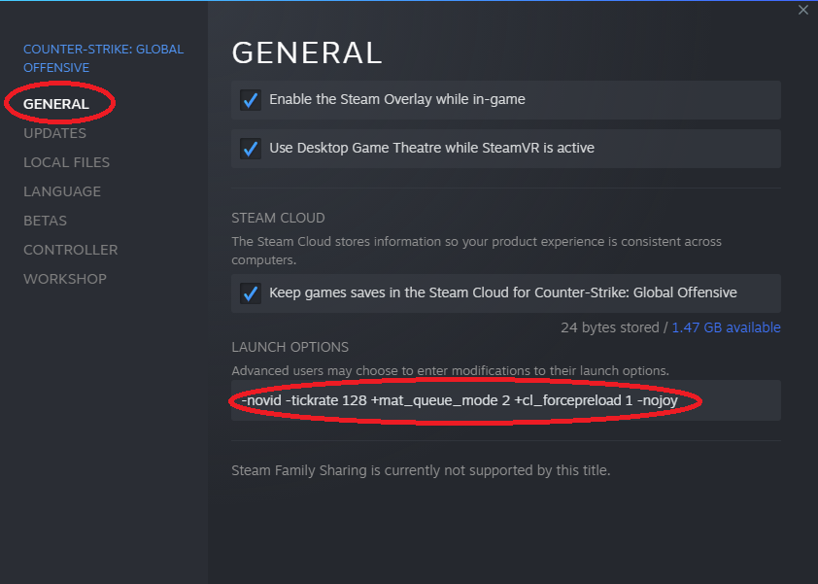

Then close the properties window and you’re good to go. **NOTE:** This has to be done on all the game clients that are connecting to the server in order for all the players to benefit from the 128 tickrate.