Claruis High Frequency Linear Scanner

Contents

Links 2

Weekly report 3

Week 1 3

# Links

Clarius cast api:  
<https://github.com/clariusdev/cast/tree/master>

Clarius cast api lib:   
<https://github.com/clariusdev/cast/releases>

# Weekly report

## Week 1

I got connected to the Clarius device. I had to be invited to the intuition from the administrator to be able to use the device. I was able to use the app to see the ultrasound data and was able to record a short recording of my arm moving and store it on my device (can also store on the Clarius cloud). Found some python api on github, not sure on how they work, or which one is better or how to connect it.

Using Clarius cast API

<https://github.com/clariusdev/cast/tree/master>

Can not find the library for the python example code.

## Week 2

Found the library download location  
<https://github.com/clariusdev/cast/releases>

I downloaded the windows.x64 version(download for whatever os you have). Inside the zip, there are different versions of the lib for different version of python, get the pyclariuscast.pyd file for the python version that you are using. There is also the cast.dll and cast.lib In the zip file, you will as need them. Download the pysidecast.py python example and scanner.mtl and scanner.obj from the github. You will also have to download PySide6 for this example if you don’t already have it. Use

pip install PySide6

to install it. The file directory should look like something like this:  
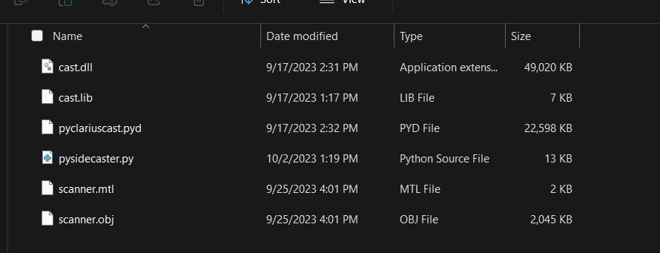

Now, on the Clarius mobile app, in settings change the clarius cast to Research(5828)  
(Note: if does not show try restarting app or connect to the devices network)  
Now turn on and connect the Clarius probe using the app. You will also have to connect your computer to the probe using Wi-Fi. To get the probes Wi-Fi name look at what your phones Wi-Fi is connected to. The password to connect will be on the phone’s clipboard when you connect the phones to the probe for 60 seconds. So go somewhere you can paste text like a web browser and paste it there to see it.

Once you have the probe connected to the phone and computer, you can run pysidecast.py. The Ip and port will be on the mobile app at the top.

When you connect the desktop application to the probe you can take a picture or record. If you don’t see the probe stream on the desktop app on window, you will have to disable your firewall.

### Notes

If I use the wifi dongle from the emg armband I can connect to the KSU wifi and the probe at the same time.  
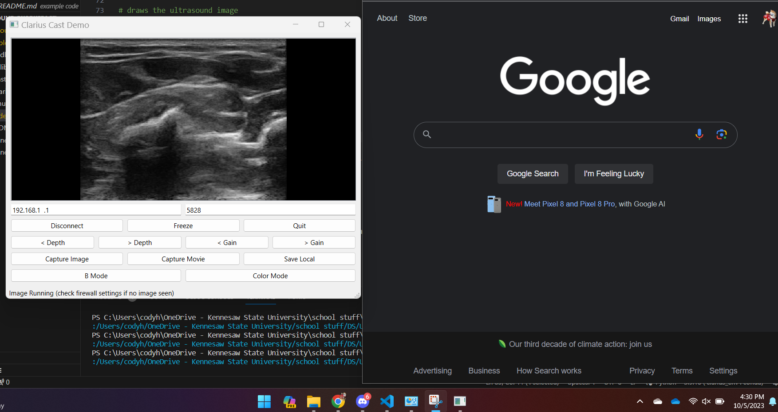

ssss