Errors
user_team_service.py
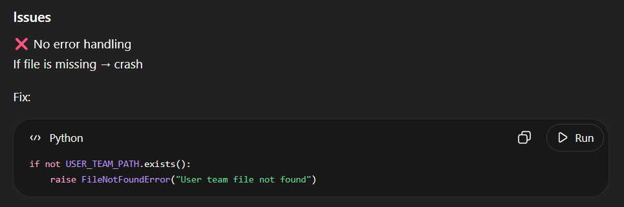
Biggest improvements needed
- Cache reference images (critical)
- Add confidence threshold
- Validate filenames in detect route
- Add logging for debugging
- Avoid broad except Exception
- Consider async for CV processing
Potential issue: "origins": "*" is fine for development, but for production you should restrict it to your frontend domain.
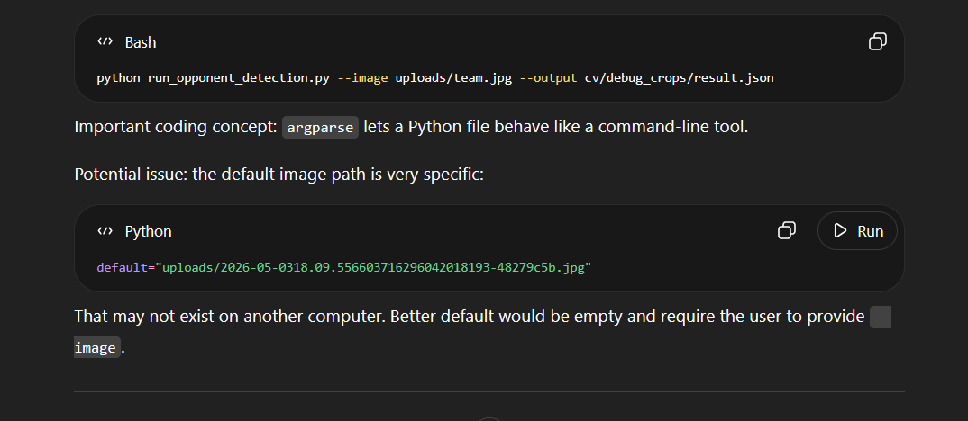
Which they will as it will be uploaded by the user.
Good candidates for OOP
1. cv_service.py — best candidate
This should probably become a class because it has shared settings and repeated operations:
class OpponentTeamDetector:
def __init__(self, reference_dir, metadata_path, debug_dir):
self.reference_dir = reference_dir
self.metadata_path = metadata_path
self.debug_dir = debug_dir
self.references = self.load_reference_images()
def detect_team(self, image_path):
Main benefit: you can load reference images once instead of every detection.
Right now:
references = load_reference_images()
runs every time. A class could cache that.
3. RAG service — optional
Could become:
class RAGService:
def answer_question(self, question):
...
Useful if you need to load the vector database once and reuse it.
Damage formula
Type effectiveness
STAB
Adaptability
Random 85–100 rolls
Burn
Guts
Weather: rain/sun/sand/snow
Screens: Reflect, Light Screen, Aurora Veil
Items: Life Orb, Choice Band, Choice Specs, Choice Scarf, Assault Vest
Speed abilities: Swift Swim, Chlorophyll, Sand Rush, Slush Rush
Stat boosts

