Learning Systems Technology Orientation

2015

**TABLE OF CONTENTS**

**I: Front End Analysis** 2

1. Needs Assessment 2
2. Instructional Goals 2

**II: Goal Analysis** 2

1. Classified by Learning Type 2
2. Major Steps to Perform Goal 3

**III: Subordinate & Entry Skills** 4-5

1. Goal 1 4
2. Goal 2 5
3. Goal 3 6

**IV: Analyzing Learners and Contexts** 7-8

1. Learner Analysis 7
2. Learning Context Analysis 8

**V: Instructional Goals ⇒ Instructional Objectives** 9

**VI: Subordinate Skills: Sub-Goals ⇒Sub-Objectives + Assessments** 10-15

1. Objective 1 10-11
2. Objective 2 12-13
3. Objective 3 14-15

**VII: Instructional Strategies for Objectives** 16-21

1. Objective 1 16-17
2. Objective 2 18-19
3. Objective 3 20-21

**VIII: Instructional Strategy Logistics** 22

**IX: Instructional Materials** 23

**X: Formative Evaluations** 22-24

1. Objective 1 22-23
2. Objective 2 23
3. Objective 3 23-24

**XI: Summative Evaluations** 24

**XII: Strategy for Problems within the Design** 25

**I: Front-End Analysis**

**Needs Assessment**

1. Blackboard Knowledge
   1. AS*: 52% of students check blackboard at least every 48 hours and participate in coursework.
   2. DS**: 90% of students check blackboard at least every 48 hours and participate in coursework.
   3. NG***: 38% more students need to check blackboard and participate in coursework at least every 48 hours.
2. Graduate School Decorum
   1. AS: 45% of new Graduate students know and model professional behavior.
   2. DS: 90% of new Graduate students know and model professional behavior.
   3. NG: 45% more new students need to know and model professional behavior.
3. LSTE Program Scheduling
   1. AS: 56% of LSTE program participants graduate within two years of joining the program.
   2. DS: 80% of LSTE program participants graduate within two years of joining the program.
   3. NG: 24% more LSTE participants need to graduate within two years of joining the program.

*AS: Actual Status

**DS: Desired Status

***NG: Need Gap

**Instructional Goals**

1. Blackboard Knowledge

- New LSTE students will be able to use their mobile device to access Blackboard and stay current with course topics and class discussions when away from their computer.

1. Graduate School Decorum

- New LSTE graduate students will be able to use the netiquette handbook to model expected professional behavior when participating in online discussions and group assignments.

1. LSTE Program Scheduling

- LSTE students will be able to work with advisors and online course requirements to plan their LSTE courses within a 2 year graduation schedule.

**II: Goal Analysis**

**Classified by Learning Type**

1. Blackboard Knowledge

- Intellectual Skill

1. Graduate School Decorum

- Intellectual Skill

1. LSTE Program Scheduling

- Intellectual Skills

**Major Steps to Perform Goal**

*(1) New LSTE students will be able to use their mobile device to access Blackboard and stay current with course topics and class discussions when away from their computer.*

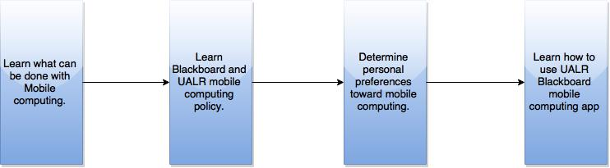

*(2) New LSTE graduate students will be able to use the netiquette handbook to model expected professional behavior when participating in online discussions and group assignments.*

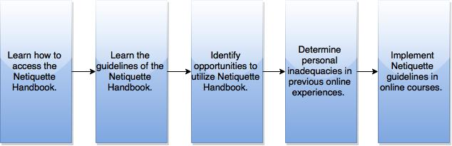

*(3) LSTE students will be able to work with advisors and online course requirements to plan their LSTE courses within a 2 year graduation schedule.*

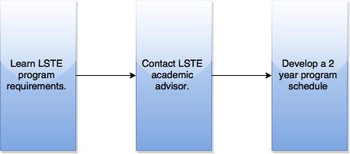

**III: Subordinate & Entry Skills**

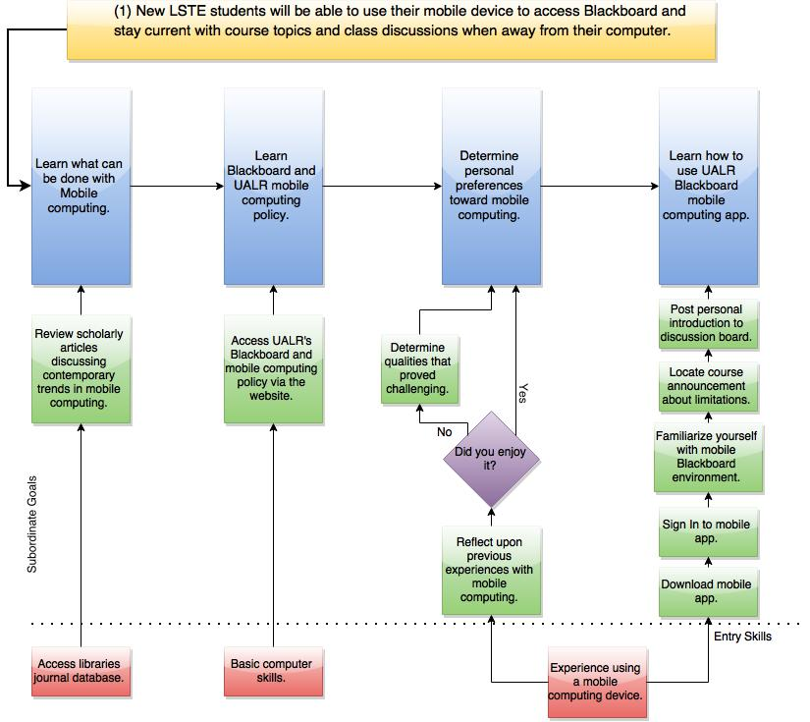

**III: Subordinate & Entry Skills cont.**

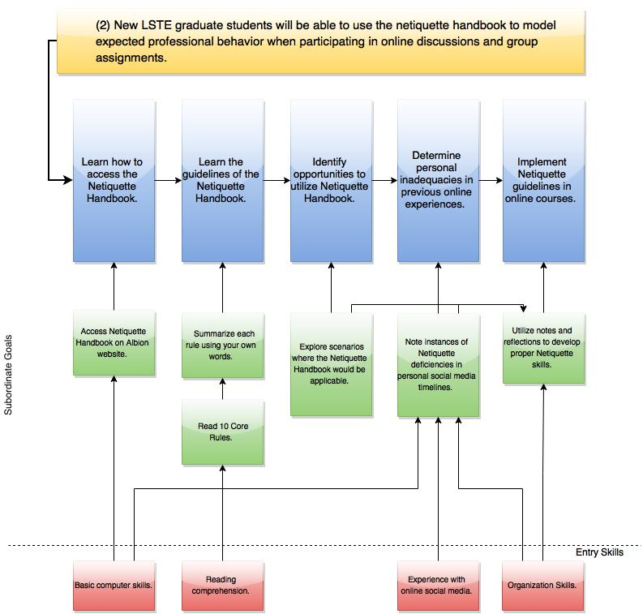

**III: Subordinate & Entry Skills cont.** 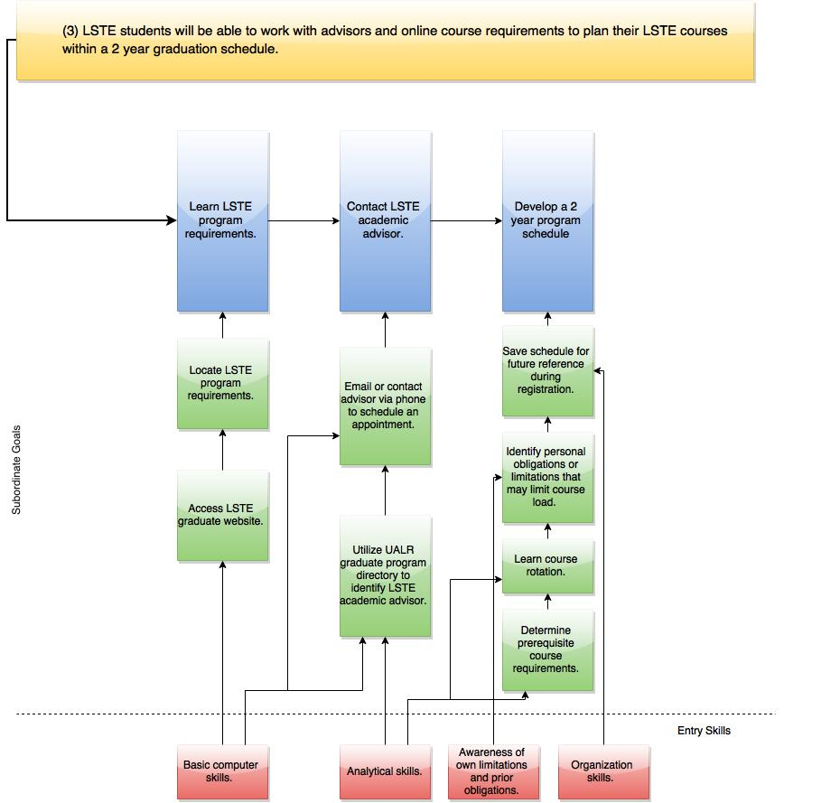

**IV: : Analyzing Learners and Contexts**

**Learner Analysis**

1. Entry Skills:

* Performance Setting: Most new LSTE students are familiar with blackboard and engaging the web application but they are not attuned to the nuances of appropriate behavior of an online program. Learners have participated in group discussions and projects within a traditional classroom; however, many have never had to execute group discussions or projects completely through distance technologies.
* Learning Setting: New LSTE students are familiar with the general functions of a university; however, many have not familiarized themselves with the expectations of graduate studies and even fewer have experience with a fully web-based curriculum. Many learners have never attended UALR.

1. Prior Knowledge of Topic Area:

* For the most part, LSTE learners are familiar with using their personal mobile device, proper etiquette and registration procedures.

1. Attitudes toward Content and Potential Delivery System:

* Learners may hold reservations about computer based learning but are confident enough in their skills that they have signed up for a complete graduate course conducted online.

1. Academic Motivation:

* Many students are enrolled to further develop professional skills that will assist in progressing their career in either education or corporate training.

1. Educational and Ability Levels:

* All students have completed undergraduate degrees and have met the requirements for admission into the program.

1. General Learning Preferences:

* Learners possess a wide variety of learning preference: independent study, group discussions, in person, long distance and group based learning.

1. Attitudes toward Training Organization:

* Learners have a generally positive attitude towards UALR and are excited to join a metropolitan university.

1. Group Characteristics:

* Heterogeneous; The qualities and characteristics of the program participants are diverse.
* Age, ethnicity and career experience all vary within the LSTE learners; however, some participants have previous experience in education or training.
* Most participants come from a variety of undergraduate programs outside of education.

**Learning Context Analysis**

1. Compatibility of Site with Instructional Requirements:

* Blackboard is a compatible site because it offer all the tools and resources necessary to provide LSTE learners with an orientation that parallels what will be expected of them throughout the LSTE program. It also provides appropriate resources for assessment and accessing internet materials.

1. Adaptability of Site to Simulate Workplace:

* Many LSTE graduates find themselves working in self-regulating home-based environments. Distance technologies, be it computer or mobile device, will offer learners an authentic feel of what may be expected of them within their future career, as well as, what will be expected of them throughout the LSTE program.

1. Adaptability for Delivery Approaches:

* Blackboard is a versatile delivery platform that accommodate a variety of delivery approaches. It is compatible with text, slide show, video, audio and interactive instructional modules. It also facilitates group discussions and can enable groups to work together effectively over long distances in collaborate.

1. Learning Site Constraints Affecting Design and Delivery:

* The constraints of Blackboard and the learner environment are greatly affected by variables of internet connections speeds, age of computer, reliability of software/web server and the environment the learner chooses for their studies.
* Blackboard does not work well in Internet Explorer. It is recommended that Firefox or Chrome be used.
* Not all features of Blackboard are suited for mobile computing.

**V: Instructional Goals ⇒ Instructional Objectives**G: (1): New LSTE students will be able to use their mobile device to access Blackboard and stay current with course topics and class discussions when away from their computer.O: (1): With a personal mobile device (CN)*, utilize Blackboard Mobile Learning (B) to contribute to course discussions at least every 48 hours (CR).

G: (2): New LSTE graduate students will be able to use the netiquette handbook to model expected professional behavior when participating in online discussions and group assignments.

O: (2): Equipped with the Netiquette online handbook (CN), model professional behavior (B) to facilitate collaborative and respectful relationships with colleagues and instructors (CR).

G: (3): LSTE students will be able to work with advisors and online course requirements to plan their LSTE courses within a 2 year graduation schedule.  
  
O: (3): Referencing academic advisors and program requirements (CN), develop a 2 year LSTE schedule (B) that adhere to prerequisite course requirements and course rotation (CR).

G: Goal

O: Objective  
CN: Conditions  
B: Behavior  
CR: Criteria

* Assumptions have been made that the Blackboard Learning Management software allows instructors to see statistics concerning users use of the Blackboard Mobile Learning App.

**VI: Subordinate Skills: Instructional Goal (1) ⇒ Subordinate Objectives + Assessments**

SG: (1.a): Review scholarly articles discussing contemporary trends in mobile computing.

SO: (1.a): Utilizing the Ottenheimer Library’s digital journal database (CN), locate an article, published within the past three years, covering contemporary trends in mobile computing and write a brief summary (B) covering at least three current trends in mobile computing (CR).

A: (1.a): Article Analysis focusing on at least three current trends in mobile computing.

SG: (1.b): Access UALR’s Blackboard and mobile computing policy via the website.

SO: (1.b): Utilizing UALR’s website resources (CN), review UALR’s “Blackboard and Mobile Computing” policy (B) and complete a multiple choice exam without missing a single question (CR).

A: (1.b): 10 question multiple choice exam covering UALR’s Blackboard and mobile computing policy.

SG: (1.c.i): Reflect upon previous experiences with mobile computing.

SO: (1.c.i): Analyzing past mobile learning and computing experiences (CN), identify personal preferences towards mobile computing (B), citing no less then three reflected experiences and stating whether they were found to be enjoyable or not (CR)

A: (1.c.i): Journal post discussing three personal experiences that have influenced the learner’s preference for or against mobile computing and learning.

SG: (1.c.ii): Determine qualities that proved challenging.  
  
SO: (1.c.ii): Using personal reflection about mobile computing preferences (CN), focus on qualities that proved challenging during previous mobile learning experiences (B)by clearly identifying at least three incompatible qualities (CR).

A: (1.c.ii): Class discussion focusing on incompatible qualities of mobile learning. Student’s against mobile learning will provide their identified qualities as topics for discussion.

SG: (1.d.i): Download mobile app.

SO: (1.d.i): Utilizing your mobile device's app store (CN), locate and download “Blackboard Mobile Learning” (B) and install it on to your device (CR).

A: (1.d.i): Student has Blackboard Mobile Learning app on their preferred mobile device.

SG: (1.d.ii): Sign in to mobile app.

SO: (1.d.ii): Recalling your personal UALR Net ID and password (CN), sign into “Blackboard Mobile Learning” app (B) and locate your courses on your “Dashboard” page (CR).

A: (1.d.ii): Student has successfully signed into Blackboard Mobile Learning app.

SG: (1.d.iii): Familiarize yourself with the mobile blackboard environment.

SO: (1.d.iii): Recalling previous experiences with Blackboard (CN), review Blackboard for a browser and the mobile app (B) to identify similarities and differences between the two platforms (CR).

A: (1.d.iii): Students will post and discuss on the discussion board about the similarities and differences between the two platforms that they were able to identify.

SG: (1.d.iv): Locate course announcement about limitations.

SO: (1.d.iv): Using the Blackboard Mobile Learning app (CN), locate the courses announcements window (B) to review all current announcements (CR).

A: (1.d.iv): Reply to announcement discussing at least two Blackboard Mobile Learning limitations covered in the course announcement.

SG: (1.d.v): Post personal introduction to discussion board.

SO: (1.d.v): Using the Blackboard Mobile Learning app (CN), locate the course discussion board(B) to write a brief self-introduction that includes details about your work experience, education experience and a selfie taken with your device (CR).

A: (1.d.v): Learner successfully creates a personal thread that contains a brief introduction and contains a selfie portrait taken with their device.

SG: Subordinate Goal

SO: Subordinate Objective

CN: Conditions

B: Behavior

CR: Criteria

**VI: Subordinate Goals : Instructional Goal (2) ⇒ Subordinate Objectives + Assessments**

SG: (2.a): Access Netiquette Handbook on Albion website.

SO: (2.a): Given the Albion website (CN), students will explore the netiquette handbook (B) to find specific information and discuss five new rules of netiquette learned from the site (CR).

A: (2.a): Post your discussions in our class discussion forum. Be sure to include the rule and provide examples for each rule. You will receive 1 point for each rule and example with a maximum of 10 points.

SG: (2.b.i): Read 10 Core Rules

SO: (2.b.i): Accessing the Albion website (CN), read all 10 core rules of netiquette (B) to be able to recite each rule when called upon in online group discussions.

A: (2.b.i): Select students will need to recite to the group the rule, identified by number.

SG: (2.b.ii): Summarize each rule using your own words

SO: (2.b.ii): Referencing the Netiquette handbook (CN), students will summarize the 10 rules (B) using

your own words (CR)

A: (2.b.ii): Post your summaries to your blog. Be mindful of grammar and spelling.

SG: (2.c): Explore scenarios where the Netiquette Handbook would be applicable.

SO: (2.c): Given a specific scenario (CN), apply netiquette rules (B) to demonstrate appropriate behavior (CR).

A: (2.c): Matching scenarios to the applicable netiquette rule.

SG: (2.d): Note instances of Netiquette deficiencies in personal social media timelines.

SO: (2.d): Reflecting on past social media timeline (CN) identify 2-3 instances where netiquette should be applied (B) and make corrections accordingly (CR).

A: (2.d): After making the corrections, submit a journal explaining the corrections you made. Also include the reason why you felt they needed changed and how you will handle similar situations in the future. This is worth 15 points.

SG: (2.e): Utilize notes and reflections to develop proper Netiquette skills.

SO: (2.e): Using your notes and reflections (CN), develop proper netiquette skills in your online discussions (B). Practice having a minimum of 3 discussions per week with classmates (CR).

A: (2.e): Post discussions with classmates using proper netiquette skills at least 3 times per week. Make sure the discussions are not all on same day, you respond to other classmates’ posts, and that you provide references when necessary. 1 point for each post and 1 point for each response will be given.

SG: Subordinate Goal

SO: Subordinate Objective

CN: Conditions

B: Behavior

CR: Criteria

**VI: Subordinate Goals: Instructional Goal (1) ⇒ Subordinate Objectives + Assessments**

SG: (3.a.i): Access LSTE graduate website.

SO: (3.a.i): Using the UALR graduate website (CN), find the LSTE program requirement (B) to correlate to proper graduation timing (CR).

A: (3.a.i): Multiple Choice. Check each box that is a requirement of the LSTE program.

SG: (3.a.ii): Locate LSTE program requirements.

SO: (3.a.ii):Using your web browser (CN), locate the LSTE graduate website (B). Be able to identify class requirements, advisors, and contact information (CR).

A: (3.a.ii): Short answer questions/matching questions. Match the class requirements to the class. Fill in the answers to questions.

SG: (3.b.i): Utilize UALR graduate program directory to identify LSTE academic advisor.

SO: (3.b.i): Using the UALR website (CN), locate the graduate program directory and identify the LSTE academic advisor (B) to keep for future reference (CR).

A: (3.b.i): Students will be assessed on whether or not they have identified the proper academic advisor.

SG: (3.b.ii): Email or contact advisor via phone to schedule an appointment.

SO: (3.b.ii): With the contact information you found on website (CN), call or email academic advisor (B) to schedule a meeting (CR).

A: (3.b.ii): Create a blog post after your meeting describing what was discussed, who it was discussed with, what you learned, and what you plan to do with the new information.

SG: (3.c.i): Determine prerequisite course requirements.

SO: (3.c.i): Given the course schedule (CN), distinguish any courses with prerequisite requirements (B) to be mindful of these during registration (CR).

A: (3.c.i): Match the course with the prerequisite classes.

SG: (3.c.ii): Learn course rotations.

SO: (3.c.ii): Given the course schedule (CN), examine the course rotation (B) to ensure awareness of the courses that are only offered at specific times of the year (CR).

A: (3.c.ii): From the list of courses given, fill in what semesters each course is available

SG: (3.c.iii): Identify personal obligation or limitations that may limit course load.

SO: (3.c.iii): Reflecting on your life and day-to-day priorities (CN), identify any personal obligations or limitations that may limit your course load (B) and detail any considerations you should make when registering (CR).

A: (3.c.iii): Create a list of the items you will have to take into consideration when you register. Briefly explain each item on your list and why it is a consideration of importance.

SG: (3.c.iv): Save schedule for future reference during course registration.

SO: (3.c.iv): After registration, using your computer (CN), save your schedule for future reference during registration (B) by downloading to your desktop (CR)

A: (3.c.iv): Construct a report to track classes registered for and completion date.

SG: Subordinate Goal

SO: Subordinate Objective

CN: Conditions

B: Behavior

CR: Criteria

**VII: Instructional Strategies for Objectives 1,2 & 3**

**Instructional Objective #1**

|  |  |  |
| --- | --- | --- |
| **Learning Components** | **Consideration for Each Component** | **Instructional Strategy of Objective 1: With a personal mobile device, utilize Blackboard Mobile Learning to contribute to course discussions at least every 48 hours.** |
| Pre Instructional Activities | Provide for motivation  Relevance  Inform learner of objectives  Promote recall of prerequisites  Link new content to existing knowledge/skills | -Program email advertising the convenience of the Blackboard Mobile Learning app.  -Blackboard Mobile learning app enables class participation in any environment.  -Utilize Blackboard Mobile learning app to connect to class at least every 48 hours.  -Remind students to have their NetID and Password available and that the app must be downloaded from the App store.  -Ask learners to think about common task they perform within the traditional Blackboard experience and find ways to navigate the Blackboard Mobile Learning application to perform the same actions. |
| Content Presentation & Learner Guidance | Sequence based on hierarchy among skills  Disclose distinguishing characteristics of concepts (purpose, physical, quality)  Point out common error in classifying (irrelevant)  Provide examples and nonexamples  Create ways of organizing new into existing skills | -Complete instructional objective #1 major steps in order from 1-4.  -Device’s operating system, speed of internet connection, ergonomics of device, mobility.  -Incorrect NetID and password  -Demonstrate task that can and cannot be executed while in Blackboard mobile environment.  -Provide a video demonstrating someone moving seamlessly from their desktop computer to their mobile device to continue working while on the go. |
| Learner Participation | Ensure congruence of practice to conditions and behaviors  Progress from less to more difficult  Use familiar context for rehearsal  Provide conditions similar to performance context  Ensure feedback is balanced with qualities and errors | -Create announcements and discussion threads within the orientation course to allow learners the opportunity to practice using these tools within the Blackboard mobile environment.  -Locate announcement; locate discussion and post reply; create a new discussion thread.  -Utilize Blackboard Mobile while away from home.  -Learners will have access to a limited functioning Blackboard environment.  -For absent participants, notify them of the correct procedure for accessing Blackboard via the mobile app. |
| Assessment | Ensure learner’s readiness for testing  Accommodate hierarchical nature of skills  Apply appropriate criteria for learner age, ability | -Confirm that all learners have acknowledged the course announcement and have created new discussion threads.  -Learners will discuss amongst each other, via the discussion thread, the conveniences of utilizing the Blackboard mobile learning app.  -Learner should be comfortable participating via the  Blackboard mobile app and understand the apps limitations concerning exams. |
| Follow-Through | Promote transfer (authentic task to performance context)  Consider memory requirements  Reflect on learning experience and future applications | -Discuss the advantages of being active within the Blackboard environment on a more frequent basis; detail how active discussion can promote understanding and success within online courses.  -Discuss circumstances that could limit use of Blackboard app aside from not knowing NetID and Password.  -Each student assesses their comfort with using the Blackboard Mobile Learning app. |

**Instructional Objective #2**

|  |  |  |
| --- | --- | --- |
| **Learning Components** | **Consideration for Each Component** | **Instructional Strategy of Objective 2: Equipped with the Netiquette online handbook, model professional behavior to facilitate collaborative and respectful relationships with colleagues and instructors.** |
| Pre Instructional Activities | Provide for motivation  Relevance  Inform learner of objectives  Link new content to existing knowledge/skills | -Provide video demonstrating the advantages of conducting one’s self in a professional manner.  -Professional behavior assures learners will not be misunderstood or intentions will not be misperceived in the online environment.  -Model professional behavior to facilitate collaborative and respectful relationships with colleagues and instructors.  -Ask learners to discuss the different expectations among informal dialogue between friends on a social media platform versus formal dialogue within the Blackboard environment among colleagues and professors. |
| Content Presentation & Learner Guidance | Sequence based on hierarchy among skills  Disclose distinguishing characteristics of concepts (purpose, physical, quality)  Point out common error in classifying (irrelevant)  Provide examples and nonexamples  Create ways of organizing new into existing skills | -Complete instructional objective #2 major steps in order from 1-5.  -Greater awareness of other’s, control over your perceived image online, greater efficiency in communication.  -Posting to discussions without proofreading or justifying your position on a topic of discussion. Falling victim of “flame wars”.  -Make available examples of posts and emails written in poor voice and with questionable tonality; as well as, post that abide by the Netiquette Handbook  -Show video building relationships between how people would conduct themselves in professional settings and how that translates to the online classroom. |
| Learner Participation | Ensure congruence of practice to conditions and behaviors  Progress from less to more difficult  Use familiar context for rehearsal  Provide conditions similar to performance context  Ensure feedback is balanced with qualities and errors | -Provide discussion posts conveying the same message but with varying degrees of adherence to netiquette and ask learners to identify the one they feel is the most professional is presentation and explain why.  -Continue identification exercise; however, increase the similarity each time until learners are having to justify their decisions with greater scrutiny.  -Exercise can be conducted within a public discussion board on Blackboard; each identification problem presented as a separate thread.  -Exercise is conducted within Blackboard; the same environment students will be expected to abide by netiquette guidelines.  -Incorrect identifications will be addressed and error’s justification will be addressed on an individual basis. |
| Assessment | Ensure learner’s readiness for testing | -Learners will be observed using proper netiquette during the identification process to determine readiness for testing. |
| Follow-Through | Promote transfer (authentic task to performance context)  Consider memory requirements  Reflect on learning experience and future applications | -Reinforce good netiquette and acknowledge poor netiquette by contacting student and providing feedback on areas of deficiency.  -Suggest that learners bookmark and re-read the netiquette handbook periodically to serve a reminder of proper behaviors.  -Provide suggested applications outside of the online classroom: work emails, group chats, online community forums, article comment sections. |

**Instructional Objective #3**

|  |  |  |
| --- | --- | --- |
| **Learning Components** | **Consideration for Each Component** | **Instructional Strategy of Objective 3: Referencing academic advisors and program requirements, develop a 2 year LSTE schedule that adheres to prerequisite course requirements and course rotation.** |
| Pre Instructional Activities | Provide for motivation  Relevance  Inform learner of objectives  Promote recall of prerequisites  Link new content to existing knowledge/skills | -Post video of LSTE Alumni about how staying on a 2 year program track has aided in their professional success.  -Graduating within the 2 year recommendation saves money and time for the learner.  -Develop a 2 year LSTE schedule that adheres to prerequisite course requirements and course rotation.  -Ask learners to think about their schedule planning for their Undergraduate degree.  -Learners should reflect upon course availability and prerequisites that affected their Undergraduate scheduling and use those experiences to better navigate their Graduate course scheduling. |
| Content Presentation & Learner Guidance | Sequence based on hierarchy among skills  Disclose distinguishing characteristics of concepts (purpose, physical, quality)  Point out common error in classifying (irrelevant)  Create ways of organizing new into existing skills | -Complete instructional objective #3 major steps in order from 1-3.  -Course rotation, course prerequisites.  -Learners often omit course rotation when planning their schedule early within the program.  -Learners should be shown that they are already aware of how to register for classes, this skill is just a further development and strategy for timely completion of their academic goals. |
| Learner Participation | Ensure congruence of practice to conditions and behaviors  Provide conditions similar to performance context  Ensure feedback is balanced with qualities and errors | -Learners will develop and devise their 2 year schedule with the aide of their academic advisor. Instructed and guided by the content of this course.  -Provide learner with a series of course offerings and ask that they place them in appropriate order according to prerequisite requirements.  -Correct incorrect ordering of classes by detailing why one class must be taken before another and refer learner to the appropriate course description to emphasize prerequisite requirements. |
| Assessment | Ensure learner’s readiness for testing | -Accurate arrangement of courses from exercise. |
| Follow-Through | Promote transfer (authentic task to performance context)  Consider memory requirements  Reflect on learning experience and future applications | -Each semester as the learner is making arrangements for being advised, they should include with their communication a copy of their predefined 2 year schedule.  -Encourage the physical and digital retention of personal schedule.  -Remind learner that this is a time saving behavior and that it will also ease concerns about future course selection and availability. Allows for the planning of personal obligations outside of the classroom. |

**VIII: Instructional Strategy Logistics**

The primary means of delivery for our instruction is going to be a highly autonomous course set up within the Blackboard learning environment. Each Instructional Objective will be presented as a separate module within the Orientation course for students to complete and participate within the 2 week timeframe set aside for the LSTE orientation. Each module will begin with an announcement that encompasses the pre instructional activities. The content presentation and learner participation activities will be made available as a learning unit within the module. Students will receive email correspondence detailing their participation within the orientation course and instructing them how to access it via Blackboard.

**IX: Instructional Materials**

Instructional Objective #1:

email announcement, web-based video, UALR website*, discussion threads, Blackboard announcement, Blackboard Mobile Learning app*.

Instructional Objective #2:

online netiquette handbook*, web-based video, discussion threads, mock email correspondence for participation exercise, social media timeline*.

Instructional Objective #3:

web-based video, UALR Graduate website*, advisor contact information*.

**\***denotes already available instructional materials.

**X: Formative Evaluation**

Instructional Objective #1:

With a personal mobile device, utilize Blackboard Mobile Learning to contribute to course discussions at least every 48 hours.

Assessments for Instructional Objective #1:

1. Article Analysis on mobile trends
2. Multiple Choice exam about UALR mobile policy
3. Journal post about personal experiences with mobile computing.
4. Discussion on incompatible qualities of mobile computing.
5. Discussion post on similarities of two platforms.
6. Creates personal thread that contains introduction and picture.

Formative Evaluations for Instructional Objective #1:

1. Group discussions about different articles they read and their reactions to those articles. As a group, creating a pros/cons list about mobile computing.
2. Compare results from multiple choice exam to determine any commonalities in missed questions.
3. Reviewing the journal posts submitted by students. Determine if any of the journals should be discussed further as a group.
4. After discussion, spontaneously collect a short paragraph from each student about one thing they agreed with during the discussion and why. Review those to see who was truly engaged in the discussion.
5. Informal Q&A session on the two platforms.
6. Review of each personal thread from students and have instructor personally reach out via Blackboard Messaging to every student after post has been made to discuss how they feel the course is going so far.

Instructional Objective #2:

Equipped with the Netiquette online handbook, model professional behavior to facilitate collaborative and respectful relationships with colleagues and instructors.

Assessments for Objective #2:

1. Post discussion on netiquette rules and examples.
2. Discussion where individual students recite a rule when called upon.
3. Matching exercise –netiquette rule to scenario.
4. Journal post on corrections made to past social media timeline.
5. Post discussion three times per week with classmates and respond to others using proper netiquette.

Formative Evaluations for Objective #2:

1. Class Q&A using the examples provided by students to apply the correct rule.
2. Informal quiz to have students list as many of the rules as they can in 15 minutes.
3. Review results of matching exercise to identify commonalities of misunderstood rules and scenarios.
4. Discussion on examples of the corrections they made and why.
5. Ask each student to create an informal discussion with one other classmate to learn about them. Then each student must introduce the other in class and give a few details of things they have learned about them over the course thus far.

Instructional Objective #3:

Referencing academic advisors and program requirements, develop a 2 year LSTE schedule that adheres to prerequisite course requirements and course rotation.

Assessments for Objective #3:

1. Multiple choice quiz about which are requirements of LSTE program.
2. Short answer/fill in answer quiz about requirements of each class.
3. Blog post about the meeting with your advisor.
4. Matching exercise-course to prerequisite.
5. Fill in answer-fill in what semesters each course is given.
6. Create a list of personal considerations and challenges.
7. Construct a report to track courses completion dates.

Formative Evaluations for Objective #3:

1. Compare results from multiple choice exam to determine any commonalities in missed question.
2. Review short answer/fill in answer quiz results to determine an commonalities in missed questions.
3. Individual presentation to class on meeting with advisor.
4. Informal group quiz that gives students the prerequisites and semesters of courses and asks them to create a 1st year schedule for a student.
5. Included in evaluation 4.
6. One on One discussions between teacher and student about their list and review the report they created.
7. Included in evaluation 6.

Additional Formative Evaluations:

1. Halfway survey will be sent out to each student asking them to rate their overall likes/dislikes of course to date. This will include clarity of materials, instructor engagement, alignment of assessments to objectives, impact the instructions are having on them, feasibility of time commitment required, etc.
2. A question/Answer quiz will be given unannounced at the end of each unit reviewing all materials covered up to date to determine how much information has been retained and to prepare them for the final essay requirement.

**XI: Summative Evaluation**

1. A final survey will be given to each student asking them to rate the overall effectiveness of the course. Survey will include questions regarding teacher engagement with students, other student engagement, quality of feedback and peer reviews, and if course material was relative to content.
2. Also a final short essay will be asked of each student to describe what they learned and how they will apply their new knowledge in the future. Essays should also include what students like most about the course, and least about the course. What expectations did students have prior to the class, and were those met? Please explain either way. Any suggestions to improve the class for future students? A rubric will be given with expectations and appropriate point values associated with each of the items. Measures of grading will include word count, making sure each instructional unit was addressed, proper grammar, and that examples are provided.
3. A skills assessment will be given at the beginning of the course and again at the end of the course to determine what the students truly learned, as well as, to identify any areas that seemed to remain unchanged.

**XII: Strategy for Problems Within the Design**

1. If after the unit Q&A informal quiz is given, common pieces of information are not understood well by the majority, a review of those specific pieces will be made. The following class will be used to review and discuss any known problem concepts. Another informal quiz will be given at the end of that class to determine if the new delivery was better understood by students.
2. The same format will also take place after the halfway survey if it reveals common concerns from the students.
3. Read the essays and review survey, taking into consideration the feedback from the students, look for commonalities whether good or bad, to determine whether to revise the instruction, omit specific the material that was deemed un-useful by majority of students, or keep material as is.