Grower X-Ray Quality Report
Yarranabee Holdings Pty Ltd | Season 25/26 | Highbury, WA | 23 Jun 2026
Thanks for another season of supplying us. Because we scan every bale with X-ray quality testing, we can share a clear picture of what is coming through in your hay, something most growers never see. We hope it helps your planning, and we are always happy to talk it through.
1,911  BALES SCANNED (3 of 9 paddocks) | 95.1%  EXPORTABLE PRODUCT | 4.9%  OVERALL REJECT RATE
What Our X-Ray Found
Here is how many flags were recorded in each category across your 1,911 bales. A bale can be flagged for more than one thing, so the total number of flags is higher than the number of bales affected.
Category | Flags Recorded | Notes
Stone | 672 | Main contributor
Dirt | 258 | Second largest contributor
Moisture | 28 | Do not be concerned
Wire | 14 | Usually old fencing wire
Others | 8
Stone and dirt are the largest factors this season. That pattern usually points to ground and soil picked up during cutting, raking or baling, rather than anything wrong with the hay. Moisture is currently an issue on our side rather than yours, so please do not be concerned about those flags.

How Your Paddocks Compared
Your three scanned paddocks did not all behave the same way.
Paddock (ARGT) | Bales | Reject Rate | Exported To | Status
Tom’s (W20250029) | 678 | 2.4% | Korea | Very clean
Pip’s (W20250030) | 929 | 4.0% | Korea | Solid
Rosies (W20250027) | 304 | 13.2% | Korea | Could improve

What This Means For You
Because we run a slicer plant rather than a decontamination line, what we record is what ships, so every reject is one we have stopped before it reaches your customer. Ahead of your next cut, checking cutting and baler pickup height and ground conditions can make a real difference to stone and dirt pickup, especially on looser or rockier ground. We are happy to talk it through if it helps.

Feeding the animals that feed the world.
Your hard work in the paddock helps feed livestock right around the world. Thank you for growing with us, and for helping us keep doing exactly that.
The Johnson’s WA Team
Supporting Data
The figures in this snapshot come directly from our live Power BI quality dashboard. The screenshot below shows the Reject Summary for your hay this season, and the table beneath confirms how each headline figure traces back to that data.
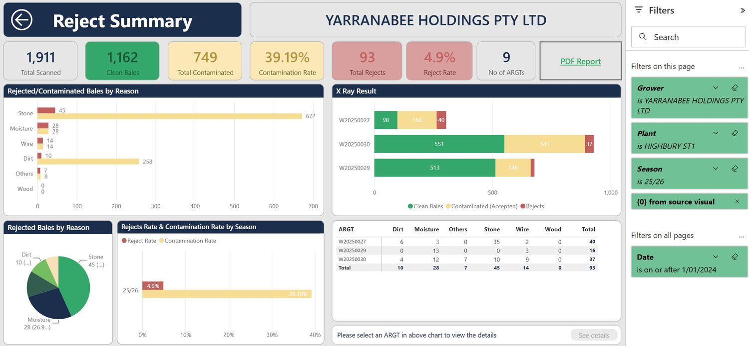
Power BI, Raw Material Rejects, Reject Summary. Yarranabee Holdings Pty Ltd, data updated 17/06/26.

How The Figures Reconcile
Figure | Value from dashboard
Total bales scanned | 1,911
Clean bales | 1,162
Contaminated or rejected | 749
Exportable product | 95.1%
Overall reject rate | 4.9%
Paddocks (ARGTs) scanned | 3 of 9
Every figure on the first page is drawn from this dataset, so the snapshot reflects real operational results rather than estimates.
Season-on-Season Improvement
38.2%  SEASON 24/25 REJECT RATE | 4.9%  SEASON 25/26 REJECT RATE
Your reject rate has dropped from 38.2% to 4.9%, a 33.3 percentage point reduction year on year! Genuine credit to the work going into your paddocks.

Thank you for your support this season.
The large majority of your hay is clean and heading to customers around the world. You are doing a great job, and we are glad to have you growing with us.
Bales Examples
The three examples below are real scans from your hay this season, showing what we are looking for and what we are stopping.
Rejected: Stone Contamination Rosies (W20250027) · Bale 110
REJECTED | X-ray plant capture, supervisor scan mode
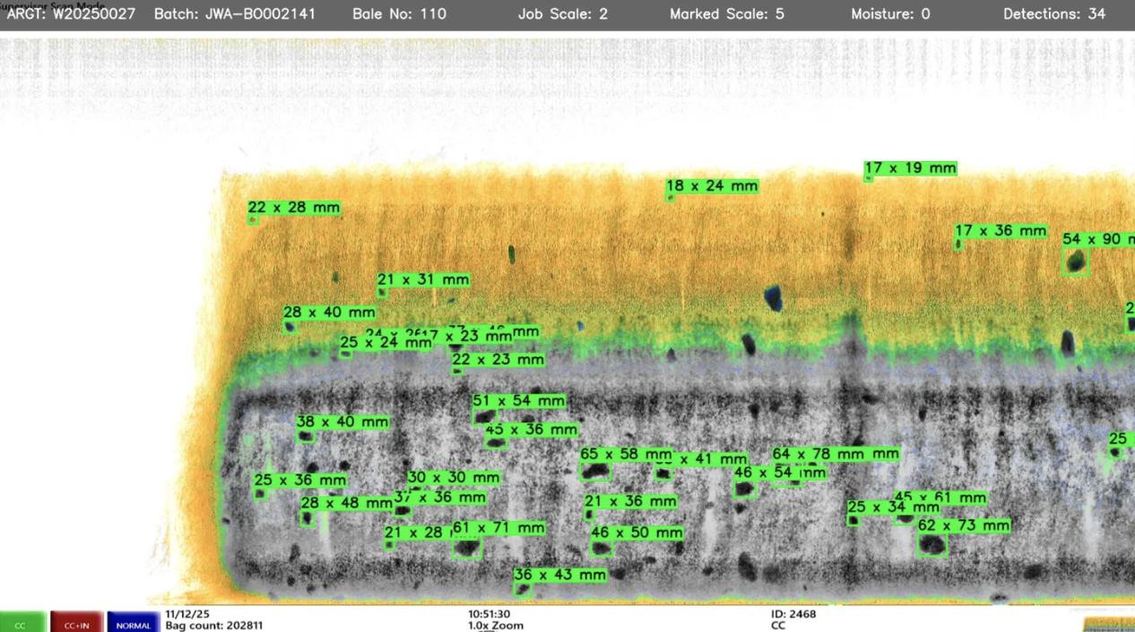
This bale was rejected for stone contamination. The dark blue marks scattered through the bale are stones picked up with the hay during baling. The green boxes show what our X-ray flagged automatically.
Clean: No Contamination Rosies (W20250027) · Bale 117
CLEAN | X-ray plant capture, supervisor scan mode
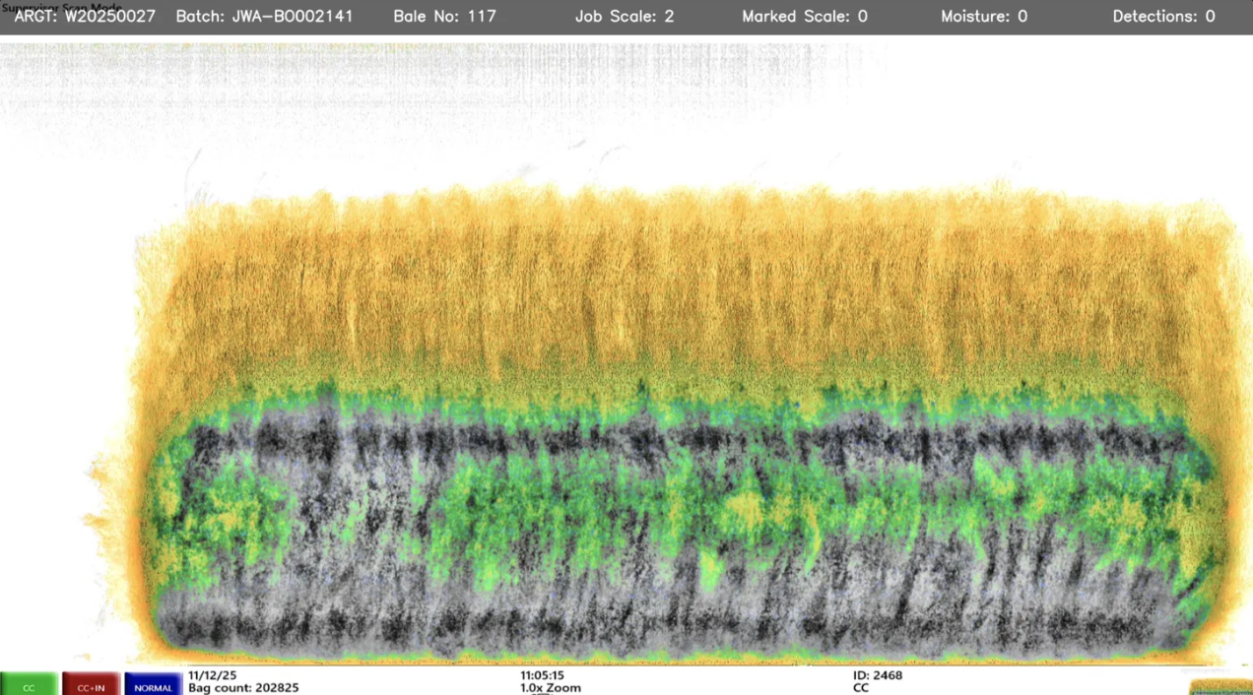
This is what a clean bale looks like through the X-ray. No contaminants flagged, no manual marks from the operator. The bale goes straight through to the press and into export packaging. The colour variation across the image is just density variation, not contamination. This is what we are aiming for on every bale.
Rejected: Wire Contamination Pip’s (W20250030) · Bale 200
REJECTED | X-ray plant capture, supervisor scan mode
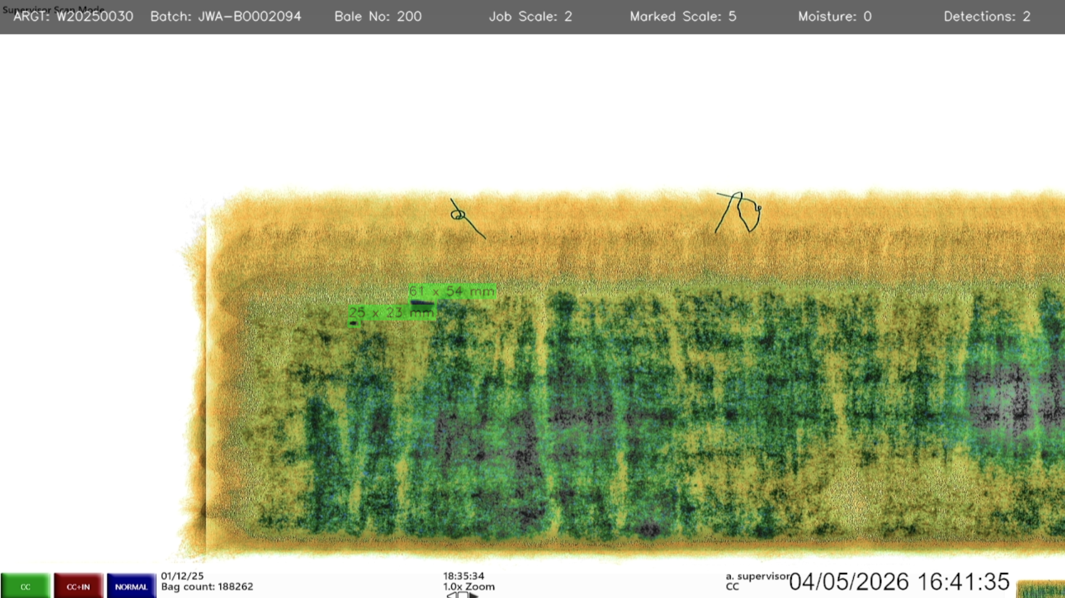
This bale was rejected for wire in the top half, marked in the image. Wire is one of the most serious contaminants we catch because of the injury risk it carries for livestock, so any detection is an automatic reject regardless of how clean the rest of the bale looks.
Note: a few stones on the rejected stone bale are not boxed because we are training an AI tool to improve stone detection. The system will catch more of them automatically as the tool develops.
If you would like to talk through any of these examples, please get in touch with the Lachlan or myself.

