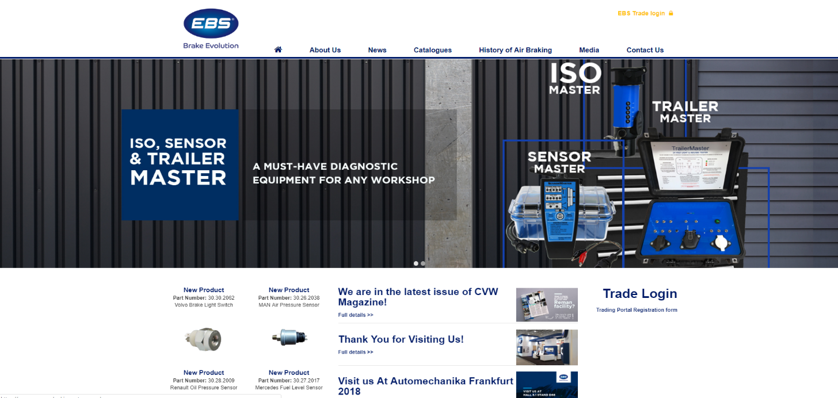
The first website that is being reviewed is EBS Brake Evolution. This website is one of the biggest companies in Europe that sell brake systems for truck and trailer.

This website at first glance is simplistic and has a nice design to the eye. Navigation bar is easy to see and read with simple terms for the user. Cycling pictures take most of the home page with new product listings underneath in the left column. A feed in the middle displaying latest in news on the company and lastly a trade portal registration form for other companies that are in business with EBS. When scrolling down throughout all the pages on this website, the page skips up when the navigation bar tries to minimise.
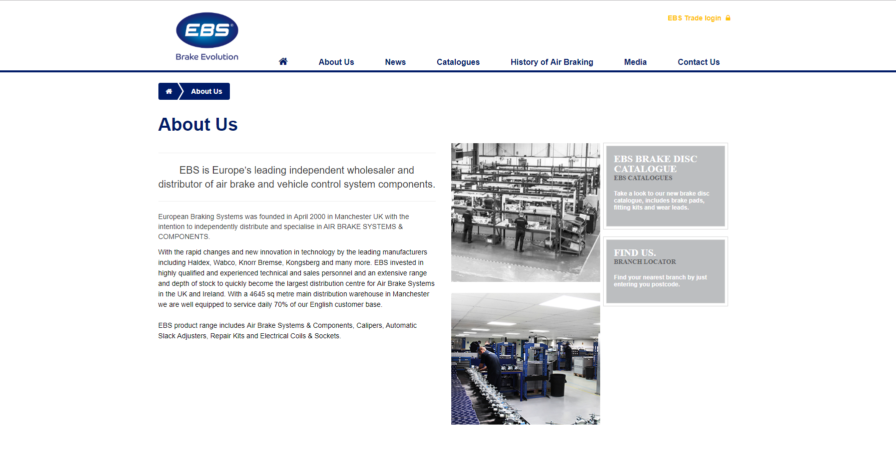
The about us page gives the user a brief description on the history of the business on the left of the page and a few pictures showing the difference between the different parts of the business. Also, there are a few links to one of the catalogues and a branch locator.

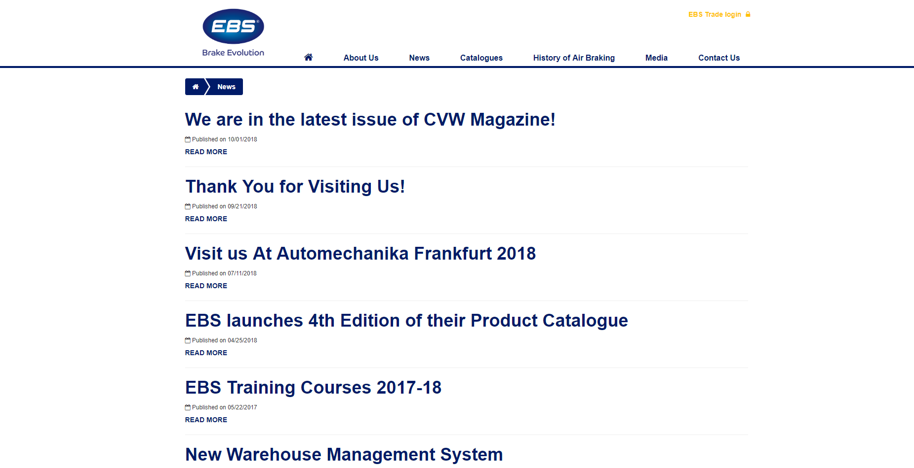
The news page is a simple feed showcasing a list of hyperlinks with published dates that are linked to different stories on what the company’s activities have been.

