Overview of visual app creation and things that can be improved in a particular app

First what do i as a developer expect to see in an app

-visuals

-organised

-no duplicated icons

-is it a million dollar idea

- is it eye catching

-is the main purpose of the app telling me a story

- colour coordination of mix of dark to light

- is the app overwhelming

**Fitness apps**

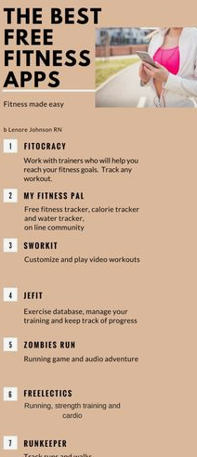

//This app is not inviting and if you want to workout it won't encourage you to do so

WHY??

1. It has numbering order

//i would improve it by adding icons

1. The logo on top is not attractive

//i would have enlarged the image and write the words on the picture with alighter colour

1. The slogan is ni

