**Product page for Unique Solar**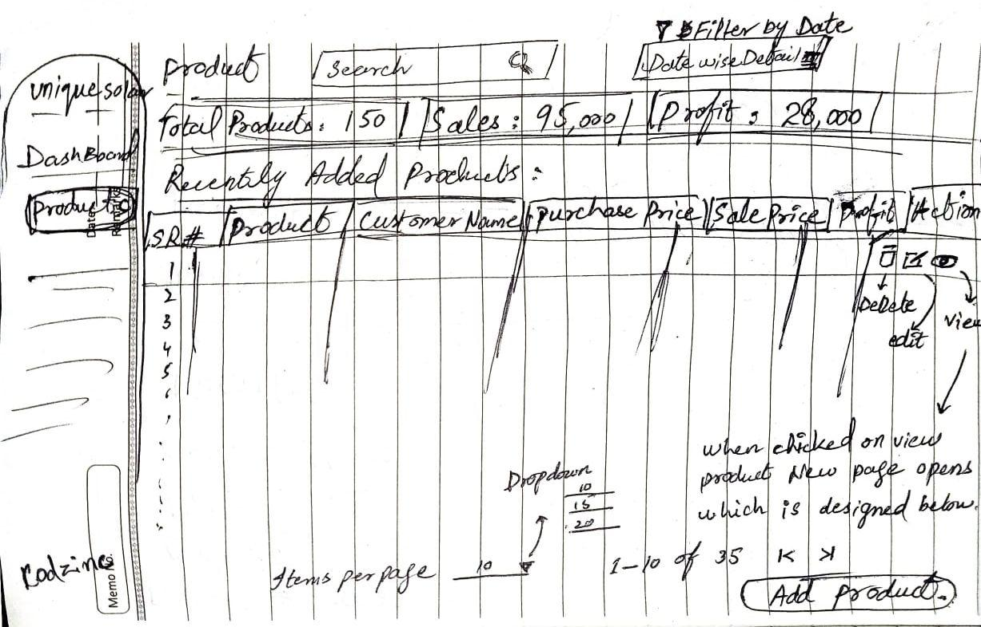

**When Clicked on Add product button show this page**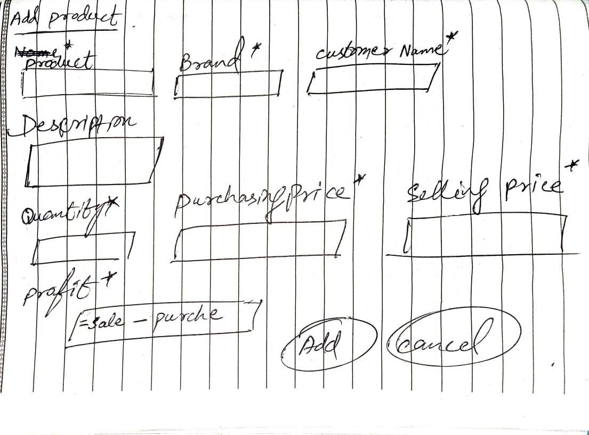

**While viewing any single product from action button of each product**

**Show this page**

