SEN 1211 Agent-Based Modelling

Final project - Plastic recycling from household waste in the Netherlands

Date: 24 January, 2022

Coen van der Pol (4366956)

Mandy Bouwhuis (5386055)

Uğurcan Işık (5597803

Content

Abstract 2

1. Introduction 3

2. Conceptual model 4

3. Formalisation 6

4. Implementation 11

5. Model verification 12

6. Model validation 13

7. Experiment 14

8. Analysis & Results 15

9. Conclusion & Discussion 18

References 20

Appendix 20

# Abstract

The aim of this research is to understand how waste bin size capacities and frequency of waste collection affects recycling behaviour of households for two different policies (Separation at home or general waste collection). In this model, households produce waste based on the number of people who live in the house, and separate their waste based on their recycling perception. They regularly check the level of their house’s trash cans and dump the waste if they are full. If they encounter a full bin when they dump their waste, they become unhappy. They throw away their waste and change their satisfaction in a negative way, which has a significant effect on perception level. Recycling company, another agent, collects waste from bins and recycles them under two different technologies (Basic vs. Advanced). Based on the recycled amounts of PMD (Plastics/Metal packaging and Drinking cartons) the recycling company calculates the recycling ratio. We are expecting to obtain a higher recycling ratio when separation at home policy is active as a result of our model. However, an improvement in the recycling technology will also give a higher recycling rate. Therefore, under advanced technology, separation at home or general waste collection might result in a non-significant change in the recycling ratio.

# Introduction

The Central Bureau of Statistics (CBS, Centraal Bureau voor Statistiek) mentions that the largest increase in household waste in almost 25 years has been observed in the year 2020. In 2019, 492 kilograms of household waste per inhabitant were collected. This number has been increased by 6.8% to 521 kilograms per inhabitant in 2020. Residual household waste and vegetable, fruit and garden waste increased the most. This data is based on numbers of the waste collection by municipalities. (Central Bureau of Statistics, 2021)

The Dutch government states that properly separated waste is easier to recycle than waste that is not separated. Therefore, it is important that waste is thrown in the right bin. The municipality must collect household waste but may decide how it does so. (Ministry of Housing, Spatial Planning, and the Environment, 2019).

If we zoom in on plastic waste or PMD (Plastics/Metal packaging and Drinking cartons), it is interesting to investigate which policy measures could help to increase the separation rate and thus reduce residual waste. It is expected that by separating all waste at the waste treatment plant, the recycling rate will increase. Based on data, the municipality of Amsterdam has adjusted its policy so that Amsterdam residents no longer have to separate waste themselves. The waste processor there achieves higher separation percentages than the households themselves (Gemeente Amsterdam, 2022). In theory, this would mean that more plastic can be recycled and reused. To understand the trade-offs in the policy space of the municipalities, if they wish to achieve the highest possible recycling rates, an agent-based model has been created. This model can answer the following research questions:

1. *What is the behaviour of the agents when they are influenced by the agents around them and their own happiness, and how does this influence the recycling perception of PMD waste?*
2. *What is the influence of a separation-at-home policy, compared to separation only by the waste company, on the recycling rate of PMD waste?*

The research questions will be answered by using the agent-based model, which is constructed by applying the modelling cycle: conceptual model, formal model, implementation, verification and validation and experiments. The structure of the report is based on these steps and with an analysis and conclusion the research questions will be answered.

The conceptual model chapter gives a description of the situation that will be modelled. This chapter also gives the delimitation of the situation: what is included and what not? The model assumptions are included. The conceptual model needs to be translated into a formal model which shows how the situation must be modelled in detail. This is done in the formalisation chapter. To represent the formalised model numerical and pseudocode methods were used.

The model is constructed in NetLogo after the formalisation step which is shown and described in the implementation chapter. However, it is required that the model is verified and validated. This has been done in the chapters of the model verification and validation.

After the whole model process of conceptualisation, formalisation, implementation, verification and validation, the experiments were carried out. The experiment is based on the introduction of separation at home, meaning people are asked to separate their waste at home. The results are the input for the analysis chapter which interprets the data and gives answers to the research questions.

# Conceptual model

The model is based on metropolitan areas where households bring their waste to centrally located waste collection points, the bins. A waste collection company collects this waste according to a schedule. As usual, all households have their own trash cans where they collect their waste. If a trash can of a household is full, so when it reaches its capacity, the household will bring it to the specific bin.

The model focuses only on general waste and PMD. Organic waste is outside the scope because of the assumption that this will always be separated from plastic and other waste by the waste collection company. In addition, as glass and paper are different streams in the Netherlands (separated waste bins and collection), it is assumed that these do not influence separation behaviour either.

**Figure 1**

Conceptual model

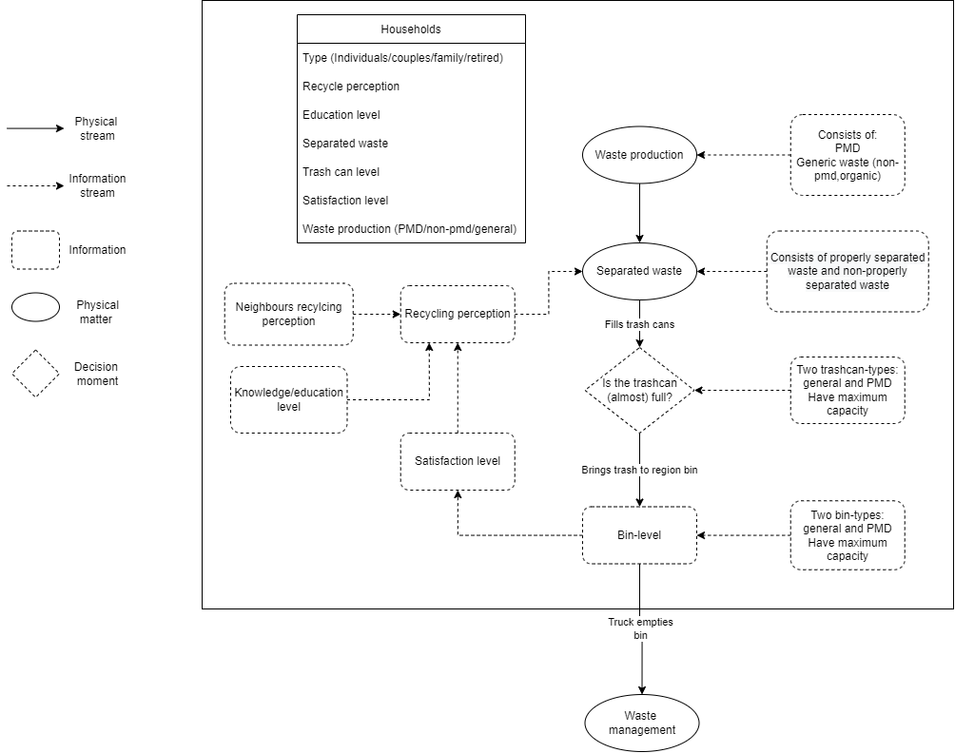

To be more specific on the households, these are divided into four categories: families, couples, retirees, and singles. The choice to make this division is because there are differences in household waste production per category. A family consisting of two adults and two children (on average) produces more waste than a one-person household (singles). Each household has an individual recycling perception which has a direct impact on the recycling rate of their waste.

There are three parameters which influence the recycling perception of households. The first one is the education level. The initial recycling perception of waste is higher when people have a higher education level, compared to people who have a lower education level (Gadellaa, 2017). Secondly, the neighbours' recycling perception is also chosen as a parameter because the recycling perception of a household can increase when others around them are already separating, such as neighbours. The third and last parameter which influences the recycling perception is the satisfaction level. The satisfaction depends on the waste collection facilities, i.e., how full the bins are in the neighbourhood. If the central waste bins are not emptied often enough, they will be full more often. This will have a negative impact on the recycling perception of the households, as people are assumed to be negatively influenced by not being able to get rid of their waste properly.

To answer the research question and to reflect on the hypotheses, the decision variables are the separation technology, separation at home or not, the sizes of the region bin for PMD and general waste and the number per week that the waste company will pick up the waste in the region bin. When the size of the region bin becomes bigger, in the conceptual model it can be seen that the bin level will be full less often. This means that the satisfaction level of the households will change less often which results in a higher recycle perception overall and so a higher recycling ratio in the end. The same is true when the pick-up times of the waste companies goes up. By changing the technology of the waste company, only the recycling ratio in the end will be higher. The recycling perception of the households will not be affected by changing the technology. When the separation at home is not in place, if this would be the policy of the municipality, the recycling perception of the households is no longer relevant. Changes in the number of pick-up times and bin-sizes won’t affect the recycling ratio in the end. As a result, the chosen technology directly represents the recycling ratio of the plastic waste of the community. The causal relation just described in this conceptual model will be translated into the formalisation.

# Formalisation

This chapter translates the conceptual model into a formal model which shows how the situation must be modelled in detail. A mix has been chosen from numerical, logical and pseudocode. This chapter is divided by the following sections: initialisation, dynamic updates, variables of the trash can, variables of the regional bin and the variables of the waste companies.

**Initialization**

The agents in the model are the households and the waste recycling company. As explained, households are divided into four different categories: singles, couples, families, and retirees. They produce waste and store it in trash cans based on their recycling perception, bin satisfaction, neighbours, and educational levels.

The level of education depends on the level of education in schools, but also on the level of information provided by, for example, a municipality on waste recycling. Once a certain level is reached, it cannot be lowered. In the model, this can only be improved by additional information facilities which can be implemented by dynamic updates. This is however not included in the model.

To set up these household-agents:

* Distribute different types of households (families/couples/retirees);
  + They are given an ID [0,3] randomly, and based on this ID they are given a waste production ratio (r), which enables them to produce different amounts of waste.
    - * Families: 2
      * Couples: 1.7
      * Retirees: 1.5
      * Singles: 1
  + Randomly distributed households on the grid in two rows (streets)
* Every household has two trash cans: one for pmd and one for general waste. Manually set a value for the maximum trash-can-capacity in kg that they have. It is assumed that trashcans don’t exceed this value.
* Randomly assign an education-level for each household-agent between [0,4]. Every household-member within the same household has the same education-level.
  + The number 0 is the education level of grammar school;
  + The number 1 is the education level of secondary school;
  + The number 2 is the education level of middle vocational education (MBO in Dutch);
  + The number 3 is the education level of high vocational education (HBO in Dutch);
  + The number 4 is the education level of university.
* Set an initial *bin satisfaction* for each household-agent between [0,1]. Every household-member within the same household has the same bin satisfaction.
  + The number 0 is the lowest satisfaction level of a household-agent;
  + The number 1 is the highest satisfaction level of a household-agent.

Implement one *waste company*. The location doesn’t matter. It collects all separated or general waste by pick-up trucks and transfers it to the recycling centre. It has a schedule for waste collection with the variable of counterpmd and countergen. Then, it recycles every waste and calculates the recycling ratio of society.

The model is built for metropolitan areas, where households are assigned to use one single bin in their area. Reason for this is to ensure that the bin only will be used by the people who live in that specific area. Within the agent-based model there must be 2 region bins: one for PMD-waste and one for general-waste. Both bins have a value for the maximum bin-capacity in kg in order to change the bin-satisfaction level if the bin is full. In the model, it isn’t possible that an agent will drop his PMD-waste into the general waste bin or his general-waste into the PMD-waste bin. It is assumed that if the bin is full, they drop it beside the bin. The waste company will collect this waste also: all the waste inside and outside the bin. The model will remember this total amount of waste as waste inside the bin, even though this may exceed the maximum value.

Values for each waste type were set at the set-up stage: organic 37%, general-waste 53% and PMD 10%. (Milieu Centraal, 2021).

**Dynamic updates**

Every tick the parameters in the model will change, depending on the events in the previous tick. There are different loops in the model which can be seen in the conceptual model. In the model **1 tick represents 1 week**.

**For each household (for each timestep)**

Agents collect waste due to their food- and other usages. As explained before the model only focuses on general waste and PMD. Organic waste, glass and paper are outside the scope of the project. There is a division in the proportion of plastic waste and other waste per person (MilieuCentraal, 2021) which can be allocated to the different types of households. However, a factor is needed because the more people in a household, the more efficient the waste-use per person in that household. We assume that waste is produced every week according to function 1.

(1)

Where: r = waste production ratio, varies for different households; x = tick

Every household-agent produces waste every tick, depending on their type of household. As said by the initialisation, every household-agent has two trashcans (one for PMD and one for general waste), both have a maximum capacity. When they produce waste, they drop this into the trash can, the proportion of recycled waste depends on their recycling-perception. Once the trash-can for PMD and/ or the trash-can for general-waste is full, the agent brings it to the region bin, which can be PMD- and/ or general-waste region bin depending on the type of trash-can which is full. They will drop their trash-can, after which the trash-can they emptied is empty again. Depending on the level of the general waste region bin or the level of the PMD region bin, the bin-satisfaction level of the specific household-agent might change. This process is described in the following steps by bullet points.

1. Produce waste by the waste function as presented before combined with the proportion of waste-type.
2. Separate waste into “general waste” and PMD waste, based on their recycling perception.
3. Collect waste per type in the right trash cans, which is in the household itself.

As explained before, the amount of waste in the trash cans of each household will change every tick depending on the amount of produced waste and their recycling perception, and therefore also the household type. The trashcan level can be described by the following simplified equations:

(x-1)

(x-1)

* 1. If the trash can is full (i.e., trash can level > trash can size)
     1. Then go dump waste into the regional bin
  2. Else (If there is enough space in trash can for the waste)
     1. Then, continue collecting waste in the house

1. Dump waste

The level of the region bin will change when an agent or more agents drop their waste into this bin. The level of the region bin, separated into PMD-waste and general-waste, will be plussed by the sum of the amount of dropped waste of the household-agents.

(x-1)

(x-1)

* 1. If bin is already full
     1. Put your waste outside of bin
     2. Make yourself not happy and change your bin satisfaction in a negative way.
  2. Else, if there is enough space in bin for your waste
     1. Put your waste into the bin
     2. Make yourself happy and change your bin satisfaction in a positive way.

1. Change Satisfaction, depending on the mood of the household-agent: happy (positive satisfaction change) or not happy (negative satisfaction change).

The bin-satisfaction level is dependent on the available region bin-capacity. The chance that a bin is full increases when it is emptied less often and/or has a smaller capacity. The value of the bin-satisfaction level, a number between [0,1], will change at the time that a household-agent drops his waste.

1. If household is happy with bins
   1. If bin satisfaction is more than 0.95,
      1. Make the satisfaction level maximum (1)
   2. If bin satisfaction is lower than 0.05, which is close to 0,
      1. Increase bin satisfaction level by 0.1
   3. If bin satisfaction is between 0.05 and 0.95
      1. Bin satisfaction * 1.05.
2. If household is not happy with bins
   1. Bin-satisfaction * 0.95.

The recycling perception of a household-agent can change every tick, depending on the changing bin-satisfaction level, the education level at the beginning, and/ or recycling perception in that tick. The recycling perception cannot be equal or higher than one due to the fact that it isn’t possible to sort all waste right by an individual agent. It is very hard to sort out the different types of plastics, so technology helps with this. In reality, it is possible that non-PMD waste (general waste) will be part of the PMD-trashcan. This is however not included in the model.

In the model a neighbour is determined by the location of the agent itself. Only the households besides the household-agent itself is a neighbour.

1. Change recycling perception of households based on their bin satisfaction and their neighbours’ mean perception level (which represent by recycle-perception-neighbour variable)
   1. If recycling-perception of household is lower than its neighbours’ average and not zero
      1. However, if it exceeds 1 with an increase of percentage difference (1/ ((Neigh - Agent)/Agent + 1))
         1. Preserve previous recycling perception and couple it to bin-satisfaction
      2. If it is between the average of neighbours and percentage difference
         1. Increase recycling perception by their percentage difference ((Neigh - Agent)/Agent + 1) between neighbours and agents and couple it to bin-satisfaction
   2. If perception of household is higher than its neighbours’ average
      1. If it is less than and equal to 0.01
         1. Increase recycling perception by 0.05.
      2. If it is greater than and equal to 0.99
         1. Preserve previous recycling perception and incorporate it with bin-satisfaction
      3. If it is between 0.01 and 0.99
         1. Increase recycling perception by 5% and incorporate it with bin-satisfaction
2. Collecting waste by recycling company
   1. If scheduled week arrives for PMD-waste
      1. Collect all PMD from the bin and make the bin empty
   2. If scheduled week arrives for general waste, which are non-PMD
      1. Collect all general waste from the bin and make the bin empty
3. Recycle the wastes for different technologies under the separation at home policy is applicable
   1. If the recycling technology is basic
      1. First recycle the collected PMD from PMD-bins and then recycle the general waste to collect missing PMD with the efficiency of 60%
   2. If the recycling technology is advanced
      1. First recycle the collected PMD from PMD-bins and then recycle the general waste to collect missing PMD with the efficiency of 80%
4. Recycle the wastes for different technologies under the separation at home policy is not applicable
   1. If the recycling technology is basic
      1. Assume that all waste is general waste, and recycle 60% of the PMD in that waste
   2. If the recycling technology is advanced
      1. Assume that all waste is general waste, and recycle 80% of the PMD in that waste
5. Calculate recycle ratio at the end to understand how different policies affect the whole system (The calculation starts after 10 ticks, since we want to reduce zeros.)
   1. Calculate the recycling ratio under the separation at home policy is applicable
      1. If the recycling technology is basic
         1. The ratio of recycled PMD missing in general waste (with eff. of 60%) are calculated and summed with ratio of separated PMD within all PMD
      2. If the recycling technology is advanced
         1. The ratio of recycled PMD missing in general waste (with eff. of 80%) are calculated and summed with ratio of separated PMD within all PMD
   2. Calculate the recycling ratio under the separation at home policy is not applicable
      1. If the recycling technology is basic
         1. The ratio of recycled all PMD in general waste with efficiency of 60% are calculated
      2. If the recycling technology is advanced
         1. The ratio of recycled all PMD in general waste with efficiency of 80% are calculated

# Implementation

The formalisation is translated into NetLogo which represents the implementation. There are tree tabs, first the interface, second the information page and third the code itself. The interface shows the results of the constructed model which are relevant for answering the research questions.

**4.1 The world**

The visualisation of the model is done by having the so-called ‘world’. This world shows the households, the number of households is determined by a slider. Also 2 bins are represented and a separation company. During the ticks the visualisation of the world won’t change, but what is happening over time is shown by the graphs.

**4.2 Sliders**

There are several sliders which can be used to analyse the agent-based-model. First the number of households can be changed from a range between 0 and 26, but as user of the model it isn’t allowed to select zero, due to the fact that the model won’t work anymore.

The second slider is the technology, which can be set on ‘basic’ and 'advanced’. The basic technology represents the current technology, with a recycling rate of 60% for PMD. The advanced technology represents the technology which can reach higher recycling rates from non-separated waste.

Four sliders for the region bins are made. By changing the slider of the size, the volume of the bin changes. With a bigger sized bin, more waste can be stored and as a consequence, decreases the chance that the bin is full, leading to an increase in chance that people will be satisfied. Changing the bin level to a smaller volume, leading to the opposite situation. This satisfaction level can also be influenced by the times that the waste company will pick up the non-separated general waste and/ or separated PMD-waste.

**4.3 Graphs**

Several graphs are made to analyse the behaviour of the agents in order to answer the research questions and verify the model. These graphs represent different parameters of the model: recycle-perception, bin-level, total waste of households, levels of the trash-can for PMD- and general waste each, amount of waste collected by the waste companies and the recycle ratio in the end.

# Model verification

Computer programs are only able to run what developers write. It should be well organised and structured to represent the systems accurately. Otherwise, even if the model runs, it will give wrong insights about the procedure. Hence, regular verification of what implemented models do becomes crucial for developers.

Verification of our recycling model is crucial for us, too. At the beginning of the project, we planned to track every step of the go section by plots or monitors to evaluate whether it is running in the way of what we intend to do. The example can be checked in Figure 1. Bin level. It should not exceed the maximum bin capacity, and it should go back to 0 after each collection. Therefore, it must oscillate between maximum bin capacity and 0. In addition to these, we also track the average bins satisfaction and recycling perception of one specific household. After this close look at one agent, we realised that the model generates negative or more extensive positive values than 1 for recycling perceptions and bin satisfactions, scaled between [0,1]. After this realisation, we implemented new rows for bin satisfaction and recycling perception to restrict them between 0 and 1. However, the code was enlarged, and tracking all monitors and plots became overburdened. Then we decided to decrease the speed of ticks to enable us to check all schemes step by step. Controlling the code at a slower speed also needs more time and ticking more than 1040 times is also overburdening. Therefore, we decided just tracking by the monitors or plots would not be sufficient verification for the model.

**Figure 2**

General and PMD waste levels in region bins

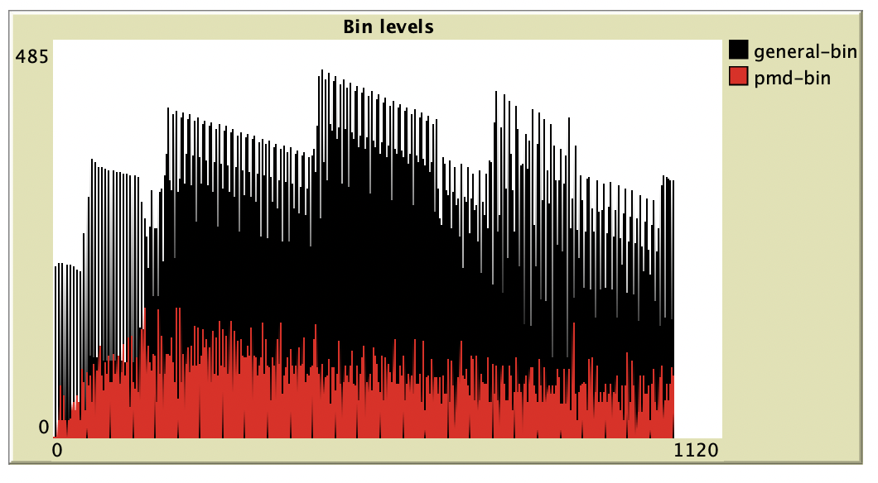

After determining new verification techniques were required, we decided to write new rows with a print function to verify the model. These print functions enabled us to track whether “if” and “ifelse” sections run correctly or not. However, with an increased row of printing, running the model became exceptionally long since it writes the commands repeatedly for each tick. Therefore, after the code assured us “if” and “ifelse” all sections run accurately, we put semicolons in front of the print functions to freeze them for readers' understandability. One example for this print function is this: [*; print "still collecting general"*]. This row was developed to track whether the households manage their waste properly or not. You can see more print rows within the code. This enabled us to validate our model. In addition to these aspects, we also verified our model with different initial values. As a result, our model consists of plots, monitors, and pseudo print sections, which all show that the code is running accurately.

# Model validation

Data about the amount of waste is used from Milieu Centraal, an organisation without commercial interests. They don’t however mention from which source the data is coming from. Because of the independence of Milieu Centraal, the data they provide is assumed to be reliable. However, for validation of our results, we may meet their experts and discuss our results. Based on their valuable feedback, we can adjust the code and re-evaluate the results of this experiment with them for the better validated model.

Furthermore, assumptions are made about the recycling rate of the technology by the basic and advanced technology. The Dutch government indicates that the current technology, so the basic technology in the model, can recycle 40 to 50% of the PMD will be recycled. And that in the future due to developments in technology, this number will increase to a number between 50 and 60%. This is the advanced technology in the model. However, these numbers are found during brainstorms for scenarios, after the model was built. The model itself contains a recycling rate of 60% for the basic technology and 80% for the advanced technology. This means that the model produces results that are more favourable than what it will be in reality.

Also, the Municipality of Amsterdam recently changed their recycling policy, since they believe the separation of all waste by recycling companies gives better results. To discuss their policy, we may request the data they use as initials and variables, then we can adjust our model with these data. We can run the experiment for one street in Amsterdam for the experiment. At the end, we can compare their result and our result for the validation of our model.

# Experiment

After the model was built and validated, first a baseline scenario was run. In this scenario, some initial conditions were changed over several runs in order to have that is comparable with the experimentation data. Afterwards, the experiments were run. In the experimentation only 1 variable was changed, “separation-at-home”. This means that the separation at home done by households was introduced. In table 2 the set-up of both the baseline scenario and the experiment are shown.

**Table 1**

Baseline and Experiment: variable composition

|  |  |  |  |
| --- | --- | --- | --- |
|  | **Definition** | **Baseline** | **Experiment** |
| Technology | Efficiency of collection technology (60 or 80%) | "Basic" & "Advanced" | "Basic" & "Advanced" |
| **Separation-at-home** | **Is waste separation at home introduced** | **false** | **true** |
| nmbr-weeks-pickup-pmd | The bins are emptied every … weeks | 2 | 2 |
| general-regionbin-size | The capacity of the general bin in the region is … kg | min=100; step=100; max=800 | min=100; step=100; max=800 |
| number-of-households | How many households are in the model? | 26 | 26 |
| nmbr-weeks-pickup-gen | The bins are emptied every … weeks | min=:1; step=1; max= 3 | min=1; step=1; max= 3 |
| pmd-regionbin-size | The capacity of the PMD bin in the region is … kg | 200 | 200 |

For both the baseline and the experiment, 8 repetitions were carried out. This set of variables and their possible combinations, including the repetitions, lead to a total of 384 runs for each scenario. It was chosen to not have the size and pickup schedule of the PMD bin in the region fixed in both scenarios. Within the system PMD accounts for only 10% of the total amount of waste, so the bin is not going to be filled as quickly as the general waste bin. In order to limit the number of variables, it was assumed that this bin would be less of an importance in comparison with the general waste.

# Analysis & Results

For the data analysis, tools from several python libraries were used to do exploratory data analysis and visualise the data. As described in the “Experiment” section, the only change within the experiment was the introduction of separation at home, as compared to the baseline scenario. In order to see if the starting conditions of both scenarios are the same, a t-test was carried out on the average waste production ratio for each run. This is used as a proxy for the demographics of the model for each run, i.e., what is the share of each type of household. These values lie between 1.3 and 1.8 for both scenarios. In order to assess whether there is a difference in the groups, the average waste production ratio of both scenarios at time 0 was used. Meaning this is the initialisation of the model, where the household types are assigned. A two-sample t-test was deemed appropriate since it is assumed that setting up the model and distribution of the households is unrelated between the baseline and experiment (Xu et al., 2017). There was no difference found in the household type distribution between the baseline (*M*=1.55*, SD*=0.070) and the experiment (*M*= 1,55, *SD*=0.069), *t* (383) = 0.42, *p*= 0.67.

As described in the “Conceptualisation” chapter, in the baseline scenario where no collection at home is in place, the recycle-ratio solely depends on the technology installed at the waste collection company. Therefore, the PMD that is separated will always be 60% for the Basic technology and 80% for the Advanced technology. However, in both scenarios the satisfaction of each household changes over time. A visual representation can be seen in figure 3 and 4, with the Basic technology in place. It was chosen to use only this technology level, otherwise too many data points would be shown making it even more unclear. It can be seen that in both scenarios that the satisfaction level sometimes remains close to zero throughout, but it also shows that satisfaction levels can increase over time.

**Figure 3**

Bin-satisfaction level when Basic technology is in place: Baseline

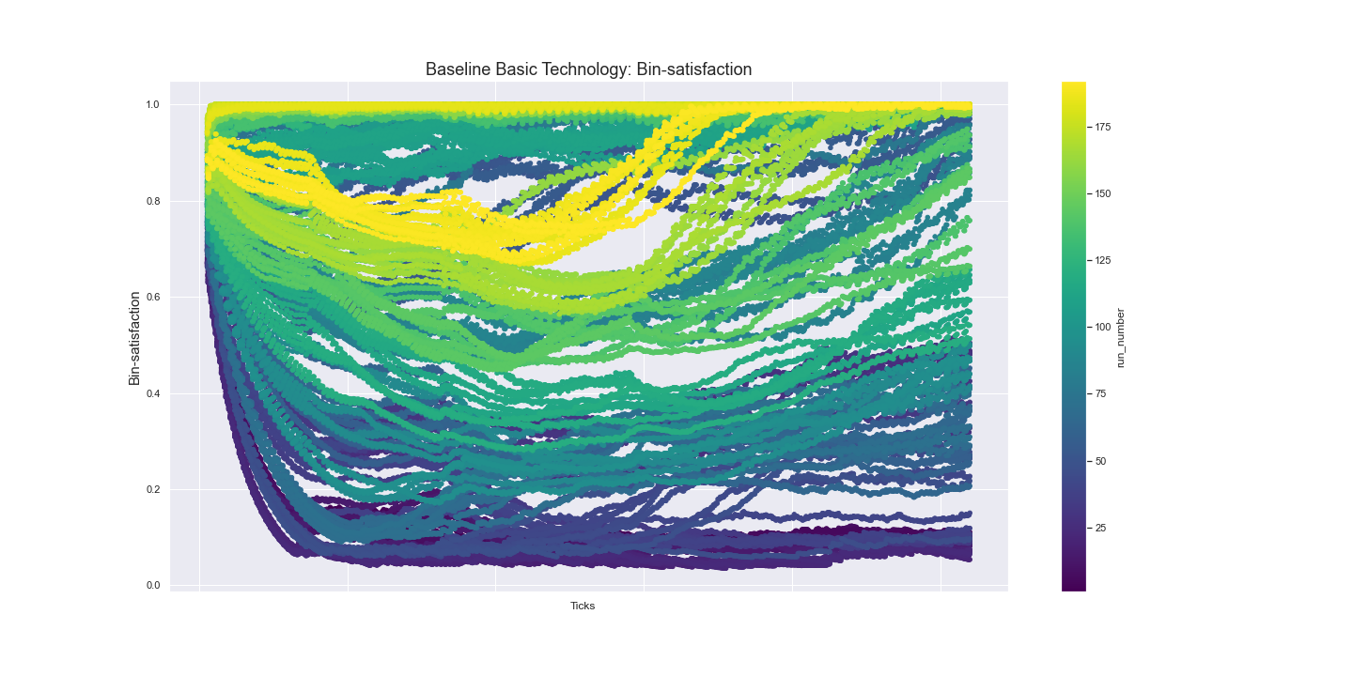

**Figure 4**

Bin-satisfaction level when Basic technology is in place: Experiment

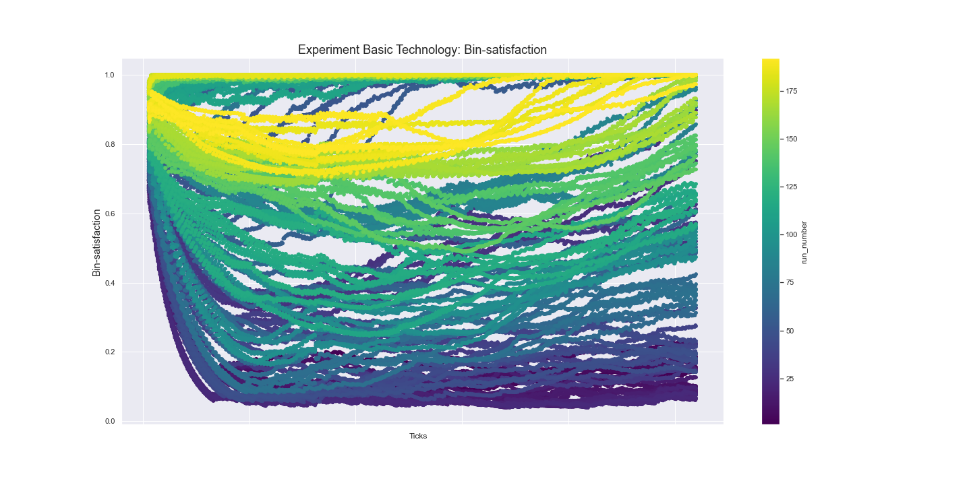

It was chosen to perform a two-sample t-test, with the same justification that the samples are unrelated, only this time a one-tailed test is used since we are expecting an increase between the recycling ratios of the baseline and experiment. For both waste separation technologies, Basic and Advanced a t-test was performed. It was found that for both technologies there was a significant change (Basic: baseline (*M*= 6.0, *SD*= 0), experiment (*M*= 8,2, *SD*= 1.94), *t* (197759)=-500.14, *p*= 0.0; Advanced: baseline (*M*=8.0, *SD*= 0), experiment (*M*= 9,1, *SD*=0.98), *t*=-500.14, *p*=0.0). This means that there is a significant difference in the recycle-ratio between the baseline and experiment scenario. As a remark, this is not a strange outcome since the baseline scenario always has the exact same recycling ratio with no deviation. This means that minor changes become significant almost instantaneously. However, we can still analyse the model by looking at the bin sizes and pickup strategies. This will be addressed in the next paragraph.

To be able to give advice on when the implementation of separation at home is beneficial for the recycling ratio, the different levels of the bin size and the pick-up rate were used as dependent variables. Below are all the outcomes shown for: the 2 types of technologies, 3 types of collection strategies for 8 levels of bin capacity. Only 1 graph is shown (fig. 5), all other graphs can be found in Appendix 1. The graphs show boxplots and can be interpreted as follows: the minimal value for the recycling ratio is 6 for the Basic technology and 8 for the Advanced technology, i.e., the level that the waste companies can recycle. With the increase in bin size the amount of recycled PMD increases, i.e., an increase in recycling ratio. The goal is to have a maximum recycling ratio of 10, i.e., the total of PMD in the system. The rate at which this maximum is reached differs per each pickup strategy. If the waste is collected every week, a bin of around 300 kg suffices for all scenarios. But if the pickup strategy is once every 3 weeks, the bins must be bigger than 800 kg. Similar results can be seen when either recycling technology is in place. Interestingly, for all scenarios the bin must be at least 300 kg to have a significant impact on the recycle-ratio.

**Figure 5**

Recycle-ratio for 8 different bin-sizes. Basic technology: Experiment

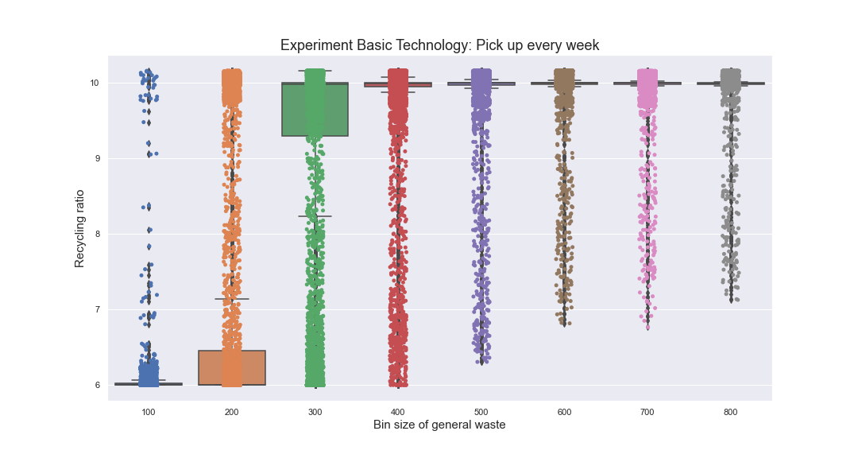

# 

# Conclusion & Discussion

The reason for the construction of the ABM model is to answer the two research questions below. The ABM model should provide insight into the behaviour of the agents and how this affects the recycling ratio in the end. Over time the behaviour of the agents emerges due to the changes in their bin-satisfaction level and neighbours’ recycle perception, and as a result in their own recycling perception which affect the recycling ratio directly. Another aspect of the research is the difference in the recycling ratio in the end between the separation-at-home policy and the policy whereby only the waste company separates and recycles.

1. *What is the behaviour of the agents when they are influenced by the agents around them and their own happiness, and how does this influence the recycling perception of PMD waste?*
2. *What is the influence of a separation-at-home policy, compared to separation only by the waste company, on the recycling rate of PMD waste?*

To answer the first research question, only the data from the experiments about separation at home is relevant. This experiment shows that on a certain level of general-bin-sizes and/ or pick-up times, the recycling ratio will increase. This indicates that the size of the containers and the number of pickup times is extremely important for the recycling ratio in the end. The behaviour of the agents is not relevant in case that is chosen for separation by the waste company. As a result of the dynamic recycling perception of the agents, the conclusion is that the minimum bin level must be 300 kg when the pick-up time is once a week to reach a recycling ratio of at least 9. Every week it takes longer, the bin-size must be 100 kg bigger.

By implementing the recycling at home scenario, an increase can be seen in the recycling ratio. However, a threshold needs to be passed before this is the case. In the model, if the bin capacity is too low, in none of the scenarios the recycling ratio will increase. However, if the bin capacity is set appropriately in combination with the pick-up strategy, an increase can be seen.

This threshold is an interesting phenomenon. If the combination of the strategy chosen and the size of the bin chosen close to this point, small changes can lead to a very different outcome. To illustrate, if a neighbourhood produces waste at a rate of 100 kg every week and the bins are exactly 100 kgs in volume, everybody should be able to get rid of their waste. However, if people in the neighbourhood start filling the bin at different rates and even increase their waste production, the 100 kgs in volume might not suffice. Our model shows that the optimal bin size differs per scenario and pick up strategy.

In order to make the system more robust, i.e., being able to handle more waste every week, an increase of the bin size is recommended. To make the system more resilient, i.e., bounce back from unhappy households due to overflowing bins, an increase in the pick-up frequency is advised. The waste company or municipality might choose to increase both; however, this will be accompanied by an increase in costs.

**Discussion & Improvements for the model**

Also, some improvements can be done to make the model better and to deal with certain assumptions which are made. First and foremost, the model is limited in the way of implementing the behaviour of municipalities and waste companies. Our limited experience with programming caused the model to be limited in its complexity. However, we were able to create different types of behaviour on the household level within our model.

As described in the “Analysis & Results” a difference was found in the baseline and experiment household distribution. This results in a difference in the amount of waste that is produced in each model. In the current model this has an effect on how full the bins are, and results in changes in the bin-satisfaction level and in turn on the recycling perception. It is advised that for further research the group demographics will be included as a predictor in the regression model, so that more can be said on the influence of waste separation at home.

In reality it can happen that when a bin is full, that the agent drops his waste into another bin which is not the right one. The recycling ratio will go down then, but this is not included in the model. In reality the results will be a little bit different, in a more negative way. By adding this behaviour as an extension, this can give more insight into the policy of picking up the waste more often by general waste companies or making bigger general bins which can store a bigger amount of waste.

The education level in the model influences only the initial recycling perception. During the dynamic changes, education is not modelled to influence the recycling perception. In real life, the education level or knowledge about recycling affects the agent-behaviour in a positive or negative way. This can be an extension of the model to investigate the effect of providing information about plastic recycling by the municipality. It can even be a kind of experiment, measuring the effect of informing households in disadvantaged areas or not. The education level will improve over time, depending on the actions of for instance the municipality to improve the knowledge on recycling. The education level however is a number between 1 and 5, so it can increase with a certain fraction, but it can’t be higher than 5. The number of 5 is the maximum level for education in the model.

Another improvement on the model can be to create more households and more region bins. It was assumed that the PMD bin is of less importance vis a vis the impact on the recycling perception of households. However, in the real world, there is less capacity for PMD in comparison with general waste, making it more likely to be full.

Another addition is making the households change colour over time based on their recycling perception. In this way, it can be visually easily shown how neighbourhoods perceive recycling. The behaviour of the agents is affected by the behaviour of the agents around them, which can result in a difference between each neighbourhood. Therefore, the model can be used for not only a small neighbourhood but also as an indication for a whole district with several region-bins. The model can serve as a kind of optimisation model for the amount of picking up times by the waste-companies.

# References

Centraal Bureau voor de Statistiek. (July 6, 2021). *Grootste toename huishoudelijk afval in bijna 25 jaar*. Retrieved January 5, 2022, from: <https://www.cbs.nl/nl-nl/nieuws/2021/27/grootste-toename-huishoudelijk-afval-in-bijna-25-jaar>

Gadellaa, S. (July , 2017). *Afvalscheiding en uitkeringsgerechtigden*. Erasmus Universiteit Rotterdam. <https://thesis.eur.nl/pub/38342/Gadellaa-S.-358387.pdf>

Gemeente Amsterdam (21 January, 2022). *Amsterdam scheidt plastic alleen nog met scheidingsinstallatie*. Amsterdam.nl. Retrieved January 21, 2022, from: <https://www.amsterdam.nl/afval-en-hergebruik/plastic-scheidingsinstallatie>

Milieu Centraal. (2021). *Afval scheiden: cijfers en kilo’s*. Retrieved January 9, 2022, from: <https://www.milieucentraal.nl/minder-afval/afval-scheiden/afval-scheiden-cijfers-en-kilo-s/>

Ministerie van Volkshuisvesting, Ruimtelijke Ordening en Milieubeheer. (September 10, 2019). *Huishoudelijk afval scheiden en recyclen*. Afval | Rijksoverheid.nl. Retrieved January 5 2022, from: <https://www.rijksoverheid.nl/onderwerpen/afval/huishoudelijk-afval>

Xu, M., Fralick, D., Zheng, J. Z., Wang, B., Tu, X. M., & Feng, C. (2017). The differences and similarities between two-sample t-test and paired t-test. Shanghai archives of psychiatry, 29(3), 184.

# Appendix

Appendix 1

