Diary

# 6/05/2022

## What was in progress

I am currently looking for assets to go into the asset table. Then I will start working of the structure of the webpage. I have finished planning and doing a problem decomposition. This means I know when and what steps need to be done before certain dates. And having those same steps decomposed make sure I have a better understanding on what to do.

## How this matches the plan

The plan was just made so I am exactly where I said I will be.

## What is coming up next and possible obstacles or helpful ideas

I can see that gathering assets can take a long time. TO help with the lack of time I have for the whole website, I will time gate this talk to only take a certain amount of time.

## Feedback

I had the teacher look over some of the write up to see if anything was missing. This led me to add a few more sentences that ensures I talked about everything needed

## Screenshots of the page and code

No website yet

## Detail of checking stuff and testing

Nothing to test

## Details of trialling

Nothing to trial

# 13/05/2022

## What was in progress

I am currently building the structure of the website, and it is currently going well as nothing has stopped me from progressing. I also have started git hub. I currently have made an online repository that is link to this computer. This was done so work can be done at home if I need to.

## How this matches the plan

I currently am exactly where I planned I would be, this is because the project just started and there has been no issues building a structure.

## What is coming up next and possible obstacles or helpful ideas

For next week I will be making sure the structure is finished being made, this should be rather easy as it is almost done. Then I will be adding the content. This will need me to finish gathering content.

## Feedback

Nothing for this week

## Screenshots of the page and code

## Detail of checking stuff and testing

Nothing to test

## Details of trialling

Nothing was trialled this week

# 20/05/2022

## What was in progress

I currently have successfully made the structure of the page and it is completely resizable and has a maximum size for most computer screens. In this time, I also found assets and placed them into the asset table and processed them for later use.

## How this matches the plan

I currently am not exactly on time with plan as some things are finished a little later then expected. That being said I am not behind as I currently am adding assets and text like my plan suggests.

## What is coming up next and possible obstacles or helpful ideas

Having to write some text may take some time however the main obstacle that may present itself will be styling the website. This could be time consuming as things may not work or look nice. The best way around this is to section off places to style and I will also use save different versions as I go on to ensure that not all progress is lost if something goes wrong.

## Feedback

I have not asked for any yet

## Screenshots of the page and code

## Detail of checking stuff and testing

Nothing to test

## Details of trialling

Resizing the some of the header things, its not too much of a notable change but it sized for better use.

# 24/05/2022

## Update

Currently the slideshow is in development and it is being annoying as I cannot seem to get it running correctly as either none of the images show or all of the images will. I putting most of my attention here.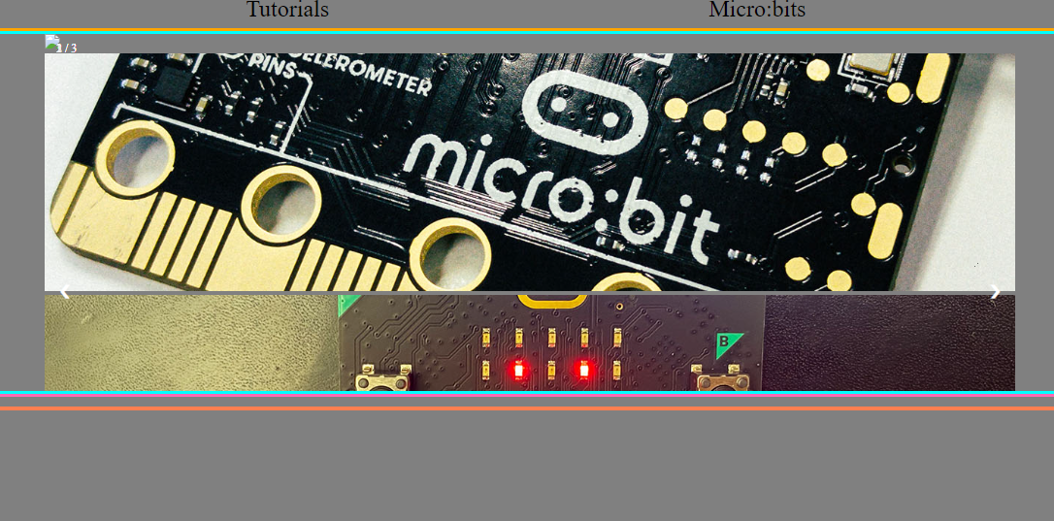

So an hour later I have found the problem it stemmed from the link between the JavaScript and HTML.

The code that failed

 <script src="/javascript/functions.js"></script>

Code that worked

 <script src="javascript/functions.js"></script>

# 26/05/2022

## Update

I have some styling problems on the slideshow so I will change some code by removing buttons and other additional things. This is because this slideshow is meant to be automatic.

