Evaluation

This project has logged all ongoing trialling and testing information with feedback in the Diary Document. The Write Up document was made before the website was made so this is the Final Report.

# How I applied user experience principles to improve the quality of the outcome.

I have used my understanding the User Experience Principle to improve the quality of the Digital Outcome as I developed the website with user feedback from user trialling to make the website function and behave as smooth as possible for end-user who come after development. This was done in multiple ways. The first in the planning phase was Snowballing Ideas about the websites design that the end-user may be interested in. like Slideshows, Theme selection and Dark Mode. These ideas were eventually incorporated into the design as they sparked interest in many possible end-users. While Development was ongoing Usability testing was done consistently throughout the entire development as bad code can severely harm changes or ideas that may happen in the future. A/B Testing was done periodically as they would give an Idea on how to shape certain sections of the page in the design and production parts. The reason is that if the end-users don’t like the product while its in development, they would not want to use it, when you don’t listen and change problem in the page.

# Some of the feedback examples I used during ongoing trialling to improve the outcome

The best example of trailing in my website will be found at the diary entry of 23/06/2022. This is because this JavaScript was key to the one of the main features of the website, which was dark mode. It took many minor edits and some were screenshotted and others were commented in to the page for you to look at. However, the reason why this trailing session was so important is because it formed the bases of text swapping and theme changing. Without understanding how to achieve this. The website would have become impossible to build. Screenshots below compare the three.

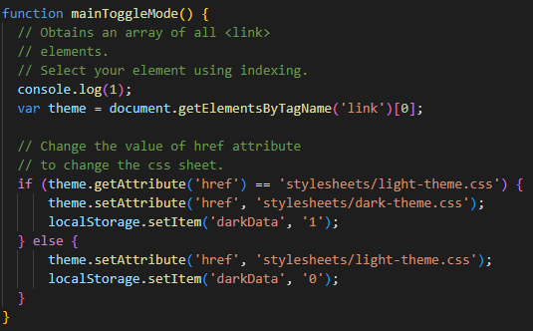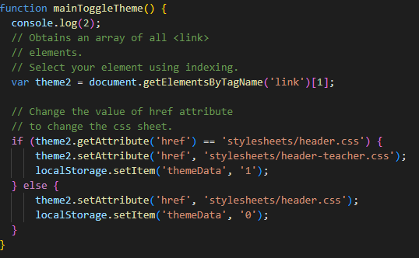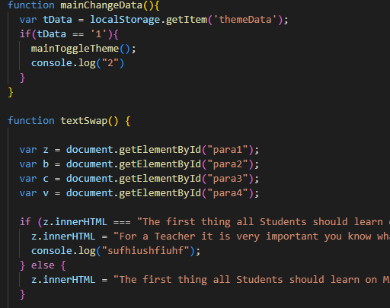

# What was the outcome of ver1 and what was needed to take it to Ver2 explain how the outcome of tests and trials informed the next version?

Version 1 was a design that had a bad colour scheme, good features and decent layout. The other two designs had the better layouts or colour scheme. However, gathering feedback from classmates’ teachers and reliever teachers (the whole group of end-users), it became clear by mixing the good attributes in to design one we would get an overall product. And gathering more feedback on version 2 showed me that this design was heading in the right direction as the colours were nice, features were good and the overall layout was much better and cleaner, so it would easier to understand for younger end-users.

# An explanation of efficient tools and techniques used in the production phase (e.g. editing techniques, versioning etc.)

Editing tools that were used were Visual Studio Code and Photoshop. These were the only two editing software used as they were all I needed. This is because Visual Studio Code can program HTML, CSS, and JavaScript. It was very easy to understand as it was clean and easy to read. Another reason why it was used over other editing software is the range of extension I can add onto it. These extension makes life a lot easier for me as it can range from automatic spell checking, a live HTML window. Another one that was very good was the GitHub integration as VSC will show me what has been pulled, committed or become a merged with the main branch. Photoshop was used as it is the world’s leading photo editing software and I have already had practice using photoshop for previous projects. This made editing photos a less of a hassle and overall, much quicker. Another reason why I used photoshop is because it was provided to me by the school, so I had no paywall, So I had free access to Photoshop, so I did not have to look for another software.

Versioning tool were GitHub and saving in the admin folder. The main software that was used for versioning is GitHub as it is fast easy to use and access. This is because GitHub is stored on servers and with the correct login I can store and retrieve any file that I have created throughout the whole project from any computer. This means moving data between from school and home was a lot less stressful. The other version tool I used was manual saving into the admin folder. This is because it provides a back-up like GitHub does, however as it is stored locally it is quick to access and very easy to keep making more. This is just a timesaver if I did make a mistake and had to restore some of the Website.

Editing techniques were the use of third-party code and adapting it into my website. It was common to adapt third-party code into the website, as sometimes things are two complicated to fully develop by yourself in a span of 10 weeks. It also gives me an understanding of what my code should look like and ways to manipulate it into doing what I want it to do. For example, the complete overhaul on how darkmode works was accomplished by the help of using W3schools as they shown me a template and how works and what it does allowing me to recreate different usages and forms like text change.

Run file validation in Dreamweaver to get a validation report for your code.

Hopefully it looks in good shape! Add the report to your collection when it

looks good.

I first went to W3.org and scanned the website there were no critical errors in the code. However, I forgot to add in the alt=”” inside most images so I had to fix all of them before I was able to get a green rating. When it came to non-code base validation Grammarly was often used to ensure my writing and my grammar were correct. Other than grammar errors and a few forgotten elements. There was no issue found in the page. 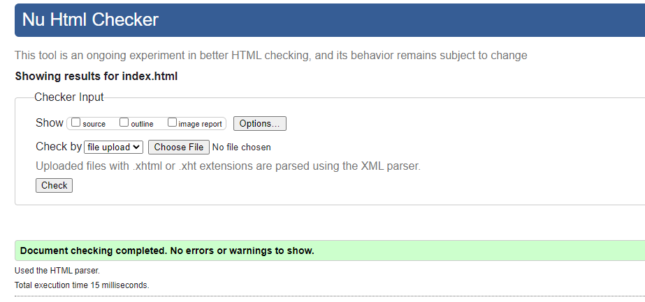

# Show your project organisation with respect to filing and naming of files

The file themselves were laid out before coding began as It good to know were to link and sink everything. It was also done to ensure it was as clean as possible for future development. The First screenshot is the main directory and all the code will be found in the index.html file, in the pages folder and the stylesheet folder. The reason for separating everything is to make pathing easier to do inside the code when I was link things together. Another benefit to sorting the pages files like this is it allows for copy and pasting pathways as many of these pages will need to use the same pathways.

The second screenshot is inside the images folder. The reason for so many subcategories is because it allows me to distinguish the image shape and purpose. For example, the I know all slideshow images are 1000px wide as that is how big they were made to be slideshows. These subcategories allowed for ease of understanding of the images that are going to be used.

folders (screen shots)

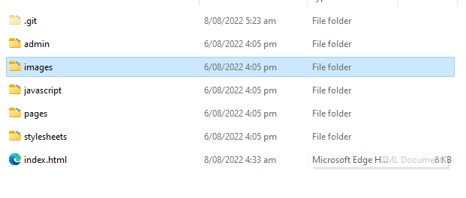

# Relevant implications that have been addressed in your outcome. How your outcome:

− is socially/culturally acceptable

− honours legal, ethical and intellectual property obligations

− considers any privacy issues

− is accessible, usable and functional

− is sustainable and future proof

− considers health and safety requirements.