Summary of Progress

Kaveh

12/29/2020

Table of Contents

## Project Progress

Recent progress on my project has been centered around the calibration of NutsFor towards the 4 base case sites I’m representing in my work. I first started by exploring the model, shifting its parameters and observing outputs. I did this by writing a R program that reads NutsFor data files and visualizes them after each model run. Once I understood how the model’s parameters functioned together, I calibrated the model by individually calibrating each sub-module within the larger model. The order of calibration was:

1). Hydrology

I used evaporation data for the Oregon Coast region(Safley et al. 2009), and drainage data from (Perakis and Sinkhorn 2011) to calibrate evapotranspiration and water leaching fluxes in my simulated sites. I assumed the same hydrological outputs between the basalt and sedimentary sites. I also assumed that hydrology was constant over time,

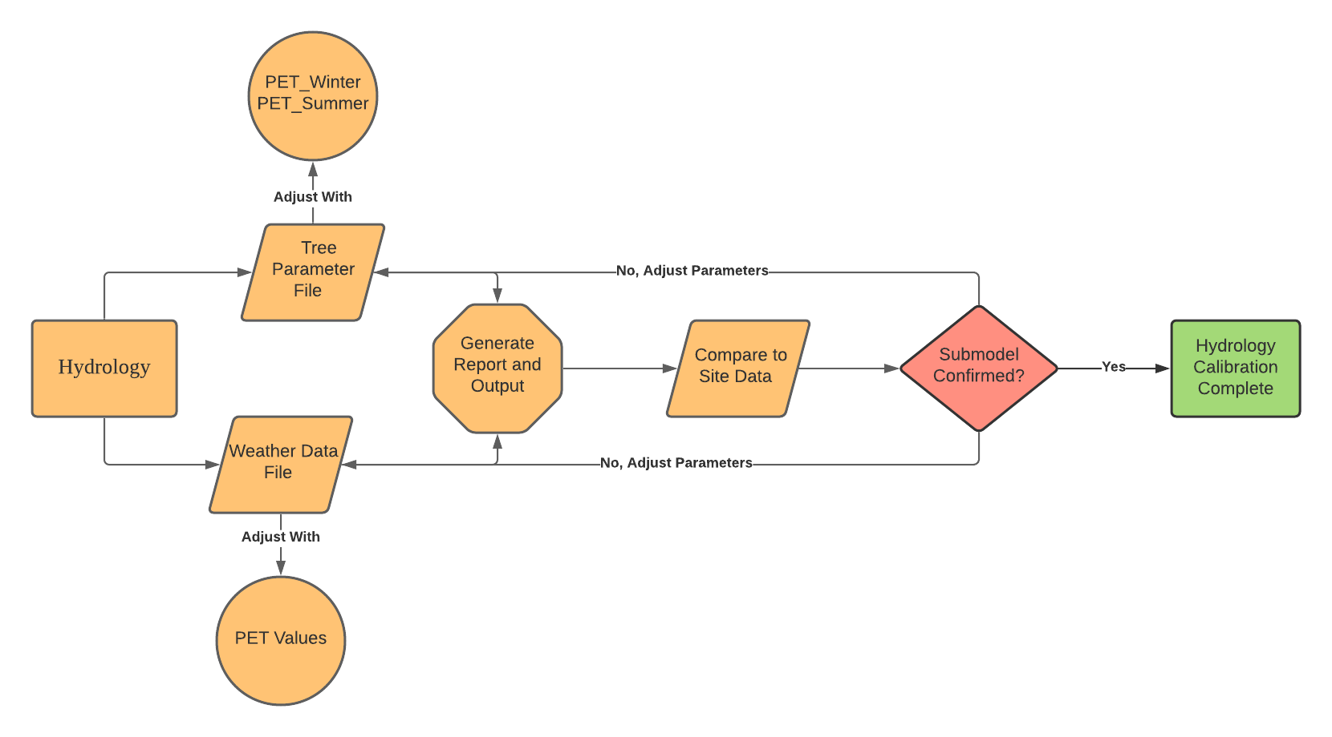

Workflow showing calibration proccess of hydrological sub-module.

2). Through fall and Deposition

Little was known about throughfall concentrations within the range of interest. Nearby throughfall data was confounded by site rain chemistry differences (Sollins et al. 1980). I instead made no assumptions about throughfall concentrations, except for $K^{+}$, which is generally known to leach in high concentrations from leaf and needle surfaces (Sollins et al. 1980; Tukey 1970).

Similar to throughfall concentrations, little was known about Dry deposition of nutrient elements, I thus made no assumptions about the input of nutrients from dry deposition.

|Wet deposition data was taken from the National Atmospheric Deposition Progam’s wet deposition data taken for the ALSEA OR02 site (“National Atmospheric Deposition Program (NRSP-3).” 2020). Rainfall concentrations for the years of 2005-2006 were used for the calibration of the model, and repeated over the length of the simulation for predictive simulations. This was necessary as NADP monitoring for the ALSEA site stopped in 2007.

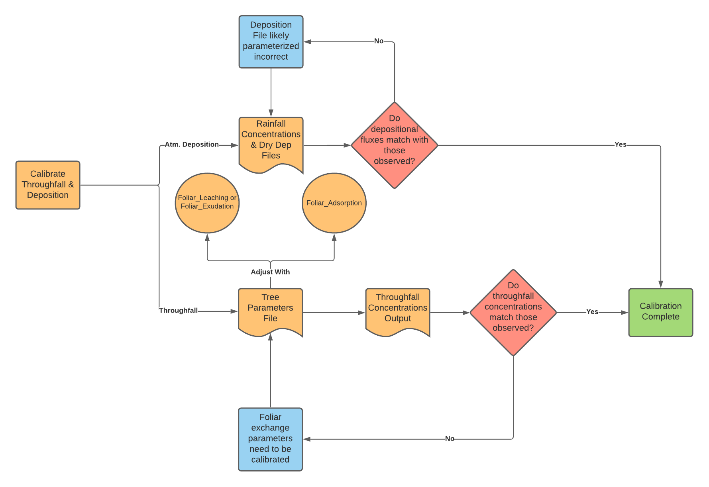

Workflow showing calibration proccess of throughfall and deposition.

3). Soil Organic Matter

Litter C pool and SOM C pool content was calibrated using decomposition parameters in the model. The litter C pool was allowed to build up over time following data from (Cole et al. 1995; Tarrant and Miller 1963; and Klopatek 2008). The SOM C pool was kept stable over the initial short term calibration, the idea is to keep SOM C stable over the entire simulation time period (~500 years).

Once the SOM C and Litter C buildup matched observed trends and roughly aligned with the known magnitude of C buildup, parameters were accepted.

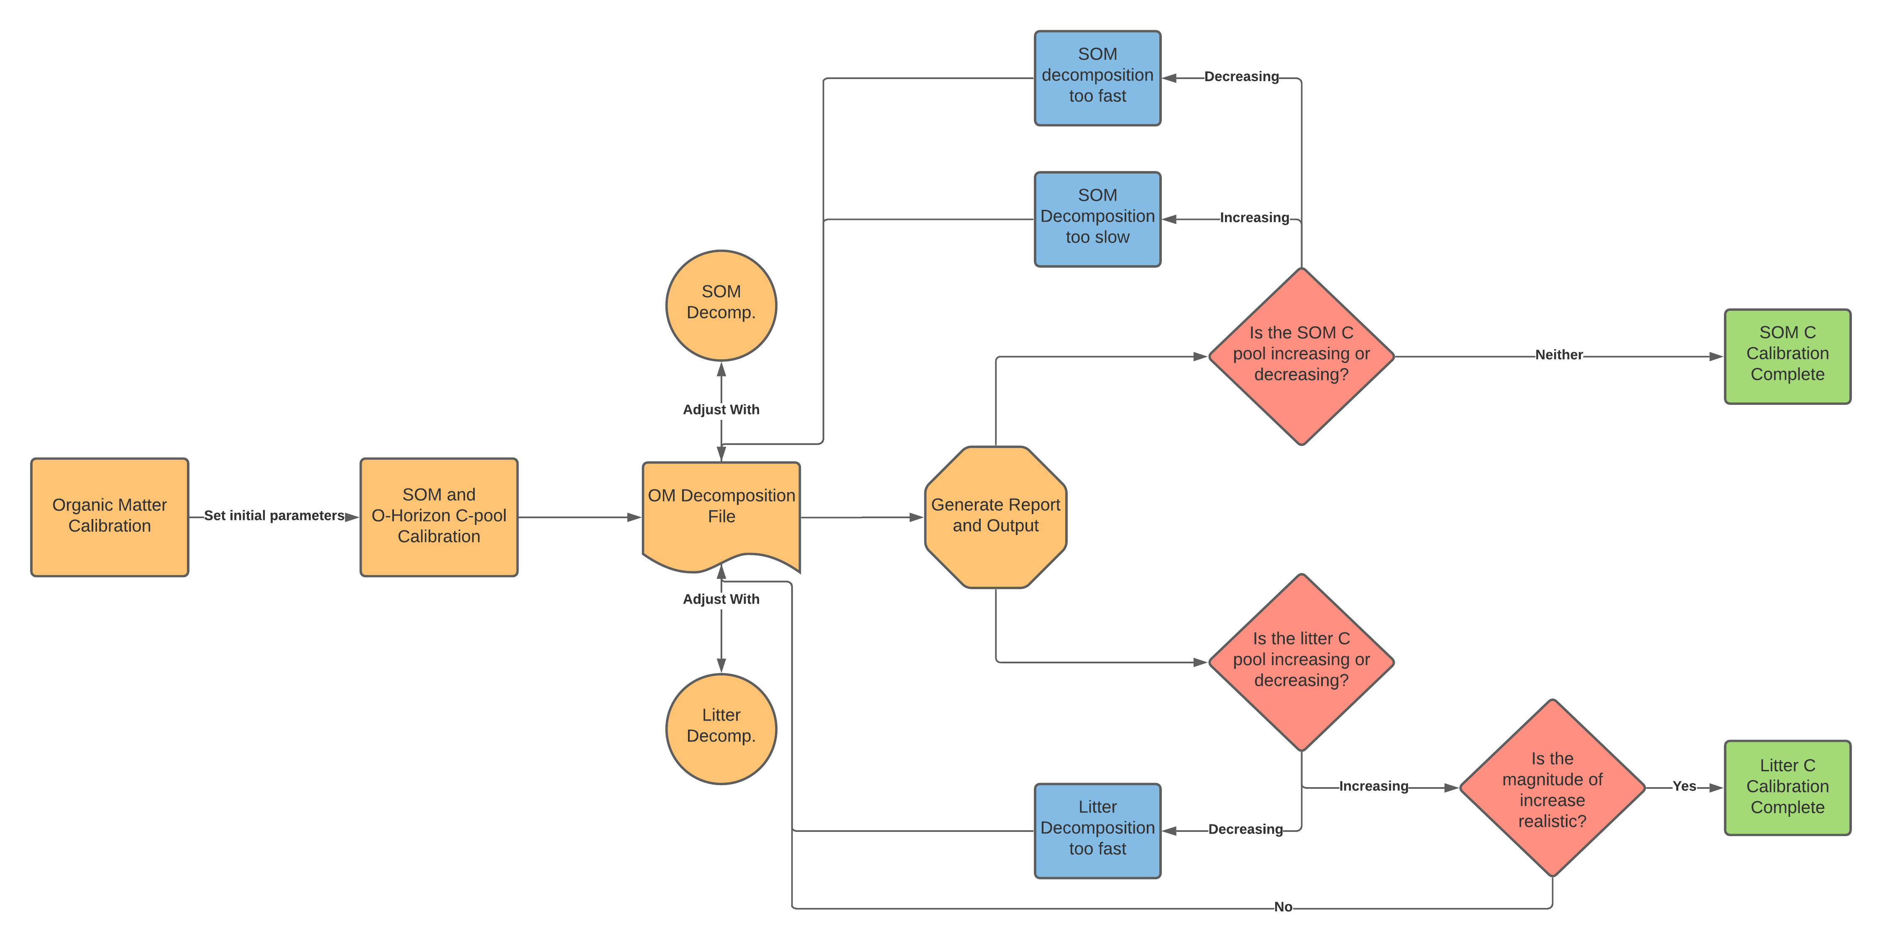

Workflow showing calibration proccess of prganic layers.

4). Anion Calibration

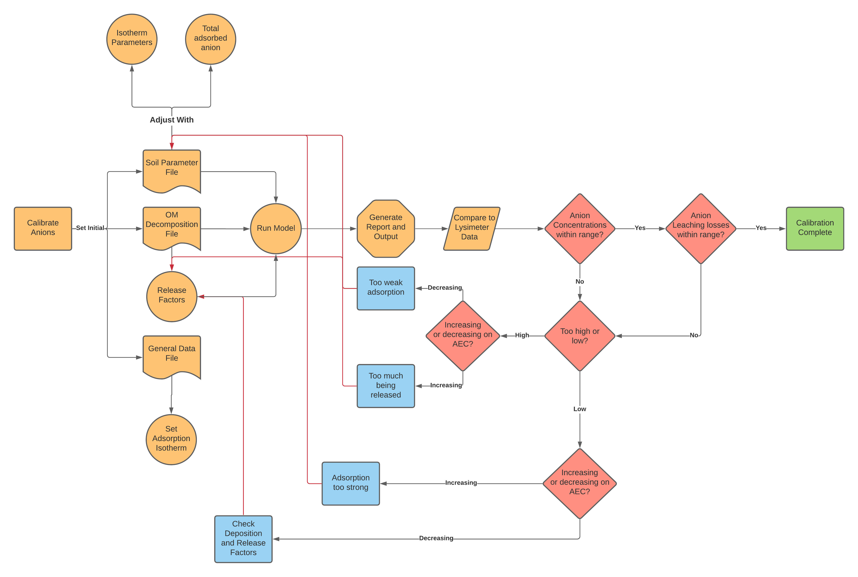

Workflow showing calibration proccess of anion concentrations.

5). Cation calibration

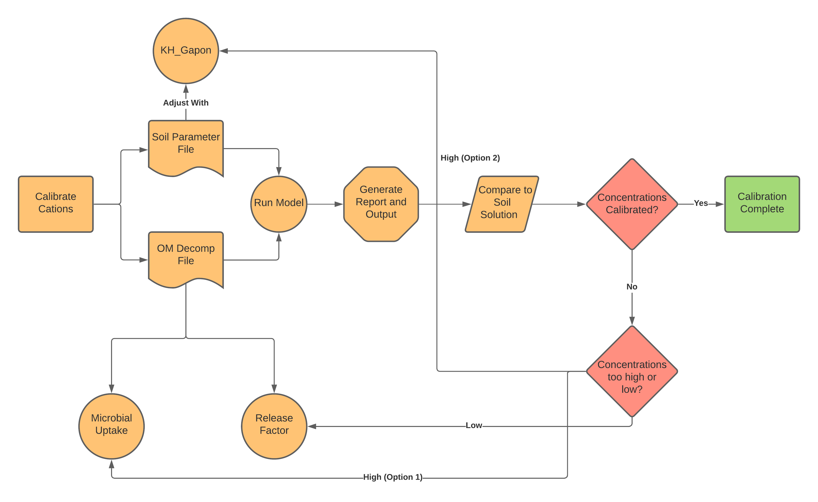

Workflow showing calibration proccess of Cation concentrations.

6). Final Calibration (10-year observation)

## Learning Outcomes Progress

## References

Cole, Dale W., Jana E. Compton, R. L. Edmonds, Peter S. Homann, and H. Van Miegroet. 1995. “Comparison of Carbon Accumulation in Douglas Fir and Red Alder Forests.” In *Carbon Forms and Functions in Forest Soils*, 527–46. John Wiley & Sons, Ltd. <https://doi.org/10.2136/1995.carbonforms.c24>.

Klopatek, Jeffrey M. 2008. “Litter Decomposition Contrasts in Second- and Old-Growth Douglas-Fir Forests of the Pacific Northwest, USA.” *Plant Ecology* 196 (1): 123–33.

“National Atmospheric Deposition Program (NRSP-3).” 2020.

Perakis, Steven S., and Emily R. Sinkhorn. 2011. “Biogeochemistry of a Temperate Forest Nitrogen Gradient.” *Ecology* 92 (7): 1481–91. <https://doi.org/10.1890/10-1642.1>.

Safley, L. M, Carl DuPoldt, Frank Geter, Donald Stettler, and Timothy Murphy. 2009. “Part 651: Appendix 10E.” In *Agricultural Waste Management Field Handbook*. United States Department of Agriculture, NRCS.

Sollins, P., C. C. Grier, F. M. McCorison, K. Cromack, R. Fogel, and R. L. Fredriksen. 1980. “The Internal Element Cycles of an Old-Growth Douglas-Fir Ecosystem in Western Oregon.” *Ecological Monographs* 50 (3): 261–85. <https://doi.org/10.2307/2937252>.

Tarrant, Robert F., and Richard E. Miller. 1963. “Accumulation of Organic Matter and Soil Nitrogen Beneath A Plantation of Red Alder and Douglas-Fir.” *Soil Science Society of America Journal* 27 (2): 231–34. <https://doi.org/10.2136/sssaj1963.03615995002700020041x>.

Tukey, H B. 1970. “The Leaching of Substances from Plants.” *Annual Review of Plant Physiology* 21 (1): 305–24. <https://doi.org/10.1146/annurev.pp.21.060170.001513>.