# 

# GT

# 

Linux Command Manual

*A Comprehensive Guide to Essential Linux Commands*

By Kenneth Cyril P. Pimentel | IT2B

# 

# **Table of Contents**

1. File System Navigation & Management
2. File Content & Text Processing
3. Users, Groups & Permissions
4. Compression & Archiving
5. Networking
6. Shell Scripting & Functions
7. File System & Quotas

## 

## 1. File System Navigation & Management

1. **pwd**
   1. Definition: Print the current working directory.
   2. Example:
   3. 
2. **ls**
   1. Definition: List files/directories. (ls -l for details, ls -a for hidden files).
   2. Example:
   3. 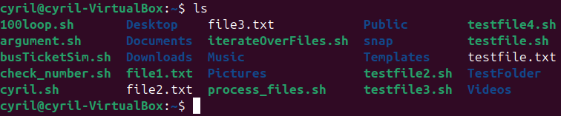
3. **cd**
   1. Definition: Change directory. (cd ~ for home, cd .. to move up).
   2. Example:
4. **mkdir**
   1. Definition: Create a directory.
   2. Example:
   3. 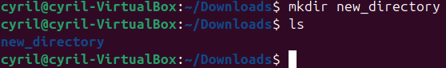
5. **rmdir**
   1. Definition: Remove an empty directory.
   2. Example:
   3. 
6. **rm**
   1. Definition: Delete files/dirs. (rm -r for recursive deletion).
   2. Example:
   3. 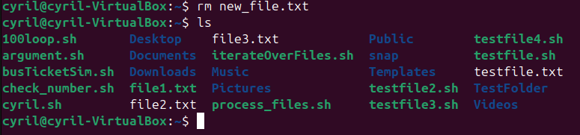
7. **cp**
   1. Definition: Copy files/dirs. (cp -r for directories).
   2. Example:
   3. 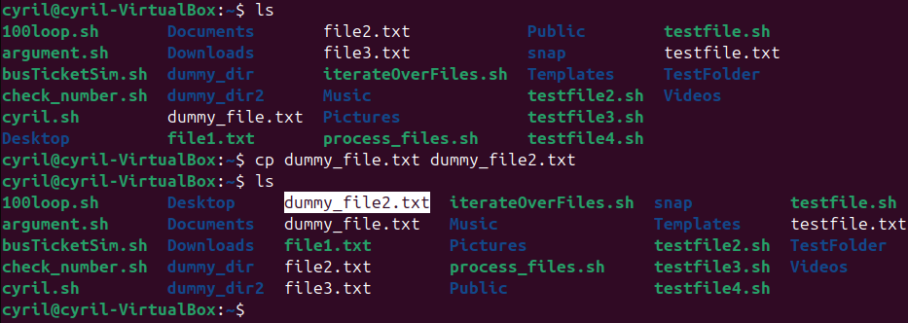
8. **mv**
   1. Definition: Move/rename files/dirs.
   2. Example:
   3. 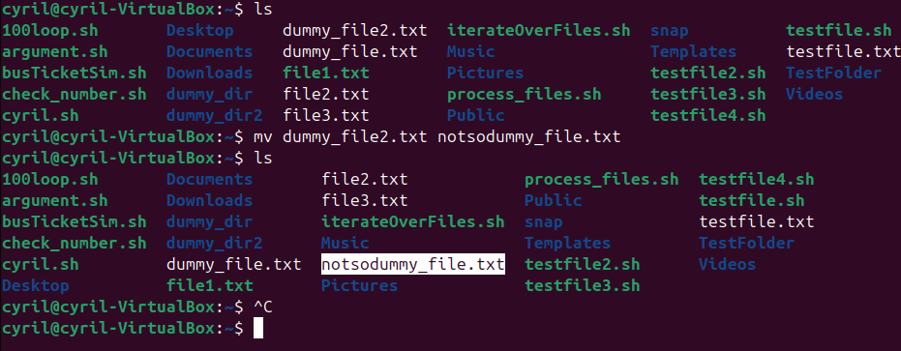
9. **touch**
   1. Definition: Create an empty file or update timestamps.
   2. Example:
   3. 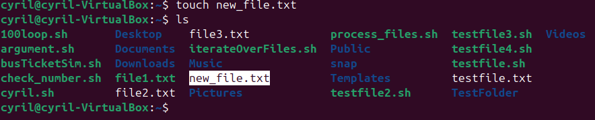
10. **find**
    1. Definition: Search for files/dirs. (find /home -name "*.txt").
    2. Example:
    3. 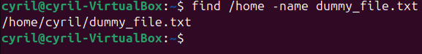
11. **locate**
    1. Definition: Quickly finds files using a prebuilt database (update with updatedb).
    2. Example:
    3. 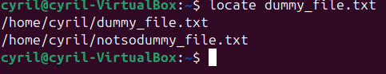

## 2. File Content & Text Processing

1. **cat**
   1. Definition: Display file content.
   2. Example:
   3. 
2. **head**
   1. Definition: Show first 10 lines of a file (head -n 5 for 5 lines).
   2. Example:
   3. 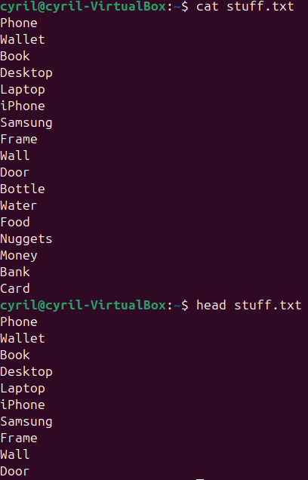
3. **tail**
   1. Definition: Show last 10 lines (tail -f for real-time logs).
   2. Example:
   3. 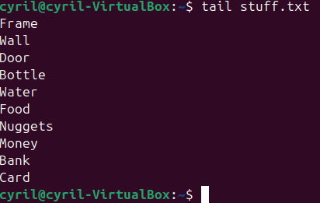
4. **Grep**
   1. Definition: Search text patterns. (grep "error" file.log).
   2. Example:
   3. 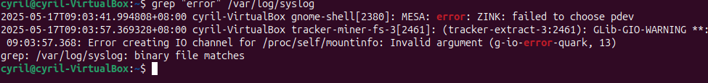

## 3. Users, Groups & Permissions

1. **useradd**
   1. Definition: Create user (useradd -m username).
   2. Example:
   3. 
2. **usermod**
   1. Definition: Modify user (usermod -aG group user).
   2. Example:
   3. 
3. **userdel**
   1. Definition: Delete user (userdel -r username).
   2. Example:
   3. 

**passwd**

* 1. Change password.
  2. Example:
  3. 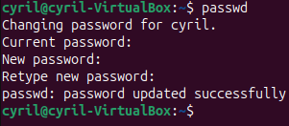

1. **groupadd**
   1. Definition: Create group.
   2. Example:
   3. 
2. **groupdel**
   1. Definition: Delete group.
   2. Example:
   3. 
3. **groupmod**
   1. Definition: Modify a group (e.g., rename).
   2. Example:
   3. 
4. gpasswd
   1. Definition:Manage group passwords/members.
      1. gpasswd -a username groupname (add user to group)
      2. gpasswd -d username groupname (remove user from group)
   2. Example:
   3. 
5. **chmod**
   1. Definition: Change permissions (chmod 755 file).
   2. Example:
   3. 
6. **chown**
   1. Definition: Change owner (chown user:group file).
   2. Example:
   3. 
7. **chgrp**
   1. Definition: Change group ownership.
   2. Example:
   3. 
8. **umask**
   1. Definition: Set default file permissions.
   2. Example:
   3. 

## 4. Compression & Archiving

1. **tar**
   1. Definition: Archive files (tar -cvf archive.tar dir/).
   2. Example:
   3. 
   4. 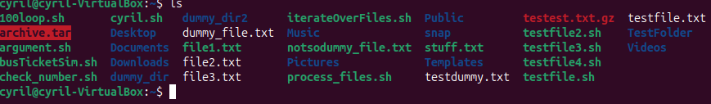
2. **gzip**
   1. Definition: Compress files (gzip file → [file.gz](http://file.gz)).
   2. Example:
   3. 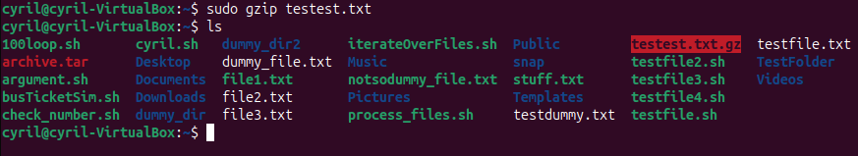
3. **gunzip**
   1. Definition: Decompress .gz files.
   2. Example:
   3. 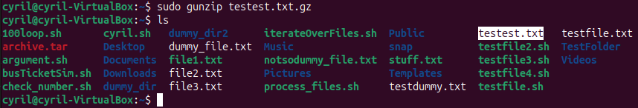
4. **zip**
   1. Definition: Create ZIP archives (zip archive.zip files/).
   2. Example:
   3. 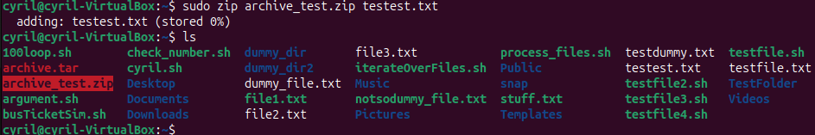
5. **unzip**
   1. Definition: Extract ZIP files.
   2. Example:
   3. 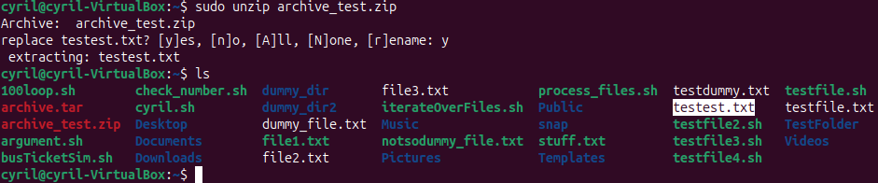

## 5. Networking

1. **ping**
   1. Definition: Test connectivity (ping [google.com](http://google.com)).
   2. Example:
   3. 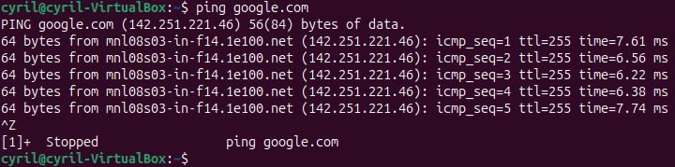
2. **ifconfig**
   1. Definition: Network interfaces (use ip addr on newer systems).
   2. Example:
   3. 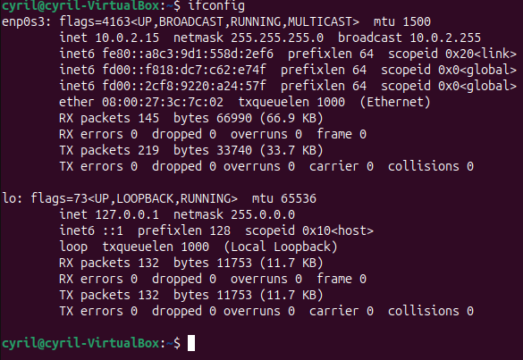
3. **Ifonfic enp0s3**
   1. Definition: Show specific info of 1 interface
   2. Example:
   3. 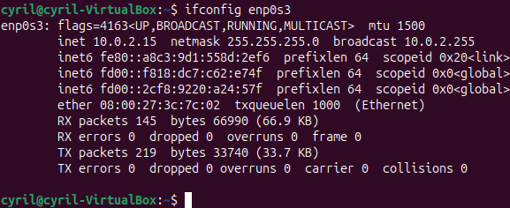
4. **sudo ifconfig [interface] [IP]**
   1. Definition: Assign a static IP address to an interface.
   2. Example:
   3. 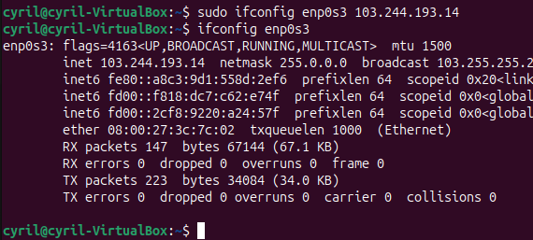
5. **sudo ifconfig [interface] down**
   1. Definition: Disable a network interface.
   2. Example:
   3. 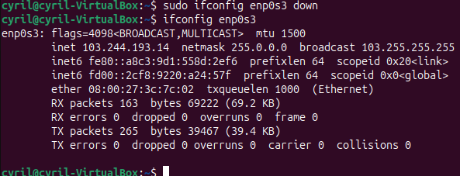
6. **sudo ifconfig [interface] up**
   1. Definition: Enable a network interface.
   2. Example:
   3. 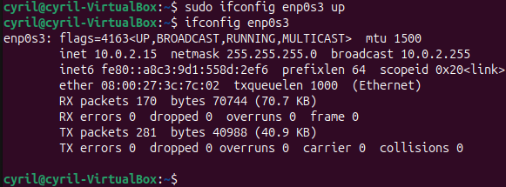
7. **traceroute [IP]**
   1. Definition: Trace the path packets take to a destination.
   2. Example:
   3. 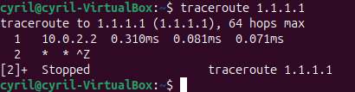
8. **nslookup [domain]**
   1. Definition: Query DNS to resolve a domain to IP(s).
   2. Example:
   3. 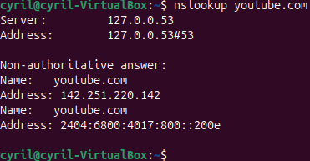
9. **dig [domain]**
   1. Definition: Advanced DNS lookup tool (more detailed than nslookup).
   2. Example:
   3. 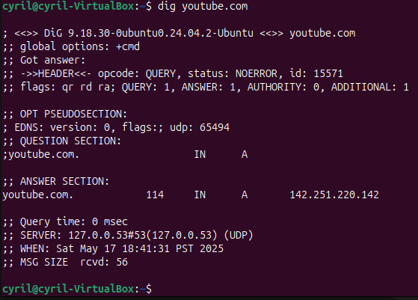

## 6. Shell Scripting & Functions

1. **chmod +x**
   1. Definition: Make script executable.
   2. Example:
   3. 
2. **./”**[**script.sh**](http://script.sh)**”**
   1. Definition: Run a script.
   2. Example:
   3. 

## 7. File System & Quotas

1. **quotacheck**
   1. Definition: Scan disk usage for quotas.
   2. Example:
   3. 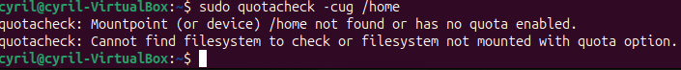
2. **quotaon**
   1. Definition: Enable quotas.
   2. Example:
   3. 
3. **repquota**
   1. Definition: Generate quota reports.
   2. Example:
   3. 
4. **setquota**
   1. Definition: Assign quota limits.
   2. Example:
   3. 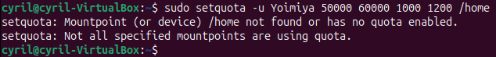
5. **edquota**
   1. Definition: Edit quotas interactively.
   2. Example:
   3. 
6. **quota**
   1. Definition: Show user/group quotas.
   2. Example:
   3. 

## 7. System Management & Package Control

1. **sudo**
   1. Definition: Execute commands as superuser.
   2. Example:
   3. 
2. **sudo apt update**
   1. Definition: Update package lists.
   2. Example:
   3. 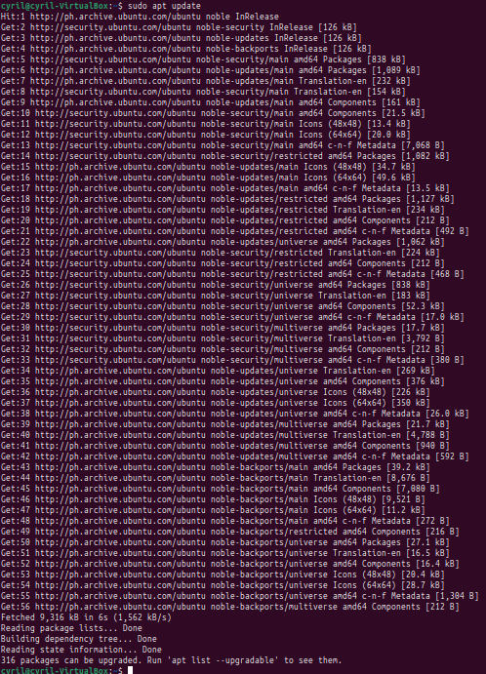
   4. 

 