# 

# GT

# 

Linux Command Manual

*A Comprehensive Guide to Essential Linux Commands*

By Kenneth Cyril P. Pimentel | IT2B

# **Table of Contents**

1. **File System, Navigation, and Basic Operations**
   1. File/Directory Operations
   2. File Viewing & Editing
   3. File Compression & Archiving
   4. File Searching & Comparison
   5. Permissions & Ownership
2. **System Administration & Process Management**
   1. User & Group Management
   2. Process Management
   3. System Monitoring & Logs
   4. System Services & Scheduling
   5. Networking Basics
3. **Advanced Utilities, Scripting & Networking**
   1. Shell Scripting & Automation
   2. Text Processing & Filters
   3. Networking & Security
   4. System Debugging & Recovery
   5. Miscellaneous & Productivity
4. **System Administration & Process Management**
   1. User & Group Management

# **1. File System, Navigation, and Basic Operations**

## **1.1 File/Directory Operations**

1. ls

**Usage:** ls [options] [directory]

**Definition:** Lists directory contents. Without arguments, shows files in the current directory.

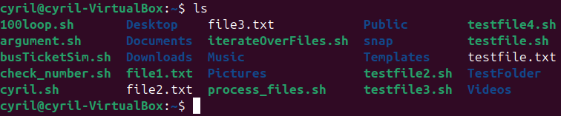

1. ls -l

**Usage:** ls -l

**Definition:** Lists contents in long format showing permissions, owner, size, and modification date.

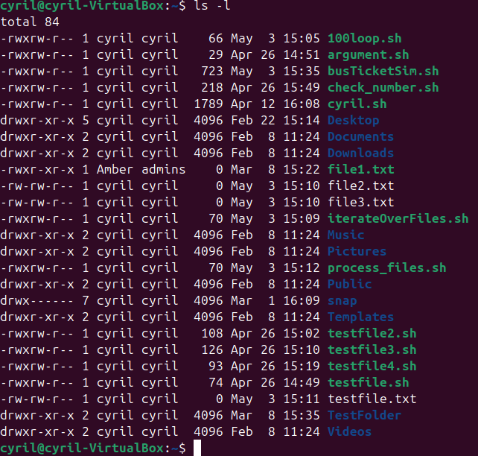

1. **Usage:** ls -a
2. **Definition:** Shows all files including hidden ones (those starting with '.').

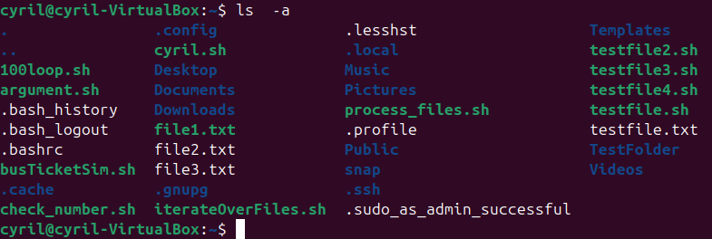

1. cd

**Usage:** cd [directory]

**Definition:** Changes current working directory. Without arguments, goes to home directory.



1. pwd

**Usage:** pwd

**Definition:** Prints the full path of the current working directory.



1. mkdir

**Usage:** mkdir [directory_name]

**Definition:** Creates a new directory with specified name.

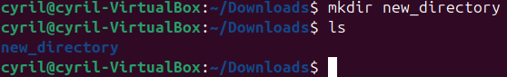

1. rmdir

**Usage:** rmdir [directory_name]

**Definition:** Removes an empty directory.



1. touch

**Usage:** touch [filename]

**Definition:** Creates an empty file or updates the timestamp of an existing file.

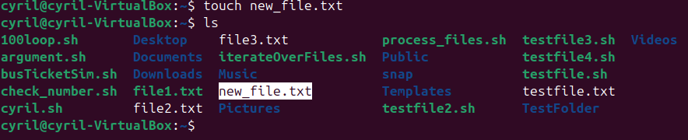

1. rm

**Usage:** rm [filename] or rm -r [directory]

**Definition:** Removes files or directories (-r for recursive directory removal).

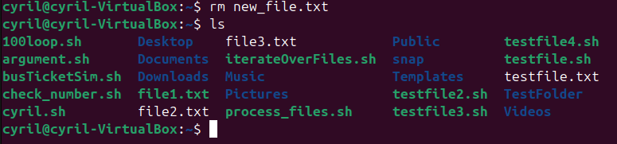

1. cp

**Usage:** cp [source] [destination]

**Definition:** Copies files from source to destination.

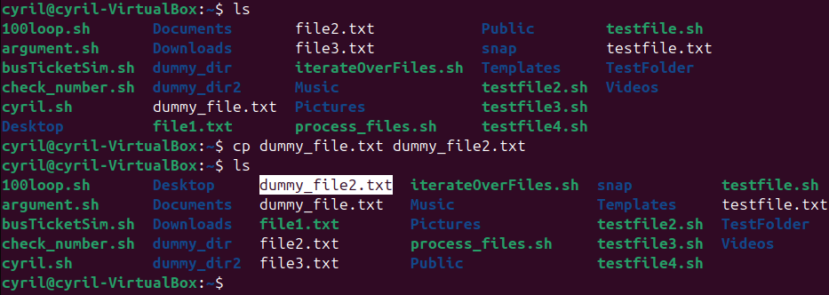

1. cp -r

**Usage:** cp -r [source_directory] [destination]

**Definition:** Recursively copies directories and their contents.

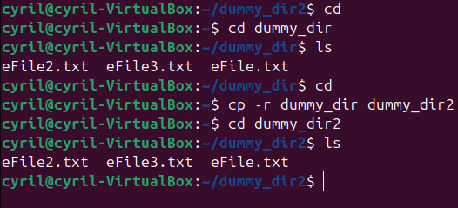

1. mv

**Usage:** mv [source] [destination]

**Definition:** Moves or renames files/directories.

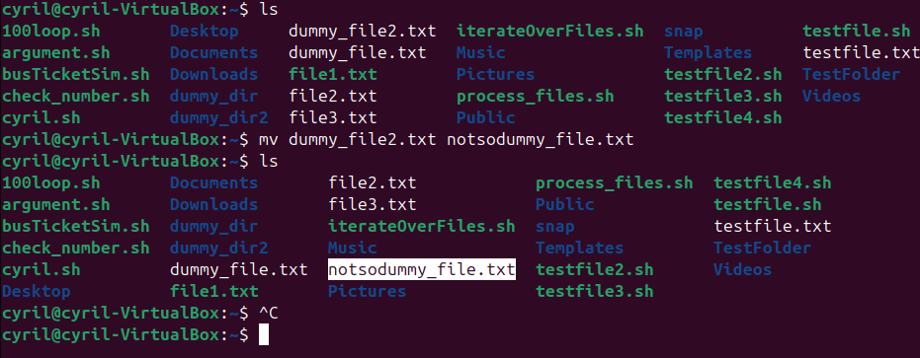

1. **tree**a) **Usage**: tree [options] [directory]  
   b) **Definition:** Displays directory contents in a tree-like format (recursive listing).  
   c) **Common Options**:
2. -d: Show directories only.
3. -L [level]: Limit depth to a specific level (e.g., -L 2).
4. -a: Include hidden files.
5. -f: Print full paths for each file.
   * 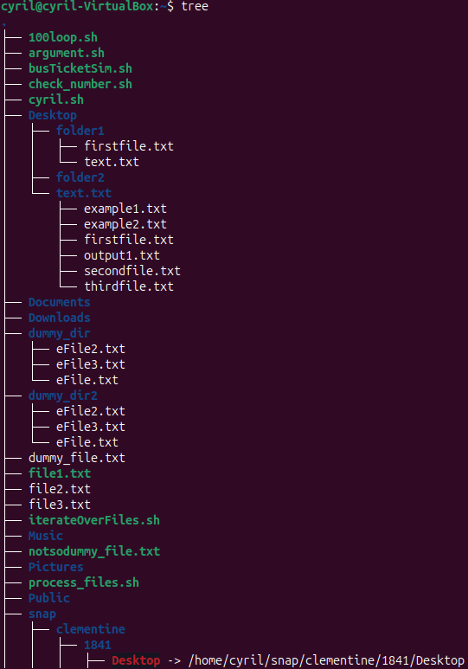  
     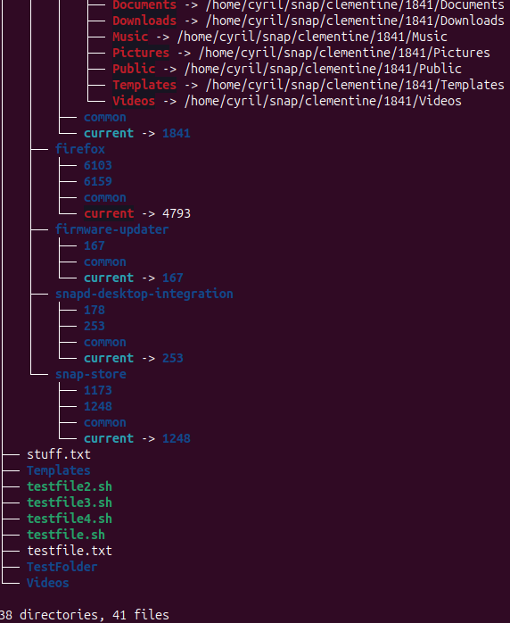
6. du
   1. **Usage: du [options] [directory]**
   2. **Definition:** Shows disk usage of files/directories.
   3. 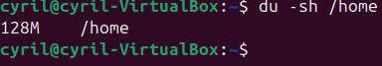
7. df
   1. **Usage**: df [options]
   2. **Definition:** Displays disk space usage for mounted filesystems.
   3. 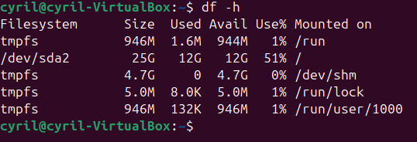

## **1.2 File Viewing & Editing**

1. cat
   1. **Usage:** cat [filename]
   2. **Definition:** Displays entire file contents in terminal.
   3. 
2. more
   1. **Usage:** more [filename]
   2. **Definition:** Views file contents one screen at a time (forward navigation only).
   3. **Navigation**
      1. **Press Space to go forward.**
      2. **Press q to quit.**
   4. 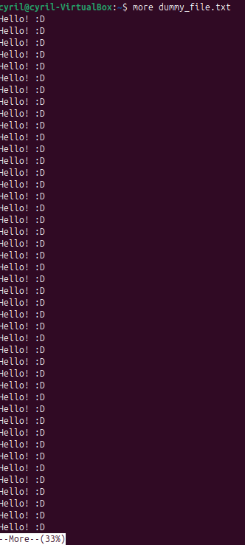
3. less
   1. **Usage:** less [filename]
   2. **Definition:** Views file with both forward and backward navigation capabilities.
   3. **Navigation**:
      1. Space: Next page.
      2. b: Previous page.
      3. /keyword: Search forward.
      4. ?keyword: Search backward.
      5. q: Quit.
   4.   
      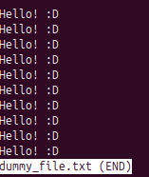
4. head
   1. **Usage:** head [filename]
   2. **Definition:** Shows first 10 lines (or specified number) of a file.

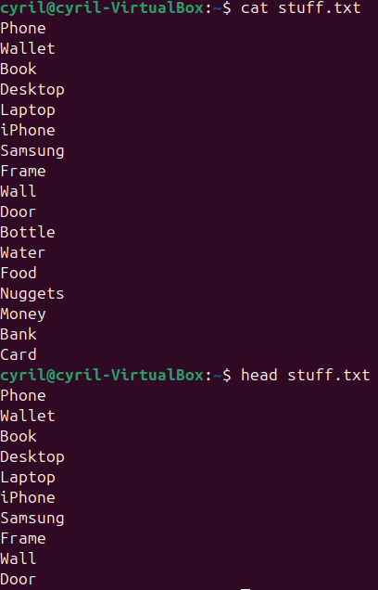

1. head -n
   1. (-n) specify the number of lines to show
   2. 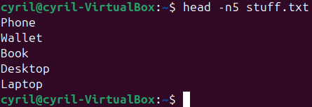
2. tail
   1. **Usage**: tail [filename]
   2. **Definition:** Shows the last **10 lines** (or specified number) of a file.
   3. 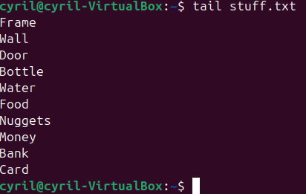
3. tail -n
   1. (-n) specify the number of lines to show
   2. 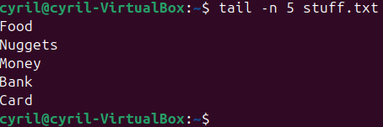
4. nano
   1. **Usage**: nano [filename]
   2. **Definition:** Simple, interactive **terminal text editor**.
   3.   
      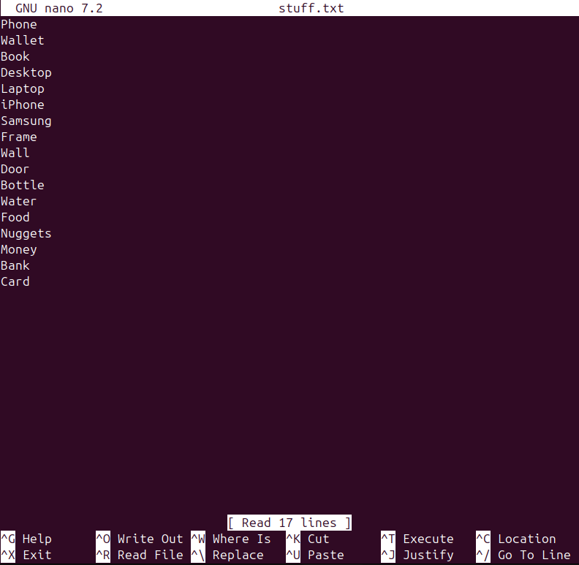
5. sort
   1. **Usage**: sort [filename]
   2. **Definition:** Sorts lines in a file alphabetically.
   3. 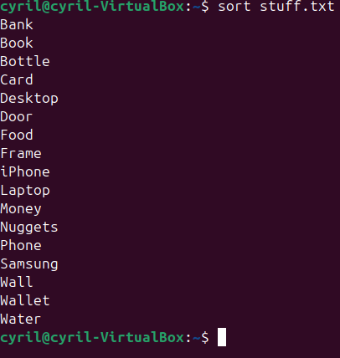

## **1.3 File Compression & Archiving**

1. tar
   1. **Usage**: tar [options] [archive_name] [files/directories]
   2. **Definition:** Creates or extracts tar archives. Common options:
      1. -c: Create archive
      2. -x: Extract archive
      3. -v: Verbose output
      4. -f: Specify archive filename
      5. -z: Compress with gzip (e.g., .[tar.gz](http://tar.gz))
   3.   
      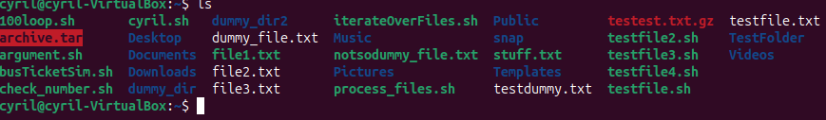
2. gzip
   1. **Usage**: gzip [filename]
   2. **Definition:** Compresses files into .gz format (replaces original file).
   3. 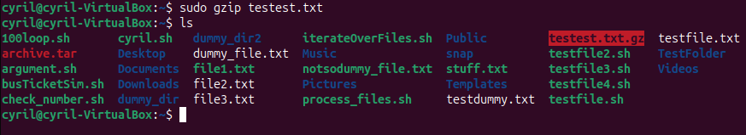
3. gunzip
   1. **Usage**: gunzip [filename.gz]
   2. **Definition:** Decompresses .gz files (restores original file).
   3. 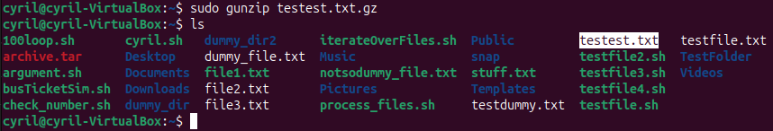
4. zip
   1. **Usage**: zip [archive_name.zip] [files/directories]
   2. **Definition:** Creates a .zip archive with specified files/directories.
   3. 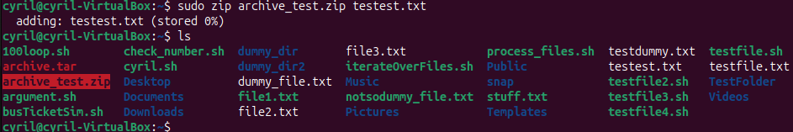
5. unzip
   1. **Usage**: unzip [archive_name.zip]
   2. **Definition:** Extracts contents of a .zip archive.
   3. 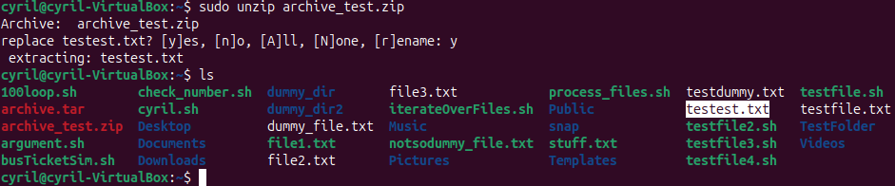

## **1.4 File Searching & Comparison**

1. find
   1. **Usage**: find [path] [options] [expression]
   2. **Definition:** Searches for files/directories recursively.
   3. 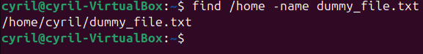
2. locate
   1. **Usage**: locate [filename]
   2. **Definition:** Quickly finds files using a prebuilt database (update with updatedb).
   3. 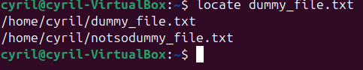
3. which
   1. **Usage**: which [command]
   2. **Definition:** Shows the full path of a shell command.
   3. 
4. whereis
   1. **Usage**: whereis [command]
   2. **Definition:** Locates binaries, manuals, and source files for a command.
   3. 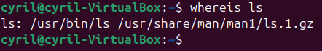
5. diff
   1. **Usage**: diff [file1] [file2]
   2. **Definition:** Compares two files line-by-line and highlights differences.
   3. 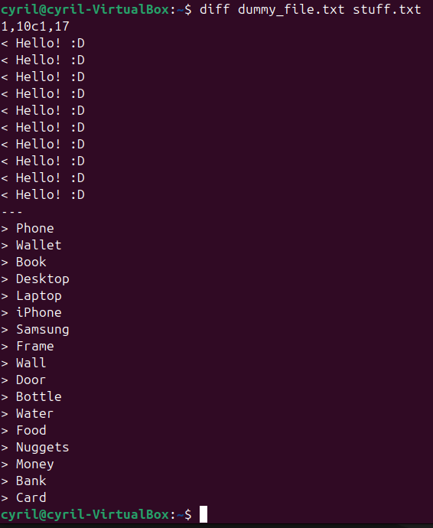
6. cmp
   1. **Usage**: cmp [file1] [file2]
   2. **Definition:** Compares two files byte-by-byte (stops at first mismatch).
   3. 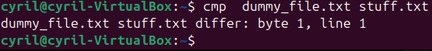
7. comm
   1. **Usage**: comm [file1] [file2]
   2. **Definition:** Compares two sorted files and shows lines unique/common to each.
   3. 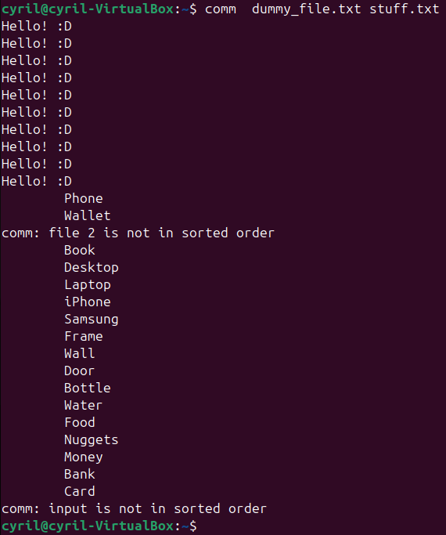
8. grep
   1. **Usage**: grep [options] "pattern" [file]
   2. **Definition:** Searches for text patterns in files.
   3. 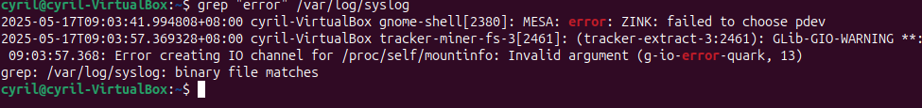
9. stat
   1. **Usage**: stat [filename]
   2. **Definition:** Displays detailed file/directory status (size, permissions, timestamps).
   3. 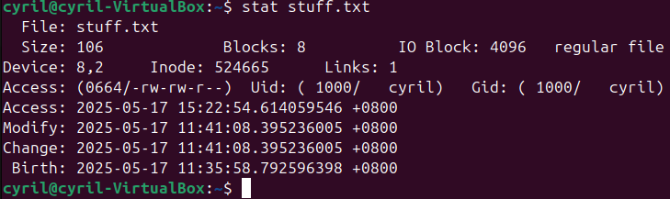

## **1.5 Permissions & Ownership**

1. chmod
   1. **Usage**: chmod [permissions] [filename]
   2. **Definition:** Changes file permissions
   3. 
2. chown
   1. **Usage**: chown [user]:[group] [filename]
   2. **Definition:** Changes file owner and/or group (e.g., chown root:admin file.txt)
   3. 
3. chgrp
   1. **Usage**: chgrp [group] [filename]
   2. **Definition:** Changes group ownership of a file.
   3. 
4. umask
   1. **Usage**: umask [value]
   2. **Definition:** Sets default permissions for new files/directories
   3. 
5. getfacl
   1. **Usage**: getfacl [filename]
   2. **Definition:** Displays Access Control Lists (ACLs) for a file/directory.
   3. 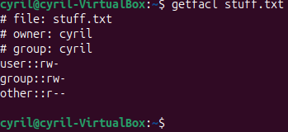
6. setfacl
   1. **Usage**: setfacl [options] [filename]
   2. **Definition:** Modifies ACLs
   3. **Commands:**
      1. -m : Modify ACL (add/update rules).
      2. -x : Remove ACL entries.
      3. -d : Apply to default ACLs (future files).
      4. -R : Recursively apply to directories.
   4. 
7. id
   1. **Usage**: id [username]
   2. **Definition:** Shows user and group IDs (current user if no argument).
   3. 
8. whoami
   1. **Usage**: whoami
   2. **Definition:** Prints the current username.
   3. 
9. groups
   1. **Usage**: groups [username]
   2. **Definition:** Lists all groups a user belongs to.
   3. 
10. passwd
    1. **Usage**: passwd [username]
    2. **Definition:** Changes a user’s password (root required for other users).
    3. 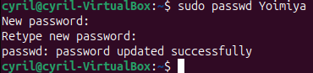
11. last
    1. **Usage**: last
    2. **Definition:** Show the last system logins.
    3. 