- 新建index.html文件，里面写如下代码！就这一页代码就行了！
<!DOCTYPE html>
<html lang="en">
<head>
<meta charset="UTF-8">
<title>3D立体</title>
<style type="text/css">
@charset "utf-8";
*{
margin:0;
padding:0;
}
body{
max-width: 100%;
min-width: 100%;
height: 100%;
background-size: cover;
background-repeat: no-repeat;
background-attachment: fixed;
background-size:100% 100%;
position: absolute;
margin-left: auto;
margin-right: auto;
}
li{
list-style: none;
}
.box{
width:200px;
height:200px;
background-size: cover;
background-repeat: no-repeat;
background-attachment: fixed;
background-size:100% 100%;
position: absolute;
margin-left: 42%;
margin-top: 22%;
-webkit-transform-style:preserve-3d;
-webkit-transform:rotateX(13deg);
-webkit-animation:move 5s linear infinite;
}
.minbox{
width:100px;
height:100px;
position: absolute;
left:50px;
top:30px;
-webkit-transform-style:preserve-3d;
}
.minbox li{
width:100px;
height:100px;
position: absolute;
left:0;
top:0;
}
.minbox li:nth-child(1){
background: url(../img/01.png) no-repeat 0 0;
-webkit-transform:translateZ(50px);
}
.minbox li:nth-child(2){
background: url(../img/02.png) no-repeat 0 0;
-webkit-transform:rotateX(180deg) translateZ(50px);
}
.minbox li:nth-child(3){
background: url(../img/03.png) no-repeat 0 0;
-webkit-transform:rotateX(-90deg) translateZ(50px);
}
.minbox li:nth-child(4){
background: url(../img/04.png) no-repeat 0 0;
-webkit-transform:rotateX(90deg) translateZ(50px);
}
.minbox li:nth-child(5){
background: url(../img/05.png) no-repeat 0 0;
-webkit-transform:rotateY(-90deg) translateZ(50px);
}
.minbox li:nth-child(6){
background: url(../img/06.png) no-repeat 0 0;
-webkit-transform:rotateY(90deg) translateZ(50px);
}
.maxbox li:nth-child(1){
background: url(../img/1.png) no-repeat 0 0;
-webkit-transform:translateZ(50px);
}
.maxbox li:nth-child(2){
background: url(../img/2.png) no-repeat 0 0;
-webkit-transform:translateZ(50px);
}
.maxbox li:nth-child(3){
background: url(../img/3.png) no-repeat 0 0;
-webkit-transform:rotateX(-90deg) translateZ(50px);
}
.maxbox li:nth-child(4){
background: url(../img/4.png) no-repeat 0 0;
-webkit-transform:rotateX(90deg) translateZ(50px);
}
.maxbox li:nth-child(5){
background: url(../img/5.png) no-repeat 0 0;
-webkit-transform:rotateY(-90deg) translateZ(50px);
}
.maxbox li:nth-child(6){
background: url(../img/6.png) no-repeat 0 0;
-webkit-transform:rotateY(90deg) translateZ(50px);
}
.maxbox{
width: 800px;
height: 400px;
position: absolute;
left: 0;
top: -20px;
-webkit-transform-style: preserve-3d;

}
.maxbox li{
width: 200px;
height: 200px;
background: #fff;
border:1px solid #ccc;
position: absolute;
left: 0;
top: 0;
opacity: 0.2;
-webkit-transition:all 1s ease;
}
.maxbox li:nth-child(1){
-webkit-transform:translateZ(100px);
}
.maxbox li:nth-child(2){
-webkit-transform:rotateX(180deg) translateZ(100px);
}
.maxbox li:nth-child(3){
-webkit-transform:rotateX(-90deg) translateZ(100px);
}
.maxbox li:nth-child(4){
-webkit-transform:rotateX(90deg) translateZ(100px);
}
.maxbox li:nth-child(5){
-webkit-transform:rotateY(-90deg) translateZ(100px);
}
.maxbox li:nth-child(6){
-webkit-transform:rotateY(90deg) translateZ(100px);
}
.box:hover ol li:nth-child(1){
-webkit-transform:translateZ(300px);
width: 400px;
height: 400px;
opacity: 0.8;
left: -100px;
top: -100px;
}
.box:hover ol li:nth-child(2){
-webkit-transform:rotateX(180deg) translateZ(300px);
width: 400px;
height: 400px;
opacity: 0.8;
left: -100px;
top: -100px;
}
.box:hover ol li:nth-child(3){
-webkit-transform:rotateX(-90deg) translateZ(300px);
width: 400px;
height: 400px;
opacity: 0.8;
left: -100px;
top: -100px;
}
.box:hover ol li:nth-child(4){
-webkit-transform:rotateX(90deg) translateZ(300px);
width: 400px;
height: 400px;
opacity: 0.8;
left: -100px;
top: -100px;
}
.box:hover ol li:nth-child(5){
-webkit-transform:rotateY(-90deg) translateZ(300px);
width: 400px;
height: 400px;
opacity: 0.8;
left: -100px;
top: -100px;
}
.box:hover ol li:nth-child(6){
-webkit-transform:rotateY(90deg) translateZ(300px);
width: 400px;
height: 400px;
opacity: 0.8;
left: -100px;
top: -100px;
}
@keyframes move{
0%{
-webkit-transform: rotateX(13deg) rotateY(0deg);
}
100%{
-webkit-transform:rotateX(13deg) rotateY(360deg);
}
}
</style>
</head>
<body>
<div class="box">
<ul class="minbox">
<li></li>
<li></li>
<li></li>
<li></li>
<li></li>
<li></li>
</ul>
<ol class="maxbox">
<li></li>
<li></li>
<li></li>
<li></li>
<li></li>
<li></li>
</ol>
</div>
</body>
</html>

2，然后导入自己的图片，也就是将新建文件夹img放入自己的照片，注意照片命名为1-6.png和01-06.png其中1-6的大小为400*400像素01-06为100*100像素的（注意2.png和02.png这两张照片需要倒着放在img中）
3，文件创建
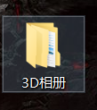
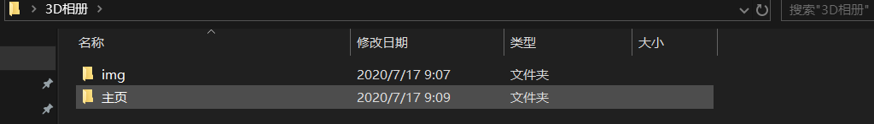
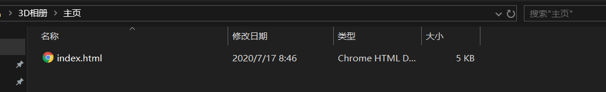
4，主页放index.html文件，img放自己图片，然后点击页面文件夹里面的index文件就可以了

