documentation for

User Database



Jellyfish: https://pixabay.com/p-152091/?no_redirect

Project WISSLearnCards - User Management

Employees of this project:

- Frithjof Hoppe

- Philippe Krüttli

- Hugo Lucca (Learning Coach)

Table of Contents

1 starting position 3

1.1 project description 3

2 Database structure 4

2.1 Notes to the DB structure 5

3 Important 6

3.1 blank entries 6

3.2 explicitness 6

4 additional features 7

4.1 download 7

4.2 Upload 7

# starting position

So basically the WISSLearnCards program was already created by our predecessors worden.Zuerst we have processed so-called issues, so we better get into the project, so that we can understand the whole processes and the structure better.

Over time, our goal was, however, also some personal contribution to the project einzubringen.Aus this reason we have chosen for some advanced user stories, which include, among other things, the project described here.

## project description

We opted for an implementation of the user functionality, which should allow the user to log in and thus have access to all of his cards, stack and subjects.

So this could be implemented, we had a database design and planning erstellen.Die cost us (due to some complications) just one day. The implementation of the database structure was in phpmyadmin on our server (lab) implemented in less than half an hour.

# Database structure

We had to take into account various factors in our database structure. Some questions that we had had to ask ourselves:

* How should the access be regulated?
* we want the functionalities?
* Which tables are suitable?

Then we had the advantages and disadvantages of different solutions to balance. This point has cost us most of the time, because it is some disagreement gab.Schlussendlich but we have opted for an improved version of our original solution proposal.

Below, the database structure is shown below:

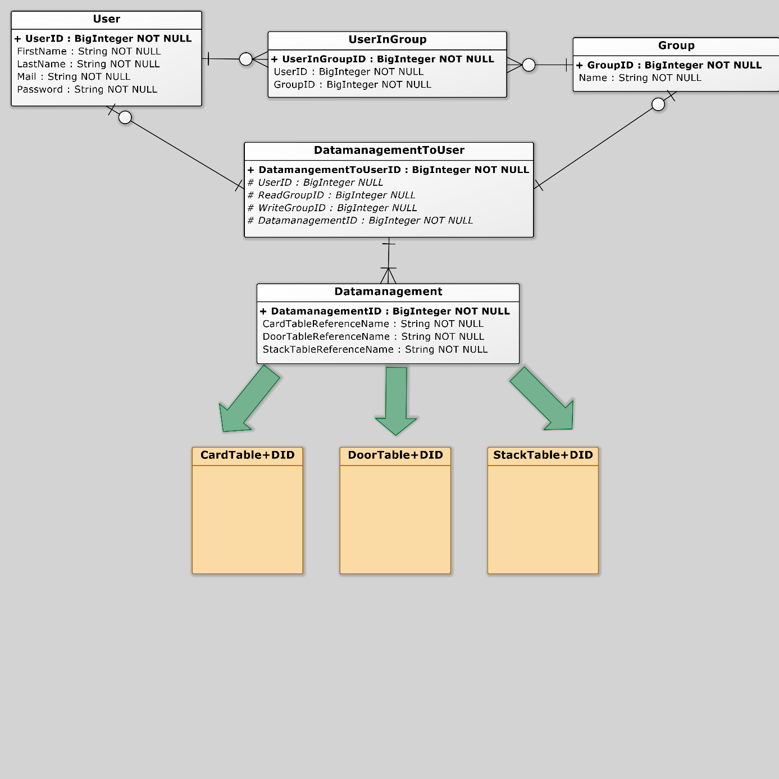

## Notes to the DB structure

The basic idea of ​​our database structure is as follows:

* Access to Cards / Stacks / Doors is managed by a central manager
* Each user gets their own separate Cards-, Stacks- and Doors table
* Each has Cards-, Stacks- and Doors table a unique name (table name + DatamanagementID)
* Company / classes can control a shared access by groups

In our solution variant, these functionalities are controlled so that the tables Data Management and Data Management TOUSER access regelt.Die to the above levels Table Data Management involves getting each one Cards-, Stacks- and Doors table to which regulated the Table Data Management TOUSER access can be.

The access concept is as follows:

* The user with the user ID, which is linked in the table Data Management TOUSER with DatamanagementID has all rights to the information contained tables. Thus, he can see in the records of both, create, edit as well as delete.
* The group has WriteGroupID the tables contained both read, and write privileges. So you can see, create, and edit the records. However, the deletion is not executable.
* The group has ReadGroupID the tables Card table, Stack Table and Table Door-only access and can thus view the data though, but not create or edit, or delete.

In the table Data Management is further referred to the unique table name to which access should be regulated.

As a user name in the user table the e-mail is used address of the user, as this is clearly in each case and thus a check is (uniqueness) pretty easy to implement.

In the table UserInGroup the group membership of all users is regulated. Thus, a user can be a member in both multiple groups and multiple users in a Gruppe.Des Furthermore, the user is not forced to be a member of a group, and no unnecessary groups are created.

# Important

There are some points that are important to consider both of us, and by our successors müssen.Diese are explained in detail below.

## blank entries

Since one user and up to two groups may have access to a data management record that we have as RIB (Referential integrity condition) specifies that when deleting a user or a group of the entry in the Data Management table to the value "NULL" to be set.

Thus, the other groups or users retain access, certainly what the only correct solution be kann.Dadurch it but it can also happen that there are Data Management entries in which all three attributes (user ID, and ReadGroupID WriteGroupID) is "NULL "possess, this entry has no more sense.

For this reason, should be at an appropriate time (after one week, one month or one year) are reviewed if there are entries where the problem zutrifft.Die tuple described above, in which this is true, should be cleared out from the table Data Management ,

## explicitness

In both the user name and the group name and the table name (of Tables Table Card + DID, Stack Table + DID and Door Table + DID) must be adhered to the uniqueness in each case and checked.

Otherwise, errors can occur which would make the whole user functionality unusable and therefore cost a lot of time and work.

# additional features

There are still some additional functionality that we were not able to before, but which facilitate the work as a user or significantly improve würde.Dazu include the following points.

## download

If the user has (at least) read access to a Door-, stack or card element, he shall also download this and save a local können.Die new data will be integrated into the existing local database.

This functionality is made easier for the user to its own elements (which he as a user with the user ID has access) can download a lot easier by the existing division into three tables and thus integrate.

The locally stored data should (as well as downloaded from Quizlet data) can be processed, but the change to the server-stored data will not be accepted.

## Upload

Just as with the download function, would now here a particular stack, a certain subject or even a particular card, the user in its Data Management entry werden.Auch integrated (in the appropriate table) this facilitates our chosen database structural work significantly.

The upload feature, combined with the download function, it would then be possible, for example, download a Quizlet stack edit it locally or to alter and then upload into its own structure on the WISS-house server.