


INFORMATION MANAGEMENT
OBJECT-ORIENTED PROGRAMMING
PROJECT

Project/System Title: __Transparent and Centralized Grading Management System___________________
Group Members: _Oropilla, Condes, Lalata, Mariano, Puyat_____________________________________
Course / Section: _BSCS - 2A__________________________________________________________
Professor: Mrs. Rebecca R. Fajardo_______________________________________________________

Project Documentation and Submission Map
Stage | Required Output | Primary Evidence | Professor Remarks
1 | Concept Paper | Problem, objectives, scope, users, proposed solution | ☐
2 | Business Rules | Operational rules, constraints, data relationships | ☐
3 | ERD | Entities, attributes, PK/FK, cardinality, optionality | ☐
4 | Normalization | UNF, 1NF, 2NF and 3NF explanation; dependencies and final relations. | ☐
5 | Data Dictionary | Complete field definitions and constraints | ☐
6 | MySQL Database | DDL, DML, sample records, queries, screenshots | ☐
7 | VB.NET System | Forms, CRUD, validation, database connectivity | ☐
8 | Test Cases | Functional tests, expected/actual results, status | ☐
9 | User Manual | Installation/access and step-by-step usage guide | ☐

General Documentation Standards
☐ All entities and fields shown in the ERD must correspond to the normalized tables and data dictionary.
☐ Primary keys, foreign keys, data types, constraints, and relationships must match the implemented MySQL database.
☐ VB.NET forms and functions must use the actual MySQL database designed in this project.
☐ Use screenshots only as supporting evidence; explain what each screenshot demonstrates.
☐ Use meaningful sample data. Do not use sensitive real-world personal data unless authorized and properly anonymized.
☐ Number and caption major figures/tables (e.g., Figure 1. ERD; Table 3. Data Dictionary).
☐ Attach source code/database scripts as appendices or as separate electronic files when required by the instructor.

1. Concept Paper
The concept paper establishes the need for the proposed system and defines what the group intends to develop.

1.1 Project Title

Transparent and Centralized Grading Management System

1.2 Background / Rationale
Academic grade records maintained in separate spreadsheets can be difficult to consolidate, review and share with authorized users. The group’s concept paper identifies delayed awareness of academic standing, overwritten grade information, limited traceability of changes and time-consuming manual interpretation. The system addresses these concerns through centralized records, consistent running-grade calculation, role-based access, revision requests and audit history.

1.3 Problem Statement

Primary Problem: Inefficiencies, vulnerability to calculation errors, and a lack of real-time transparency in traditional manual grade recording and dispute resolution processes.
Supporting Problems:
- Delays in student visibility regarding individual assessment marks, weighting distributions, and running grades.
- Absence of an auditable tracking mechanism for grade modifications and formal revision requests.
- Administrative friction in managing user credentials, class section enrollments, and faculty assignments across academic departments.

1.4 General Objective

To develop a database-driven desktop grading management system for the project context of Pamantasan ng Lungsod ng Pasig that supports current running-grade computation, traceable clarification requests and organized academic record management.

1.5 Specific Objectives

Database Objectives: Implement a relational MySQL/MariaDB schema with keys, referential constraints and parameterized queries. Separate entity data to reduce update anomalies, document the cached running grade, and protect passwords using salted PBKDF2-SHA256 hashing in the active authentication workflow.
System Objectives: Develop a VB.NET Windows Forms application with role-based access control tailored for Students, Teachers, and System Administrators.
Functional Objectives:
- Calculate running grades consistently from raw scores, maximum scores and relative assessment weights, excluding ungraded items and including recorded zero scores.
- Provide student clarification requests and assigned-teacher review with Pending, Under Review, Approved and Closed statuses, recording decisions and approved score corrections.
- Implement automated system audit logs capturing all grade modifications with timestamps and user attributions.
Provide readable PDF grade reports and supported administrative CSV/PDF exports for record review. These are application reports, not a claim of institutional certification.

1.6 Proposed Solution / System Overview

Teachers record raw assessment scores for assigned classes. A shared calculator normalizes relative weights over graded items and updates current standing. Students view their own grades and request clarification. Assigned teachers approve corrections or close requests, with related score and decision changes saved transactionally. Administrators manage accounts, class setup, authorized grade entry and oversight. Audit entries support traceability; they are not cryptographically immutable. Relevant screens refresh when reopened or through periodic database polling.

1.7 Target Users / Stakeholders

User Role in the system Main features they use
Students | View their own grades and check how they are doing | Live grade report with running grade and standing, grade history showing who changed a grade and why, revision requests with status tracking, and a performance overview
Professors | Record and manage grades for their classes | Gradebook for entering scores, handling student revision requests, and viewing their assigned classes
Administrators | Manage the system and its records | Student and professor management (add, edit, search, filter), class and subject setup, request monitoring, and audit logs

1.8 Scope

- Role-based authentication and salted password verification, including compatibility with supported legacy SHA-256 hashes.
- Score entry and automated dynamic grade recalculation.
- Database-backed digital gradebook, class roster and assessment CSV imports, and PDF reports.
- Student grade dispute submission and teacher approval/rejection panel.
- Class performance analytics dashboard.
- Comprehensive grade audit logging.
- Admin account creation and editing, activation/deactivation, protected deletion, class creation and administrative grade entry.

1.9 Limitations

- Windows desktop interface only; no browser or mobile client is included.
- No Google Classroom, LMS or university SIS integration is implemented.
- No student image/video upload or supporting-file attachment feature is implemented.
- No built-in automated online backup or offline synchronization is implemented.
- The application requires its configured MySQL/MariaDB database. Local setup is supported; remote access requires network and server configuration. Internet access is not a substitute for database connectivity.
1.10 Significance / Expected Benefits

For Students: Provides access to current recorded scores, standing, history and review responses, supporting earlier awareness of academic performance.
For Faculty: Reduces repeated calculation and data-entry steps and provides structured records of score corrections. Invalid inputs and operational errors remain possible and require validation and review.
For Administration: Consolidates account management and oversight through searchable directories, request monitoring and audit history. These benefits have not been quantified by a formal timing or respondent study in the supplied materials.

1.11 Major System Modules
Module | Main Functions | Primary User/s
Authentication & Session | Role-based login, password verification, active App Session management. | All Users
Teacher Gradebook & Entry | Raw score recording, running grade recalculation, gradebook filter, PDF/CSV export. | Professors
Revision Module | Request submission, review and decisions: Pending, Under Review, Approved and Closed. | Students and Professors
Student/Professor Dashboard | Live grade breakdown, percentage weighting display, score revision history. | Students for student dashboard & Professors for professor dashboard
Analytics & Audit Log | Class averages, top scores, at-risk flags, timestamped audit log of all changes. | Students (own data), Teachers (assigned classes), Admin (oversight)
Admin Management Portal | Student/Professor directory CRUD, class assignments, system stats. | Admin

2. Business Rules
Business rules describe how the organization operates and how data must be stored, related, validated, and processed. Rules should be clear enough to guide the ERD and database constraints.

2.1 Narrative Business Rules

Rule No. | Business Rule | Database/Relationship Impact | Validation/Constraint
1 | Each student, teacher and admin must have a unique account ID. Emails must be unique within each role, and passwords must be stored as hashes. | Separate Student, Teacher and Admin tables. | PRIMARY KEY; per-table UNIQUE email; NOT NULL password_hash. Backend: hashing.
2 | Only admins may delete accounts without protected related records. Linked accounts may be deactivated instead. | Student.status; Teacher.status; linked records. | Active/Inactive status; restrictive foreign keys. Backend: admin and linked-record checks.
3 | A course may have many classes and must not be deleted while classes reference it. | Course 1:M Class. | FOREIGN KEY course_code; ON DELETE RESTRICT.
4 | Each class must have one teacher and a unique course, section, semester and academic year combination. | Teacher 1:M Class. | NOT NULL teacher_id foreign key; UNIQUE(course_code, section, semester, academic_year).
5 | A student may join many classes but must not enroll in the same class twice. | Student M:N Class through Enrollment. | Foreign keys; UNIQUE(student_id, class_id).
6 | Each assessment must belong to one class and term, with a valid type, positive maximum score and positive weight not exceeding 100. | Class 1:M Assessment. | Class foreign key; term/type ENUMs; CHECK maximum > 0, weight 0–100. Backend: weight > 0; two-decimal limits.
7 | Each enrollment may have only one grade per assessment. | Enrollment and Assessment linked by StudentGrade. | Foreign keys; UNIQUE(enrollment_id, assessment_id).
8 | Scores must remain blank until graded, fall between zero and the maximum, use at most two decimal places and match the enrollment’s class. | StudentGrade, Enrollment and Assessment. | Nullable DECIMAL(6,2). Backend: range, precision and same-class checks.
9 | Running grades must use relative weights of graded assessments only. Recorded zeros must count; ungraded items must not. Fixed totals or term splits are not required. | Assessment and StudentGrade → Enrollment.running_grade. | Backend: sum(score/max × weight) ÷ sum(graded weights) × 100; NULL if no qualifying grades.
10 | A running grade of at least 75% is Passed; below 75% is At risk. No running grade is Not Yet. | Enrollment.running_grade. | Nullable DECIMAL(5,2). Backend: shared calculator and 75% threshold.
11 | Students may request a re-check or point increase for their own graded assessments, with only one open request per grade. | StudentGrade 1:M RevisionRequest. | Grade foreign key; reason required; NULL points = re-check. Backend: ownership, positive points and one Pending/Under Review request.
12 | Requests must start Pending. The assigned active teacher may mark them Under Review, Approved or Closed. Approval or closure must record reviewer and time. Under Review must be audited. Final decisions must not be processed again. | RevisionRequest; Teacher; AuditLog. | Status ENUM. Backend: transition checks; reviewer/time on approval or closure; audit Under Review.
13 | Assigned active teachers and authorized admins may record scores. Only the assigned active teacher may decide revision requests. | Class.teacher_id; Teacher.status; Admin. | Backend: actor authorization, active teacher and class ownership.
14 | Important actions must be audited with one actor and a timestamp. Score changes must record available old and new values. | AuditLog references one account actor. | Actor foreign keys; CHECK exactly one actor; default timestamp; optional old/new values.
15 | Audit history must remain when its target record is deleted. | AuditLog.entity_type and entity_id. | Entity fields are not foreign keys; INDEX(entity_type, entity_id).
16 | Protected references must block deletion. Permitted deletions must follow defined cascade or null-setting rules. | Class, Enrollment, StudentGrade, RevisionRequest and audit actors. | RESTRICT protected links; CASCADE enrollment/assessment → grades → requests; SET NULL reviewed_by.
17 | Users must access only role-authorized records and actions. Protected operations must validate applicable role, ownership and account status. | Role-based screens and service operations. | Backend: applicable access and account-status checks.

2.2 Assumptions
- A class offering is identified by course code, section, semester and academic year. Midterm and Finals are assessment grading periods, distinct from 1st Semester and 2nd Semester.
- Assessment weights are relative, positive values set for the class; the application does not enforce fixed category percentages, a total of 100 or a 50/50 term split.
- A committed score correction becomes available to subsequent database reads. Screen refreshes and polling introduce a short display delay; the application does not use push notifications.

2.3 User Roles and Permissions
User Role | Can View | Can Add/Edit/Delete | Special Permissions
Admin | Dashboard, account directories, classes, requests and audit reports. | Create/edit accounts; activate/deactivate; delete eligible unlinked accounts; create classes; enter scores. | Monitor requests read-only; filter and export supported administrative reports.
Student | Own grades, history, performance, profile and request decisions. | Submit own clarification requests; change own password. | Cannot edit scores or decide requests; profile is read-only.
Teacher | Assigned classes, gradebook, requests, analytics and audit records. | Create assessments/classes; enroll active registered students; record scores; decide assigned-class requests; change own password. | CSV imports, PDF reports, fast score entry and surname ordering; no full administrative access.

3. Entity-Relationship Diagram (ERD)
Create the ERD based on the approved business rules. The final ERD must show entities, attributes, primary keys, foreign keys, relationships, cardinality, and optionality where applicable.
☐ All required entities are present.
☐ Every entity has a primary key.
☐ Foreign keys correctly represent relationships.
☐ Many-to-many relationships are resolved using associative/intersection entities.
☐ Attribute names are meaningful and consistent.
☐ Cardinality/optionality agree with the business rules.

3.1 ERD
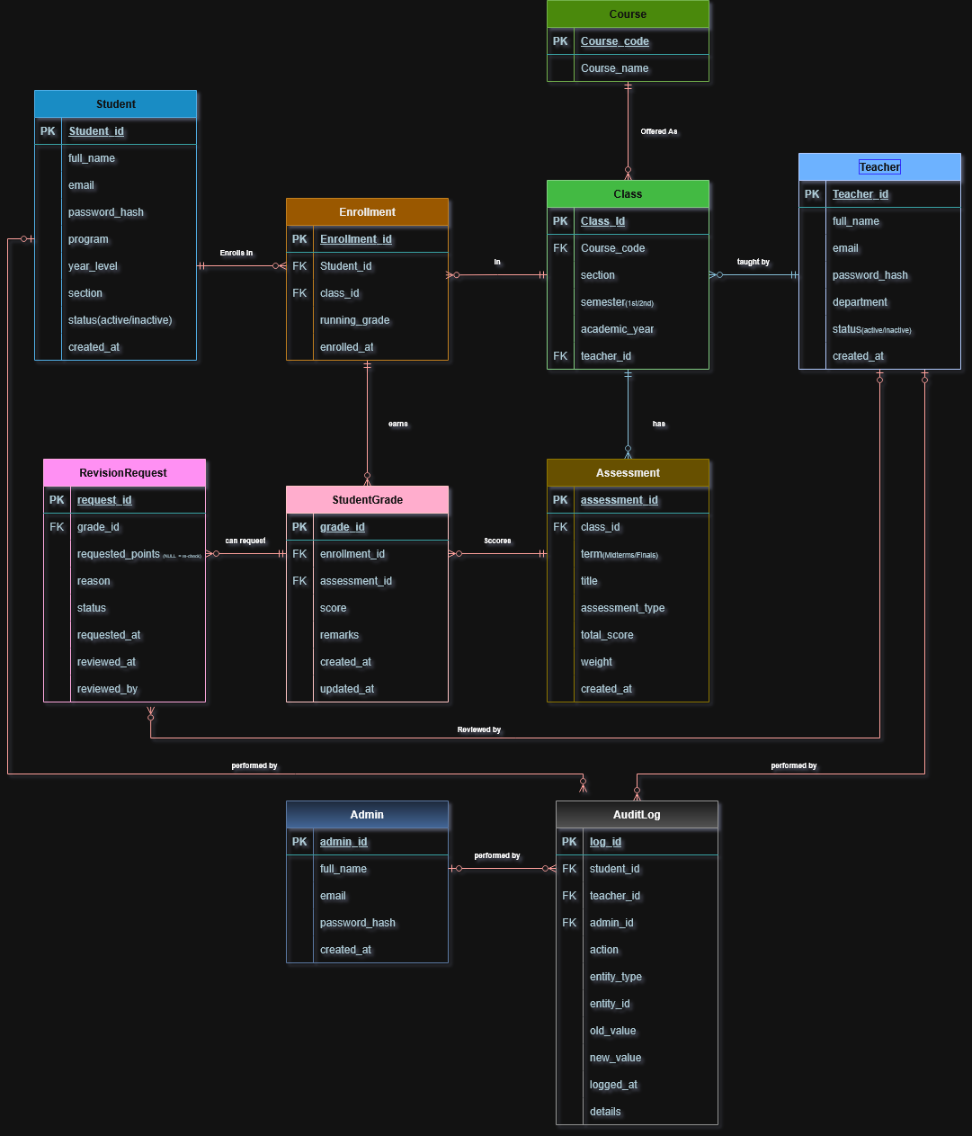

3.2 ERD Explanation
Student
Stores each student’s account and details, such as name, email, program, year level and section. It matters because students are the people the system exists for. They log in to see their grades and to ask for a re-check. It connects to Enrollment, which shows the classes the student takes, and to AuditLog, which records the student’s actions.
Teacher
Stores each teacher’s account and department. It matters because teachers record the scores and review revision requests. It connects to Class, which shows the classes they handle, to RevisionRequest, which shows the requests they reviewed, and to AuditLog, which records their actions.
Admin
Stores the administrator accounts that manage the system, such as creating accounts and assigning classes. It matters because someone must be accountable for system setup. It connects to AuditLog, which records every admin action.
Course
Stores the subject itself, such as CS 103 and its name. It matters because the course name is stored once here instead of being repeated in every class. This keeps the data clean and follows third normal form. It connects to Class, since one course can be offered as many classes.
Class
Stores one offering of a course: the section, the semester and the academic year. It matters because grades and enrollments belong to a specific class, not just to a subject. It connects to Course (what is taught), Teacher (who teaches it), Enrollment (who is in it) and Assessment (what is graded in it).
Enrollment
Stores which student is in which class, with the running grade for that class. It matters because a student takes many classes and a class has many students. Without it we could not link them. It connects to Student, Class and StudentGrade, which holds the student’s scores in that class.
Assessment
Stores each quiz, activity, exam or project, with its term (Midterm or Finals), total score and weight. It matters because it defines what is graded and how much each item counts. It connects to Class (which class it belongs to) and StudentGrade (the scores students got on it).
StudentGrade
Stores one student’s score on one assessment, with remarks and timestamps. It matters because it holds the actual grades, which is the main data the system shows. It connects to Enrollment (whose grade it is), Assessment (what was graded) and RevisionRequest (any dispute about the score).
RevisionRequest
Stores a student’s request to re-check a score, with the reason, the points asked for and the review status. It matters because it is what makes the system transparent: students can question a grade, and the outcome is recorded. It connects to StudentGrade (the grade in question) and Teacher (who reviewed it).
AuditLog
Stores a permanent record of who did what and when, including the old and new value of a changed score. It matters because it makes every change traceable, so no grade can be changed without a record. It connects to Student, Teacher and Admin, and each entry names exactly one of them. The record that changed is stored as plain text, so the history stays even if that record is deleted later.

4. Database Normalization: 1NF to 3NF
Show the transformation of the initial/un-normalized data structure into First, Second, and Third Normal Form. Do not submit only the final tables; demonstrate the reasoning at each stage.

4.1 Initial / Unnormalized Data

The following worksheets illustrate a design transformation, not an additional production table. A hypothetical unnormalized grade sheet groups a student’s classes and repeated assessment/score entries in one record. Repeating assessment columns and duplicated course/teacher details create insertion, update and deletion anomalies.
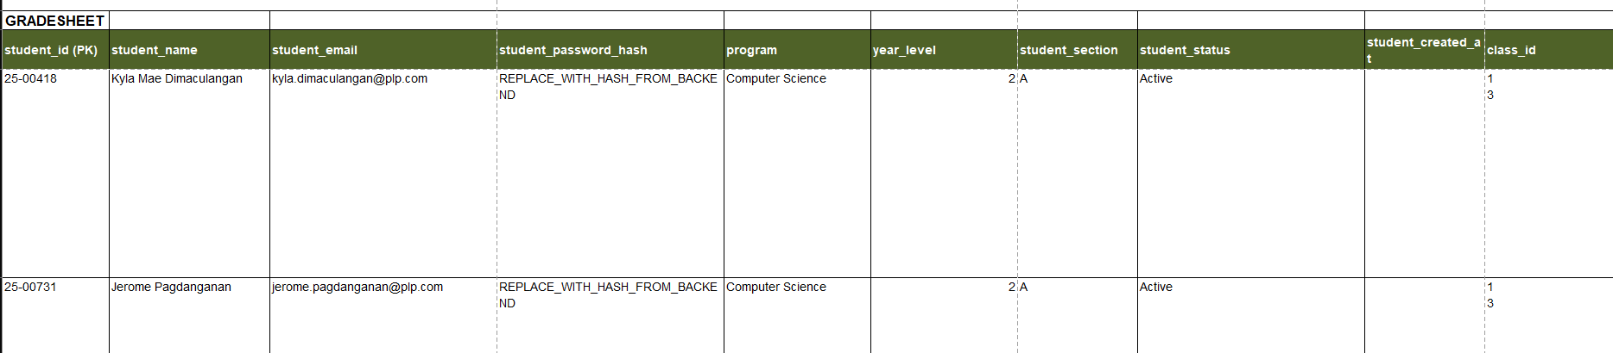
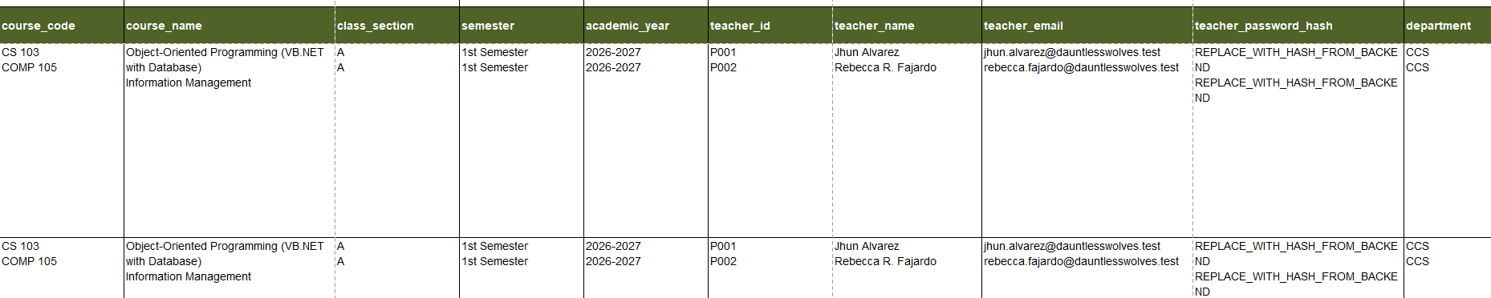
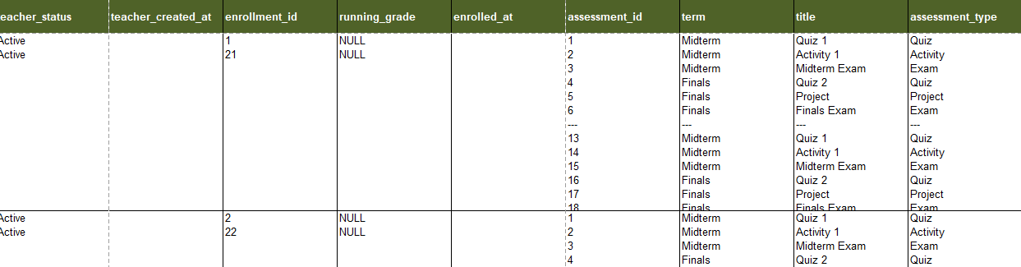
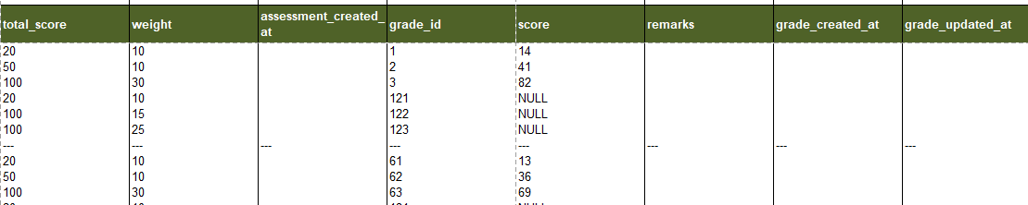
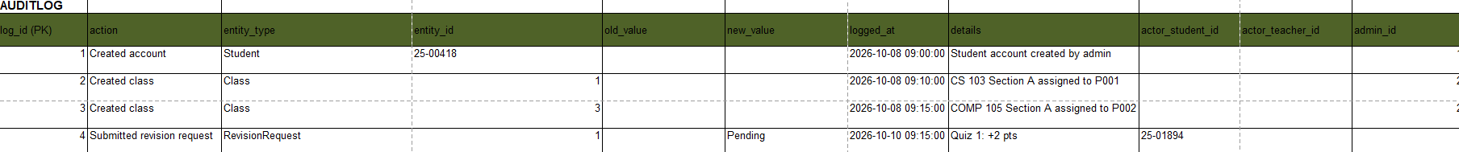
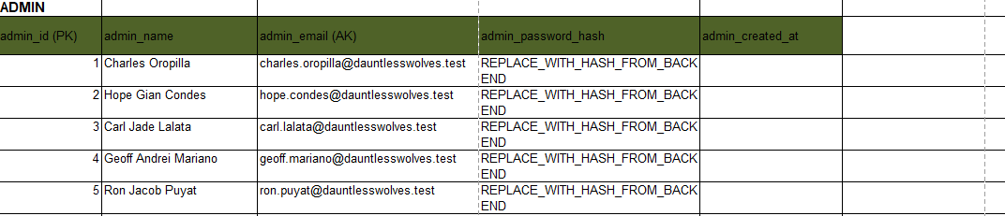

4.2 First Normal Form (1NF)

First Normal Form: flatten repeating assessment entries into one row per enrollment–assessment pair and store one value per field. Use (enrollment_id, assessment_id) as the composite candidate key for this illustrative grade relation. Keep independent request and audit histories outside this relation, since each may contain multiple records per grade.
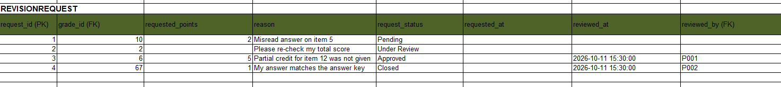
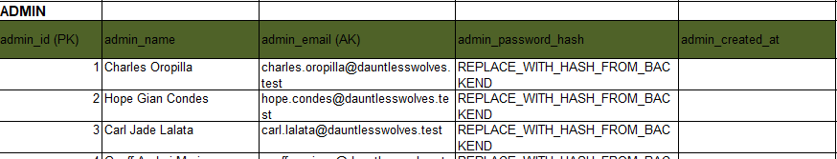
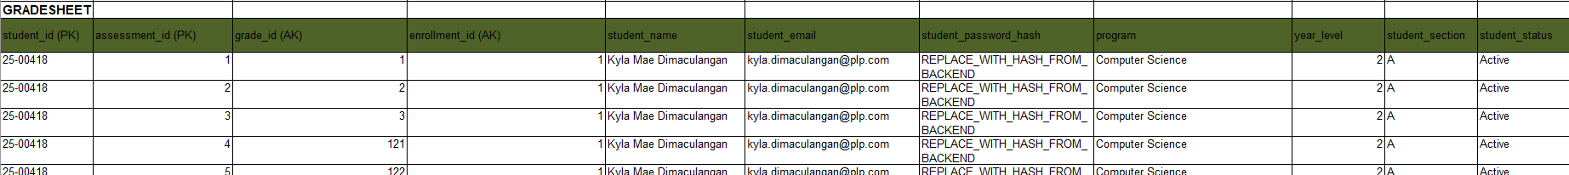
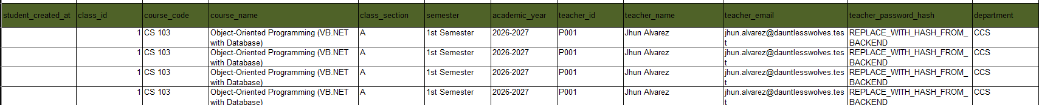
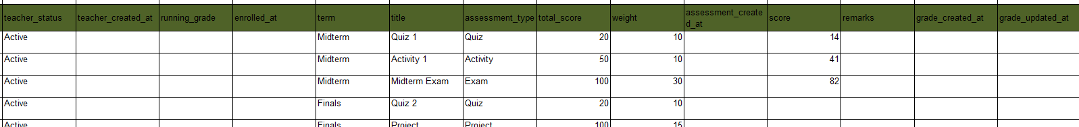

4.3 Second Normal Form (2NF)

Second Normal Form: separate attributes that depend on only part of the composite key. Enrollment attributes depend on enrollment_id; assessment definitions depend on assessment_id. The score and grade timestamps depend on the complete enrollment–assessment pair. StudentGrade uses grade_id as its implemented primary key and a UNIQUE constraint on that pair.
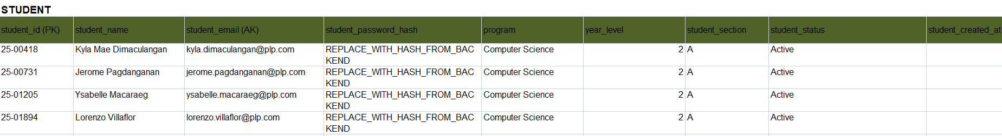
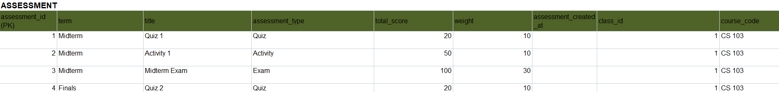
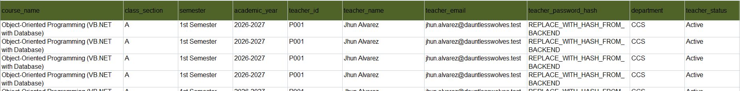
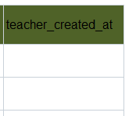
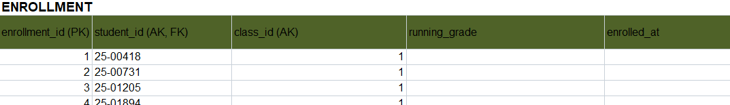
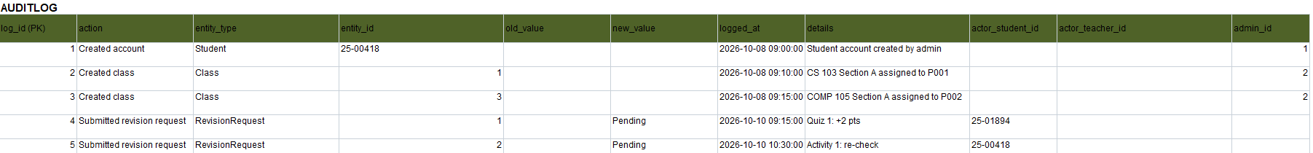
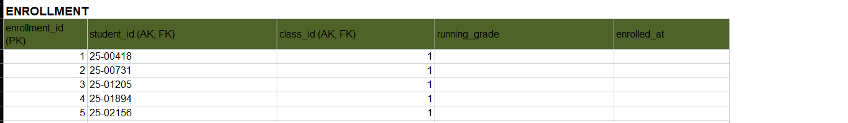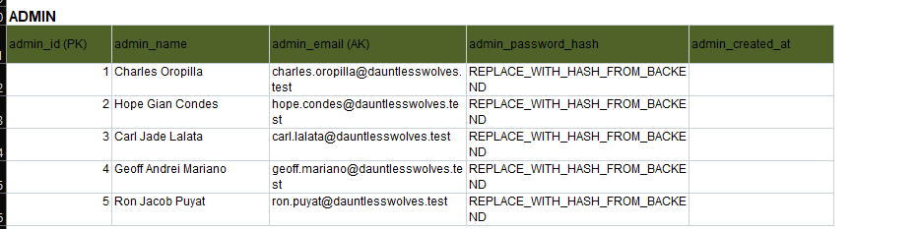
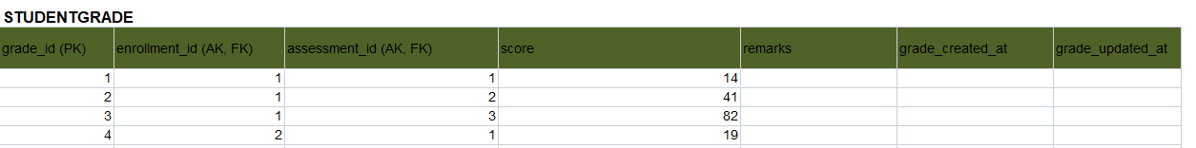

4.4 Third Normal Form (3NF)

Third Normal Form: remove transitive descriptive dependencies. Student details depend on student_id; class details on class_id; course_name on course_code; and teacher details on teacher_id. Store them in Student, Class, Course and Teacher and reference them through keys. Admin, RevisionRequest and AuditLog represent separate entities with their own keys.
Enrollment.running_grade is intentionally cached derived data rather than an independent input. The score-saving transaction maintains it; displays may recompute through the shared calculator. This controlled redundancy must be distinguished from the normalized entity relationships.
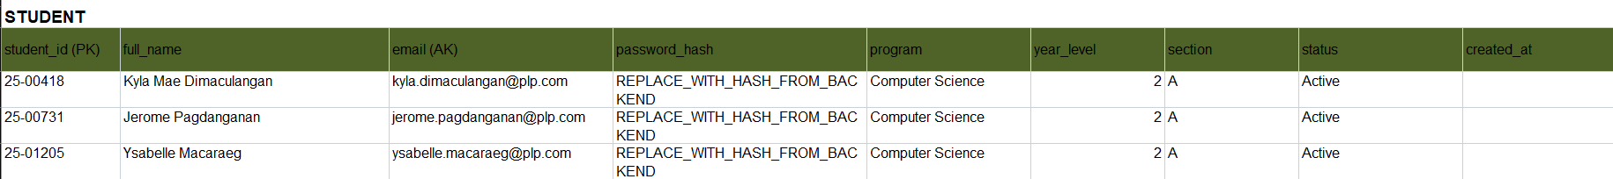
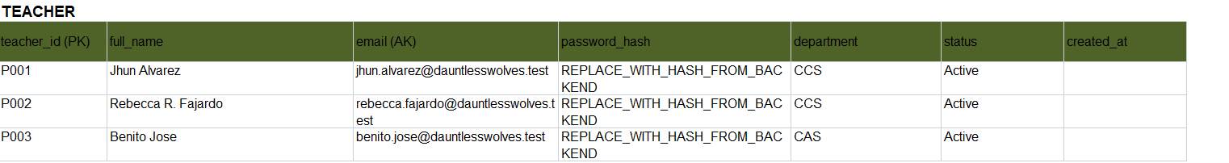
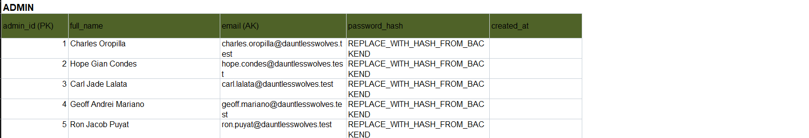
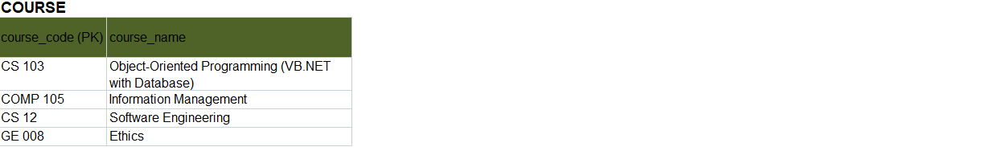
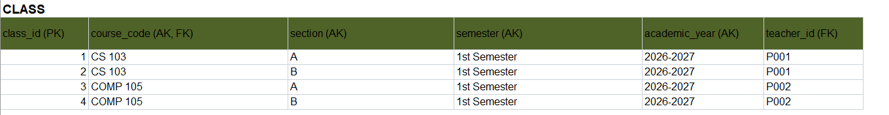

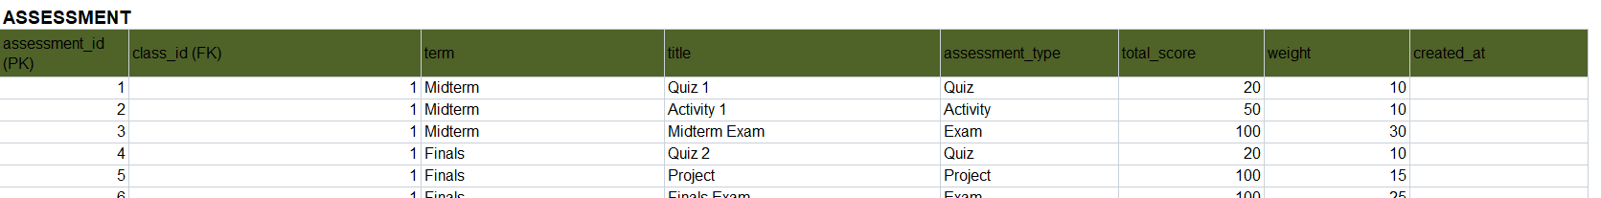
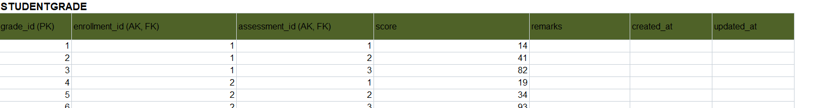
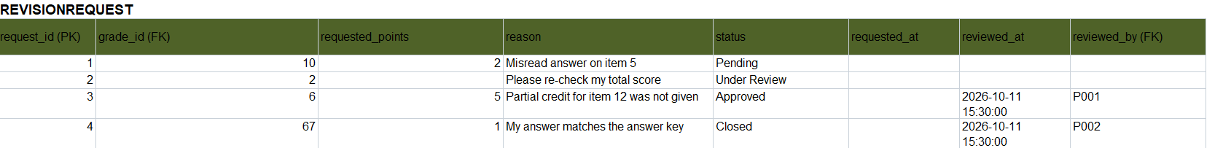
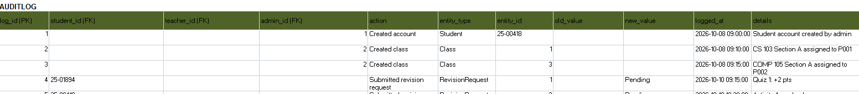

4.5 Functional Dependency Analysis
Table/Relation | Determinant | Dependent Attribute/s | Action / Normal Form Issue
Grade Sheet (UNORMALIZED) | student_id | classes, assessments, scores | Repeating groups and multi-valued cells (violates 1NF). Flattened to one row per student and assessment.
GRADE_SHEET_1NF | (enrollment_id, assessment_id) | all other columns | Minimal candidate key. 1NF satisfied: atomic values, unique rows.
GRADE_SHEET_1NF | student_id | student name, email, password_hash, program, year_level, section, status, created_at | Transitive descriptive dependency through Enrollment; isolate Student details in 3NF.
GRADE_SHEET_1NF | assessment_id | class_id, term, title, assessment_type, total_score, weight, created_at, and the class, course and teacher details | Partial dependency (2NF). Moved to Assessment.
GRADE_SHEET_1NF | enrollment_id | student_id, class_id, running_grade, enrolled_at | Partial dependency (2NF). Moved to Enrollment.
GRADE_SHEET_1NF | (enrollment_id, assessment_id) | grade_id, score, remarks, created_at, updated_at | Full dependency. Kept as StudentGrade.
Assessment (2NF) | class_id | course_code, section, semester, academic_year, teacher_id | Transitive dependency (assessment_id → class_id → class details). Moved to Class (3NF).
Class | course_code | course_name | Transitive dependency (class_id → course_code → course_name). Moved to Course (3NF).
Class | teacher_id | teacher name, email, password_hash, department, status, created_at | Transitive dependency (class_id → teacher_id → teacher details). Moved to Teacher (3NF).
Final 10 tables (see 4.6) | Each table's primary key | All other attributes of that table | Entity relations are separated by their determinants. running_grade is intentionally cached derived data maintained by the application.

4.6 Final 3NF Tables
Table Name | Primary Key | Foreign Key/s | Major Non-Key Attributes | Purpose
Student | student_id | None | full_name, email, password_hash, program, year_level, section, status, created_at | Stores student accounts. Students log in to view their grades and send revision requests.
Teacher | teacher_id | None | full_name, email, password_hash, department, employment_type, status, created_at | Stores teacher accounts. Teachers handle classes, record scores and review revision requests.
Admin | admin_id | None | full_name, email, password_hash, created_at | Stores admin accounts. Admins manage student and teacher accounts and class assignments.
Course | course_code | None | course_name | Stores the subjects offered, such as CS 103 Object-Oriented Programming.
Class | class_id | course_code (Course), teacher_id (Teacher) | section, semester, academic_year | One offering of a course for a section, semester and academic year, handled by one teacher.
Enrollment | enrollment_id | student_id (Student), class_id (Class) | running_grade, enrolled_at | Places a student in a class. Resolves the many-to-many between Student and Class. A student can enroll in a class only once.
Assessment | assessment_id | class_id (Class) | term, title, assessment_type, total_score, weight, created_at | A gradable item in a class (quiz, activity, exam, project) with its term and weight.
StudentGrade | grade_id | enrollment_id (Enrollment), assessment_id (Assessment) | score, remarks, created_at, updated_at | One student's score on one assessment. Resolves the many-to-many between Enrollment and Assessment. One score per student per assessment.
RevisionRequest | request_id | grade_id (StudentGrade), reviewed_by (Teacher) | requested_points, reason, status, requested_at, reviewed_at | Student score concern and decision; reviewer/time are populated on approval or closure, not merely Under Review.
AuditLog | log_id | student_id (Student), teacher_id (Teacher), admin_id (Admin) | action, entity_type, entity_id, old_value, new_value, logged_at, details | Permanent record of who did what. Exactly one actor ID is filled per entry.

5. Data Dictionary
Document every field in every final 3NF table. The data dictionary must match the actual MySQL implementation.
Table | Field | Data Type | Size | PK/FK | Null? | Default | Constraint | Description
Student | student_id | VARCHAR | 10 | PK | NO | - | PRIMARY KEY | Student ID number (e.g. 25-06767)
Student | full_name | VARCHAR | 100 | - | NO | - | - | Student's full name
Student | email | VARCHAR | 100 | - | NO | - | UNIQUE | School email address
Student | password_hash | VARCHAR | 255 | - | NO | - | - | Hashed login password
Student | program | VARCHAR | 100 | - | NO | - | - | Degree program (e.g. BS Computer Science)
Student | year_level | TINYINT UNSIGNED | - | - | NO | - | - | Year level of the student
Student | section | VARCHAR | 20 | - | NO | - | - | Section (e.g. BSCS 2A)
Student | status | ENUM | - | - | NO | ‘Active’ | Values: Active, Inactive | Whether the account is in use
Student | created_at | TIMESTAMP | - | - | NO | CURRENT_TIMESTAMP | - | When the record was created
Teacher | teacher_id | VARCHAR | 10 | PK | NO | - | PRIMARY KEY | Teacher ID (e.g. P001)
Teacher | full_name | VARCHAR | 100 | - | NO | - | - | Teacher's full name
Teacher | email | VARCHAR | 100 | - | NO | - | UNIQUE | School email address
Teacher | password_hash | VARCHAR | 255 | - | NO | - | - | Hashed login password
Teacher | department | VARCHAR | 50 | - | NO | - | - | Department the teacher belongs to
Teacher | employment_type | ENUM | - | - | NO | Full-time | Full-time, Part-time | Teacher employment classification
Teacher | status | ENUM | - | - | NO | ‘Active’ | Values: Active, Inactive | Whether the account is in use
Teacher | created_at | TIMESTAMP | - | - | NO | CURRENT_TIMESTAMP | - | When the record was created
Admin | admin_id | INT UNSIGNED | - | PK | NO | - | PRIMARY KEY, AUTO_INCREMENT | Admin identifier
Admin | full_name | VARCHAR | 100 | - | NO | - | - | Admin's full name
Admin | email | VARCHAR | 100 | - | NO | - | UNIQUE | Admin email address
Admin | password_hash | VARCHAR | 255 | - | NO | - | - | Hashed login password
Admin | created_at | TIMESTAMP | - | - | NO | CURRENT_TIMESTAMP | - | When the record was created
Course | course_code | VARCHAR | 20 | PK | NO | - | PRIMARY KEY | Course code (e.g. CS 103)
Course | course_name | VARCHAR | 100 | - | NO | - | - | Course title (e.g. Object Oriented Programming)
Class | class_id | INT UNSIGNED | - | PK | NO | - | PRIMARY KEY, AUTO_INCREMENT | Class identifier
Class | course_code | VARCHAR | 20 | FK | NO | - | FOREIGN KEY →Course(course_code), ON UPDATE CASCADE, ON DELETE RESTRICT;part of UNIQUE uq_class | Course this class belongs to
Class | section | VARCHAR | 20 | - | NO | - | Part of UNIQUE uq_class | Section (e.g. BSCS 2A)
Class | semester | ENUM | - | - | NO | - | Values:1st Semester, 2nd Semester; part of UNIQUE uq_class | Semester the class runs in
Class | academic_year | VARCHAR | 9 | - | NO | - | Part of UNIQUE uq_class | Academic year (e.g. 2026-2027)
Class | teacher_id | VARCHAR | 10 | FK | NO | - | FOREIGN KEY →Teacher(teacher_id),ON UPDATE CASCADE, ON DELETE RESTRICT | Teacher handling the class
Enrollment | enrollment_id | INT UNSIGNED | - | PK | NO | - | PRIMARY KEY, AUTO_INCREMENT | Enrollment identifier
Enrollment | student_id | VARCHAR | 10 | FK | NO | - | FOREIGN KEY →Student(student_id), ON UPDATE CASCADE, ON DELETE RESTRICT; part of UNIQUEuq_enrollment | Enrolled student
Enrollment | class_id | INT UNSIGNED | - | FK | NO | - | FOREIGN KEY →Class (class_id), ON UPDATE CASCADE, ON DELETE RESTRICT; part of UNIQUEuq_enrollment | Class the student is enrolled in
Enrollment | running_grade | DECIMAL | 5,2 | - | YES | NULL | - | Overall standing in the class; NULL until the first score is recorded
Enrollment | enrolled_at | TIMESTAMP | - | - | NO | CURRENT_TIMESTAMP | - | When the student was enrolled
Assessment | assessment_id | INT UNSIGNED | - | PK | NO | - | PRIMARY KEY, AUTO_INCREMENT | Assessment identifier
Assessment | class_id | INT UNSIGNED | - | FK | NO | - | FOREIGN KEY → Class(class_id), ON UPDATE CASCADE, ON DELETE CASCADE | Class the assessmentbelongs to
Assessment | term | ENUM | - | - | NO | - | Values: Midterm, Finals | Grading period
Assessment | title | VARCHAR | 100 | - | NO | - | - | Assessment name (e.g. Quiz 2)
Assessment | assessment_type | ENUM | - | - | NO | - | Values: Quiz, Activity, Exam, Project, Attendance | Kind of assessment
Assessment | total_score | DECIMAL | 6,2 | - | NO | - | CHECK (total_score > 0) | Highest possible score
Assessment | weight | DECIMAL | 5,2 | - | NO | - | CHECK (weight BETWEEN 0 AND 100) | Relative assessment weight; not an enforced category percentage
Assessment | created_at | TIMESTAMP | - | - | NO | CURRENT_TIMESTAMP | - | When the record was created
StudentGrade | grade_id | INT UNSIGNED | - | PK | NO | - | PRIMARY KEY, AUTO_INCREMENT | Grade identifier
StudentGrade | enrollment_id | INT UNSIGNED | - | FK | NO | - | FOREIGN KEY → Enrollment(enrollment_id), ON UPDATECASCADE, ON DELETECASCADE; part of UNIQUE uq_grade | Enrollment the grade belongs to
StudentGrade | assessment_id | INT UNSIGNED | - | FK | NO | - | FOREIGN KEY → Assessment(assessment_id), ON UPDATECASCADE, ON DELETECASCADE; part of UNIQUE uq_grade | Assessment being graded
StudentGrade | score | DECIMAL | 6,2 | - | YES | NULL | - | Score earned; NULL until graded
StudentGrade | remarks | VARCHAR | 255 | - | YES | NULL | - | Stored assessment remarks, maintained by score-saving logic
StudentGrade | created_at | TIMESTAMP | - | - | NO | CURRENT_TIMESTAMP | - | When the grade row was created
StudentGrade | updated_at | TIMESTAMP | - | - | NO | CURRENT_TIMESTAMP | ON UPDATECURRENT_TIMESTAMP | When the grade row was last changed
RevisionRequest | request_id | INT UNSIGNED | - | PK | NO | - | PRIMARY KEY, AUTO_INCREMENT | Request identifier
RevisionRequest | grade_id | INT UNSIGNED | - | FK | NO | - | FOREIGN KEY → StudentGrade(grad_id), ON UPDATE CASCADE, ON DELETE CASCADE | Grade being questioned
RevisionRequest | requested_points | DECIMAL | 5,2 | - | YES | NULL | - | Points asked for (e.g. 2.00); NULL for a plain re- check
RevisionRequest | reason | VARCHAR | 255 | - | NO | - | - | Student's reason for the request
RevisionRequest | status | ENUM | - | - | NO | ‘Pending’ | Values: Pending, Under Review, Approved,Closed | Where the request stands
RevisionRequest | requested_at | TIMESTAMP | - | - | NO | CURRENT_TIMESTAMP | - | When the request was filled
RevisionRequest | reviewed_at | TIMESTAMP | - | - | YES | NULL | - | Approval or closure time; NULL before a final decision
RevisionRequest | reviewed_by | VARCHAR | 10 | FK | YES | NULL | FOREIGN KEY → Teacher(teacher_id), ON UPDATE CASCADE, ON DELETE SET NULL | Teacher who approved or closed the request; nullable
AuditLog | log_id | BIGINT UNSIGNED | - | PK | NO | - | PRIMARY KEY, AUTO_INCREMENT | Log entry identifier
AuditLog | student_id | VARCHAR | 10 | FK | YES | NULL | FOREIGN KEY → Student(student_id), ON DELETE RESTRICT; CHECK exactly one actor | Student who did the action
AuditLog | teacher_id | VARCHAR | 10 | FK | YES | NULL | FOREIGN KEY → Teacher(teacher_id), ON DELETE RESTRICT; CHECK exactly one actor | Teacher who did the action
AuditLog | admin_id | INT UNSIGNED | - | FK | YES | NULL | FOREIGN KEY → Admin(admin_id), ON DELETE RESTRICT; CHECK exactly one actor | Admin who did the action
AuditLog | action | VARCHAR | 100 | - | NO | - | - | What was done (e.g. Grade updated)
AuditLog | entity_type | VARCHAR | 50 | - | NO | - | INDEX idx_entity | Kind of record affected (not a foreign key)
AuditLog | entity_id | VARCHAR | 20 | - | NO | - | INDEX idx_entity | ID of the record affected (not a foreign key)
AuditLog | old_value | VARCHAR | 100 | - | YES | NULL | - | Value before a score  change (e.g. 16/20)
AuditLog | new_value | VARCHAR | 100 | - | YES | NULL | - | Value after a score change (e.g. 18/20)
AuditLog | logged_at | TIMESTAMP | - | - | NO | CURRENT_TIMESTAMP | - | When the action was recorded
AuditLog | details | VARCHAR | 500 | - | YES | NULL | - | Extra notes about the action

6. MySQL Database Implementation
Implement the approved 3NF design in MySQL/MariaDB. The implementation must be consistent with the ERD and data dictionary.

6.1 Database Creation

Database name used in the supplied SQL dump: centralized_and_transparent_grading_system.
CREATE DATABASE IF NOT EXISTS centralized_and_transparent_grading_system CHARACTER SET utf8mb4 COLLATE utf8mb4_unicode_ci;
USE centralized_and_transparent_grading_system;
The Database value in dbconfig.json must exactly match the imported database. The application fallback name is different, so explicitly configure it rather than relying on defaults.
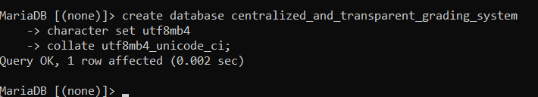

6.2 DDL – Table Creation

The screenshots below document the ten implemented tables. Use the supplied SQL dump as the executable source for exact definitions, constraints and sample rows. It contains teacher.employment_type, which is also included in the completed data dictionary. Database foreign keys enforce relationships; cross-table score limits, class ownership and request transitions are checked by the application.
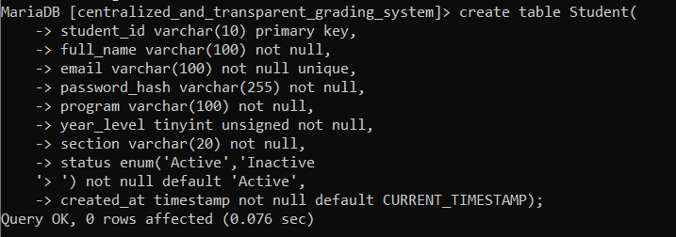
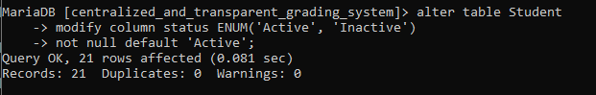
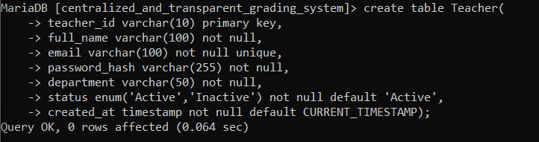
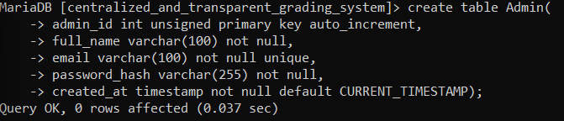
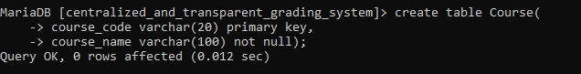
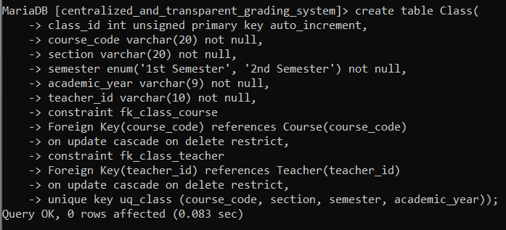
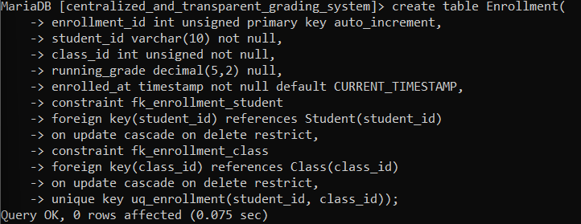
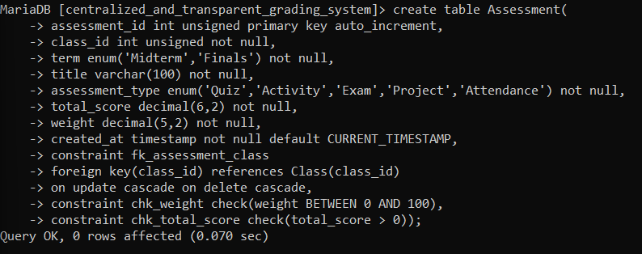
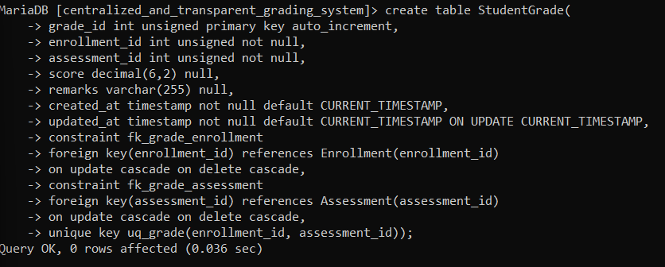
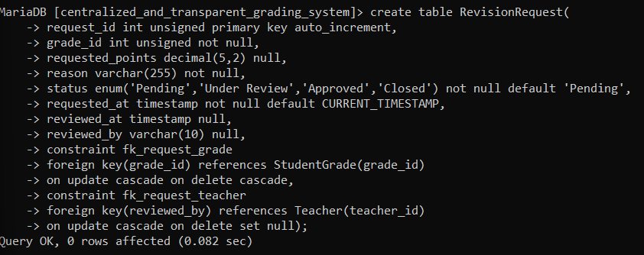
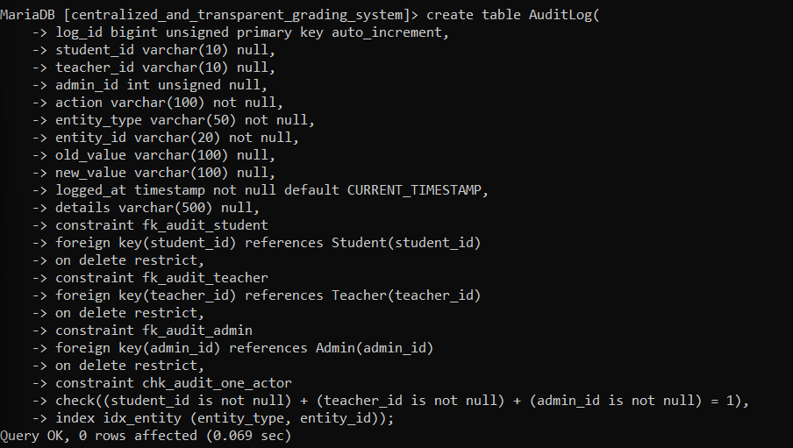

6.3 DML – Sample Data

Import the supplied SQL dump into a disposable or project database using MySQL/MariaDB tools. It includes fictional sample accounts, class offerings, enrollments, assessments, scores, requests and audits. Some seeded passwords are placeholders and must be initialized through an approved account setup procedure before login; do not use placeholder hash text as a password. CSV imports require registered active students and do not create accounts.
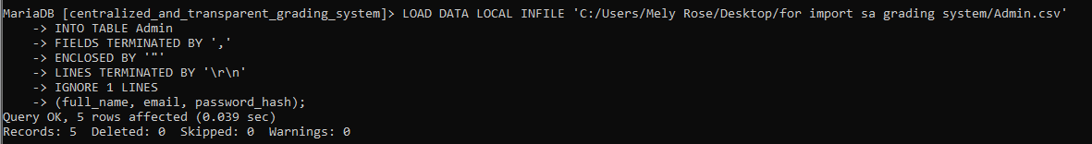
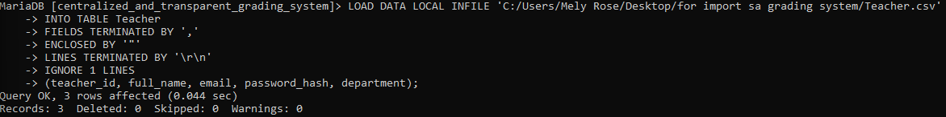
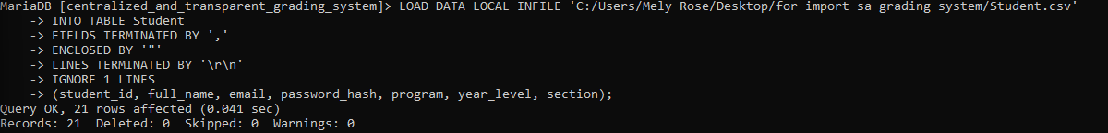
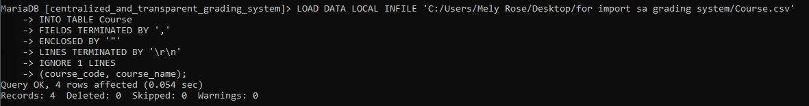
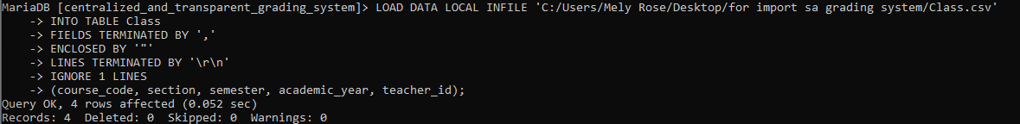
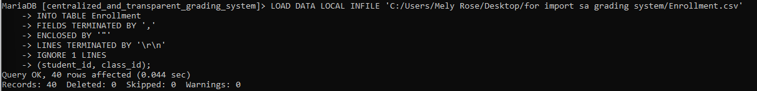
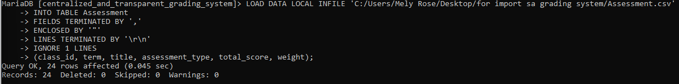
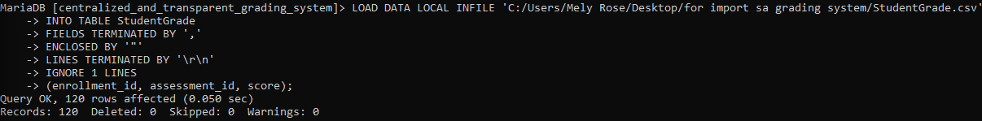
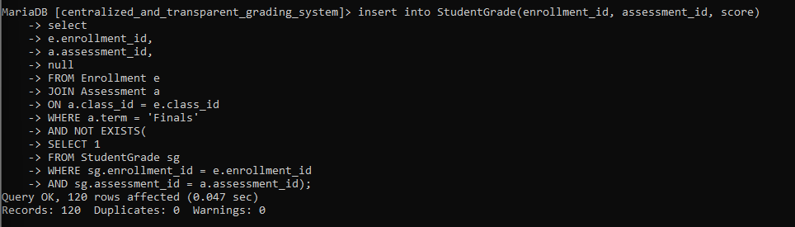
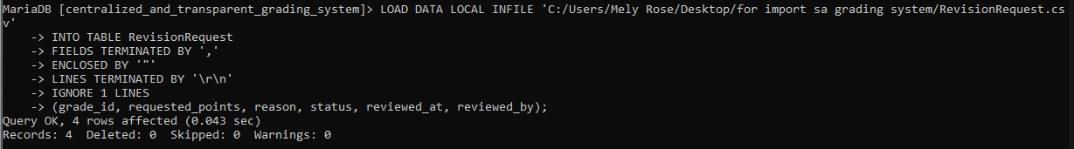
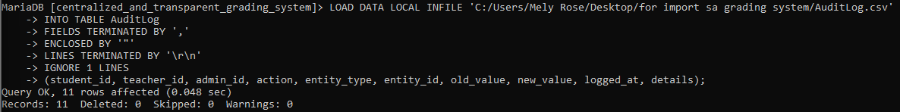

6.4 Required Queries

Examples below supplement the existing query screenshots. Replace parameter values through bound parameters in application code.
SELECT s.student_id, s.full_name, c.course_code, c.section FROM enrollment e JOIN student s ON s.student_id=e.student_id JOIN class c ON c.class_id=e.class_id WHERE e.class_id=@ClassId ORDER BY s.full_name;
SELECT e.enrollment_id, ROUND(SUM(sg.score/a.total_score*a.weight)/SUM(a.weight)*100,2) AS running_grade FROM enrollment e JOIN studentgrade sg ON sg.enrollment_id=e.enrollment_id JOIN assessment a ON a.assessment_id=sg.assessment_id AND a.class_id=e.class_id WHERE e.class_id=@ClassId AND sg.score IS NOT NULL AND a.total_score>0 AND a.weight>0 GROUP BY e.enrollment_id HAVING running_grade<75;
SELECT r.request_id,r.status,r.requested_at,s.full_name,a.title FROM revisionrequest r JOIN studentgrade sg ON sg.grade_id=r.grade_id JOIN enrollment e ON e.enrollment_id=sg.enrollment_id JOIN student s ON s.student_id=e.student_id JOIN assessment a ON a.assessment_id=sg.assessment_id WHERE r.status IN ('Pending','Under Review') ORDER BY r.requested_at DESC;
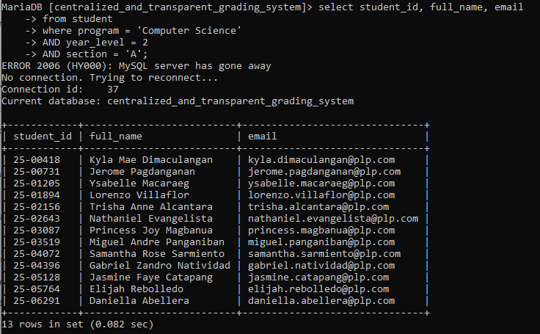

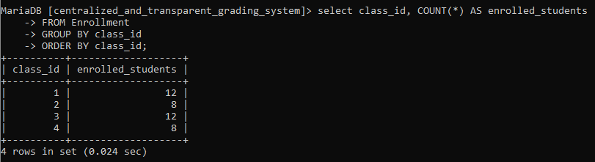

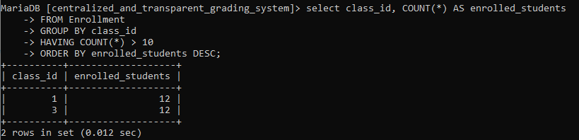

6.5 Database Evidence

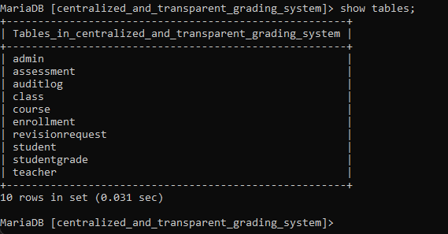
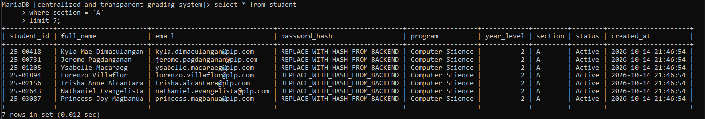
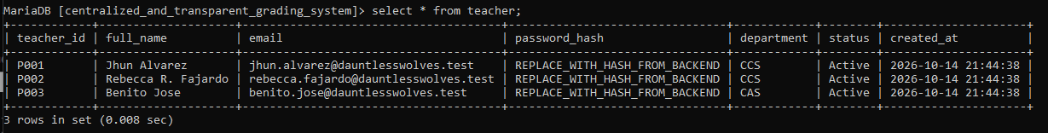
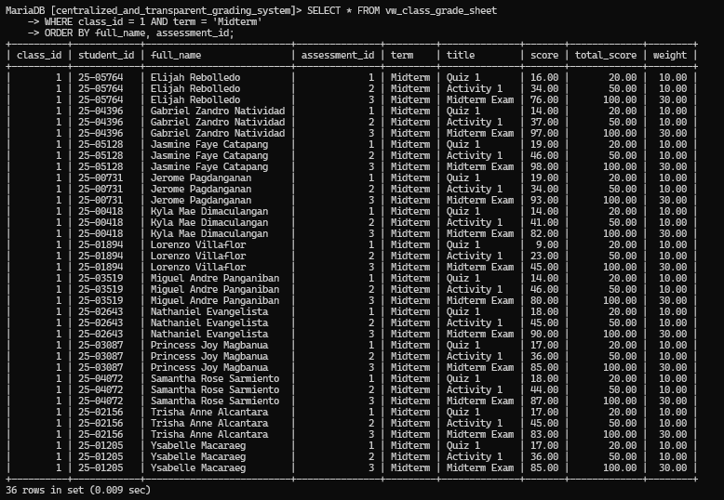
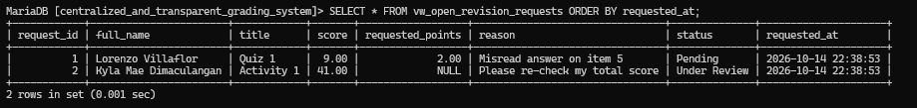
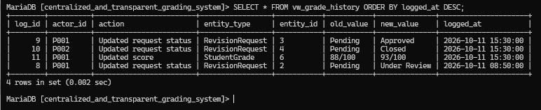

7. VB.NET System Implementation
Develop a working VB.NET front-end connected to the MySQL database. The interface must support the approved project scope and enforce relevant business rules.

7.1 Reports / Outputs

7.1 Reports / Outputs
Professor
- Class Grade Sheet: displays students' assessment scores, running grades, and academic status. It can be filtered and exported as a PDF.
- Class Performance Summary (Analytics): displays the class average, number of passing students, number of at-risk students, and highest grade.
- Averages by Assessment Type: displays average scores for quizzes, activities, examinations, and projects using progress bars.
- Audit Log – Recent Changes: records score updates and request status changes, including the affected student, item, date and time, and user responsible. It can be exported as a PDF.
- Digital Gradebook: displays persisted raw assessment scores, percentages and shared weighted running grades. It supports PDF export; legacy worksheet-only inputs with incompatible calculations are hidden.
- Student Grade Record: displays a selected student's assessment scores and allows professors to record scores and recalculate grades.
- Clarification Requests: displays students' grade clarification requests, including the assessment, current score, requested adjustment, reason, and request status.
Student
- My Grades (Grade Report): displays assessment scores, relative weights, running grades, and academic status. Students can filter grades by midterm, finals, or combined results and select a course.
- Grade History: displays recorded grade changes, including the date, assessment, old score, new score, person responsible, and reason.
- My Performance Overview: displays the current average, activities passed, open clarification requests, and highest score. Progress bars show performance in quizzes, activities, examinations, and projects.
- Clarification Request Status: displays submitted requests, including the course, assessment, requested action, and current status. It also shows the reviewer's response.
- Student Profile: a read-only dialog shows student ID, name, email, program, year, section, status, enrolled-class count, open-request count and current per-class grades and standing. Open requests include Pending and Under Review.
- Change Password: students can change their own password; teachers also have a Change Password button beside Log out. Both require the current password and use the existing hashing and audit service.
Admin
- Admin Dashboard: displays student, professor and class counts, open-request count and recent updates. The Active Classes caption reflects the available class count; there is no class active/inactive status field.
- Student Records: displays student IDs, full names, year levels, sections, programs, and account statuses. Administrators can add, edit, search, filter, and delete student records.
- Professor Records: displays professor names, employee IDs, departments, assigned classes, employment types, and account statuses. Administrators can add, edit, search, filter, and delete professor records.
- Class/Subject Management: allows administrators to create classes by entering the subject code, subject name, section, assigned professor, semester, and academic year.
- Grade Entry: allows administrators to select a student, subject, and assessment before entering and saving grades.
- Clarification Requests: read-only administrative overview with request and review dates, reasons, teacher responses, offering/status filters and CSV/PDF exports. Administrators do not decide these requests here.
- Audit Logs: records administrative and system activities, including the user responsible, action performed, affected entity, previous and updated values, date, time, and additional details. Records can be filtered and exported as CSV or PDF.

7.2 System Screenshots

STUDENT
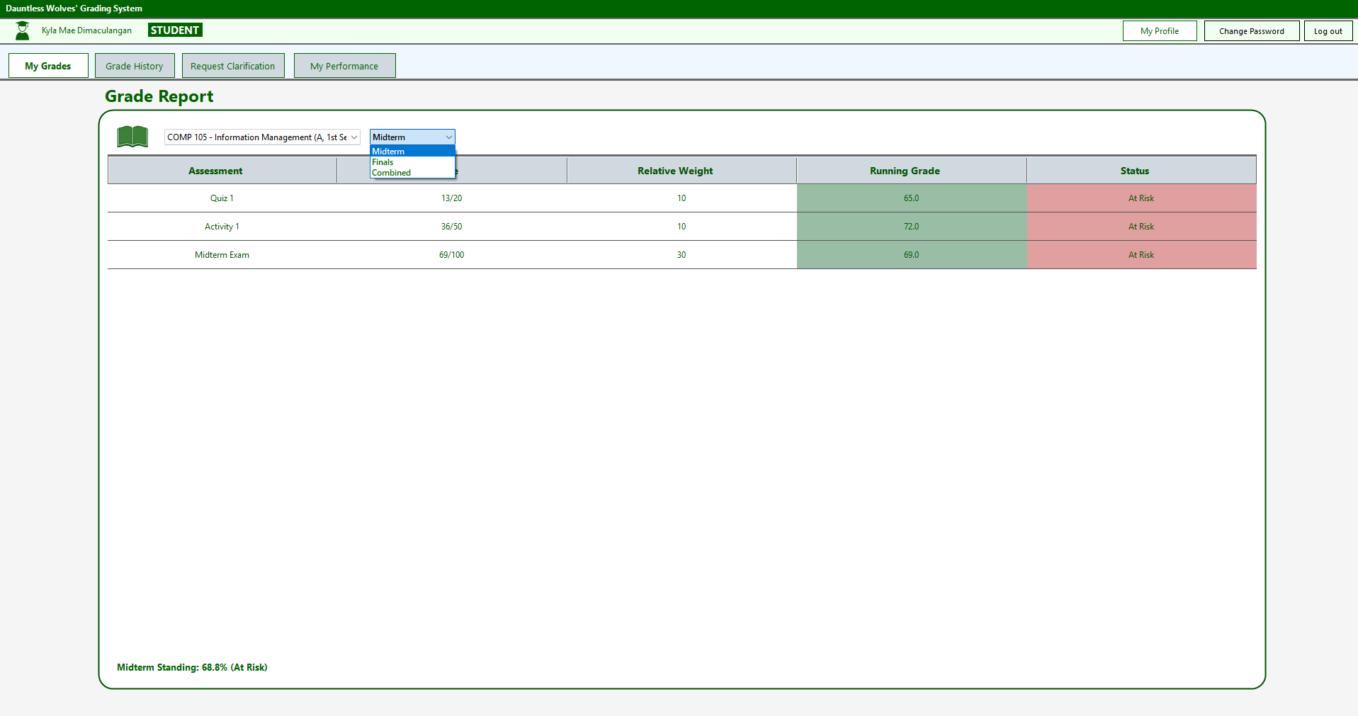
My Grades – View grades for quizzes, activities, exams, and projects. Include Midterm, Finals, and Combined views, running grades, assessment weights, and academic standing.
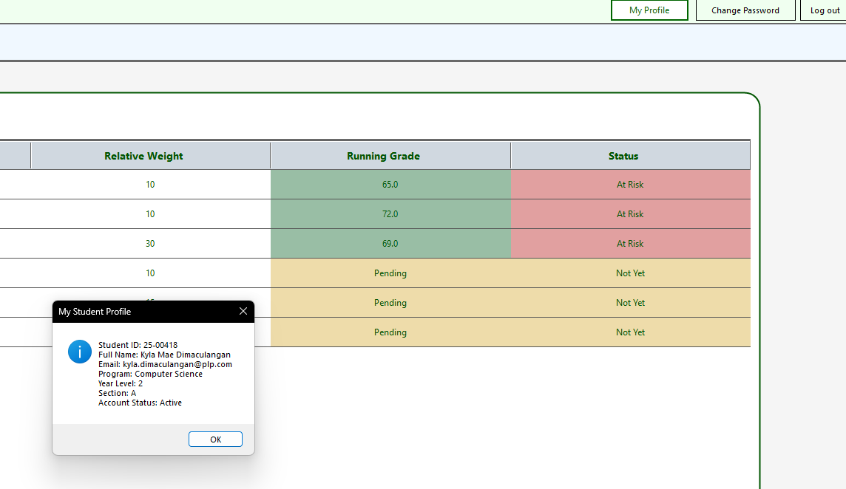

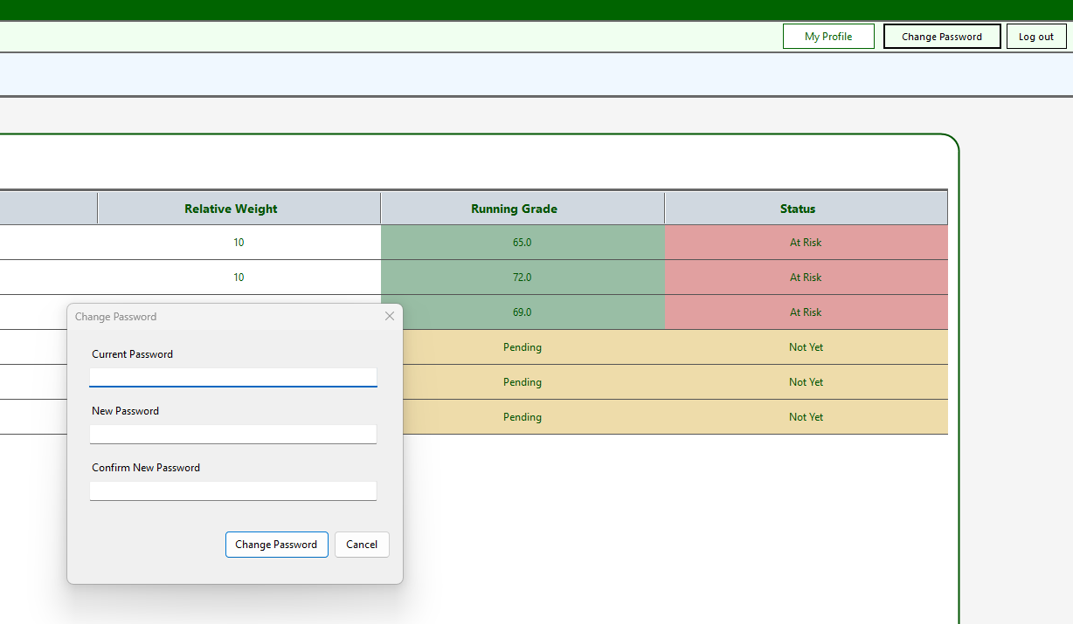
My Profile & Account Security – View student information and change the account password, with confirmation and validation.
Student profile: click My Profile to view personal details, enrolled classes, open requests and per-class standing. Click Refresh to reload current records, or Close/Escape to return. This form is read-only.
Professor password: click Change Password beside Log out; enter the current password, a new password of at least four characters, and matching confirmation. Click Change password. On success, use the new password at the next login. Cancel/Escape makes no change.

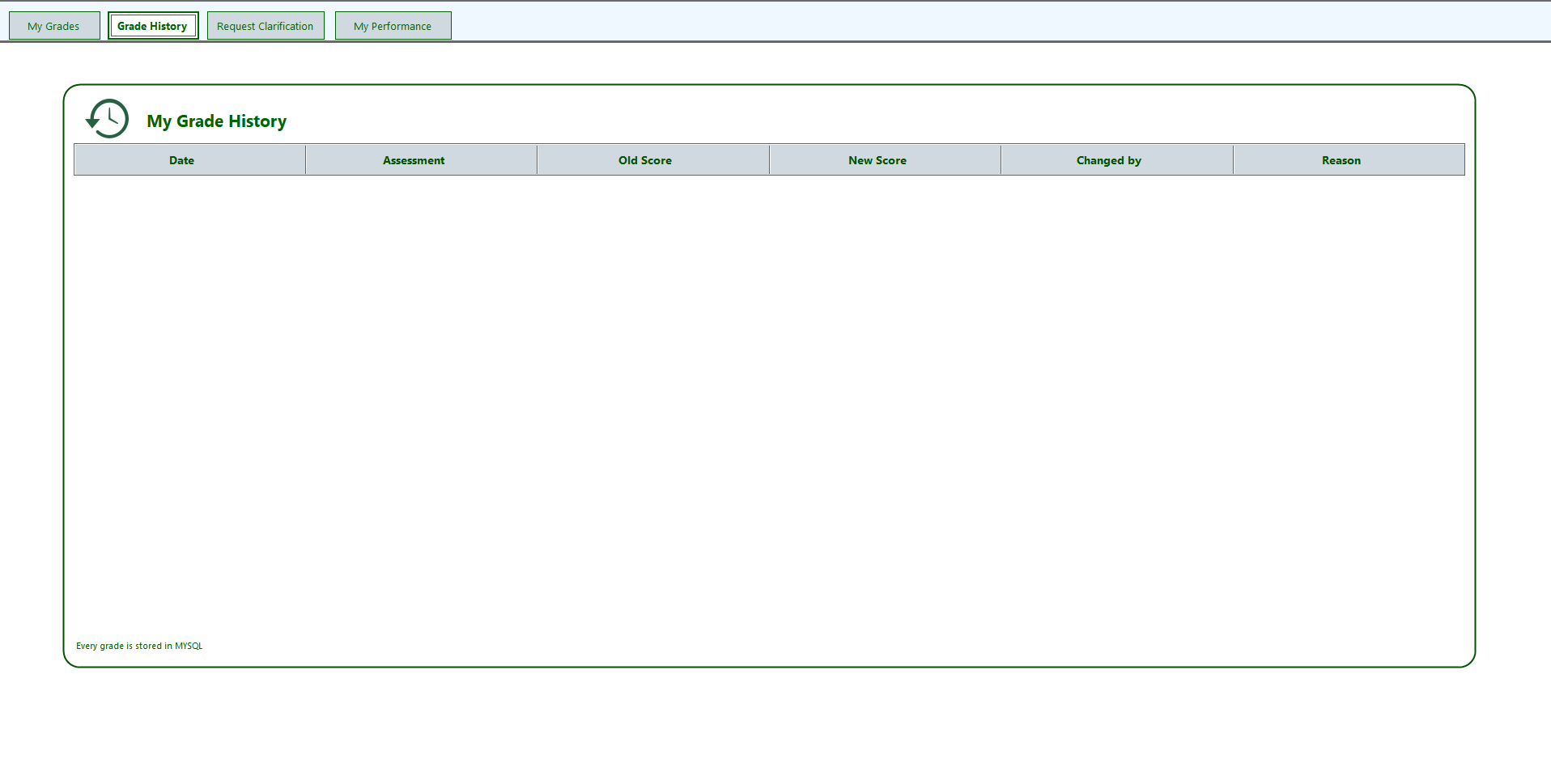
Grade History – View changes to grades, including the date, assessment, old score, new score, person who changed the grade, and reason.
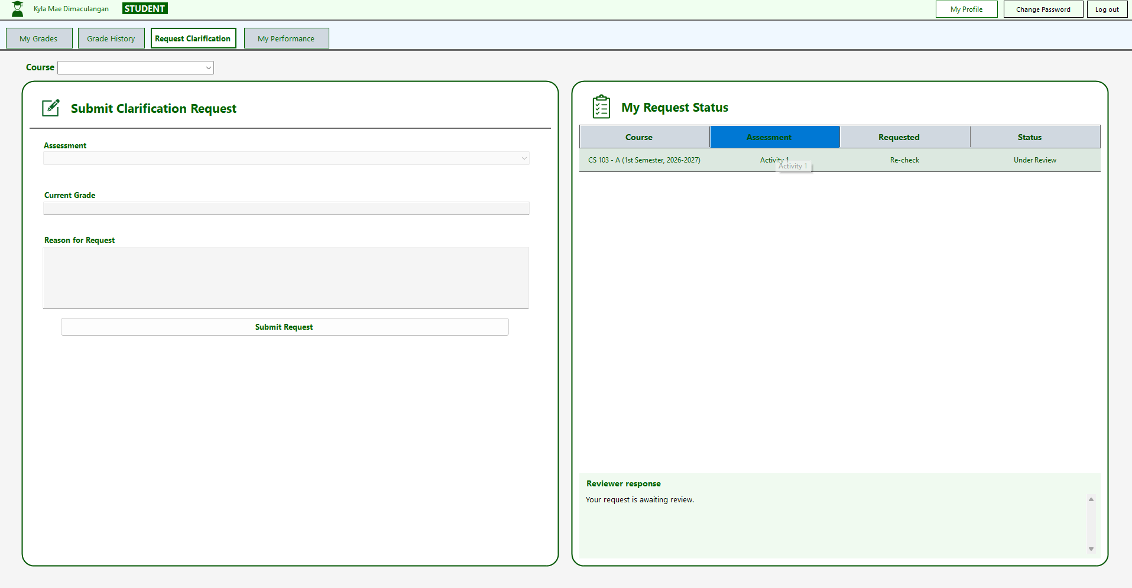
Request Clarification – Submit requests for grade rechecks, select a course and assessment, provide the current grade and reason, and track request status and reviewer responses.
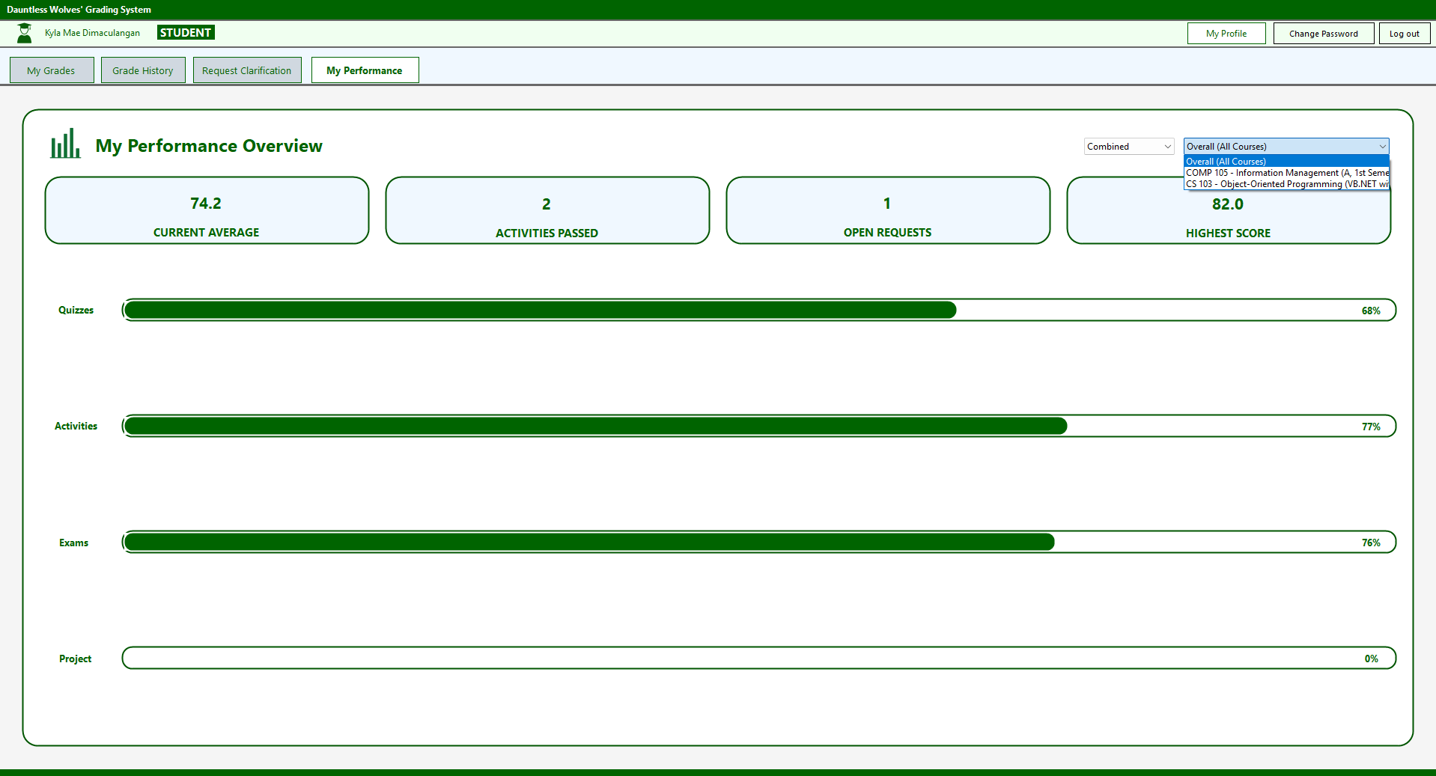
My Performance – Display the student's current average, activities passed, open requests, highest score, and performance percentages for quizzes, activities, exams, and projects.
PROFESSOR
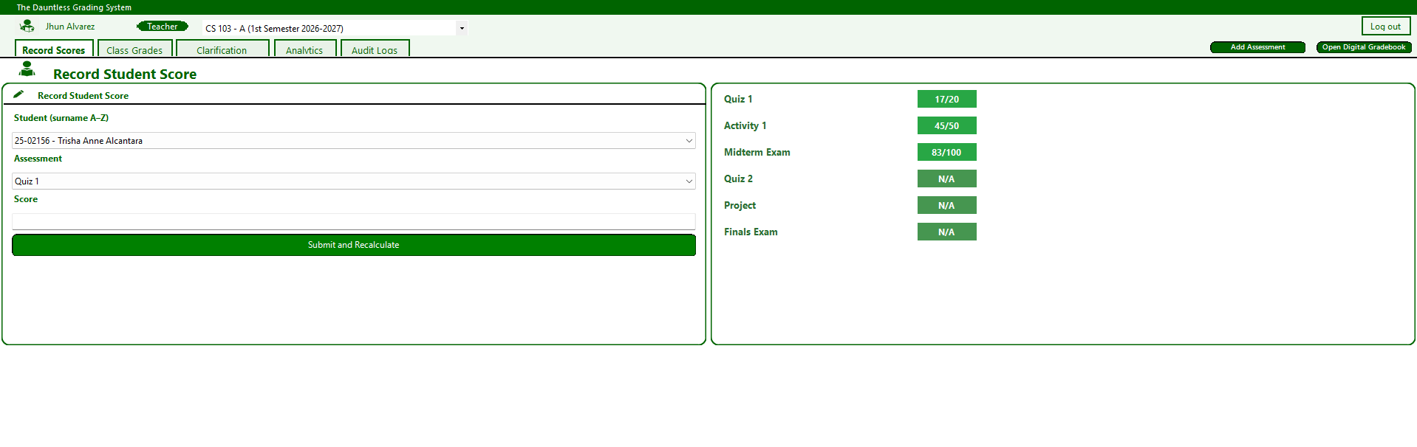
Record Student Score
Allows professors to select a student, choose an assessment, enter scores, and recalculate grades automatically.

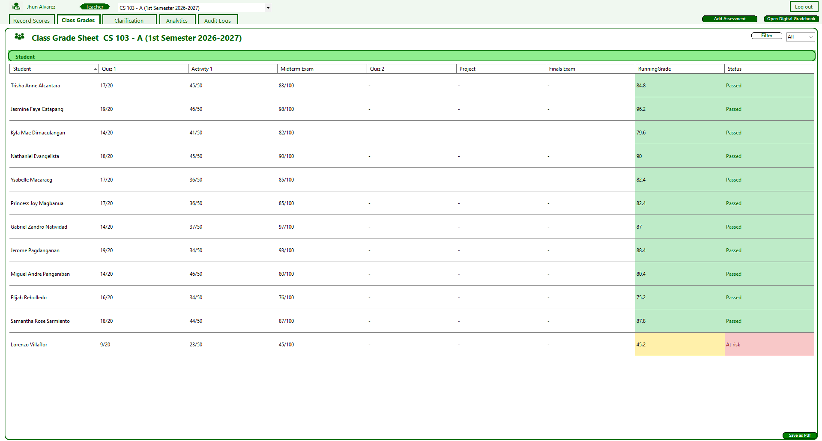
Class Grade Sheet
Displays students' assessment scores, running grades, and academic status. Professors can filter records and export the grade sheet as a PDF.

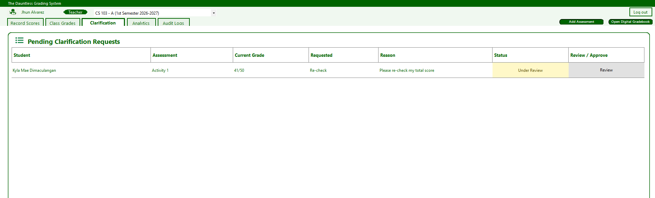
Pending Clarification Requests
Displays students' grade clarification requests, including assessment details, current grades, requested adjustments, reasons, and request statuses. Professors can review and approve requests.

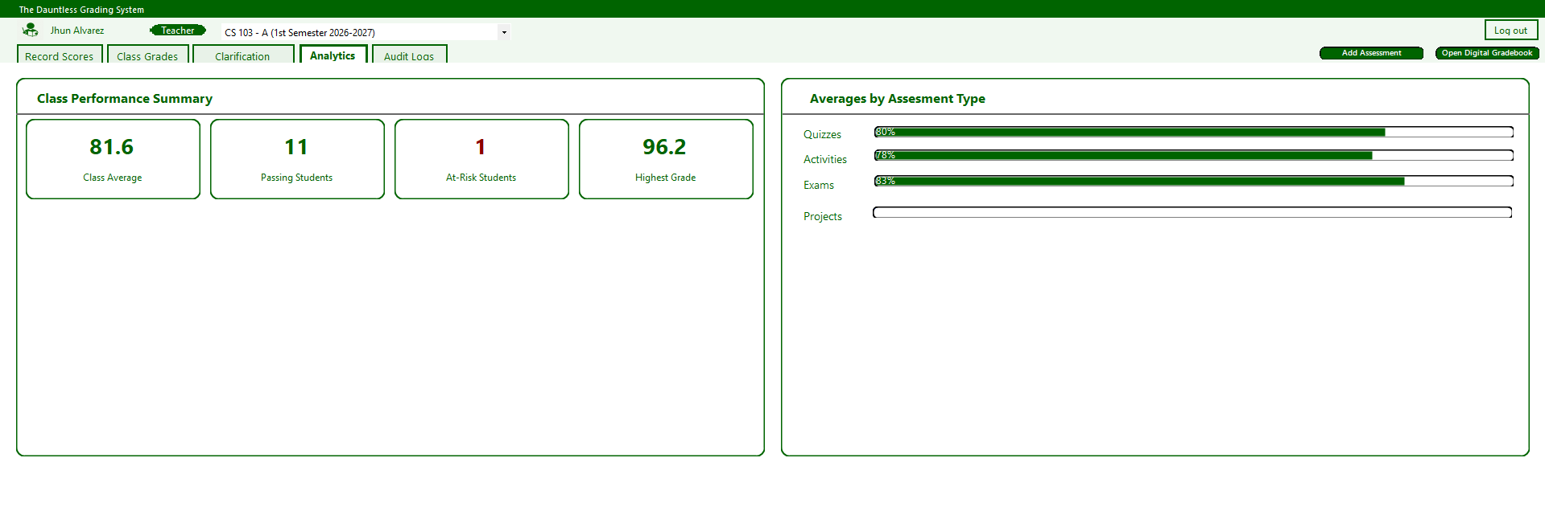
Analytics
Displays the class average, number of passing students, at-risk students, and highest grade. Progress bars summarize average performance by assessment type.
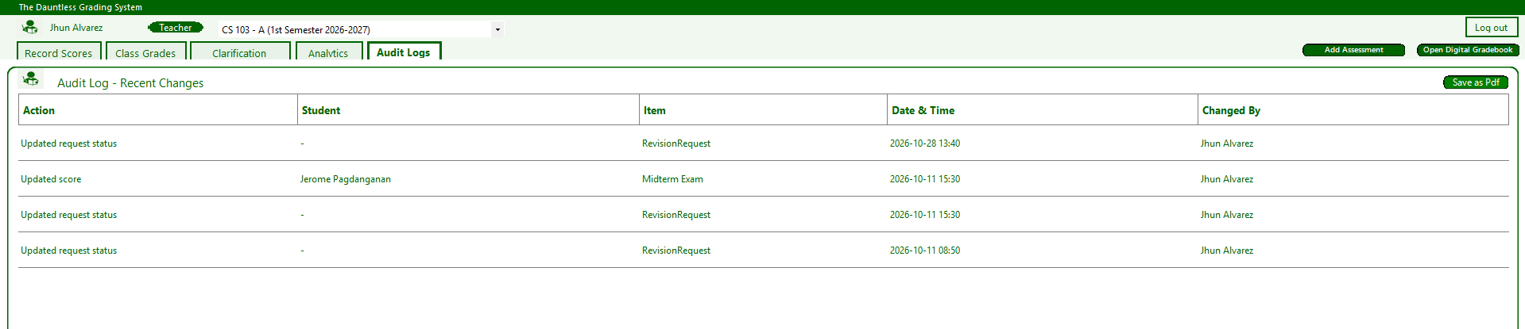
Audit Log
Records score updates and clarification request status changes, including the affected student, assessment, date and time, and responsible user. Records can be exported as a PDF.

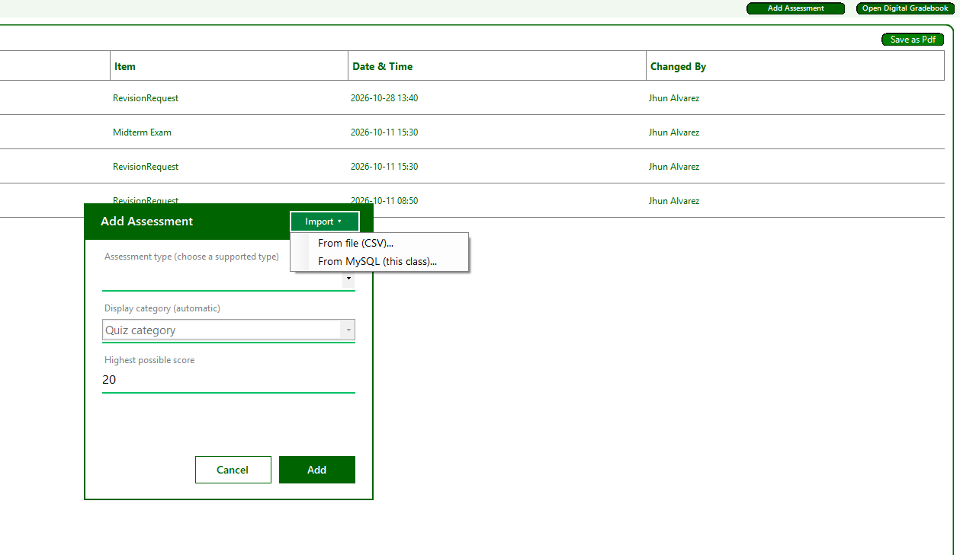
Add Assessment: create Quiz, Activity, Exam, Project or Attendance items with maximum score, Midterm/Finals period and relative weight. Assessment definitions can be imported from CSV; database refresh reloads existing configured records rather than creating an external integration.
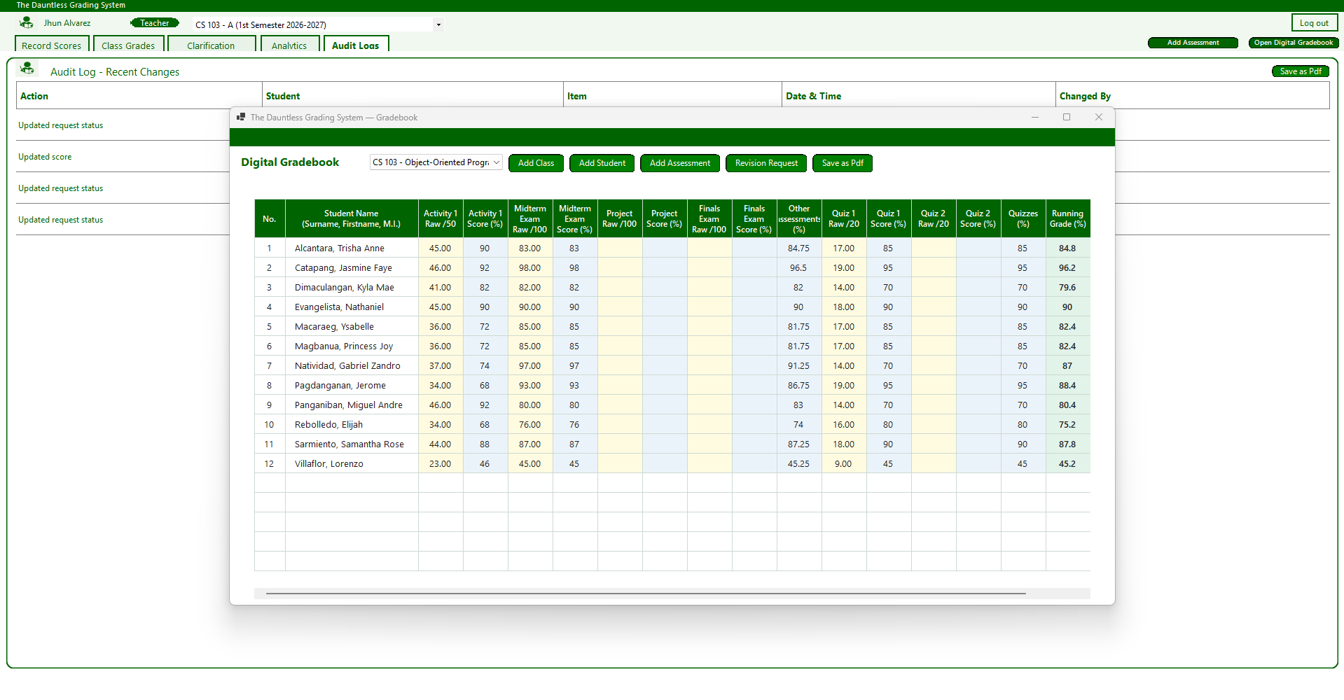
Digital Gradebook
Displays students' raw scores, percentage scores, and running grades in a spreadsheet-style layout. Professors can manage classes, students, and assessments, handle revision requests, and export the gradebook as a PDF.
ADMIN
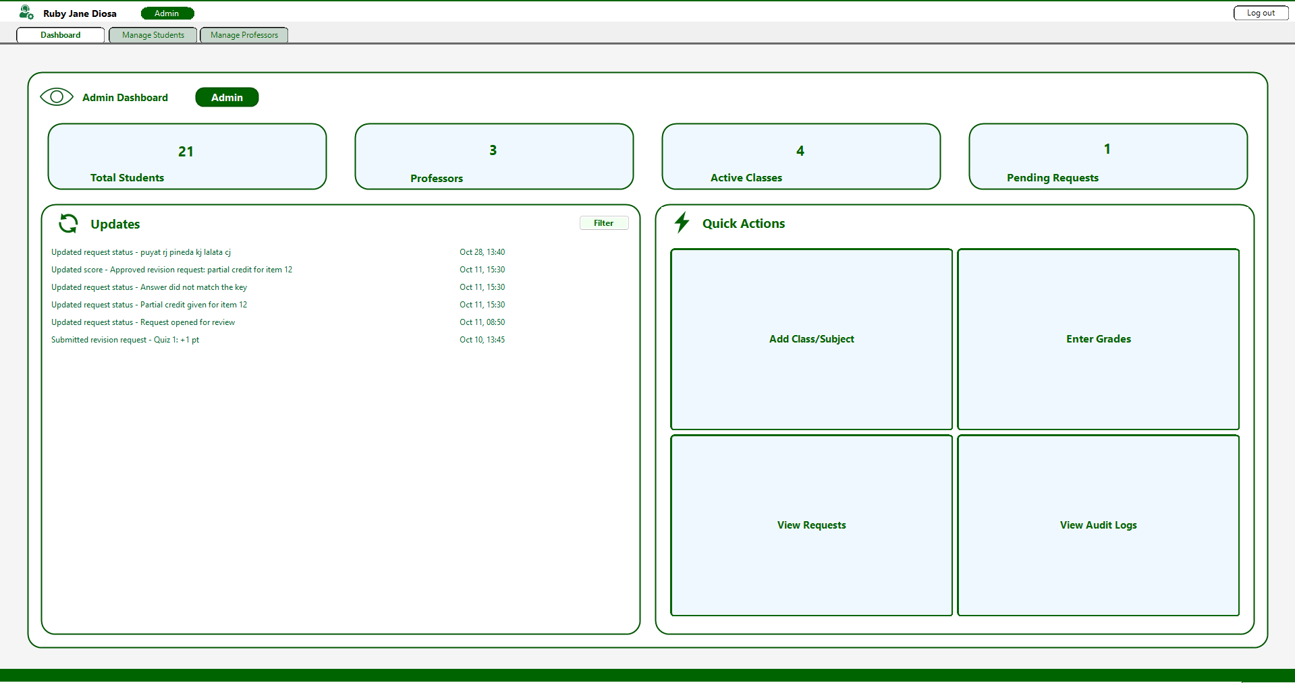
Admin Dashboard
Displays system statistics, recent updates, and quick actions for managing classes, grades, clarification requests, and audit logs.

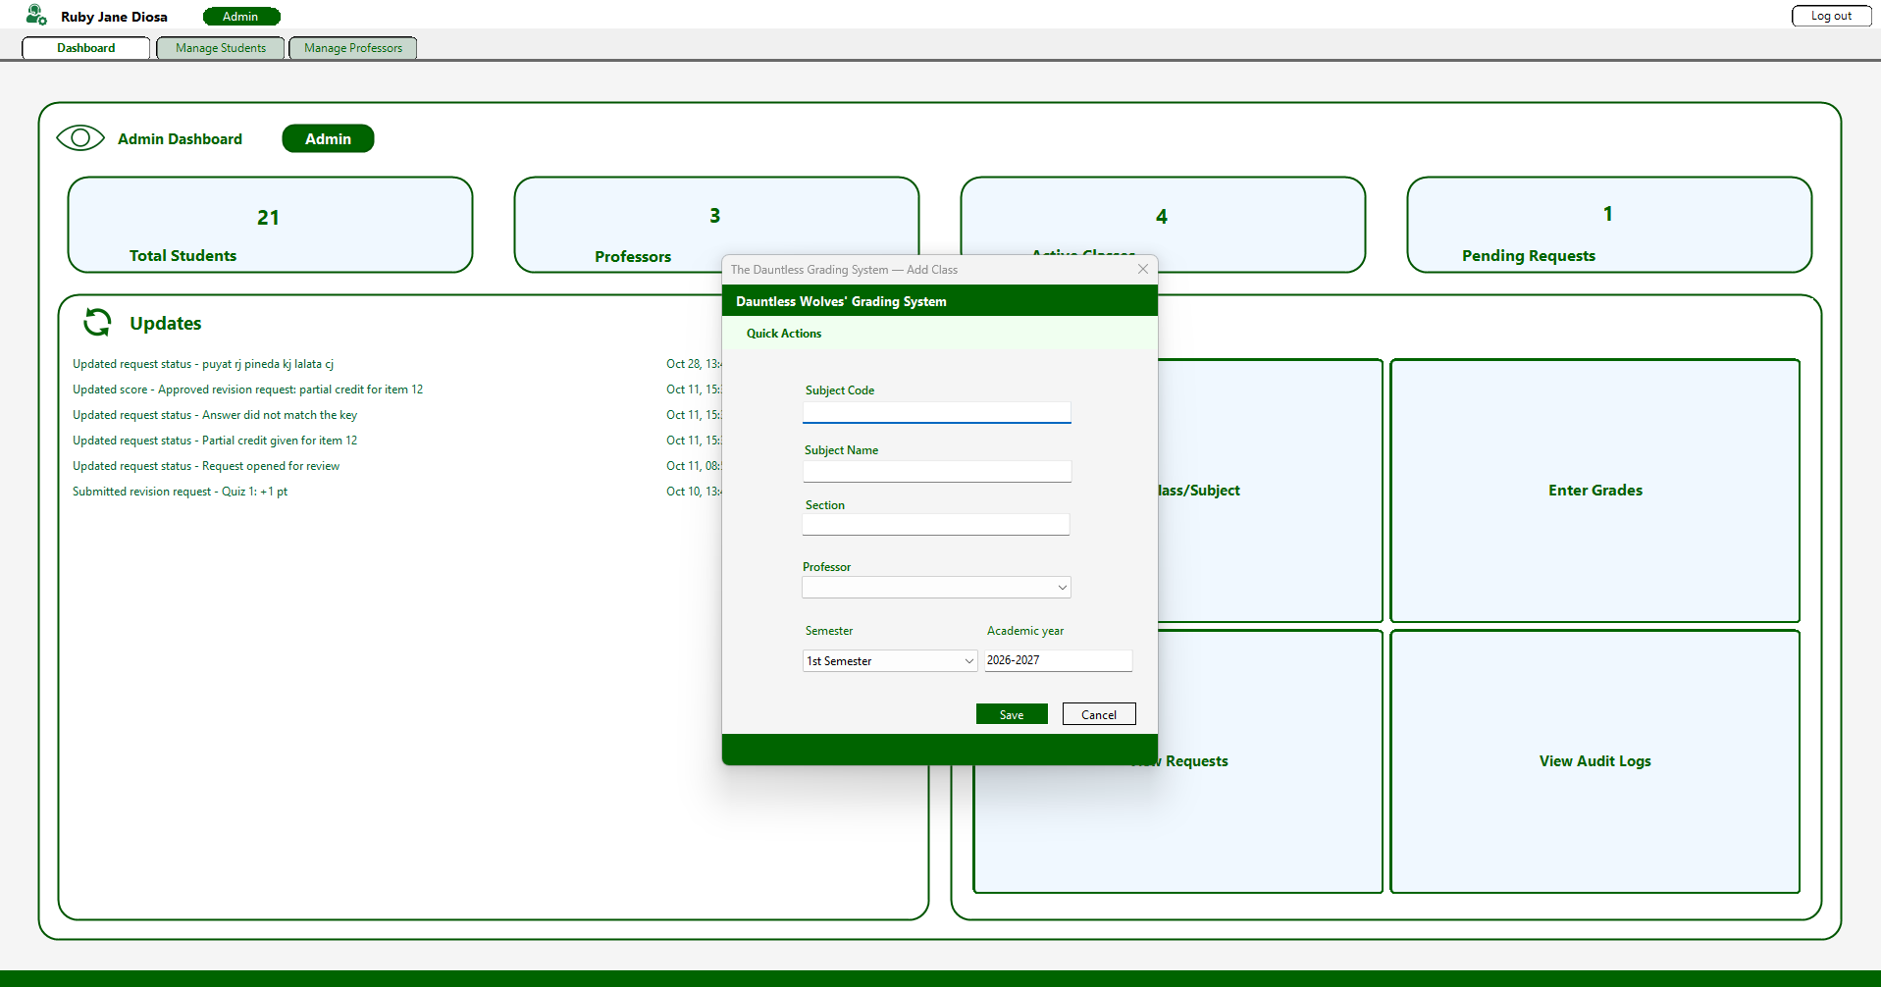
Enter Grade
Allows administrators to insert the grade of each student specific of the matching course with the ability to choose which semester.

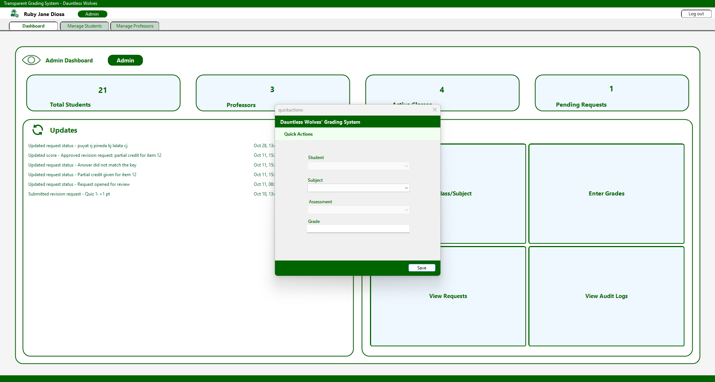
Add Class/Subject
Allows administrators to create classes by specifying subject details, sections, professors, semesters, and academic years.

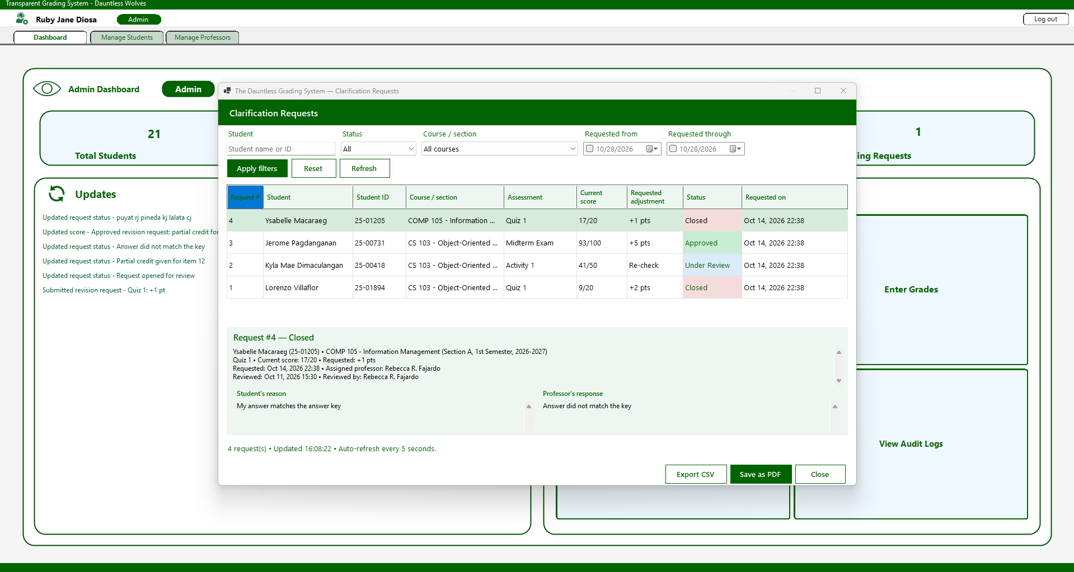
Clarification Requests
Displays students' grade clarification requests, including scores, requested adjustments, and request statuses.

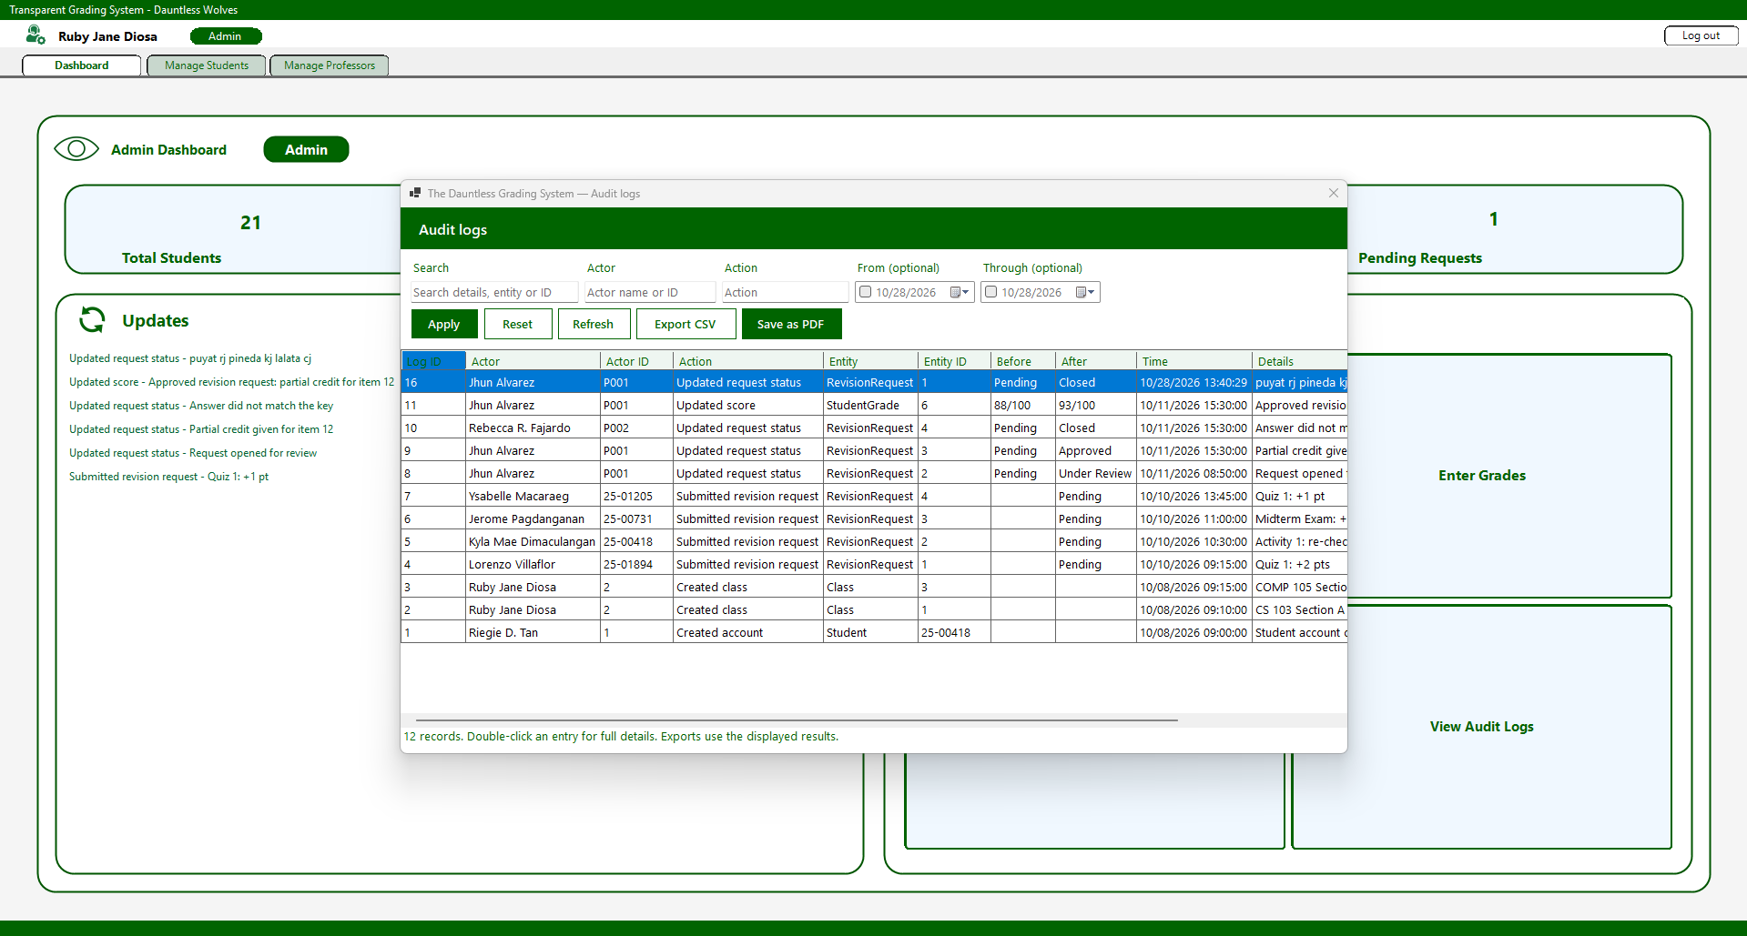
Audit Logs
Records system activities, including changes made, affected records, timestamps, and details. Administrators can also export logs to CSV or PDF.

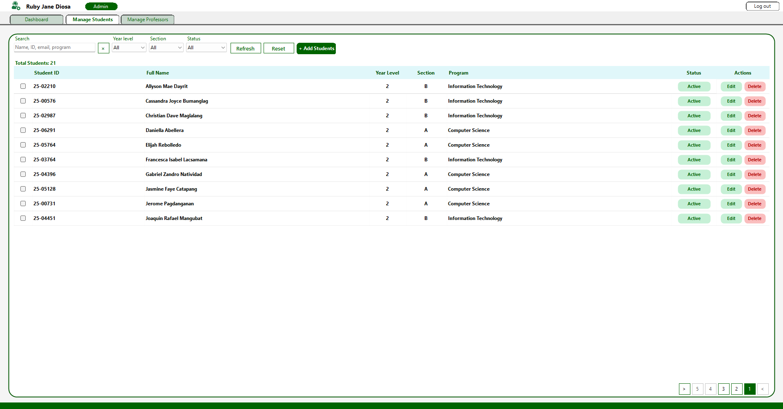
Manage Students
Allows administrators to search, filter, add, edit, and delete student records.

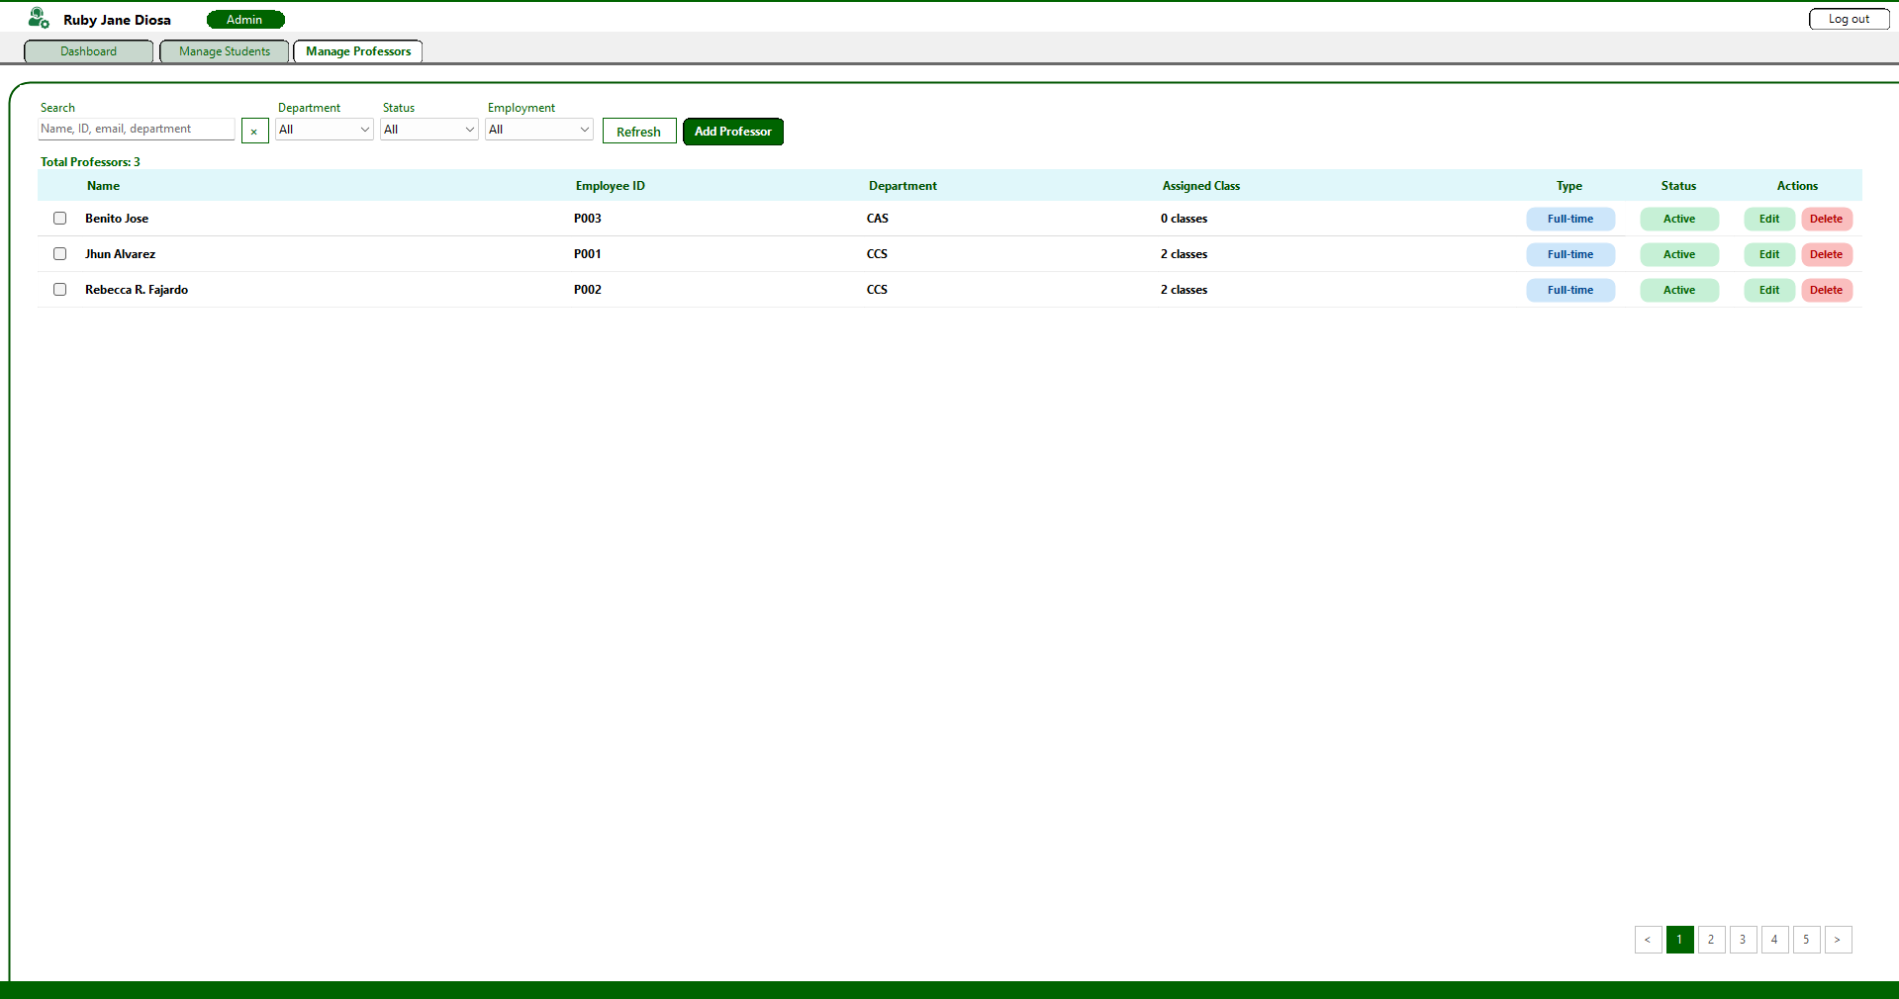
Manage Professors
Allows administrators to manage professor information, departments, employment types, and assigned classes.

7.8 Form/Module Inventory
The inventory below identifies the actual forms and their database responsibilities. Shared services handle validation, transactions, authorization, exports and calculation rather than duplicating business rules in each form.
Form/Module | Purpose | Tables Used | Main Functions | User Role
frmlogin | Authenticate and route users | student, teacher, admin | Role-aware login; Enter submission; password verification | All
frmstudent | Student academic portal | enrollment, class, course, assessment, studentgrade, revisionrequest, auditlog | Own grades/history/performance; requests and responses | Student
StudentProfileForm | Read-only profile and summaries | student, enrollment, class, course, assessment, studentgrade, revisionrequest | Personal details; enrolled/open counts; per-class standing | Student
frmprof | Teacher portal | teacher, class, enrollment, assessment, studentgrade, revisionrequest, auditlog | Fast score entry; class sheet; analytics; reviews | Teacher
frmGradebook | Spreadsheet-style saved scores | class, course, student, enrollment, assessment, studentgrade, auditlog | Persisted edits; CSV imports; enrollment; PDF | Teacher
ProfessorPasswordForm | Own password change | teacher, auditlog | Current-password verification; hashing; transactional audit | Teacher
Admin / frmUserEditor | Account management | student, teacher, class, enrollment, revisionrequest, auditlog | Create/edit; status/employment; protected delete | Admin
quickactions / frmAddClass | Administrative class/grade operations | course, class, teacher, enrollment, assessment, studentgrade, auditlog | Create offering; authorized grade entry | Admin
AdminRequestsForm / AdminAuditForm | Oversight and reporting | revisionrequest, studentgrade, enrollment, class, course, student, teacher, admin, auditlog | Read-only requests; date/search filters; CSV/PDF | Admin

7.9 Validation and Test Evidence
Recorded validation: 211 backend integration checks passed against a disposable seeded database. A separate CSV validation run passed 48 checks. The student-profile/professor-password suite passed 21 targeted checks. These are separate runs, not a claim of exhaustive coverage. The application builds with zero warnings/errors in the recorded build. Windows interaction harnesses compile; their compilation is not proof of runtime success.
Test area | Expected result | Recorded status | Evidence / follow-up
Grade validation and ownership | Reject invalid scores and unauthorized writes. | Backend cases passed | validation/README.md; professor-services harness
Import and batch rollback | Failed supported transactional batch leaves no partial data. | Backend cases passed | Disposable failure-injection checks
Student profile isolation | Own details only; correct counts and weighted grades. | 21-check suite includes this area | validation/profile-password.vbproj
Professor password | Wrong current password rejected; new password works; audit retained. | 21-check suite includes this area | validation/profile-password.vbproj
CSV samples | Valid files accepted; intentional invalid files rejected. | 48 checks passed | docs/test-csv/README.md
Windows layouts and keyboard | No clipping; Enter/Escape and window behavior correct. | Group verification required | Capture actual results at 100%/125% scaling
Final PDF print/export | Readable complete report and saved destination file. | Group verification required | Run on Windows with Microsoft Print to PDF
Attach the group’s actual Windows screenshots and execution dates in Appendix F. Do not mark unexecuted cases Passed. No respondent count, survey result, measured speed improvement or formal approval is supplied in the source documents.

8. User Manual

8.1 System Overview
The Transparent and Centralized Grading Management System for Pamantasan ng Lungsod ng Pasig (DAUNTLESS_WOLVES_PROF) is a desktop application developed in VB.NET WinForms paired with a MySQL/MariaDB database. It helps in transforming manual computation errors and lack of academic transparency by replacing manual spreadsheets with an automated, auditable, and role-based grading infrastructure.
The system serves three primary user groups:
- System Administrators: Responsible for institutional setup, account management (CRUD for students and professors), class assignments, and overall system audit monitoring.
- Faculty / Professors: Responsible for defining class assessment weightings, recording student raw scores, reviewing automated running grades, processing grade clarification requests, viewing performance analytics, and exporting official grade sheets.
- Enrolled Students: Responsible for tracking real-time academic performance across enrolled subjects, reviewing historical grade change logs, and submitting formal score revision requests with written justifications.

8.2 System Requirements

Operating system: Windows 10/11 with the .NET 8 Windows Desktop Runtime for a framework-dependent build. Development: Visual Studio 2022 with .NET desktop development and a .NET 8-compatible SDK. Database: a compatible MySQL/MariaDB server; the supplied dump identifies MariaDB 10.4.32. Restore the MySql.Data 26.7.0 NuGet dependency. PDF export requires Microsoft Print to PDF. Configure dbconfig.json beside the executable.
Hardware: use a Windows computer capable of running these components, with enough storage for the application, database and backups. No measured minimum RAM, CPU or concurrent-user capacity was established. A 1366×768 display is a practical review target; verify both 100% and 125% scaling.

8.3 Installation / Setup
Requirements: Windows 10/11, Visual Studio 2022, and MySQL/MariaDB (XAMPP).
A. Set up the database
- Start MySQL (XAMPP Control Panel or Windows Services).
- Open MySQL shell and log in as root.
Create centralized_and_transparent_grading_system, then select it before importing the supplied SQL dump. Use CREATE DATABASE IF NOT EXISTS centralized_and_transparent_grading_system;
- Import the supplied complete SQL dump. Import separate sample_data.sql only if the submission actually provides one; do not import the same sample rows twice.
B. Connect the application
- Create or edit dbconfig.json beside the application executable. Use the existing file if provided; no separate example file is required.
- Set Host, Port, Database, User and Password to the actual server values. Database must be centralized_and_transparent_grading_system if using the supplied dump. Use a restricted database account for deployment; do not assume root with a blank password is appropriate.
C. Run the application
- Open the .sln file in Visual Studio 2022.
- Right-click the solution and choose Restore NuGet Packages.
- Make sure frmlogin is the startup form, then press F5.

8.4 Login / Starting the System

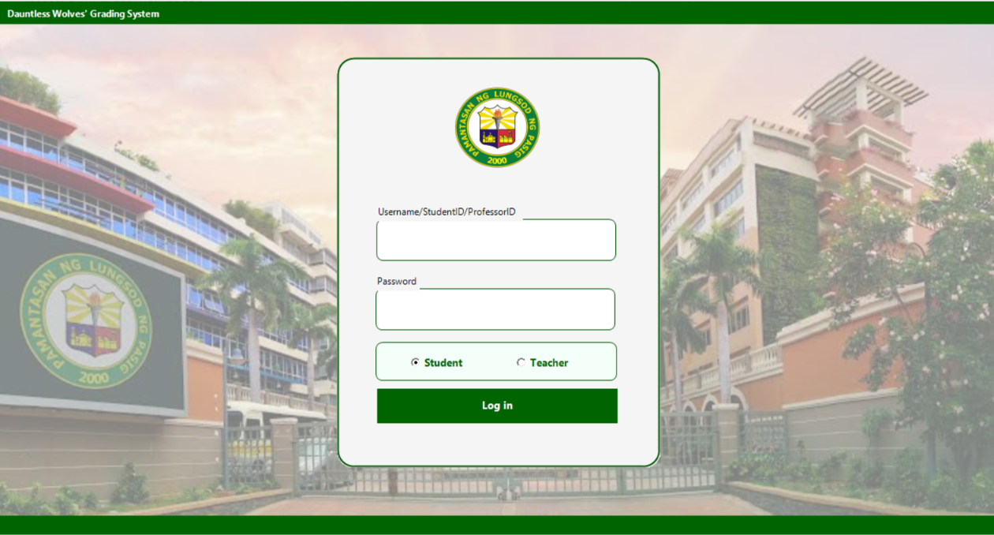
- Run the built application executable (normally DAUNTLESS WOLVES PROF.exe) from its output folder, or start the solution through Visual Studio.
- The User Login Portal (frmlogin.vb) will open.
- Enter the assigned student ID, teacher ID or email. Select Student or Teacher as appropriate; administrator email login is available with either role selection. Use a registered account with an initialized password.
- Enter your account Password into the txtPassword field.
- Click Log In or press Enter in the username or password field. Invalid credentials or inactive student/teacher accounts must not open the portal.

8.5 Main Menu / Navigation

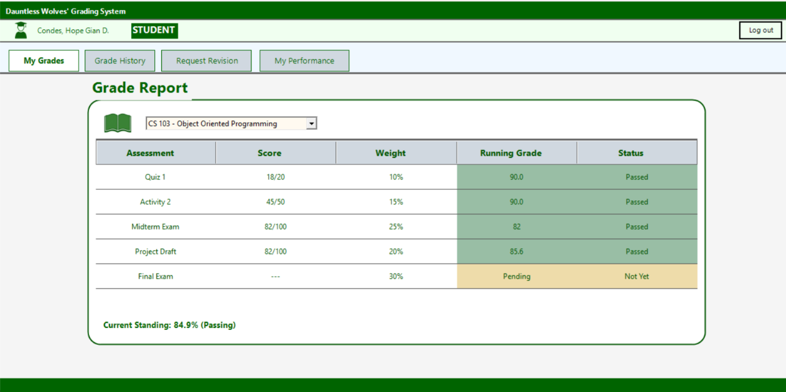
Figure 8.5.A Student Main Dashboard
- My Grades - this form exhibits the current running grade of the student, it also shows the accomplished and pending activities of the student. Status of the assessment is also indicated here.
- Grade History - Transparent timeline recording every score entry and modification, old vs. new values, teacher notes, and timestamps
- Request Clarification: select a graded assessment, enter a reason and submit a formal review request. Free-text adjustments do not automatically change a score. The assigned teacher supplies or approves the correction.
- My performance : It demonstrates the overall performance of the student in his/her current semester.

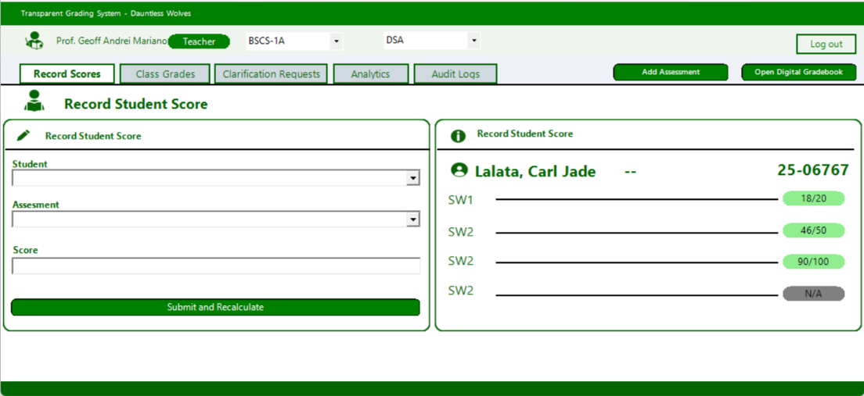
Figure 8.5.B Professors Main Dashboard
- Shows the complete class list with automatically calculated grades, visual pass/fail indicators, options to filter by term, and the ability to export results as a PDF
- Class Grades:Shows the complete class list with automatically calculated grades, visual pass/fail indicators, options to filter by term, and the ability to export results as a PDF
- Revision/Clarification Requests : Queue to evaluate student dispute requests, view written justifications, and approve or reject requested score changes.
- Class Performance Analytics: Visual graphs and progress bars showing class averages, top performers, passing distribution, and assessment breakdowns.
- Audit Logs: Maintains a detailed, timestamped log of all grade entries, modifications, and revision approvals made by faculty to ensure data integrity.
- Digital Gradebook: Displays a spreadsheet‑style, full‑screen grid of student scores across all course components, with options to export the data as a PDF.
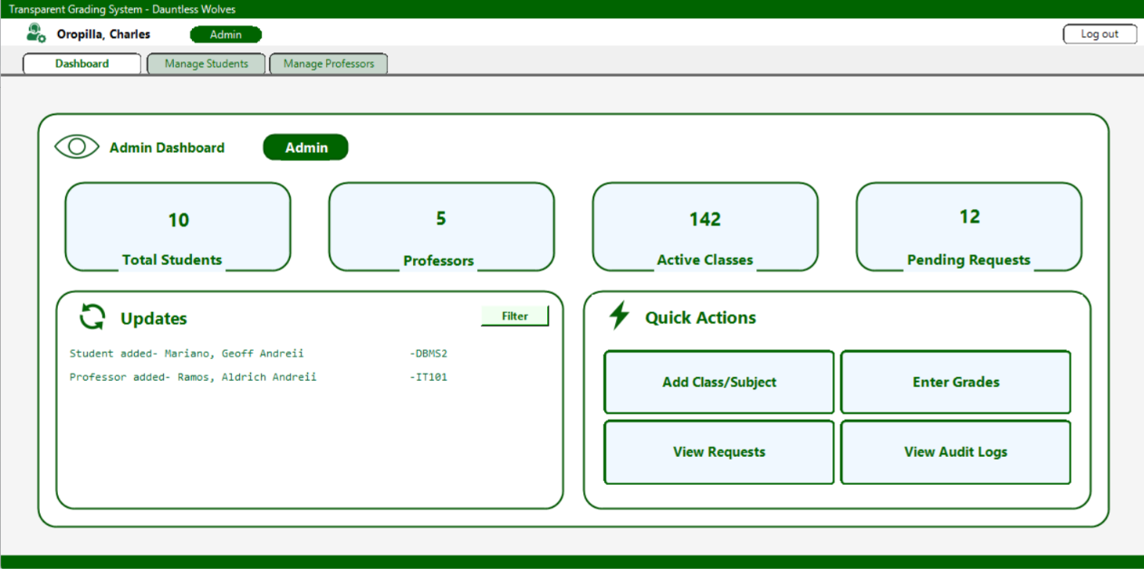
Figure 8.5.C Admin Main Dashboard
- Dashboard: student, professor and class counters, open-request count and recent updates. No separate system-health metrics are implemented.
- Manage Students: Directory interface to add, edit, filter, or deactivate student accounts.
- Manage Professors: Directory interface to manage faculty listings and assign academic department parameters.
- Class & Section Offering: Module to create subject sections and link assigned professors.
- Audit History: Comprehensive log viewer recording administrative actions across the platform.

8.6 Backup / Restore or Data Maintenance

1. Database Backup Procedure
- Open a terminal or administrative command prompt on the database server host.
- Run mysqldump to generate a timestamped SQL backup file:
- Bash
mysqldump -u root -p transparent_grading_system > backup_grading_system_%date:~10,4%%date:~4,2%%date:~7,2%.sql

- Alternatively, in phpMyAdmin, select centralized_and_transparent_grading_system $→$ click Export $→$ select Quick Export Method $→$ click Go.

2. Database Restore Procedure
- Create or clear the target database instance.
- Execute the import command via terminal:
- Bash
mysql -u root -p transparent_grading_system < backup_grading_system_YYYYMMDD.sql

- Or import the backup .sql file using phpMyAdmin's Import tab.

9.9 Logout / Exit

1. Logging Out of an Active Session
- Click the Logout button located on the top navigation bar of any active portal.
- The application clears the local AppSession user information. It does not delete the account or change its password. The portal closes and returns to the login window.
- The active portal form closes, and the system redirects back to the User Login Portal.

10. Conclusion and Recommendations

10.1 Project Conclusion
The Transparent and Centralized Grading Management System brings account management, enrollment, assessment definition, score recording and clarification requests into a database-backed Windows application. Its role-based portals organize administrative, teacher and student responsibilities while providing access to current academic records.
A shared weighted calculator supports consistent standing across grading screens. Input validation, ownership checks and transactions help protect supported operations from invalid input and partial saves. Audit entries and teacher review responses make score corrections more traceable without giving students direct grade-editing authority. CSV imports, faster score entry and report exports support routine record management.
Development included repeated feedback and regression checks addressing calculation inconsistencies, editing errors, refresh behavior and interface problems. Recorded backend results support the tested workflows, while Windows runtime, usability, printing and larger-scale deployment still require appropriate verification. The project provides a practical foundation for organized and transparent grade management, with further improvements possible in security, accessibility, backup and integration.

10.2 Recommendations / Future Enhancements
The following enhancements are recommended beyond the current project scope. Their inclusion here does not imply they are implemented or evaluated:
- Cloud / Web Migration: Re-architect the client application from a WinForms desktop environment to a cloud-hosted web framework (e.g., ASP.NET Core Blazor or React with a RESTful Web API backend) to allow multi-device browser access without local software installation.
- Automated Push & Email Notifications: Integrate an automated notification engine (using SMTP or push services) to notify students immediately via email or mobile alerts when new grades are posted or revision requests are resolved.
- LMS and University SIS Integration: Develop API connectors to sync class rosters, enrollment records, and final term marks directly with the university Registrar's Student Information System (SIS) and Learning Management Systems (e.g., Canvas or Moodle).
- Native Mobile Application: Build Android and iOS companion apps using MAUI or React Native to give students quick mobile access to running grades and dispute updates.
- Predictive Performance Analytics: Incorporate machine learning models to analyze early-term assessment trends, automatically triggering early intervention alerts for students at risk of academic failure.

11. References

Condes, H. G., Lalata, C. J., Mariano, G. A., Oropilla, C., & Puyat, R. J. (2026, August 23). Transparent and Centralized Grading Management System [Unpublished project concept paper]. IT102 – Object Oriented Programming with Database.
Dauntless Wolves. (2026). The Dauntless Grading System [VB.NET source code, SQL schema and validation documentation]. https://github.com/CoffeeIsThere/dauntless-wolves-re-re
Microsoft. (n.d.). Windows Forms overview. Microsoft Learn. https://learn.microsoft.com/en-us/dotnet/desktop/winforms/overview/
Microsoft. (n.d.). Rfc2898DeriveBytes class. Microsoft Learn. https://learn.microsoft.com/en-us/dotnet/api/system.security.cryptography.rfc2898derivebytes
Oracle. (n.d.). MySQL Connector/NET Developer Guide. https://dev.mysql.com/doc/connector-net/en/
MariaDB. (n.d.). Foreign keys. MariaDB Documentation. https://mariadb.com/docs/server/ha-and-performance/optimization-and-tuning/optimization-and-indexes/foreign-keys
Format these references according to the instructor’s required citation style and verify any additional sources actually consulted by the group.

12. Appendices
☐ Appendix A – Approved Concept Paper / Revision History
The concept paper supplied with this documentation is dated August 23, 2026. It identifies spreadsheet fragmentation, delayed feedback, overwritten grades, difficult manual interpretation, audit logging and revision requests as the initial project concerns. The implemented scope is described in Sections 1 and 7; proposed home access, immutable history and predictive trends must not be assumed to be implemented features.
☐ Appendix B – Complete ERD
See the ERD figure in Section 3.1 and the entity explanations in Section 3.2. Validate all labels in the embedded image against the final dictionary, especially teacher.employment_type.
☐ Appendix C – Normalization Worksheets
See the worksheets in Sections 4.1–4.4 and the accompanying dependency explanation. The prose documents the enrollment–assessment candidate key and intentional running-grade cache; older image labels should be checked before submission.
☐ Appendix D – Complete SQL Script (.sql)
Attach the supplied update3_centralized_and_transparent_grading_system.sql as a separate electronic file. It provides the actual ten-table schema and sample inserts; do not replace it with screenshots alone.
☐ Appendix E – Selected VB.NET Source Code / Repository Submission Details
Repository: https://github.com/CoffeeIsThere/dauntless-wolves-re-re . Source modules include Services/GradeCalculator.vb, GradeService.vb, RevisionRequestService.vb, AuthService.vb and Core/DatabaseHelper.vb. The profile and professor-password additions were merged to main through pull request #8. Submit the final agreed revision and retain its commit identifier.
☐ Appendix F – Additional Test Evidence
See Section 7.9 and validation/README.md. Add genuine Windows execution screenshots, actual dates, tester names and observed results. No results or signatures should be inferred from the test instructions.
☐ Appendix G – Additional User Manual Screenshots
Existing interface screenshots are retained in Section 7.2. Capture updated Student Profile and Professor Change Password screens on Windows if they are included in the submitted build.
☐ Appendix H – Other Instructor-Required Evidence
Professor remarks, approval/signatures, individual grades and any institution-specific forms must be completed by the responsible people. They are not generated as project evidence here.

Final Submission Checklist
☐ Concept Paper is complete and approved/revised.
☐ Business Rules are clear and reflected in the ERD.
☐ ERD matches the final normalized tables.
☐ Normalization process shows 1NF, 2NF, and 3NF—not only the final answer.
☐ Data Dictionary matches the MySQL database.
☐ MySQL database contains correct constraints and sufficient sample data.
☐ VB.NET system is connected to the submitted MySQL database.
☐ CRUD, validation, and required project functions are working.
☐ Test Cases include expected and actual results with evidence.
☐ User Manual is understandable to a first-time user.
☐ All screenshots are readable and captioned.
☐ All files use the required naming convention and are submitted in the required format.

REQUIRED Electronic Submission Package
Recommended folder structure: Folder name: Group # and Title
01_Documentation/
Final_Project_Documentation.docx
Final_Project_Documentation.pdf
02_Database/
database.sql
sample_data.sql
03_VBNet_System/
[Visual Studio solution/project files]
04_Test_Evidence/
[screenshots and test files]
05_User_Manual/
User_Manual.pdf
06_Grade/
Indi_score.xlsx

