


INFORMATION MANAGEMENT
OBJECT-ORIENTED PROGRAMMING
PROJECT

Project/System Title: __Transparent and Centralized Grading Management System___________________
Group Members: _Oropilla, Condes, Lalata, Mariano, Puyat_____________________________________
Course / Section: _BSCS - 2A__________________________________________________________
Professor: Mrs. Rebecca R. Fajardo_______________________________________________________

Project Documentation and Submission Map
Stage | Required Output | Primary Evidence | Professor Remarks
1 | Concept Paper | Problem, objectives, scope, users, proposed solution | ☐
2 | Business Rules | Operational rules, constraints, data relationships | ☐
3 | ERD | Entities, attributes, PK/FK, cardinality, optionality | ☐
4 | Normalization | UNF/initial data → 1NF → 2NF → 3NF | ☐
5 | Data Dictionary | Complete field definitions and constraints | ☐
6 | MySQL Database | DDL, DML, sample records, queries, screenshots | ☐
7 | VB.NET System | Forms, CRUD, validation, database connectivity | ☐
8 | Test Cases | Functional tests, expected/actual results, status | ☐
9 | User Manual | Installation/access and step-by-step usage guide | ☐

General Documentation Standards
☐ All entities and fields shown in the ERD must correspond to the normalized tables and data dictionary.
☐ Primary keys, foreign keys, data types, constraints, and relationships must match the implemented MySQL database.
☐ VB.NET forms and functions must use the actual MySQL database designed in this project.
☐ Use screenshots only as supporting evidence; explain what each screenshot demonstrates.
☐ Use meaningful sample data. Do not use sensitive real-world personal data unless authorized and properly anonymized.
☐ Number and caption major figures/tables (e.g., Figure 1. ERD; Table 3. Data Dictionary).
☐ Attach source code/database scripts as appendices or as separate electronic files when required by the instructor.

1. Concept Paper
The concept paper establishes the need for the proposed system and defines what the group intends to develop.

1.1 Project Title
State a concise and specific title for the proposed database-driven system.
Transparent and Centralized Grading Management System

1.2 Background / Rationale
In academic institutions, traditional grade computation and dispute resolution often rely on paper records or isolated spreadsheets. This decentralization creates significant delays in providing students with real-time feedback on their running marks and weighting distributions. Furthermore, handling grade disputes verbally or informally lacks verifiable tracking, which can lead to administrative mistrust, human error, and loss of records. A centralized, database-driven system bridges these gaps by enforcing real-time calculation rules, automating grade change audits, and providing clear role-based portals for students, faculty, and administrators

1.3 Problem Statement
Identify the main problem and supporting problems that the system will address.
Primary Problem: Inefficiencies, vulnerability to calculation errors, and a lack of real-time transparency in traditional manual grade recording and dispute resolution processes.
Supporting Problems:
- Delays in student visibility regarding individual assessment marks, weighting distributions, and running grades.
- Absence of an auditable tracking mechanism for grade modifications and formal revision requests.
- Administrative friction in managing user credentials, class section enrollments, and faculty assignments across academic departments.

1.4 General Objective
State the overall purpose of the project.
To design, implement, and deploy a secure, database-driven grading management system that provides real-time running grade computation, transparent dispute tracking, and auditable record management for Pamantasan ng Lungsod ng Pasig

1.5 Specific Objectives
List measurable objectives. Include database-related and system-related objectives.
Database Objectives: Implement a 3NF-normalized MariaDB/MySQL relational schema with parameterized queries, referential integrity constraints, and SHA-256 hashed password storage.
System Objectives: Develop a VB.NET Windows Forms application with role-based access control tailored for Students, Teachers, and System Administrators.
Functional Objectives:
- Automate real-time running grade calculations based on dynamic category weights (Quizzes, Activities, Exams, Projects).
- Build a digital revision request workflow where students submit score disputes and teachers review, approve, or reject changes with mandatory reason logging.
- Implement automated system audit logs capturing all grade modifications with timestamps and user attributions.
Output Objectives: Generate downloadable PDF and CSV class grade sheets for official administrative reporting.

1.6 Proposed Solution / System Overview
Explain how the proposed system will work and how users will interact with it.
The proposed platform establishes a single source of truth for academic performance. Teachers record raw assessment scores, which dynamically trigger weight calculations and update student status indicators ("Passed" / "At Risk"). Students gain transparent access to their live running average, score history, and assessment breakdowns. When discrepancies occur, students submit a formal digital Revision Request. Teachers evaluate requests within their portal, and any approved change automatically updates the database and writes an immutable record to the Audit Log. Administrators maintain overarching control through user profile management and class allocation directories

1.7 Target Users / Stakeholders
Identify the intended users and their roles.

User Role in the system Main features they use
Students | View their own grades and check how they are doing | Live grade report with running grade and standing, grade history showing who changed a grade and why, revision requests with status tracking, and a performance overview
Professors | Record and manage grades for their classes | Gradebook for entering scores, handling student revision requests, and viewing their assigned classes
Administrators | Manage the system and its records | Student and professor management (add, edit, search, filter), class and subject setup, request monitoring, and audit logs

1.8 Scope
State the functions, records, transactions, reports, and users included in the project.
- Authentication and SHA-256 password validation.
- Score entry and automated dynamic grade recalculation.
- Digital class gradebook with PDF/CSV export functionality.
- Student grade dispute submission and teacher approval/rejection panel.
- Class performance analytics dashboard.
- Comprehensive grade audit logging.
- Admin user management (CRUD for Students, Professors, Classes).

1.9 Limitations
State functions or conditions intentionally excluded from the project.
- No Cloud Connection
- No Google Classroom Integration
- Can't store images, Videos
- No Automatic Online Backup
- Local Database Only
1.10 Significance / Expected Benefits
Explain the expected benefits to users, organization, and information management process.
To Students: Delivers immediate feedback on academic standing, eliminating surprise failing marks and ensuring fair dispute resolution.
To Faculty: Saves manual calculation time, eliminates human arithmetic errors, and provides structured documentation for grade adjustments.
To Administration: Enhances institutional integrity, guarantees full auditable accountability, and streamlines user directory management.

1.11 Major System Modules
Module | Main Functions | Primary User/s
Authentication & Session | Role-based login, password verification, active App Session management. | All Users
Teacher Gradebook & Entry | Raw score recording, running grade recalculation, gradebook filter, PDF/CSV export. | Professors
Revision Module | Dispute submission, request queue management, status updates (Pending/Approved/Closed). | Students and Professors
Student/Professor Dashboard | Live grade breakdown, percentage weighting display, score revision history. | Students for student dashboard & Professors for professor dashboard
Analytics & Audit Log | Class averages, top scores, at-risk flags, timestamped audit log of all changes. | All users
Admin Management Portal | Student/Professor directory CRUD, class assignments, system stats. | Admin

2. Business Rules
Business rules describe how the organization operates and how data must be stored, related, validated, and processed. Rules should be clear enough to guide the ERD and database constraints.

2.1 Narrative Business Rules
Write at least the rules needed to define users, records, transactions, relationships, validation, and status changes. Use statements such as “One customer may have many orders” or “Each equipment record must belong to one category.”
Rule No. | Business Rule | Database/Relationship Impact | Validation/Constraint
1 | Each user must possess a unique account with an assigned role (Admin, Teacher, Student). | Users table primary key (user_id), unique constraint on username / student_number. | NOT NULL, Hashed SHA-256 password requirement
2 | A student can be enrolled in multiple classes; each class contains multiple students. | Resolves M:N relationship using Enrollments junction table. | Foreign Keys referencing Students and Classes.
3 | Assessment scores must not exceed the defined maximum score for that item. | Enforced in Scores table. | CHECK (score >= 0 AND score <= max_points).
4 | Running grades are calculated dynamically based on predefined assessment weightings. | Computed via application business logic / database views. | Weights across active categories must sum to 100%.
5 | A student may submit a revision request only for existing, published scores | Foreign Key in RevisionRequests referencing score_id. | Single pending request per assessment item constraint
6 | Approving a revision request automatically updates the score and records an audit entry. | Database transaction updating Scores and inserting into AuditLogs. | Status constraint: Pending, Approved, Under Review, Closed.
7 | Every grade insertion, edit, or dispute approval must produce a timestamped log entry. | Insert-only AuditLogs table. | Foreign Key referencing changed_by_user_id, TIMESTAMP DEFAULT CURRENT_TIMESTAMP.
8 | Only active professors assigned to a specific course can modify scores or export grade sheets. | Foreign Key in Classes referencing professor_id. | Application-level authorization check via AppSession.
9
10

2.2 Assumptions
- One academic year is divided into distinct terms (e.g., Midterms, Finals).
- Category weights (Quizzes: 10%, Activities: 15%, Midterms: 25%, Projects: 20%, Finals: 30%) remain uniform within a given course module unless updated by administration.
- Approved score adjustments take effect immediately across all student and teacher dashboard views

2.3 User Roles and Permissions
User Role | Can View | Can Add/Edit/Delete | Special Permissions
Admin | System Dashboard, Student Directory, Professor Directory, Global Audit Logs. | Add/Edit/Deactivate Students, Professors, and Class Assignments. | Full System Administration
Student | Own Live Grades, Grade History, Performance Stats, Own Revision Requests. | Submit Revision Requests.  PDF | Export Grade Sheets to PDF/CSV.
Teacher | Assigned Class Gradebooks, Revision Request Queue, Class Analytics, Grade Audit Logs. | Add/Edit Assessment Scores, Approve/Reject Revision Requests. | Full System Administration

3. Entity-Relationship Diagram (ERD)
Create the ERD based on the approved business rules. The final ERD must show entities, attributes, primary keys, foreign keys, relationships, cardinality, and optionality where applicable.
☐ All required entities are present.
☐ Every entity has a primary key.
☐ Foreign keys correctly represent relationships.
☐ Many-to-many relationships are resolved using associative/intersection entities.
☐ Attribute names are meaningful and consistent.
☐ Cardinality/optionality agree with the business rules.

3.1 ERD
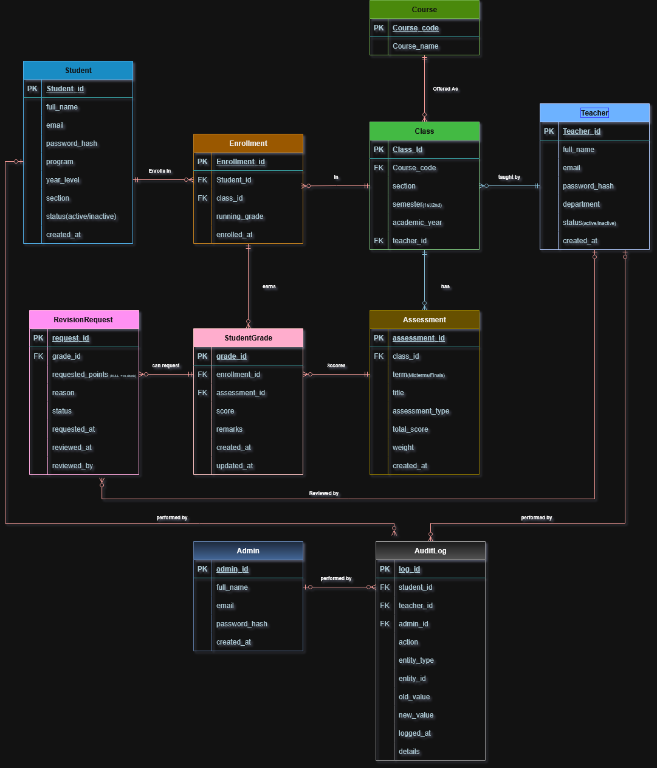

3.2 ERD Explanation
Student
Stores each student’s account and details, such as name, email, program, year level and section. It matters because students are the people the system exists for. They log in to see their grades and to ask for a re-check. It connects to Enrollment, which shows the classes the student takes, and to AuditLog, which records the student’s actions.
Teacher
Stores each teacher’s account and department. It matters because teachers record the scores and review revision requests. It connects to Class, which shows the classes they handle, to RevisionRequest, which shows the requests they reviewed, and to AuditLog, which records their actions.
Admin
Stores the administrator accounts that manage the system, such as creating accounts and assigning classes. It matters because someone must be accountable for system setup. It connects to AuditLog, which records every admin action.
Course
Stores the subject itself, such as CS 103 and its name. It matters because the course name is stored once here instead of being repeated in every class. This keeps the data clean and follows third normal form. It connects to Class, since one course can be offered as many classes.
Class
Stores one offering of a course: the section, the semester and the academic year. It matters because grades and enrollments belong to a specific class, not just to a subject. It connects to Course (what is taught), Teacher (who teaches it), Enrollment (who is in it) and Assessment (what is graded in it).
Enrollment
Stores which student is in which class, with the running grade for that class. It matters because a student takes many classes and a class has many students. Without it we could not link them. It connects to Student, Class and StudentGrade, which holds the student’s scores in that class.
Assessment
Stores each quiz, activity, exam or project, with its term (Midterm or Finals), total score and weight. It matters because it defines what is graded and how much each item counts. It connects to Class (which class it belongs to) and StudentGrade (the scores students got on it).
StudentGrade
Stores one student’s score on one assessment, with remarks and timestamps. It matters because it holds the actual grades, which is the main data the system shows. It connects to Enrollment (whose grade it is), Assessment (what was graded) and RevisionRequest (any dispute about the score).
RevisionRequest
Stores a student’s request to re-check a score, with the reason, the points asked for and the review status. It matters because it is what makes the system transparent: students can question a grade, and the outcome is recorded. It connects to StudentGrade (the grade in question) and Teacher (who reviewed it).
AuditLog
Stores a permanent record of who did what and when, including the old and new value of a changed score. It matters because it makes every change traceable, so no grade can be changed without a record. It connects to Student, Teacher and Admin, and each entry names exactly one of them. The record that changed is stored as plain text, so the history stays even if that record is deleted later.

4. Database Normalization: 1NF to 3NF
Show the transformation of the initial/un-normalized data structure into First, Second, and Third Normal Form. Do not submit only the final tables; demonstrate the reasoning at each stage.

4.1 Initial / Unnormalized Data
Present the original transaction, form, spreadsheet, or record structure. Identify repeating groups, multi-valued attributes, and redundancy.
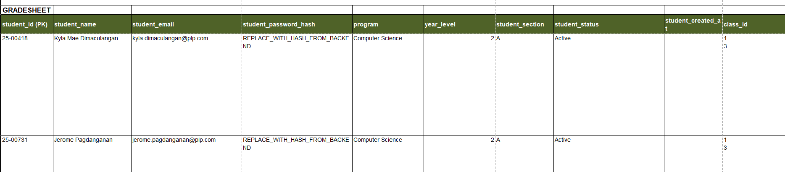
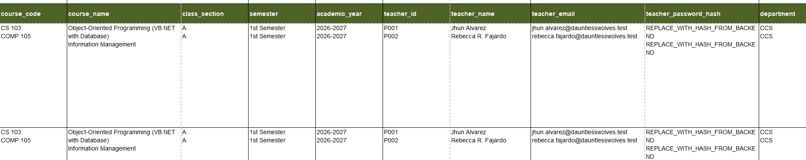
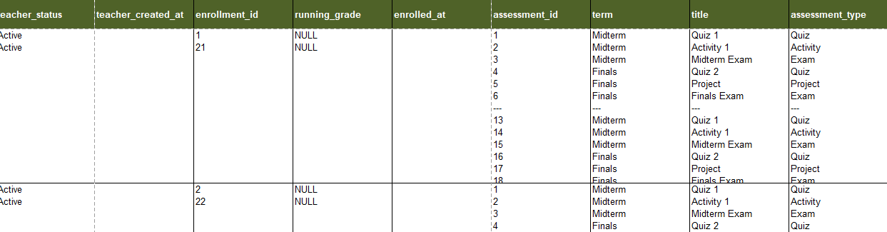
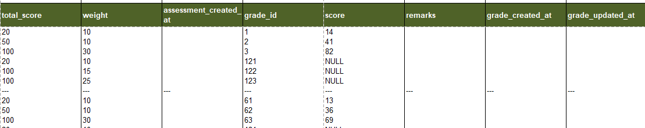
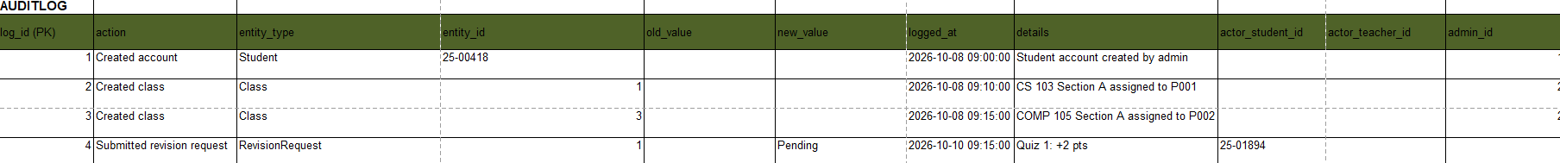
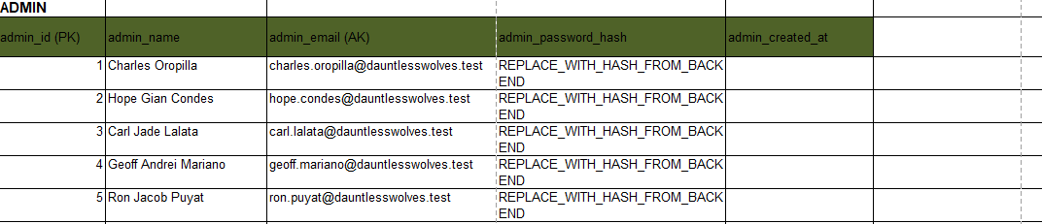

4.2 First Normal Form (1NF)
Show atomic values, removal of repeating groups, and the primary key.
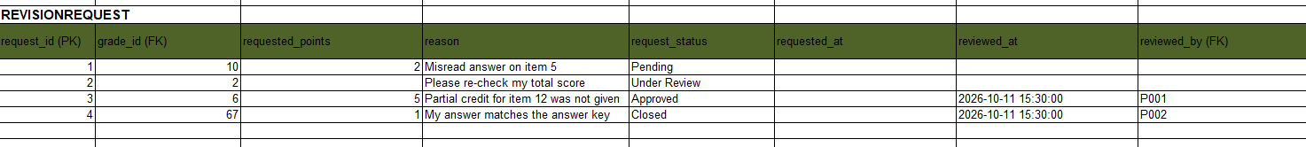
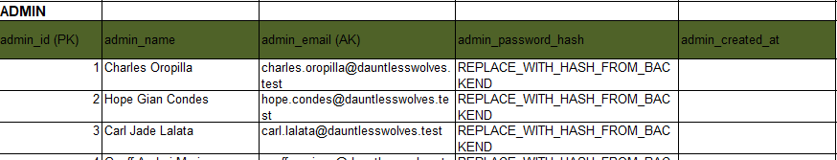
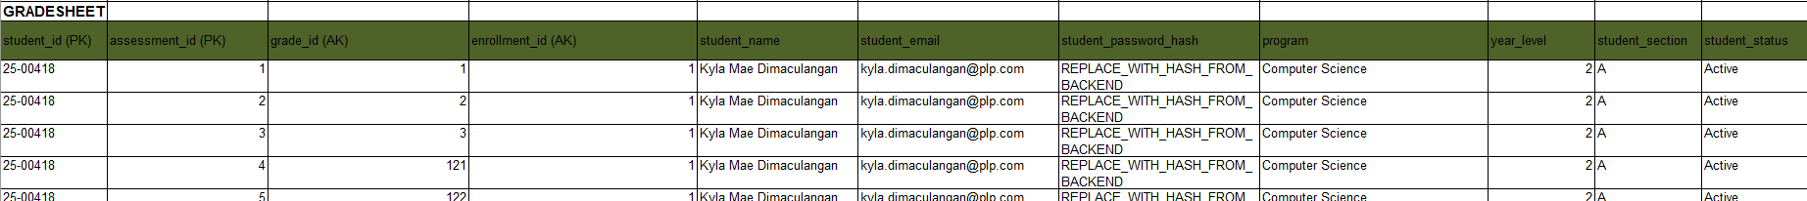
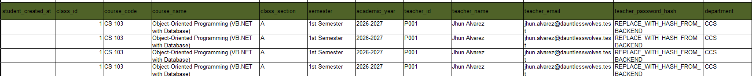
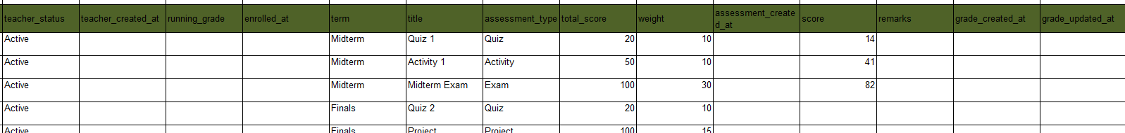

4.3 Second Normal Form (2NF)
Identify partial dependencies and decompose tables as necessary. This is especially important when composite keys are present.
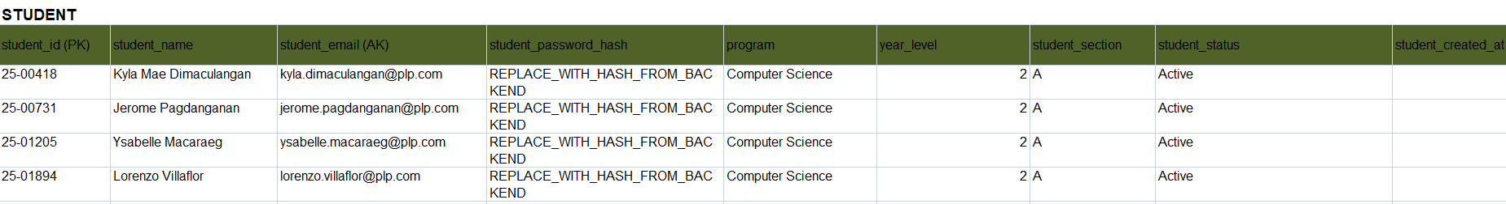
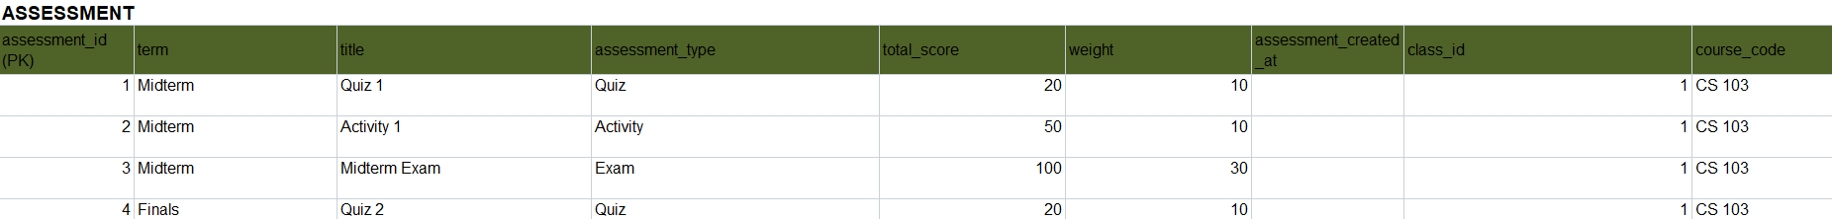
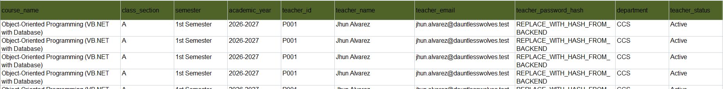
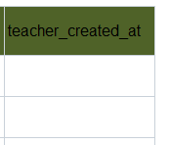
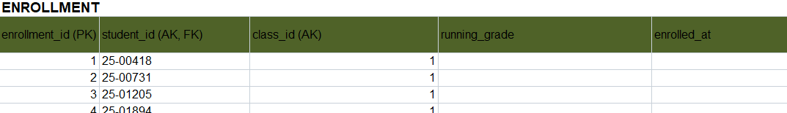
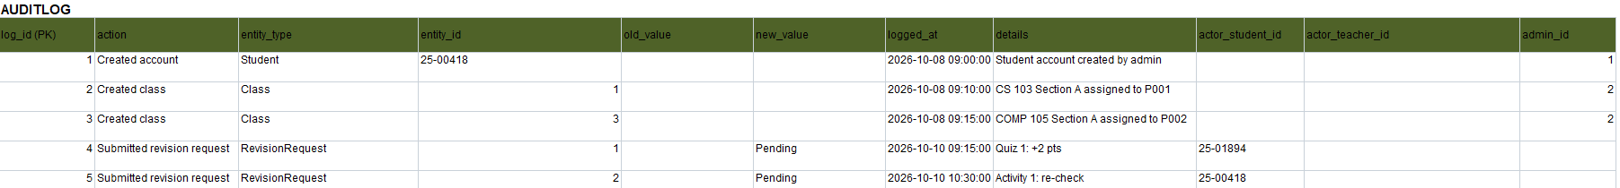
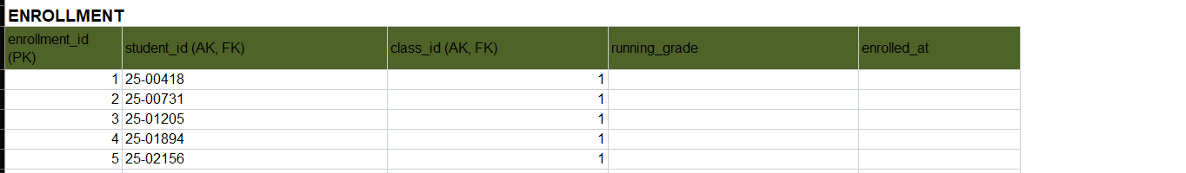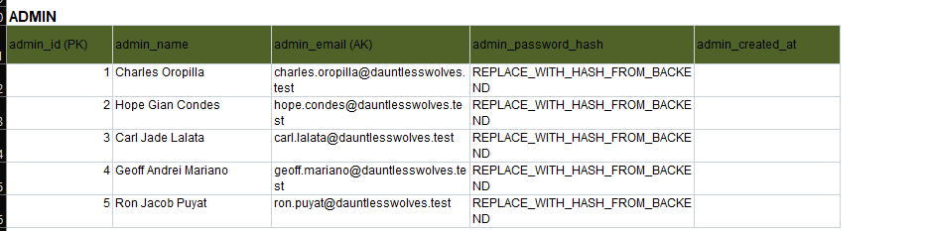
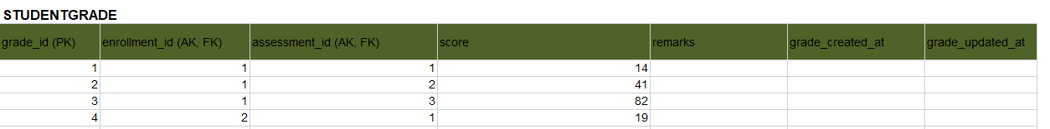

4.4 Third Normal Form (3NF)
Identify transitive dependencies and produce the final set of normalized relations.
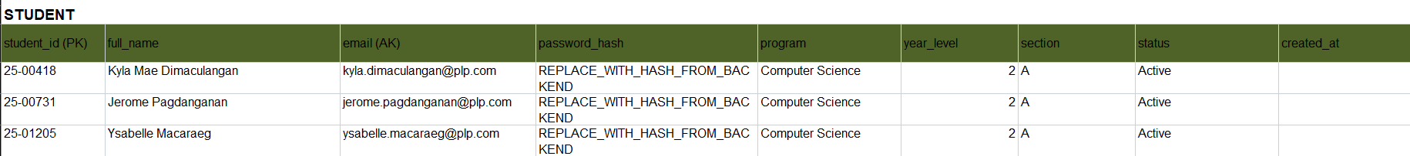
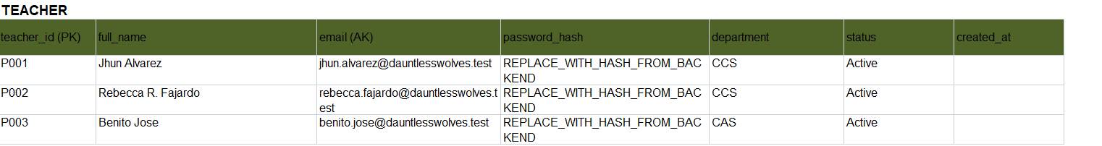
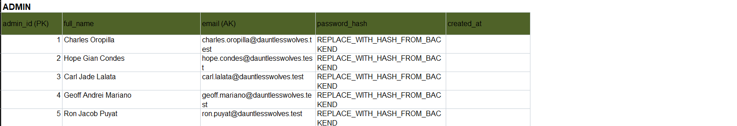
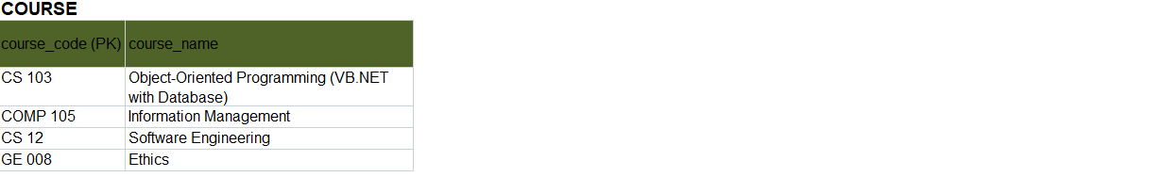
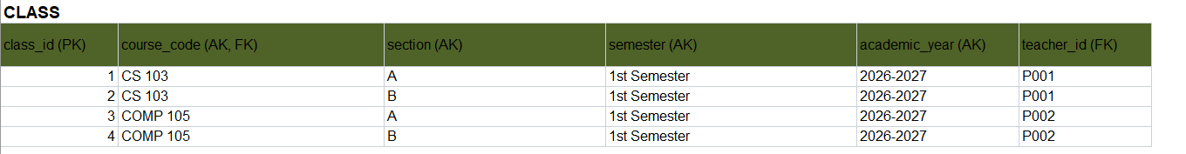

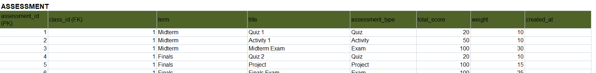
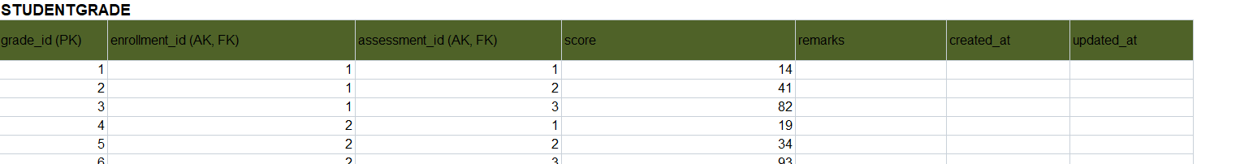
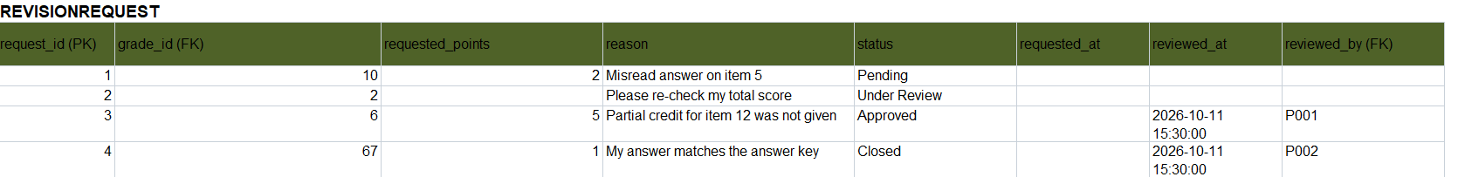
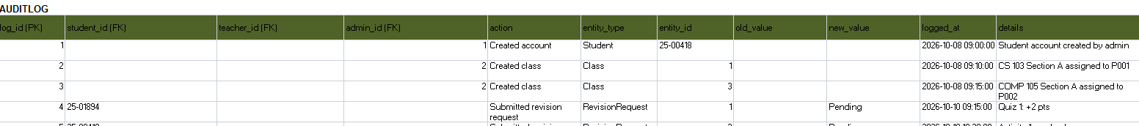

4.5 Functional Dependency Analysis
Table/Relation | Determinant | Dependent Attribute/s | Action / Normal Form Issue
Grade Sheet (UNORMALIZED) | student_id | classes, assessments, scores | Repeating groups and multi-valued cells (violates 1NF). Flattened to one row per student and assessment.
GRADE_SHEET_1NF | (student_id, assessment_id) | all other columns | Minimal candidate key. 1NF satisfied: atomic values, unique rows.
GRADE_SHEET_1NF | student_id | student name, email, password_hash, program, year_level, section, status, created_at | Partial dependency (2NF). Moved to Student.
GRADE_SHEET_1NF | assessment_id | class_id, term, title, assessment_type, total_score, weight, created_at, and the class, course and teacher details | Partial dependency (2NF). Moved to Assessment.
GRADE_SHEET_1NF | enrollment_id | student_id, class_id, running_grade, enrolled_at | Partial dependency (2NF). Moved to Enrollment.
GRADE_SHEET_1NF | (enrollment_id, assessment_id) | grade_id, score, remarks, created_at, updated_at | Full dependency. Kept as StudentGrade.
Assessment (2NF) | class_id | course_code, section, semester, academic_year, teacher_id | Transitive dependency (assessment_id → class_id → class details). Moved to Class (3NF).
Class | course_code | course_name | Transitive dependency (class_id → course_code → course_name). Moved to Course (3NF).
Class | teacher_id | teacher name, email, password_hash, department, status, created_at | Transitive dependency (class_id → teacher_id → teacher details). Moved to Teacher (3NF).
Final 10 tables (see 4.6) | Each table's primary key | All other attributes of that table | Already in 3NF: no partial or transitive dependency. running_grade in Enrollment is derived, so the backend must keep it updated.

4.6 Final 3NF Tables
Table Name | Primary Key | Foreign Key/s | Major Non-Key Attributes | Purpose
Student | student_id | None | full_name, email, password_hash, program, year_level, section, status, created_at | Stores student accounts. Students log in to view their grades and send revision requests.
Teacher | teacher_id | None | full_name, email, password_hash, department, status, created_at | Stores teacher accounts. Teachers handle classes, record scores and review revision requests.
Admin | admin_id | None | full_name, email, password_hash, created_at | Stores admin accounts. Admins manage student and teacher accounts and class assignments.
Course | course_code | None | course_name | Stores the subjects offered, such as CS 103 Object-Oriented Programming.
Class | class_id | course_code (Course), teacher_id (Teacher) | section, semester, academic_year | One offering of a course for a section, semester and academic year, handled by one teacher.
Enrollment | enrollment_id | student_id (Student), class_id (Class) | running_grade, enrolled_at | Places a student in a class. Resolves the many-to-many between Student and Class. A student can enroll in a class only once.
Assessment | assessment_id | class_id (Class) | term, title, assessment_type, total_score, weight, created_at | A gradable item in a class (quiz, activity, exam, project) with its term and weight.
StudentGrade | grade_id | enrollment_id (Enrollment), assessment_id (Assessment) | score, remarks, created_at, updated_at | One student's score on one assessment. Resolves the many-to-many between Enrollment and Assessment. One score per student per assessment.
RevisionRequest | request_id | grade_id (StudentGrade), reviewed_by (Teacher) | requested_points, reason, status, requested_at, reviewed_at | A student's request to re-check a score, with its review status. reviewed_by stays empty until a teacher reviews it.
AuditLog | log_id | student_id (Student), teacher_id (Teacher), admin_id (Admin) | action, entity_type, entity_id, old_value, new_value, logged_at, details | Permanent record of who did what. Exactly one actor ID is filled per entry.

5. Data Dictionary
Document every field in every final 3NF table. The data dictionary must match the actual MySQL implementation.
Table | Field | Data Type | Size | PK/FK | Null? | Default | Constraint | Description
Student | student_id | VARCHAR | 10 | PK | NO | - | PRIMARY KEY | Student ID number (e.g. 25-06767)
Student | full_name | VARCHAR | 100 | - | NO | - | - | Student's full name
Student | email | VARCHAR | 100 | - | NO | - | UNIQUE | School email address
Student | password_hash | VARCHAR | 255 | - | NO | - | - | Hashed login password
Student | program | VARCHAR | 100 | - | NO | - | - | Degree program (e.g. BS Computer Science)
Student | year_level | TINYINTUNSIGNED | - | - | NO | - | - | Year level of the student
Student | section | VARCHAR | 20 | - | NO | - | - | Section (e.g. BSCS 2A)
Student | status | ENUM | - | - | NO | ‘Active’ | Values: Active, Inactive | Whether the account is in use
Student | created_at | TIMESTAMP | - | - | NO | CURRENT_TIMESTAMP | - | When the record was created
Teacher | teacher_id | VARCHAR | 10 | PK | NO | - | PRIMARY KEY | Teacher ID (e.g. P001)
Teacher | full_name | VARCHAR | 100 | - | NO | - | - | Teacher's full name
Teacher | email | VARCHAR | 100 | - | NO | - | UNIQUE | School email address
Teacher | password_hash | VARCHAR | 255 | - | NO | - | - | Hashed login password
Teacher | department | VARCHAR | 50 | - | NO | - | - | Department the teacher belongs to
Teacher | status | ENUM | - | - | NO | ‘Active’ | Values: Active, Inactive | Whether the account is in use
Teacher | created_at | TIMESTAMP | - | - | NO | CURRENT_TIMESTAMP | - | When the record was created
Admin | admin_id | INT UNSIGNED | - | PK | NO | - | PRIMARY KEY, AUTO_INCREMENT | Admin identifier
Admin | full_name | VARCHAR | 100 | - | NO | - | - | Admin's full name
Admin | email | VARCHAR | 100 | - | NO | - | UNIQUE | Admin email address
Admin | password_hash | VARCHAR | 255 | - | NO | - | - | Hashed login password
Admin | created_at | TIMESTAMP | - | - | NO | CURRENT_TIMESTAMP | - | When the record was created
Course | course_code | VARCHAR | 20 | PK | NO | - | PRIMARY KEY | Course code (e.g. CS 103)
Course | course_name | VARCHAR | 100 | - | NO | - | - | Course title (e.g. Object Oriented Programming)
Class | class_id | INT UNSIGNED | - | PK | NO | - | PRIMARY KEY, AUTO_INCREMENT | Class identifier
Class | course_code | VARCHAR | 20 | FK | NO | - | FOREIGN KEY →Course(course_code), ON UPDATE CASCADE, ON DELETE RESTRICT;part of UNIQUE uq_class | Course this class belongs to
Class | section | VARCHAR | 20 | - | NO | - | Part of UNIQUE uq_class | Section (e.g. BSCS 2A)
Class | semester | ENUM | - | - | NO | - | Values:1st Semester, 2nd Semester; part of UNIQUE uq_class | Semester the class runs in
Class | academic_year | VARCHAR | 9 | - | NO | - | Part of UNIQUE uq_class | Academic year (e.g. 2026-2027)
Class | teacher_id | VARCHAR | 10 | FK | NO | - | FOREIGN KEY →Teacher(teacher_id),ON UPDATE CASCADE, ON DELETE RESTRICT | Teacher handling the class
Enrollment | enrollment_id | INT UNSIGNED | - | PK | NO | - | PRIMARY KEY, AUTO_INCREMENT | Enrollment identifier
Enrollment | student_id | VARCHAR | 10 | FK | NO | - | FOREIGN KEY →Student(student_id), ON UPDATE CASCADE, ON DELETE RESTRICT; part of UNIQUEuq_enrollment | Enrolled student
Enrollment | class_id | INT UNSIGNED | - | FK | NO | - | FOREIGN KEY →Class (class_id), ON UPDATE CASCADE, ON DELETE RESTRICT; part of UNIQUEuq_enrollment | Class the student is enrolled in
Enrollment | running_grade | DECIMAL | 5,2 | - | YES | NULL | - | Overall standing in the class; NULL until the first score is recorded
Enrollment | enrolled_at | TIMESTAMP | - | - | NO | CURRENT_TIMESTAMP | - | When the student was enrolled
Assessment | assessment_id | INT UNSIGNED | - | PK | NO | - | PRIMARY KEY, AUTO_INCREMENT | Assessment identifier
Assessment | class_id | INT UNSIGNED | - | FK | NO | - | FOREIGN KEY → Class(class_id), ON UPDATE CASCADE, ON DELETE CASCADE | Class the assessmentbelongs to
Assessment | term | ENUM | - | - | NO | - | Values: Midterm, Finals | Grading period
Assessment | title | VARCHAR | 100 | - | NO | - | - | Assessment name (e.g. Quiz 2)
Assessment | assessment_type | ENUM | - | - | NO | - | Values: Quiz, Activity, Exam, Project, Attendance | Kind of assessment
Assessment | total_score | DECIMAL | 6,2 | - | NO | - | CHECK (total_score > 0) | Highest possible score
Assessment | weight | DECIMAL | 5,2 | - | NO | - | CHECK (weight BETWEEN 0 AND 100) | Percentage weight (e.g. 15.00)
Assessment | created_at | TIMESTAMP | - | - | NO | CURRENT_TIMESTAMP | - | When the record was created
StudentGrade | grade_id | INT UNSIGNED | - | PK | NO | - | PRIMARY KEY, AUTO_INCREMENT | Grade identifier
StudentGrade | enrollment_id | INT UNSIGNED | - | FK | NO | - | FOREIGN KEY → Enrollment(enrollment_id), ON UPDATECASCADE, ON DELETECASCADE; part of UNIQUE uq_grade | Enrollment the grade belongs to
StudentGrade | assessment_id | INT UNSIGNED | - | FK | NO | - | FOREIGN KEY → Assessment(assessment_id), ON UPDATECASCADE, ON DELETECASCADE; part of UNIQUE uq_grade | Assessment being graded
StudentGrade | score | DECIMAL | 6,2 | - | YES | NULL | - | Score earned; NULL until graded
StudentGrade | remarks | VARCHAR | 255 | - | YES | NULL | - | Optional teacher remarks
StudentGrade | created_at | TIMESTAMP | - | - | NO | CURRENT_TIMESTAMP | - | When the grade row was created
StudentGrade | updated_at | TIMESTAMP | - | - | NO | CURRENT_TIMESTAMP | ON UPDATECURRENT_TIMESTAMP | When the grade row was last changed
RevisionRequest | request_id | INT UNSIGNED | - | PK | NO | - | PRIMARY KEY, AUTO_INCREMENT | Request identifier
RevisionRequest | grade_id | INT UNSIGNED | - | FK | NO | - | FOREIGN KEY → StudentGrade(grad_id), ON UPDATE CASCADE, ON DELETE CASCADE | Grade being questioned
RevisionRequest | requested_points | DECIMAL | 5,2 | - | YES | NULL | - | Points asked for (e.g. 2.00); NULL for a plain re- check
RevisionRequest | reason | VARCHAR | 255 | - | NO | - | - | Student's reason for the request
RevisionRequest | status | ENUM | - | - | NO | ‘Pending’ | Values: Pending, Under Review, Approved,Closed | Where the request stands
RevisionRequest | requested_at | TIMESTAMP | - | - | NO | CURRENT_TIMESTAMP | - | When the request was filled
RevisionRequest | reviewed_at | TIMESTAMP | - | - | YES | NULL | - | When the teacher reviewed it
RevisionRequest | reviewed_by | VARCHAR | 10 | FK | YES | NULL | FOREIGN KEY → Teacher(teacher_id), ON UPDATE CASCADE, ON DELETE SET NULL | Teacher who reviewed it
AuditLog | log_id | BEGINT UNSIGNED | - | PK | NO | - | PRIMARY KEY, AUTO_INCREMENT | Log entry identifier
AuditLog | student_id | VARCHAR | 10 | FK | YES | NULL | FOREIGN KEY → Student(student_id), ON DELETE RESTRICT; CHECK exactly one actor | Student who did the action
AuditLog | teacher_id | VARCHAR | 10 | FK | YES | NULL | FOREIGN KEY → Teacher(teacher_id), ON DELETE RESTRICT; CHECK exactly one actor | Teacher who did the action
AuditLog | admin_id | INT UNSIGNED | - | FK | YES | NULL | FOREIGN KEY → Admin(admin_id), ON DELETE RESTRICT; CHECK exactly one actor | Admin who did the action
AuditLog | action | VARCHAR | 100 | - | NO | - | - | What was done (e.g. Grade updated)
AuditLog | entity_type | VARCHAR | 50 | - | NO | - | INDEX idx_entity | Kind of record affected (not a foreign key)
AuditLog | entity_id | VARCHAR | 20 | - | NO | - | INDEX idx_entity | ID of the record affected (not a foreign key)
AuditLog | old_value | VARCHAR | 100 | - | YES | NULL | - | Value before a score  change (e.g. 16/20)
AuditLog | new_value | VARCHAR | 100 | - | YES | NULL | - | Value after a score change (e.g. 18/20)
AuditLog | logged_at | TIMESTAMP | - | - | NO | CURRENT_TIMESTAMP | - | What the action happened
AuditLog | details | VARCHAR | 500 | - | YES | NULL | - | Extra notes about the action

6. MySQL Database Implementation
Implement the approved 3NF design in MySQL/MariaDB. The implementation must be consistent with the ERD and data dictionary.

6.1 Database Creation
Provide the CREATE DATABASE statement and database name.
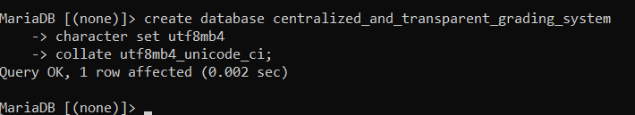

6.2 DDL – Table Creation
Provide CREATE TABLE statements showing data types, primary keys, foreign keys, NOT NULL, UNIQUE, DEFAULT, CHECK, AUTO_INCREMENT, and other appropriate constraints.
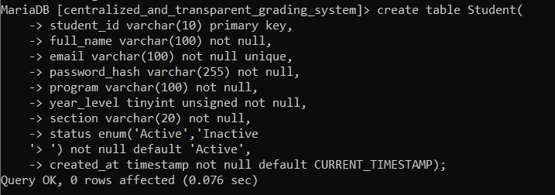
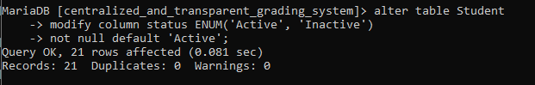
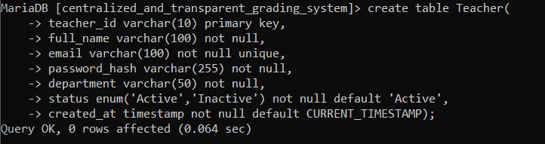
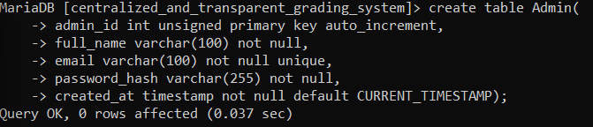
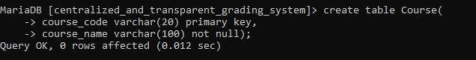
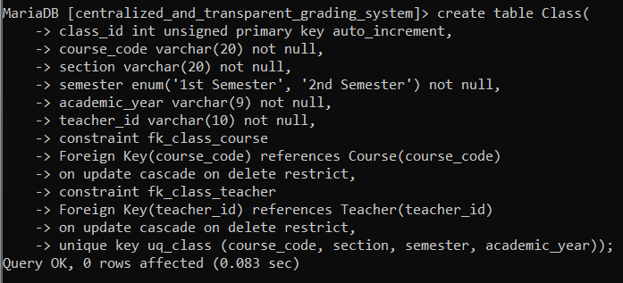
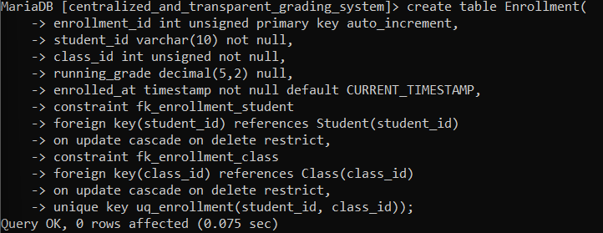
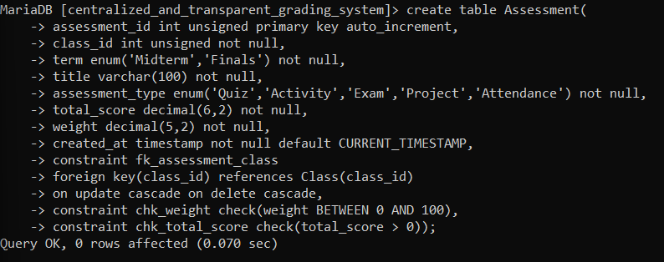
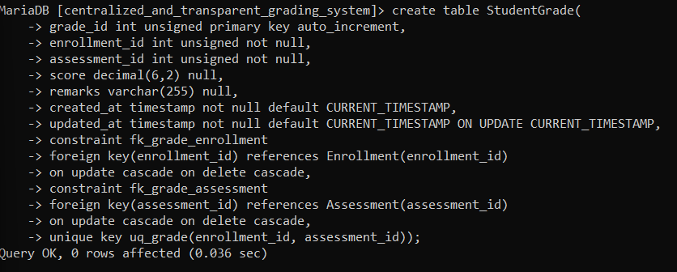
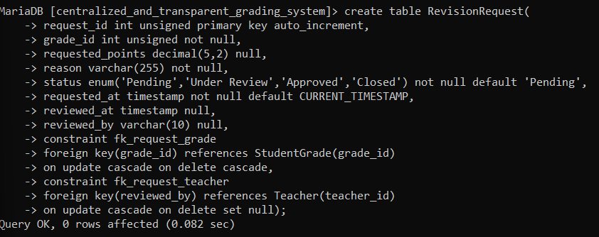
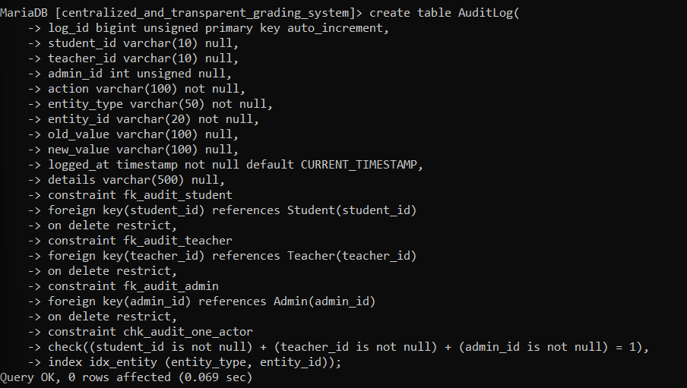

6.3 DML – Sample Data
Provide INSERT statements or approved import/bulk-load method. Include enough records to demonstrate all major system functions.
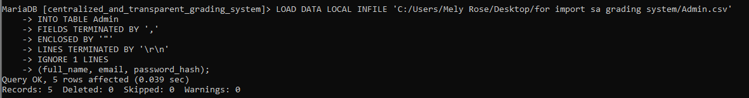
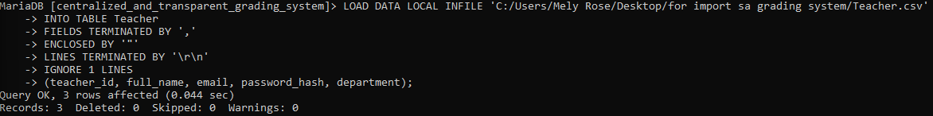
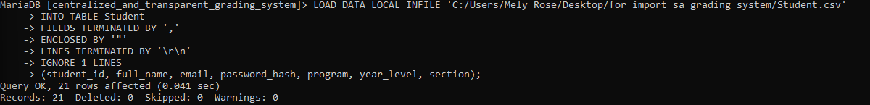
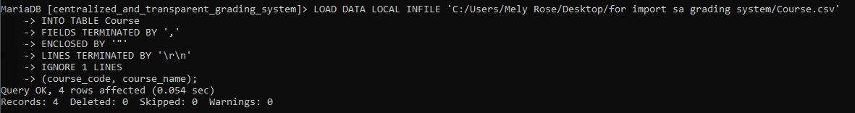
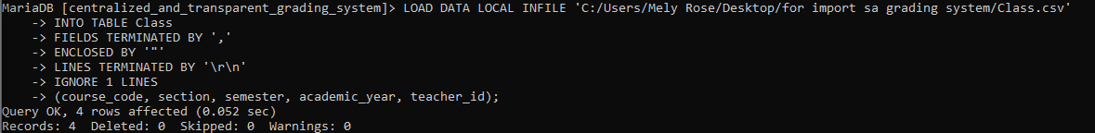
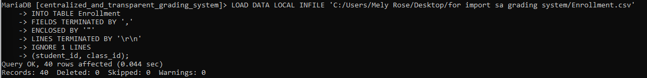
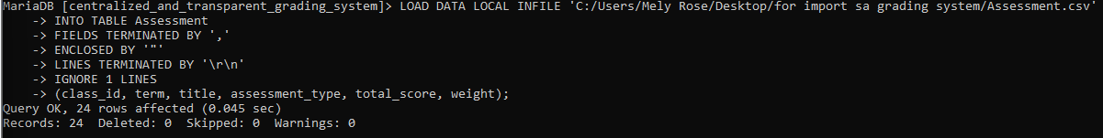
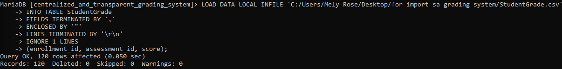
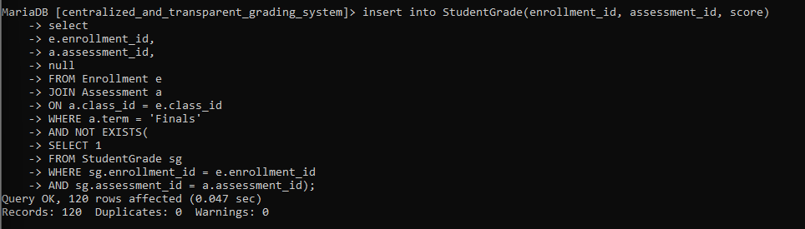
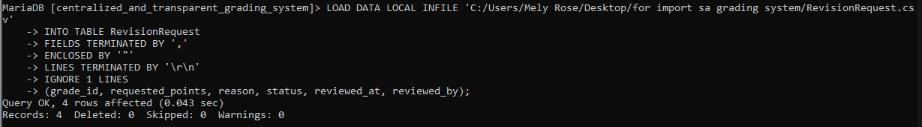
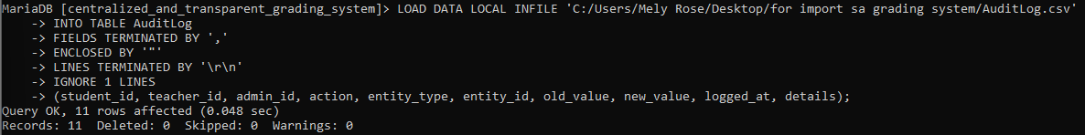

6.4 Required Queries
Provide meaningful SELECT queries using filtering, sorting, joins, aggregate functions, GROUP BY/HAVING, and other queries appropriate to the project.
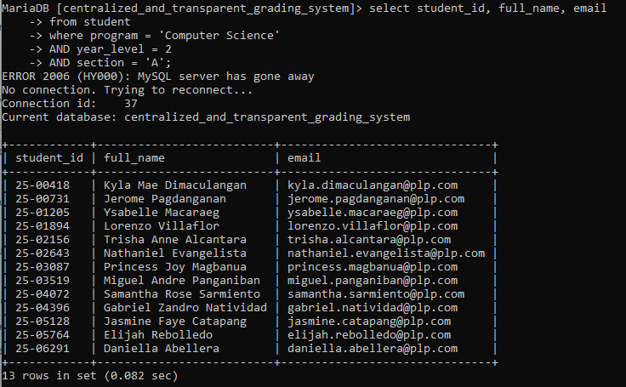

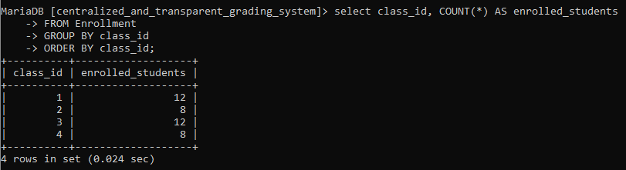

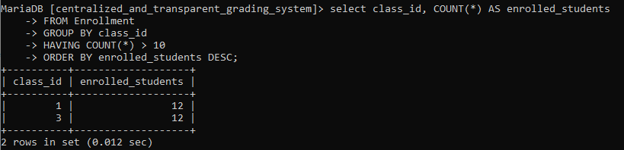

6.5 Database Evidence
Insert screenshots of the schema/tables, sample records, relationships/constraints, and selected query results.
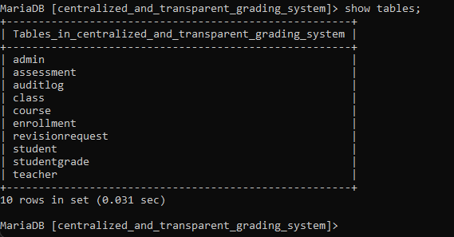
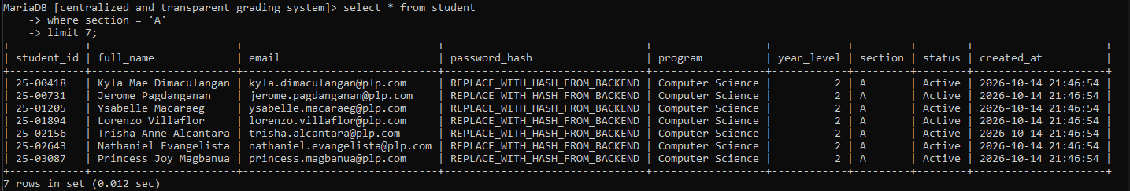
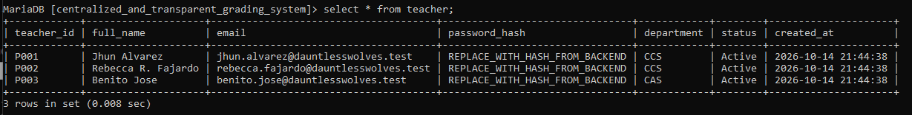
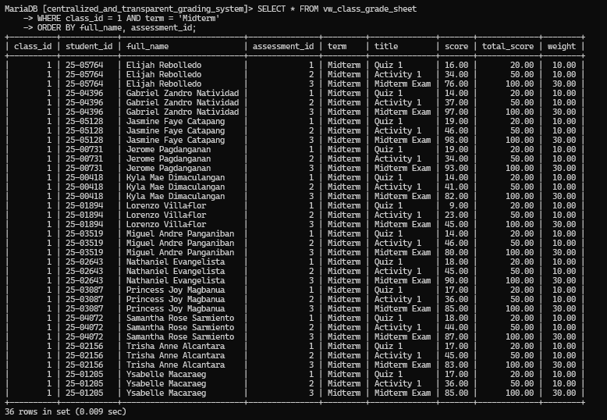
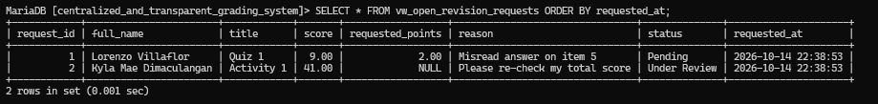
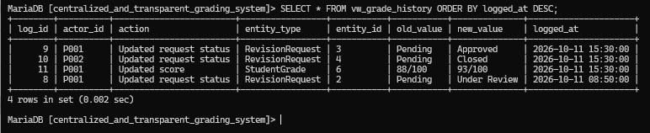

7. VB.NET System Implementation
Develop a working VB.NET front-end connected to the MySQL database. The interface must support the approved project scope and enforce relevant business rules.

7.1 Reports / Outputs
Document reports, summaries, printable forms, dashboards, or exports included in the system.
7.1 Reports / Outputs
Professor
- Class Grade Sheet: displays students' assessment scores, running grades, and academic status. It can be filtered and exported as a PDF.
- Class Performance Summary (Analytics): displays the class average, number of passing students, number of at-risk students, and highest grade.
- Averages by Assessment Type: displays average scores for quizzes, activities, examinations, and projects using progress bars.
- Audit Log – Recent Changes: records score updates and request status changes, including the affected student, item, date and time, and user responsible. It can be exported as a PDF.
- Digital Gradebook: displays students' raw scores, percentage scores, assessment results, and running grades. It also supports PDF export. Replicating the original Professor grading sheet in Excel.
- Student Grade Record: displays a selected student's assessment scores and allows professors to record scores and recalculate grades.
- Clarification Requests: displays students' grade clarification requests, including the assessment, current score, requested adjustment, reason, and request status.
Student
- My Grades (Grade Report): displays assessment scores, relative weights, running grades, and academic status. Students can filter grades by midterm, finals, or combined results and select a course.
- Grade History: displays recorded grade changes, including the date, assessment, old score, new score, person responsible, and reason.
- My Performance Overview: displays the current average, activities passed, open clarification requests, and highest score. Progress bars show performance in quizzes, activities, examinations, and projects.
- Clarification Request Status: displays submitted requests, including the course, assessment, requested action, and current status. It also shows the reviewer's response.
- Student Profile: displays the student's account information, including student ID, full name, email, program, year level, section, and account status.
- Change Password: allows the student to change their password
Admin
- Admin Dashboard: displays the total number of students, professors, active classes, and pending clarification requests. It also shows recent system updates and provides quick access to administrative functions.
- Student Records: displays student IDs, full names, year levels, sections, programs, and account statuses. Administrators can add, edit, search, filter, and delete student records.
- Professor Records: displays professor names, employee IDs, departments, assigned classes, employment types, and account statuses. Administrators can add, edit, search, filter, and delete professor records.
- Class/Subject Management: allows administrators to create classes by entering the subject code, subject name, section, assigned professor, semester, and academic year.
- Grade Entry: allows administrators to select a student, subject, and assessment before entering and saving grades.
- Clarification Requests: displays students' grade clarification requests, including the assessment, current score, requested adjustment, reason, and request status. Administrators can review requests and view the professor's response.
- Audit Logs: records administrative and system activities, including the user responsible, action performed, affected entity, previous and updated values, date, time, and additional details. Records can be filtered and exported as CSV or PDF.

7.2 System Screenshots
Insert screenshots with captions and short explanations.
STUDENT
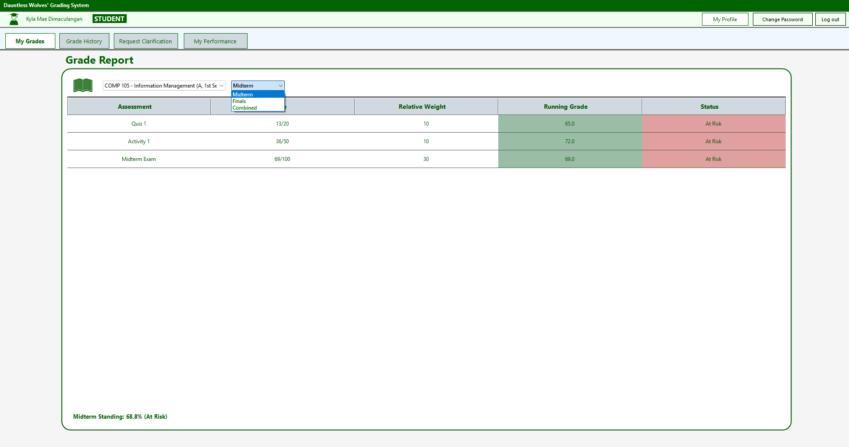
My Grades – View grades for quizzes, activities, exams, and projects. Include Midterm, Finals, and Combined views, running grades, assessment weights, and academic standing.
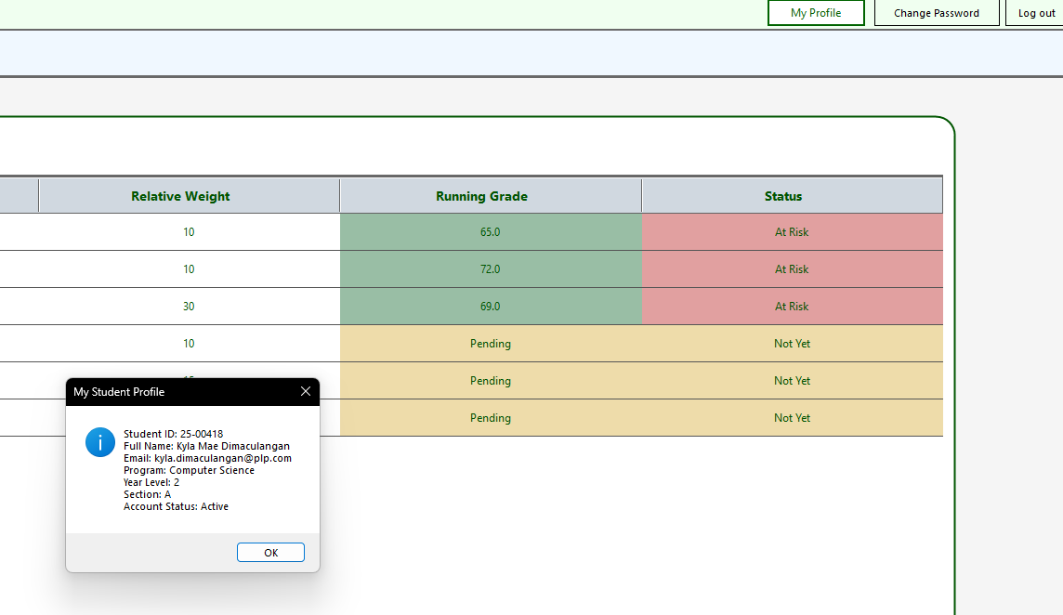

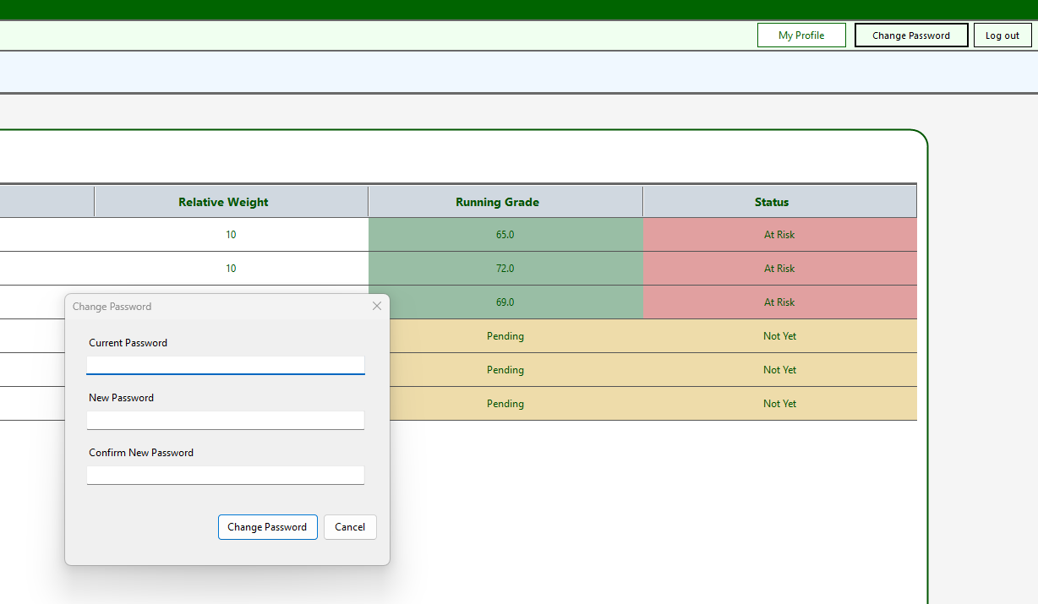
My Profile & Account Security – View student information and change the account password, with confirmation and validation.

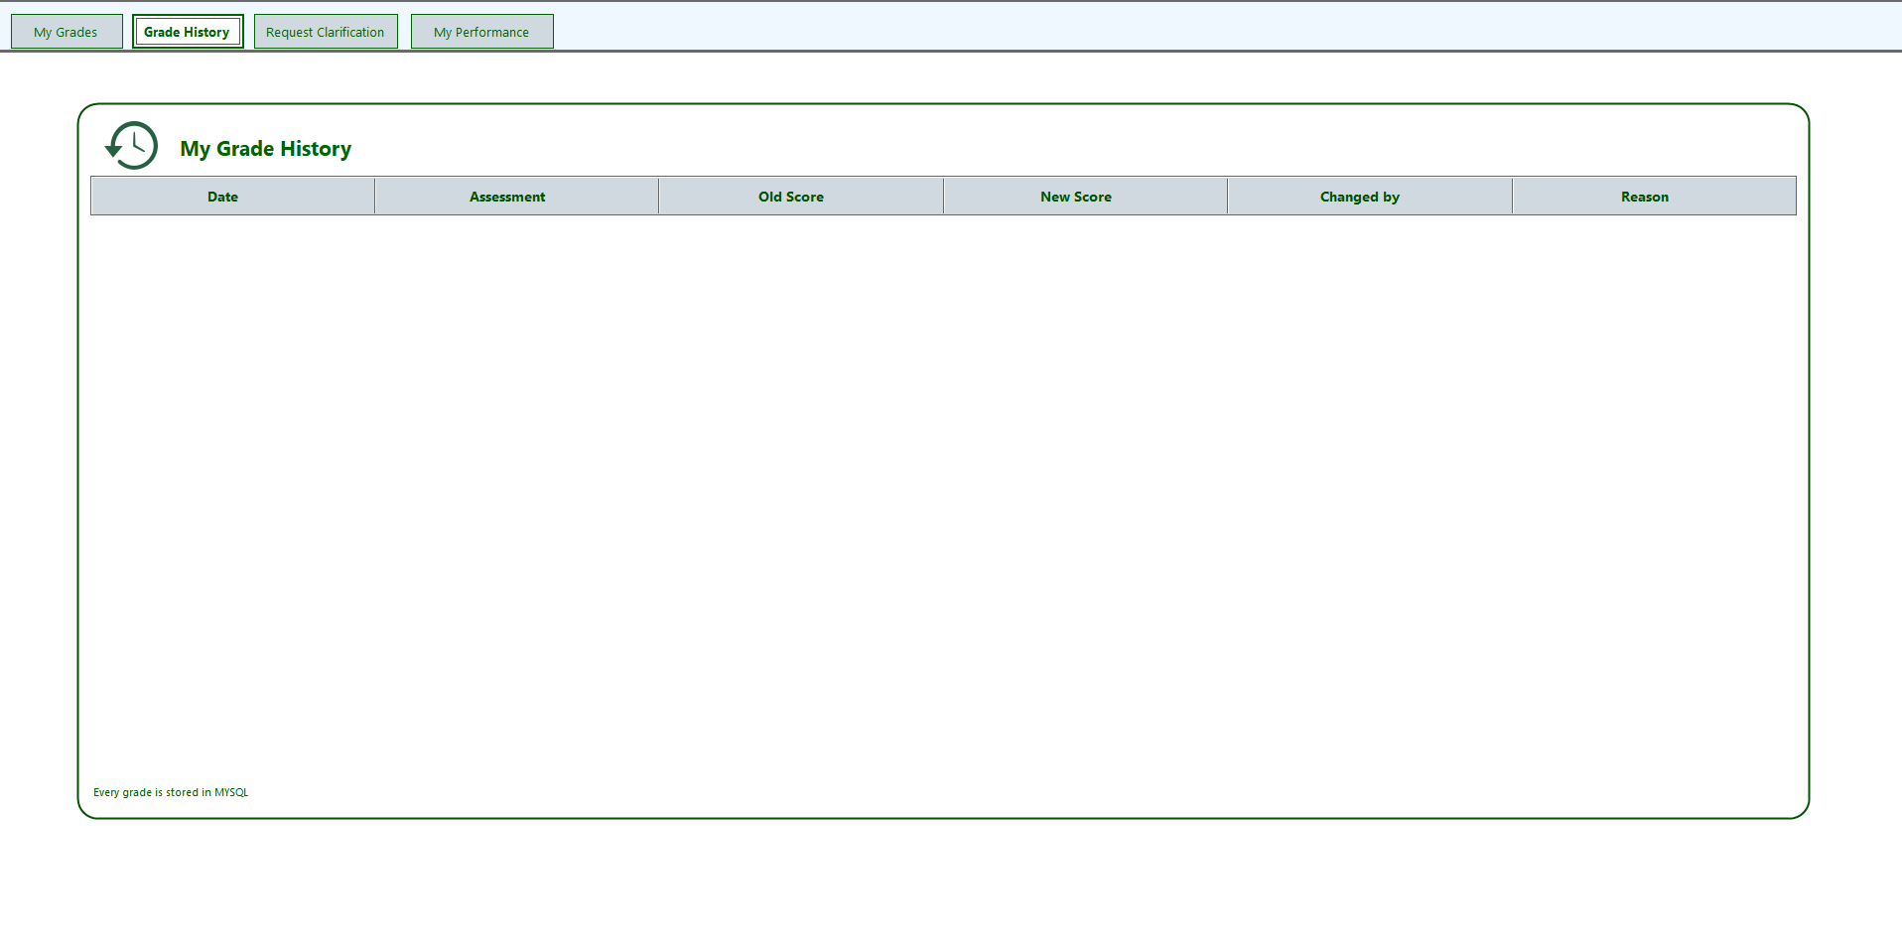
Grade History – View changes to grades, including the date, assessment, old score, new score, person who changed the grade, and reason.
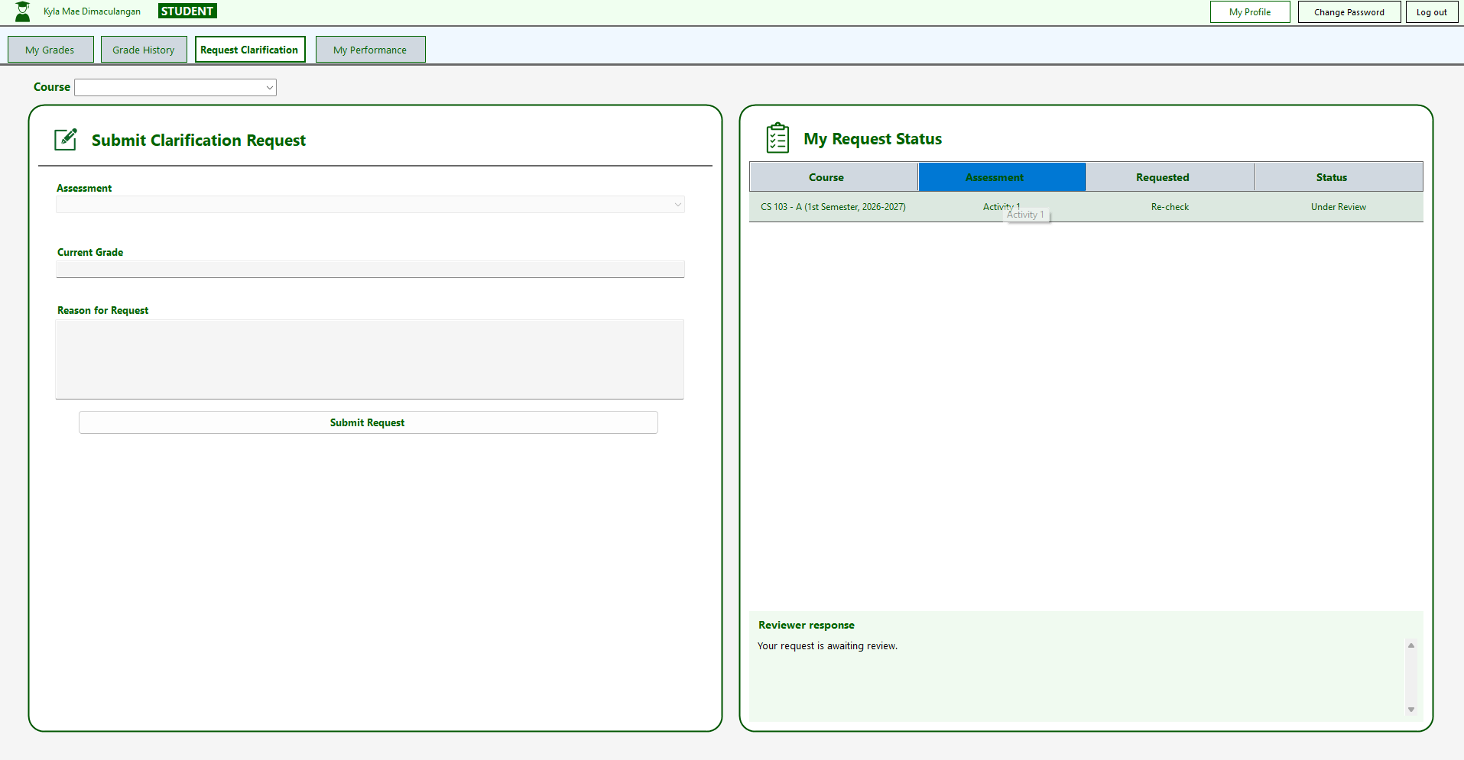
Request Clarification – Submit requests for grade rechecks, select a course and assessment, provide the current grade and reason, and track request status and reviewer responses.
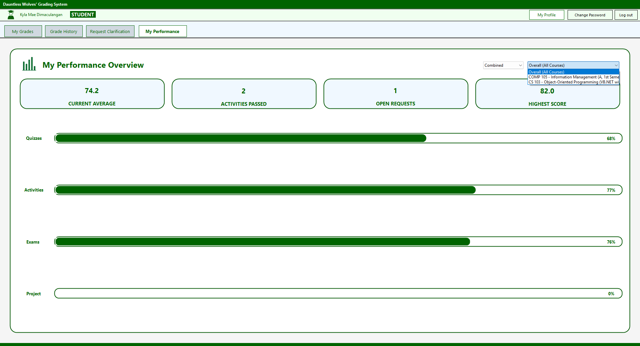
My Performance – Display the student's current average, activities passed, open requests, highest score, and performance percentages for quizzes, activities, exams, and projects.
PROFESSOR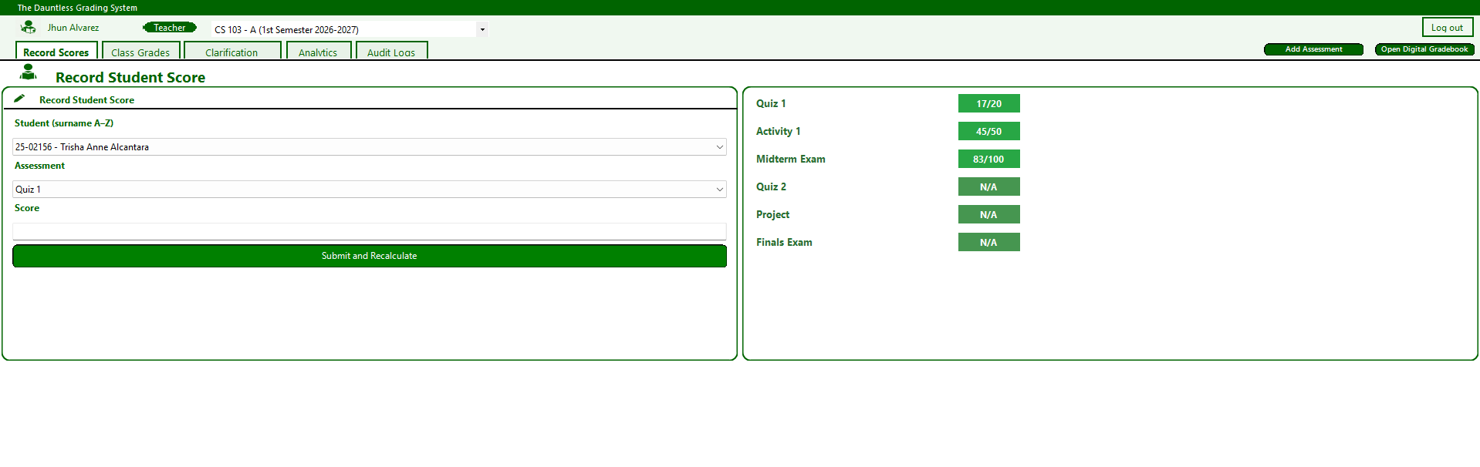Record Student Score
Allows professors to select a student, choose an assessment, enter scores, and recalculate grades automatically.

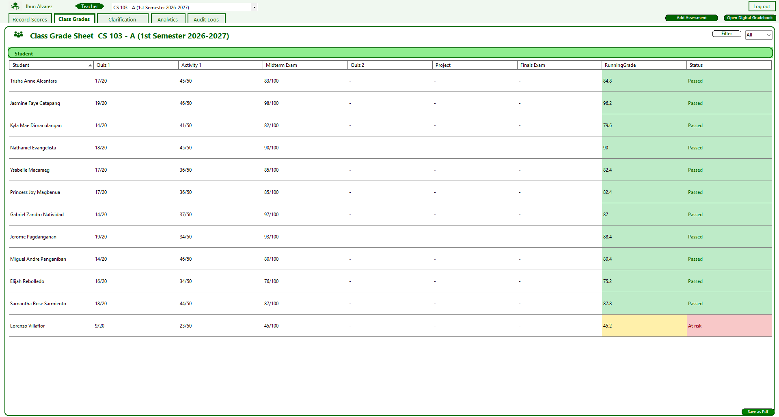
Class Grade Sheet
Displays students' assessment scores, running grades, and academic status. Professors can filter records and export the grade sheet as a PDF.

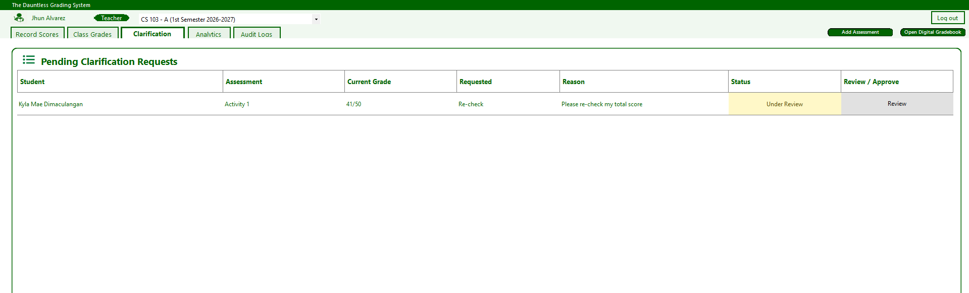
Pending Clarification Requests
Displays students' grade clarification requests, including assessment details, current grades, requested adjustments, reasons, and request statuses. Professors can review and approve requests.

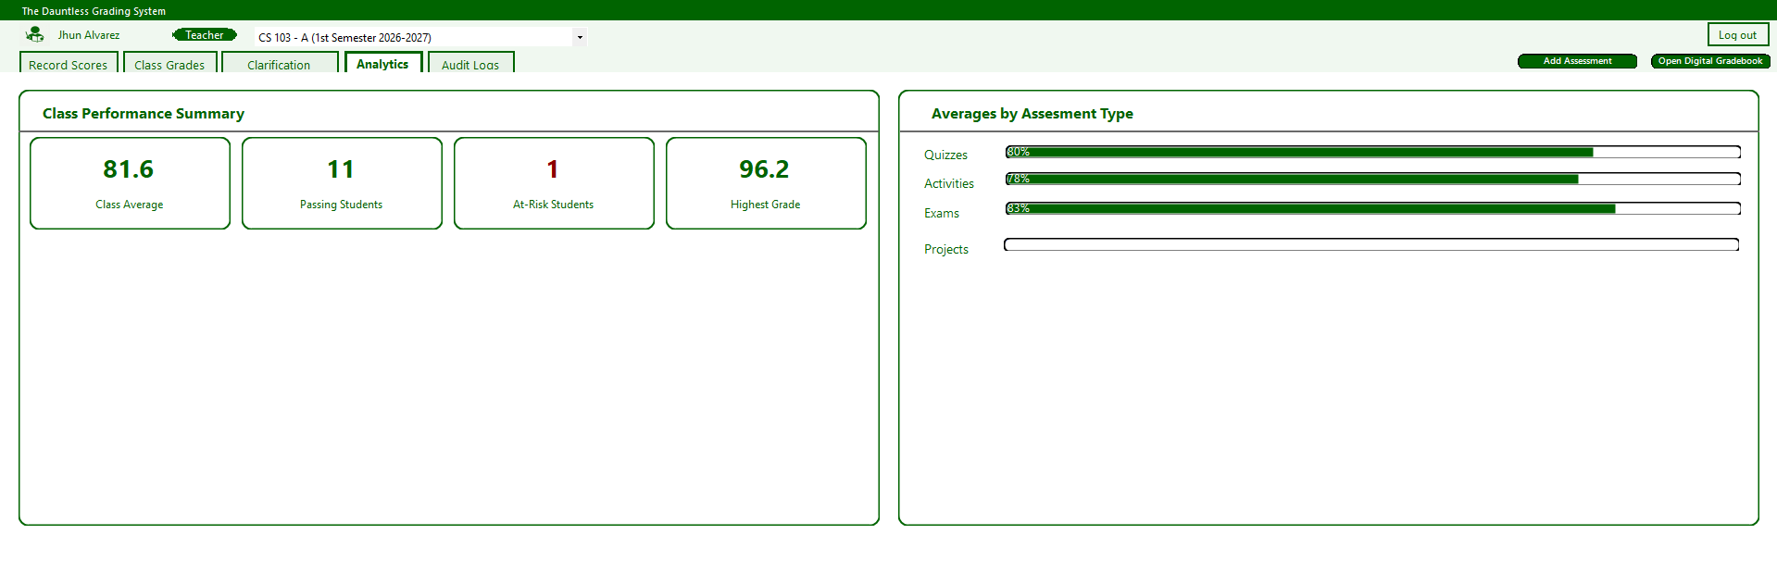
Analytics
Displays the class average, number of passing students, at-risk students, and highest grade. Progress bars summarize average performance by assessment type.
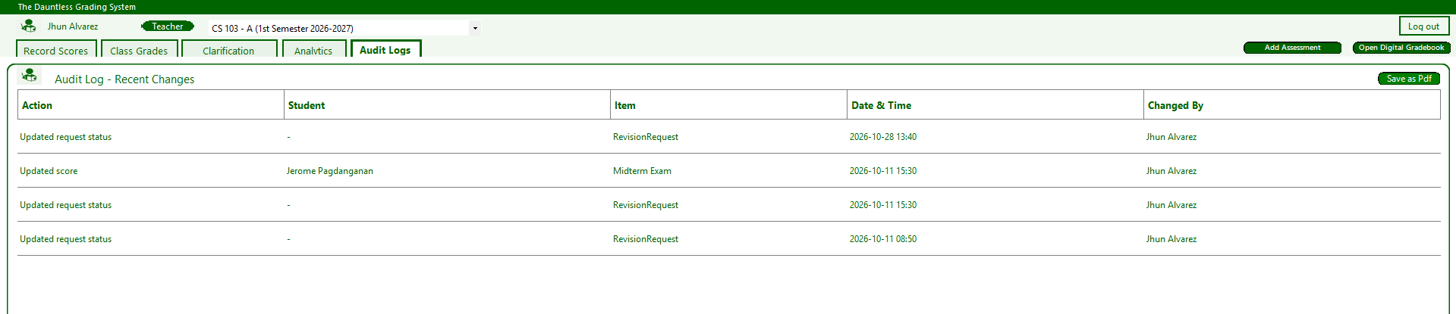
Audit Log
Records score updates and clarification request status changes, including the affected student, assessment, date and time, and responsible user. Records can be exported as a PDF.

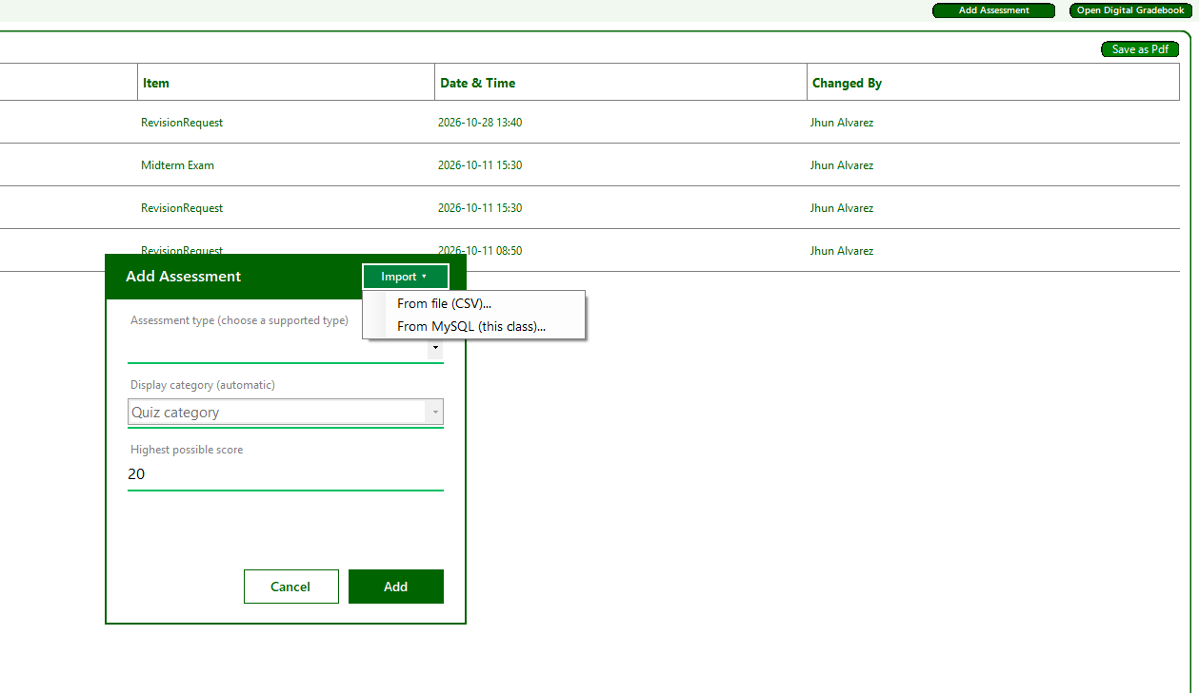
Add Assessment
Allows professors to create assessments by selecting an assessment type, display category, and highest possible score. Assessments can also be imported from CSV files or MySQL.
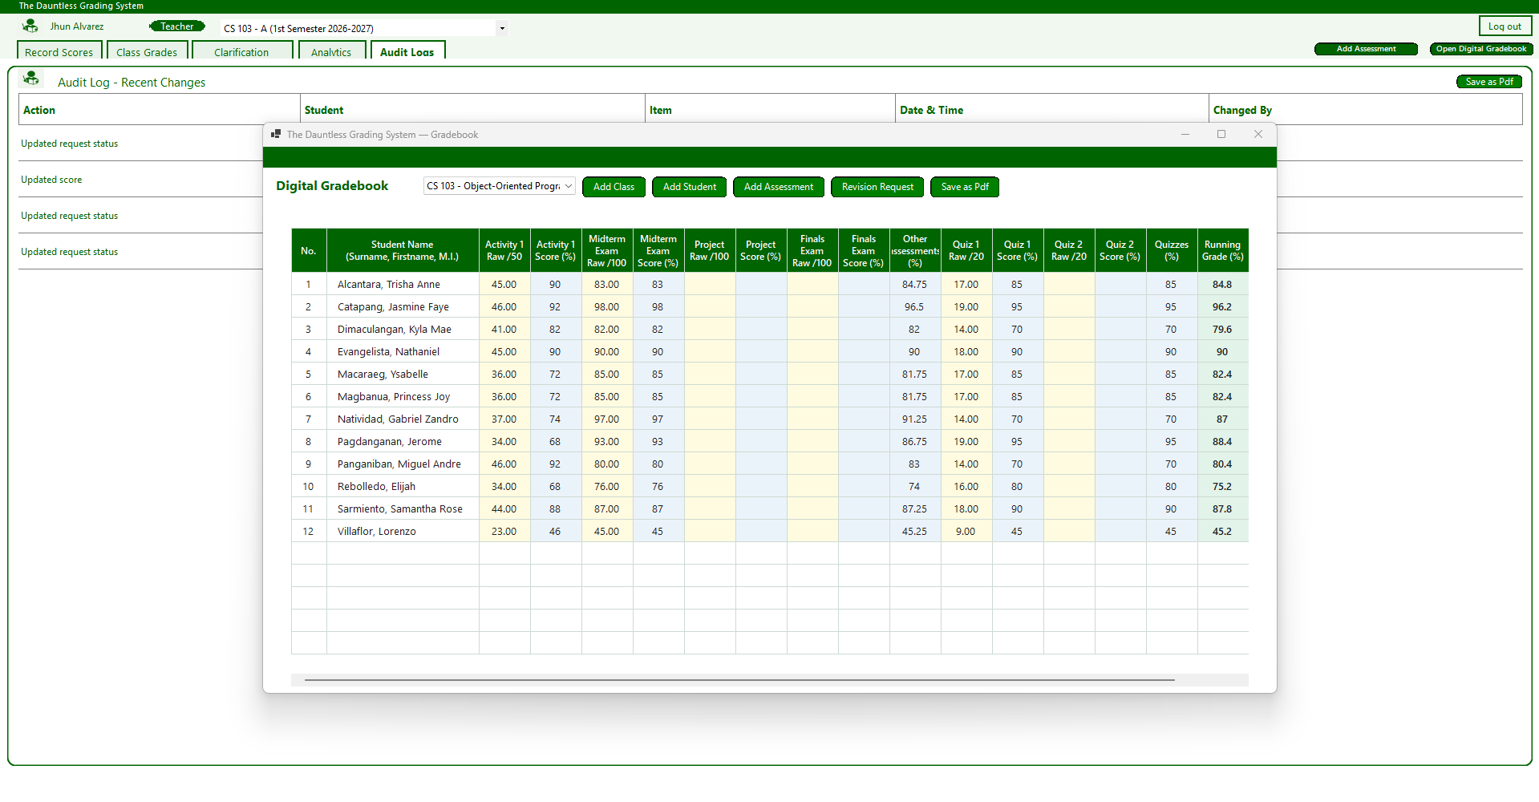
Digital Gradebook
Displays students' raw scores, percentage scores, and running grades in a spreadsheet-style layout. Professors can manage classes, students, and assessments, handle revision requests, and export the gradebook as a PDF.
ADMIN
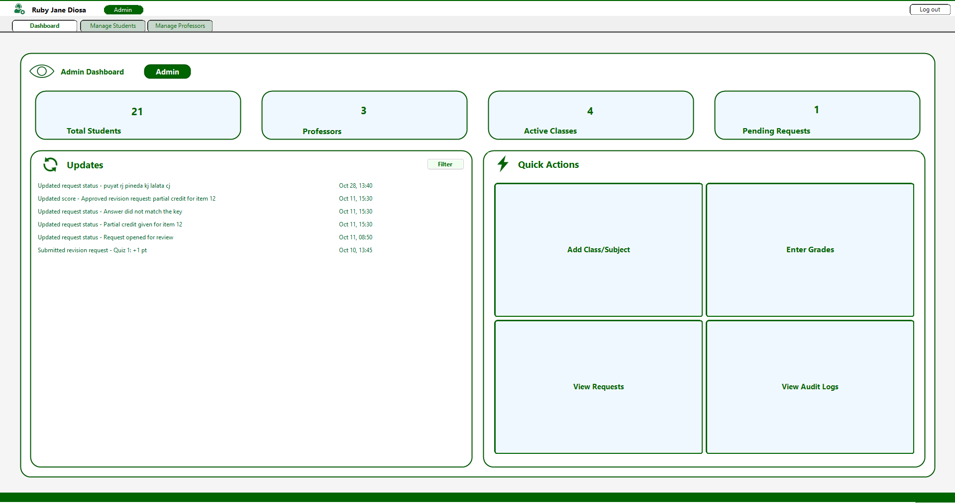
Admin Dashboard
Displays system statistics, recent updates, and quick actions for managing classes, grades, clarification requests, and audit logs.
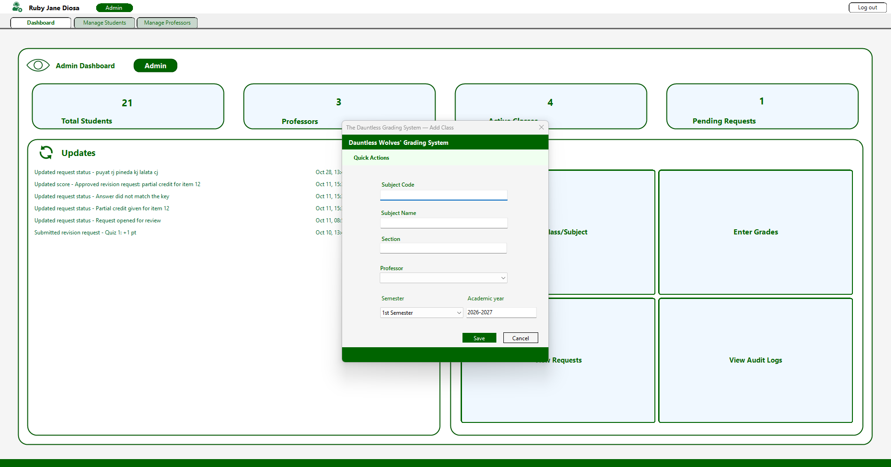
Enter Grade
Allows administrators to insert the grade of each student specific of the matching course with the ability to choose which semester.
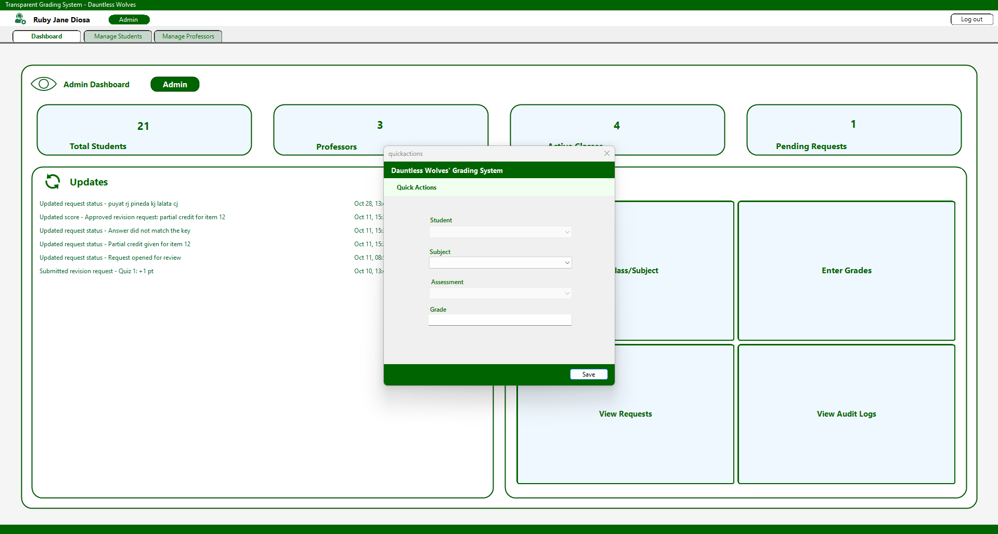
Add Class/Subject
Allows administrators to create classes by specifying subject details, sections, professors, semesters, and academic years.
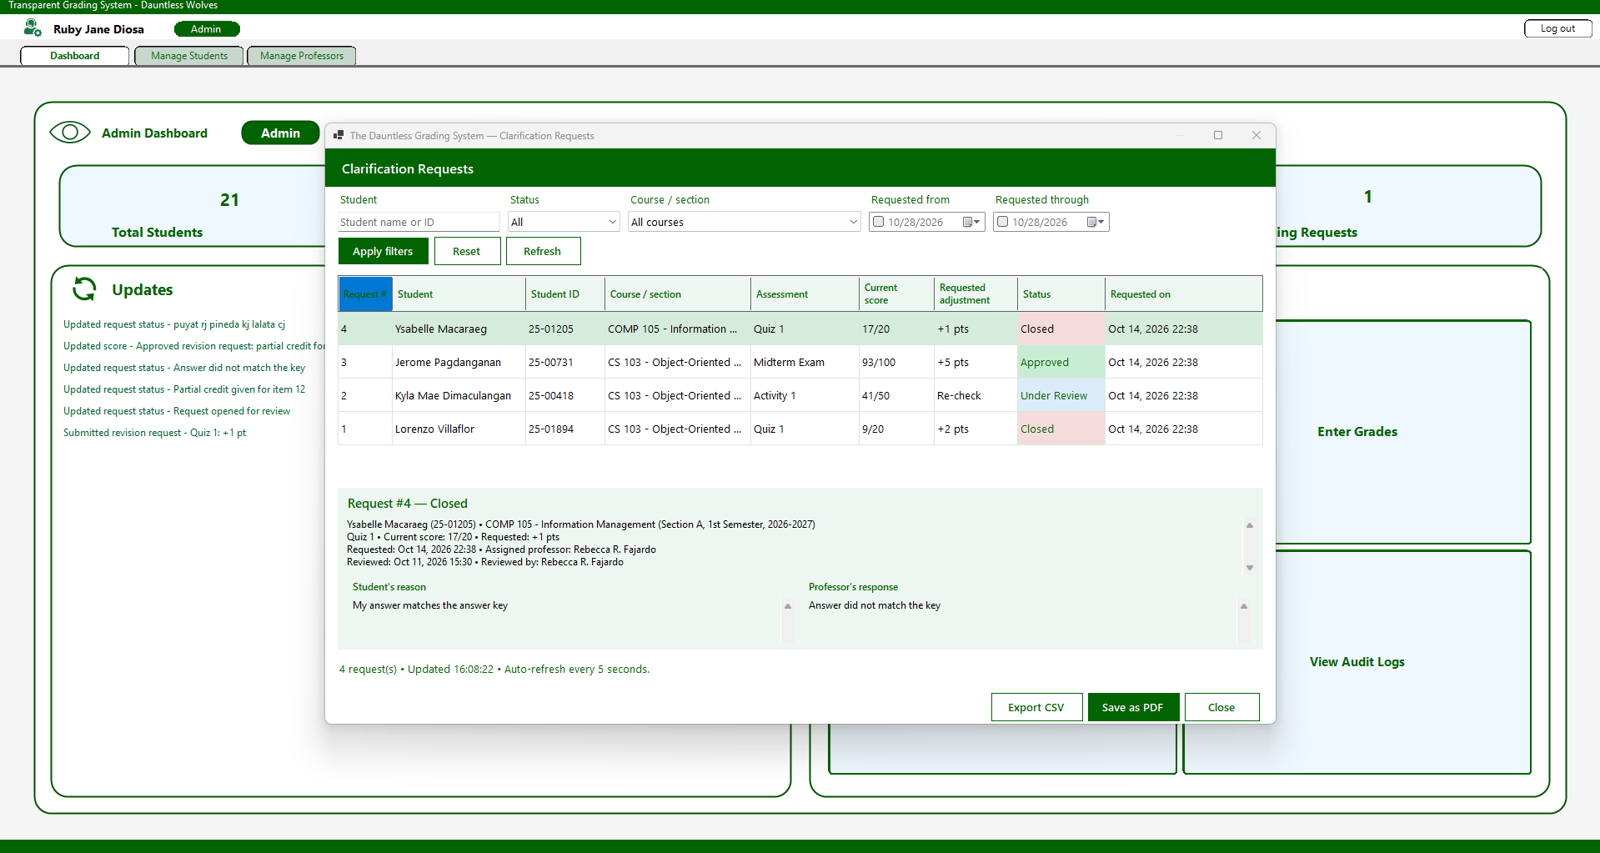
Clarification Requests
Displays students' grade clarification requests, including scores, requested adjustments, and request statuses.
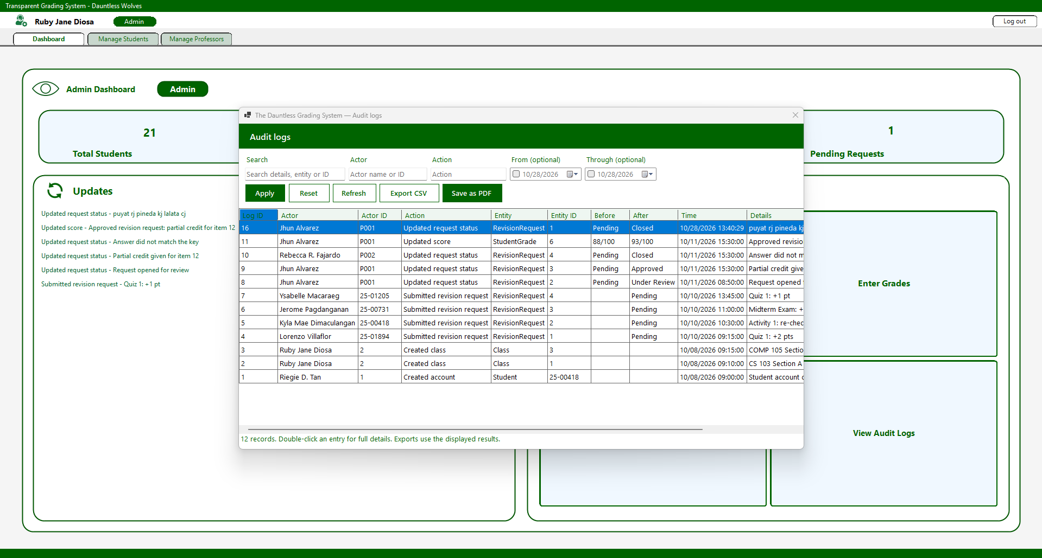
Audit Logs
Records system activities, including changes made, affected records, timestamps, and details. Administrators can also export logs to CSV or PDF.
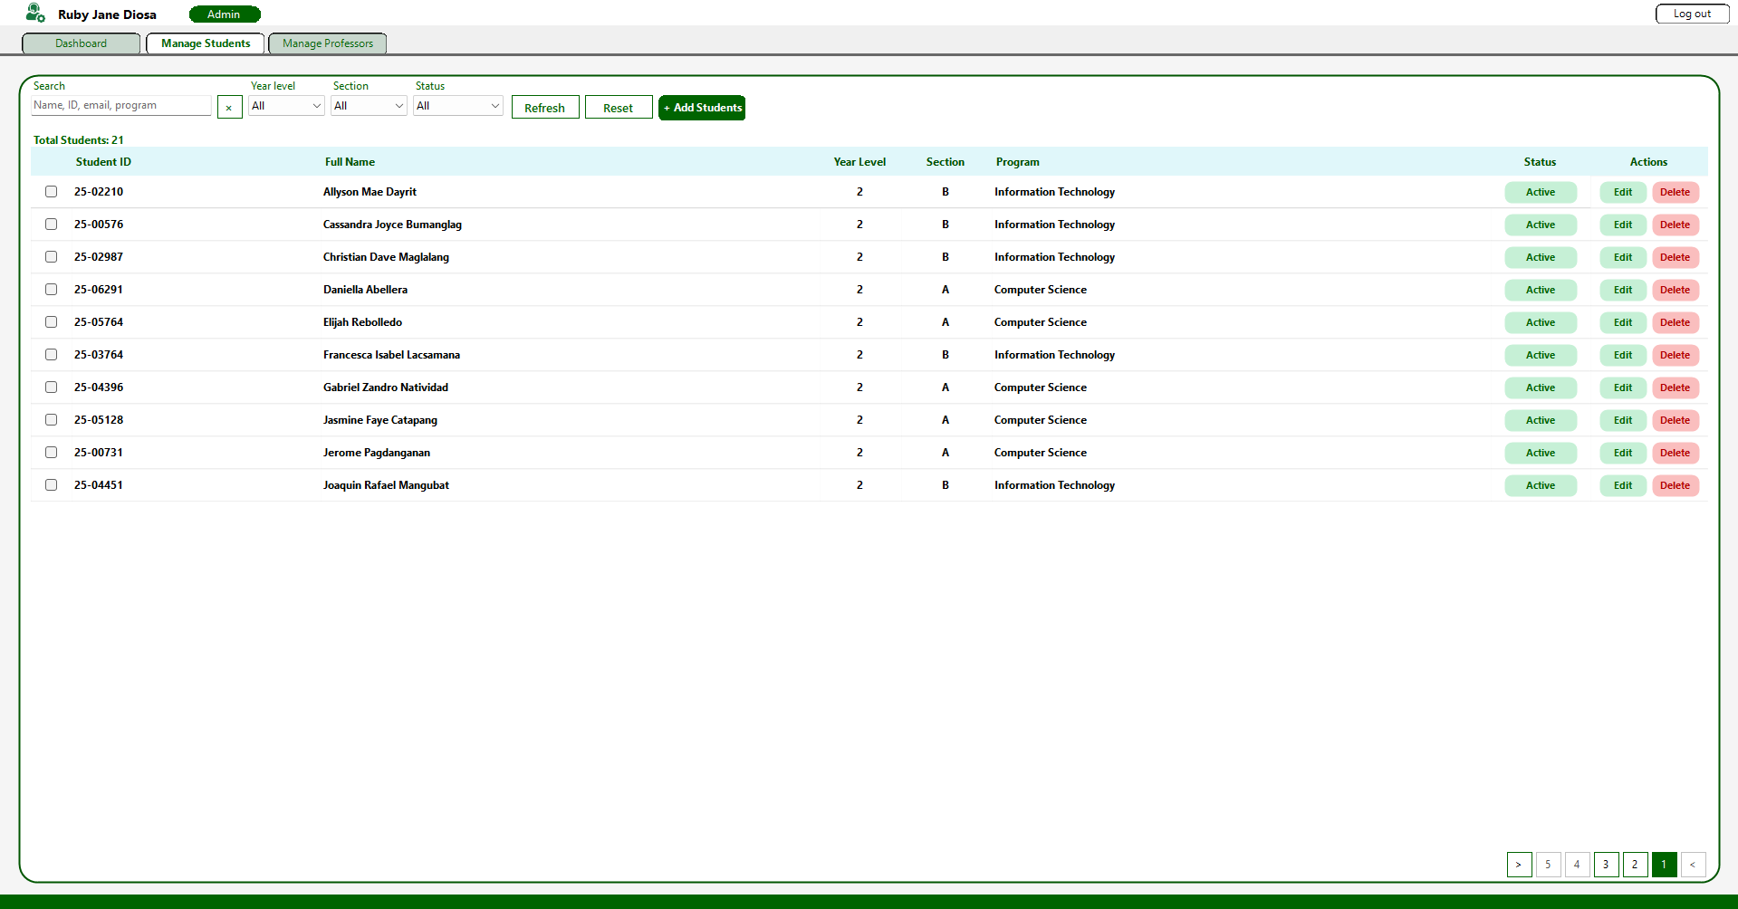
Manage Students
Allows administrators to search, filter, add, edit, and delete student records.

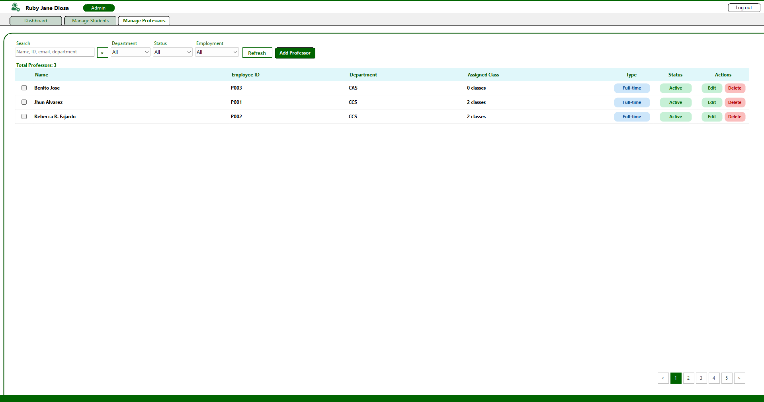
Manage Professors
Allows administrators to manage professor information, departments, employment types, and assigned classes.

7.8 Form/Module Inventory
Form/Module | Purpose | Tables Used | Main Functions | User Role
frmlogin | User login | Admin, Teacher, Student | Credential validation and navigation | All users
frmprof | Professor grading interface | Class, Course, Student, Enrollment, Assessment, StudentGrade, RevisionRequest, AuditLog | View class records and access grading panels | Professor
frmstudent | Student interface | Student, Enrollment, Class, Course, Assessment, StudentGrade, RevisionRequest, AuditLog | View grades and revision requests | Student
Admin | Administration interface | Admin, Teacher, Student, Course, Class, Enrollment, Assessment, StudentGrade, RevisionRequest, AuditLog | Manage users and class records | Admin
Database | Handles database access | All tables | Opens database connections and executes queries | System Module

8. User Manual
Write the manual for a first-time user. Use clear steps, screenshots, and expected results.

8.1 System Overview
The Transparent and Centralized Grading Management System for Pamantasan ng Lungsod ng Pasig (DAUNTLESS_WOLVES_PROF) is a desktop application developed in VB.NET WinForms paired with a MySQL/MariaDB database. It helps in transforming manual computation errors and lack of academic transparency by replacing manual spreadsheets with an automated, auditable, and role-based grading infrastructure.
The system serves three primary user groups:
- System Administrators: Responsible for institutional setup, account management (CRUD for students and professors), class assignments, and overall system audit monitoring.
- Faculty / Professors: Responsible for defining class assessment weightings, recording student raw scores, reviewing automated running grades, processing grade clarification requests, viewing performance analytics, and exporting official grade sheets.
- Enrolled Students: Responsible for tracking real-time academic performance across enrolled subjects, reviewing historical grade change logs, and submitting formal score revision requests with written justifications.

8.2 System Requirements
List hardware/software requirements and required database/connector components.
[Write your response here.]

8.3 Installation / Setup
Requirements: Windows 10/11, Visual Studio 2022, and MySQL/MariaDB (XAMPP).
- Server side
- Create the VPN network: Radmin VPN > Network > Create New Network (name + password). Note the server’s IP address.
- Start the database: open XAMPP and start MYSQL. Allow inbound TCP port 3306 in Windows Firewall
- Create the database:
[ CREATE DATABASE centralized_and_transparent_grading_system; ]
- Import the data:
[mysql -u root -p centralized_and_transparent_grading_system < centralized_and_transparent_grading_system.sql ]
- Create the app user:
[CREATE USER ‘grade’@’26.%’ IDENTIFIED BY ‘<your-password>’;
GRANT SELECT, INSERT, UPDATE, DELETE ON centralized_and_transparent_grading_system.* TO ‘gradeapp’@’26.%’;
FLUSH PRIVILEGES;}
- Client Side
- Join the VPN: Radmin VPN > Network > Join Network (same name + password).
- Install the .NET 8 Desktop Runtime
- Download the release zip file and unzip it
- Configure dbconfig.json in the same folder as the .exe:

[ {
“Host”: “26.xxx.xxx.xxx”,
“Port”: 3306,
“Database”: “centralized_and_transparent_grading_system”,
“User”: “gradapp”,
“Password”: “<your-password>”
}]
Host is the server’s Radmin IP. The template is dbconfig.example.json
- Run the .exe and log in. “DAUNTLESS WOLVES PROF”

8.4 Login / Starting the System

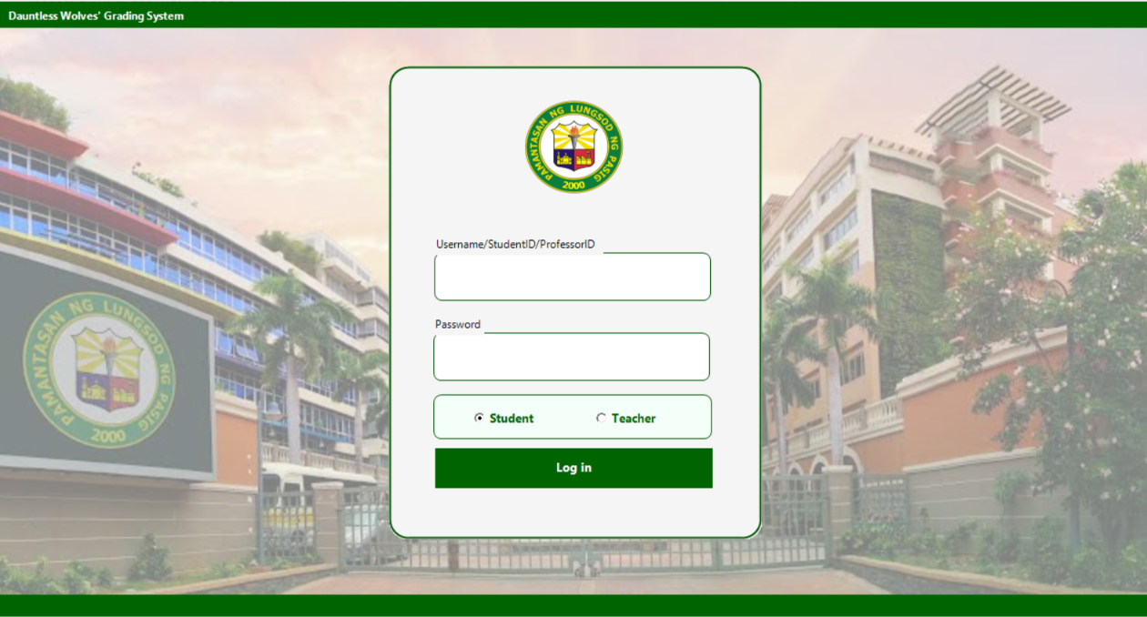
- Execute the compiled application binary (WinFormsApp2.exe).
- The User Login Portal (frmlogin.vb) will open.
- Enter your assigned User ID / Email into the txtEmailOrId field (e.g., 25-00418 for students, P001 for professors, or admin@plpasig.edu.ph).
- Enter your account Password into the txtPassword field.
- Click Log In (btnLogin).

8.5 Main Menu / Navigation

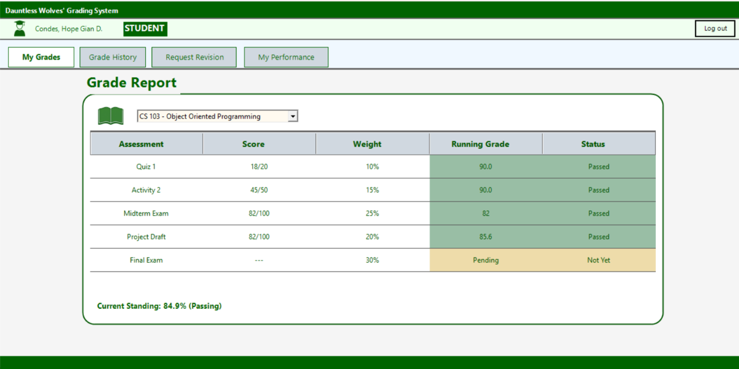
Figure 8.5.A Student Main Dashboard
- My Grades - this form exhibits the current running grade of the student, it also shows the accomplished and pending activities of the student. Status of the assessment is also indicated here.
- Grade History - Transparent timeline recording every score entry and modification, old vs. new values, teacher notes, and timestamps
- Request Revision/Clarification : Interface allowing students to select a specific score, input proposed point adjustments, attach justification notes, and submit formal clarification requests.
- My performance : It demonstrates the overall performance of the student in his/her current semester.

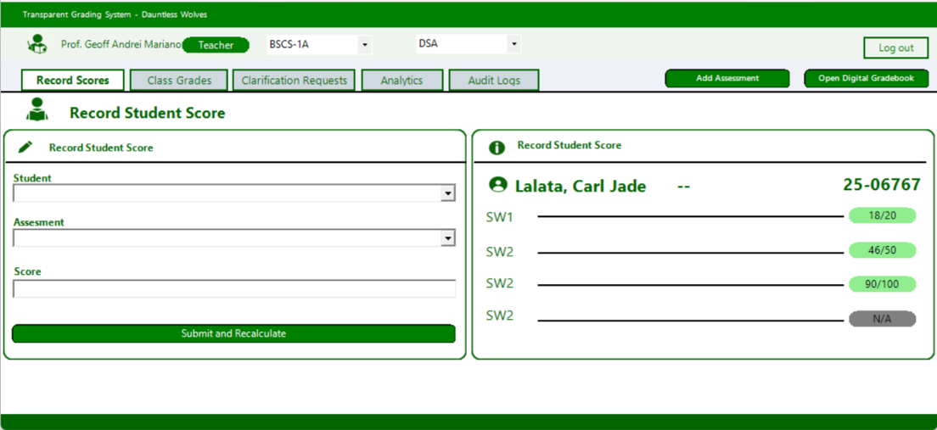
Figure 8.5.B Professors Main Dashboard
- Shows the complete class list with automatically calculated grades, visual pass/fail indicators, options to filter by term, and the ability to export results as a PDF
- Class Grades:Shows the complete class list with automatically calculated grades, visual pass/fail indicators, options to filter by term, and the ability to export results as a PDF
- Revision/Clarification Requests : Queue to evaluate student dispute requests, view written justifications, and approve or reject requested score changes.
- Class Performance Analytics: Visual graphs and progress bars showing class averages, top performers, passing distribution, and assessment breakdowns.
- Audit Logs: Maintains a detailed, timestamped log of all grade entries, modifications, and revision approvals made by faculty to ensure data integrity.
- Digital Gradebook: Displays a spreadsheet‑style, full‑screen grid of student scores across all course components, with options to export the data as a PDF.
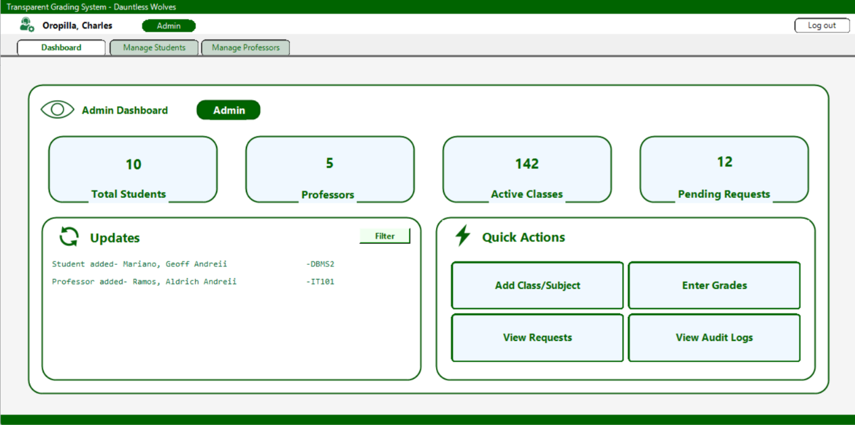
Figure 8.5.C Admin Main Dashboard
- Dashboard Analytics: Displays quick summary counters (total students, professors, active classes, pending requests) and system health metrics.
- Manage Students: Directory interface to add, edit, filter, or deactivate student accounts.
- Manage Professors: Directory interface to manage faculty listings and assign academic department parameters.
- Class & Section Offering: Module to create subject sections and link assigned professors.
- Audit History: Comprehensive log viewer recording administrative actions across the platform.

8.6 Backup / Restore or Data Maintenance

1. Database Backup Procedure
- Open a terminal or administrative command prompt on the database server host.
- Run mysqldump to generate a timestamped SQL backup file:
- Bash
mysqldump -u root -p centralized_and_transparent_grading_system > centralized_and_transparent_grading_system.sql

- Alternatively, in phpMyAdmin, select transparent_grading_system $→$ click Export $→$ select Quick Export Method $→$ click Go.

2. Database Restore Procedure
- Create or clear the target database instance.
- Execute the import command via terminal:
- Bash
mysql -u root -p centralized_and_transparent_grading_system < centralized_and_transparent_grading_system.sql

- Or import the backup .sql file using phpMyAdmin's Import tab.

9.9 Logout / Exit

1. Logging Out of an Active Session
- Click the Logout button located on the top navigation bar of any active portal.
- The application executes AppSession.ClearSession(), revoking user access credentials and clearing session data from memory.
- The active portal form closes, and the system redirects back to the User Login Portal.

10. Conclusion and Recommendations

10.1 Project Conclusion

10.2 Recommendations / Future Enhancements
While the current version meets all specified project objectives, the following realistic enhancements are recommended for future iterations:
- Cloud / Web Migration: Re-architect the client application from a WinForms desktop environment to a cloud-hosted web framework (e.g., ASP.NET Core Blazor or React with a RESTful Web API backend) to allow multi-device browser access without local software installation.
- Automated Push & Email Notifications: Integrate an automated notification engine (using SMTP or push services) to notify students immediately via email or mobile alerts when new grades are posted or revision requests are resolved.
- LMS and University SIS Integration: Develop API connectors to sync class rosters, enrollment records, and final term marks directly with the university Registrar's Student Information System (SIS) and Learning Management Systems (e.g., Canvas or Moodle).
- Native Mobile Application: Build Android and iOS companion apps using MAUI or React Native to give students quick mobile access to running grades and dispute updates.
- Predictive Performance Analytics: Incorporate machine learning models to analyze early-term assessment trends, automatically triggering early intervention alerts for students at risk of academic failure.

11. References
List references used for database concepts, programming libraries, standards, domain information, and other external materials using the citation format required by the instructor.
[Write your response here.]

12. Appendices
☐ Appendix A – Approved Concept Paper / Revision History
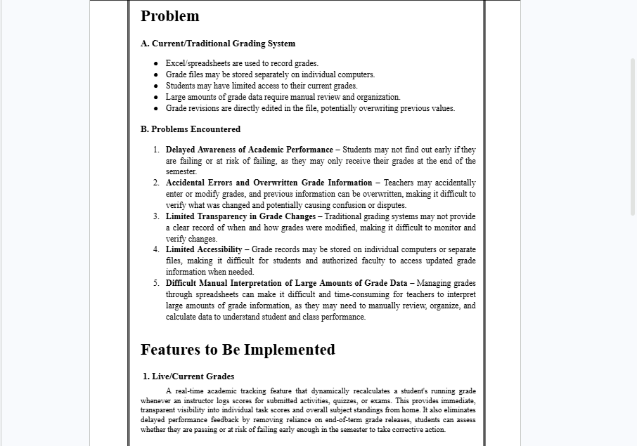



☐ Appendix B – Complete ERD
☐ Appendix C – Normalization Worksheets

☐ Appendix D – Complete SQL Script (.sql)
Appendix E – Selected VB.NET Source Code / Repository Submission Details
Repository: https://github.com/CoffeeIsThere/dauntless-wolves-re-re
Reviewed branch: main | Commit: a2037141aa3bfd7da30c50218e4ef6c553eed691 | Retrieved: 2 November 2026
Project: DAUNTLESS WOLVES PROF.sln | VB.NET, .NET 8 Windows Forms, MySQL/MariaDB. The listings below are selected excerpts, not standalone programs. Helpers and supporting methods remain in the repository. Read each listing down the left column, then down the right. Visual wrapping is for documentation only.
Code E1: GradeCalculator.vb – Shared grade calculation
Source: Services/GradeCalculator.vb, lines 1–59.
Computes assessment percentages and weighted running grades. Ungraded items are excluded; recorded zeros count; no running grade is Not Yet.
' Pure grade math. No database, so it is easy to test.  Public Class GradeCalculator  ' Passing mark: the ONE place to change it. Forms should use  this constant instead of typing 75.  Public Const PassingGrade As Double = 75.0  Public Shared Function CalculateScorePercentage(score As  Double, totalScore As Double) As Double  If totalScore <= 0 Then Return 0.0  Return Math.Round((score / totalScore) * 100, 2,  MidpointRounding.AwayFromZero)  End Function  ' Kept for older callers. Statuses are worked out when  displaying; do not store them in the database.  Public Shared Function DetermineRemarks(percentage As  Double) As String  Return If(percentage >= PassingGrade, "Passed", "Needs  Improvement")  End Function  ' Status of ONE assessment: Pending when not graded yet  Public Shared Function GetScoreStatus(score As Double?,  totalScore As Double) As String  If Not score.HasValue Then Return "Pending"  Return If(CalculateScorePercentage(score.Value,  totalScore) >= PassingGrade, "Passed", "Needs  Improvement")  End Function  ' Weighted running grade over graded items only:  ' sum(score / total x weight) / sum(weight of graded  items) x 100  ' Nothing graded yet = Nothing (NULL), never 0.  Public Shared Function CalculateRunningGrade(items As  IEnumerable(Of ScoreItem)) As Double?  Dim earned As Double = 0.0 | Dim weightUsed As Double = 0.0  For Each it As ScoreItem In items  If it.Score.HasValue AndAlso it.TotalScore > 0  AndAlso it.Weight > 0 Then  earned += (it.Score.Value / it.TotalScore) *  it.Weight  weightUsed += it.Weight  End If  Next  If weightUsed = 0 Then Return Nothing  Return Math.Round(earned / weightUsed * 100, 2,  MidpointRounding.AwayFromZero)  End Function  Public Shared Function GetStatus(runningGrade As Double?) As  String  If Not runningGrade.HasValue Then Return "Not Yet"  Return If(runningGrade.Value >= PassingGrade, "Passed",  "At risk")  End Function  End Class  ' One graded (or not yet graded) item, used by the calculator  Public Class ScoreItem  Public ReadOnly Property Score As Double?  Public ReadOnly Property TotalScore As Double  Public ReadOnly Property Weight As Double  Public Sub New(score As Double?, totalScore As Double,  weight As Double)  Me.Score = score  Me.TotalScore = totalScore  Me.Weight = weight  End Sub  End Class
Full source: https://github.com/CoffeeIsThere/dauntless-wolves-re-re/blob/a2037141aa3bfd7da30c50218e4ef6c553eed691/Services/GradeCalculator.vb

Code E2: AuthService.vb – Role-aware authentication
Source: Services/AuthService.vb, lines 7–51.
Looks up eligible accounts with a bound login parameter, verifies the password hash and upgrades supported older hashes after successful login.
Public Function VerifyLogin(login As String, rawPassword As  String, Optional preferredRole As String = Nothing) As  UserModel  Dim cleanLogin As String =  ValidationHelper.CleanInput(login)  If cleanLogin = "" OrElse  String.IsNullOrEmpty(rawPassword) Then Return  Nothing  ' Cast IDs to CHAR and fetch department/program under  'department_or_program'  Dim sql As String =  "SELECT 'Admin' AS Role, CAST(admin_id AS CHAR) AS  UserId, full_name AS FullName, email,  password_hash, '' AS department_or_program " &  "FROM admin WHERE email = @Login " &  "UNION ALL " &  "SELECT 'Teacher', CAST(teacher_id AS CHAR),  full_name, email, password_hash, department " &  "FROM teacher WHERE (email = @Login OR teacher_id =  @Login) AND status = 'Active' " &  "UNION ALL " &  "SELECT 'Student', CAST(student_id AS CHAR),  full_name, email, password_hash, program " &  "FROM student WHERE (email = @Login OR student_id =  @Login) AND status = 'Active'"  Dim params As MySqlParameter() = {New  MySqlParameter("@Login", cleanLogin)}  Dim dt As DataTable = DatabaseHelper.ExecuteQuery(sql,  params)  For Each row As DataRow In  dt.AsEnumerable().OrderByDescending(Function(r)  String.Equals(r("Role").ToString(), preferredRole,  StringComparison.OrdinalIgnoreCase)) | If preferredRole IsNot Nothing AndAlso  row("Role").ToString() <> "Admin" AndAlso Not  row("Role").ToString().Equals(preferredRole,  StringComparison.OrdinalIgnoreCase) Then  Continue For  Dim storedHash As String =  row("password_hash").ToString()  If SecurityHelper.VerifyPassword(rawPassword,  storedHash) Then  Dim role As String = row("Role").ToString()  Dim userId As String = row("UserId").ToString()  ' Old SHA-256 hashes are quietly upgraded to the  salted format after a good login  If SecurityHelper.NeedsRehash(storedHash) Then  UpgradeHash(role, userId, rawPassword)  End If  Dim deptOrProg As String = If(Not  IsDBNull(row("department_or_program")),  row("department_or_program").ToString(), "")  Return New UserModel With {  .UserId = userId,  .FullName = row("FullName").ToString(),  .Email = row("email").ToString(),  .Role = role,  .DepartmentOrProgram = deptOrProg  }  End If  Next  Return Nothing  End Function
Full source: https://github.com/CoffeeIsThere/dauntless-wolves-re-re/blob/a2037141aa3bfd7da30c50218e4ef6c553eed691/Services/AuthService.vb

Code E3: GradeService.vb – Transactional score saving
Source: Services/GradeService.vb, lines 12–32.
Wraps the shared score-saving operation in a database transaction. RecordScoreTx performs the related authorization, validation, grade update and audit work.
Public Function RecordScore(enrollmentId As Integer,  assessmentId As Integer,  newScore As Double, teacherId As  String,  Optional reason As String =  Nothing) As OperationResult  Try  Using conn As MySqlConnection =  DatabaseHelper.GetConnection()  Using tx As MySqlTransaction =  conn.BeginTransaction()  Try  Dim res As OperationResult =  RecordScoreTx(conn, tx, enrollmentId,  assessmentId, newScore, teacherId, reason)  If res.Success Then tx.Commit() Else | tx.Rollback()  Return res  Catch  tx.Rollback()  Throw  End Try  End Using  End Using  Catch ex As Exception  Console.WriteLine("[RECORD SCORE ERROR] " &  ex.Message)  Return OperationResult.Fail("Could not save the  score: " & ex.Message)  End Try  End Function
Full source: https://github.com/CoffeeIsThere/dauntless-wolves-re-re/blob/a2037141aa3bfd7da30c50218e4ef6c553eed691/Services/GradeService.vb

Code E4: RevisionRequestService.vb – Revision approval and score correction
Source: Services/RevisionRequestService.vb, lines 276–315.
Checks the active assigned teacher and open request, determines the corrected score, and updates the decision and grade within the caller’s transaction.
Private Function ApproveTx(conn As MySqlConnection, tx As  MySqlTransaction,  requestId As Integer, teacherId  As String,  overrideScore As Double?,  reviewerResponse As String) As OperationResult  If Not AccountAccess.IsActive(conn, tx, "Teacher",  teacherId) Then Return OperationResult.Fail("Your  professor account is inactive.")  Dim info As RequestInfo = LoadRequest(conn, tx,  requestId)  Dim check As OperationResult = CheckOpenAndOwned(info,  teacherId)  If Not check.Success Then Return check  Dim target As Double  If overrideScore.HasValue Then  target = overrideScore.Value  ElseIf info.RequestedPoints.HasValue AndAlso  info.CurrentScore.HasValue Then  target = Math.Min(info.CurrentScore.Value +  info.RequestedPoints.Value, info.TotalScore)  Else  Return OperationResult.Fail("NEEDSCORE")  End If  ' Mark the request approved (only if it is still open)  Dim rows As Integer  Dim updateSql As String =  "UPDATE revisionrequest SET status = 'Approved',  reviewed_at = NOW(), reviewed_by = @TeacherId "  &  "WHERE request_id = @RequestId AND status IN | ('Pending','Under Review')"  Using cmd As New MySqlCommand(updateSql, conn, tx)  cmd.Parameters.AddWithValue("@TeacherId", teacherId)  cmd.Parameters.AddWithValue("@RequestId", requestId)  rows = cmd.ExecuteNonQuery()  End Using  If rows <= 0 Then Return OperationResult.Fail("The  request could not be updated.")  ' Apply the score through the same code path as normal  grading (ownership, range, running grade, audit)  Dim gradeRes As OperationResult =  _gradeService.RecordScoreTx(conn, tx,  info.EnrollmentId, info.AssessmentId, target,  teacherId,  "Approved revision request #" & requestId.ToString())  If Not gradeRes.Success Then Return gradeRes  ' Log the decision itself too (the score change was  logged by RecordScoreTx)  AuditService.LogActionTx(conn, tx, "Teacher", teacherId,  "Updated request status", "RevisionRequest",  requestId.ToString(),  info.Status, StatusApproved, "Score set to " &  Fmt(target) & "/" & Fmt(info.TotalScore) &  If(String.IsNullOrWhiteSpace(reviewerResponse),  "", vbCrLf & reviewerResponse.Trim()))  Return OperationResult.Ok("Request #" &  requestId.ToString() & " approved. Score is now " &  Fmt(target) & "/" & Fmt(info.TotalScore) & ".")  End Function
Full source: https://github.com/CoffeeIsThere/dauntless-wolves-re-re/blob/a2037141aa3bfd7da30c50218e4ef6c553eed691/Services/RevisionRequestService.vb

Code E5: DatabaseHelper.vb – Parameterized database query
Source: Core/DatabaseHelper.vb, lines 75–88.
Uses the configured connection and supplied parameters to execute a query and return its rows as a DataTable.
Public Shared Function ExecuteQuery(sql As String,  ParamArray params As MySqlParameter()) As DataTable  Dim dt As New DataTable()  Using conn As MySqlConnection = GetConnection()  Using cmd As New MySqlCommand(sql, conn)  If params IsNot Nothing AndAlso params.Length >  0 Then  cmd.Parameters.AddRange(params) | End If  Using adapter As New MySqlDataAdapter(cmd)  adapter.Fill(dt)  End Using  End Using  End Using  Return dt  End Function
Full source: https://github.com/CoffeeIsThere/dauntless-wolves-re-re/blob/a2037141aa3bfd7da30c50218e4ef6c553eed691/Core/DatabaseHelper.vb

Code E6: StudentProfileService.vb – Student-scoped profile summary
Source: Services/StudentProfileService.vb, lines 6–37.
Reads the logged-in student’s profile, class grades and open-request count without changing academic records. Uses the shared grade calculator.
Public Function LoadCurrent() As StudentProfileSnapshot  If Not AppSession.IsStudent Then Throw New  UnauthorizedAccessException("Student access is  required.")  Dim studentId = AppSession.CurrentUser.UserId  Using conn = DatabaseHelper.GetConnection()  Using tx =  conn.BeginTransaction(IsolationLevel.RepeatableR  ead)  Dim profile = ReadTable(conn, tx, "SELECT  student_id,full_name,email,program,year_level,se  ction,status FROM student WHERE  student_id=@Student", studentId)  If profile.Rows.Count <> 1 Then Throw New  InvalidOperationException("Student profile not  found.")  Dim grades = ReadTable(conn, tx,  "SELECT e.enrollment_id,c.course_code,co.cou  rse_name,c.section,c.semester,c.academic_year,sg  .score,a.total_score,a.weight " &  "FROM enrollment e JOIN class c ON  c.class_id=e.class_id JOIN course co ON  co.course_code=c.course_code " &  "LEFT JOIN assessment a ON  a.class_id=c.class_id LEFT JOIN studentgrade sg  ON sg.enrollment_id=e.enrollment_id AND  sg.assessment_id=a.assessment_id " &  "WHERE e.student_id=@Student ORDER BY  c.course_code,c.academic_year,c.semester,c.secti  on", studentId)  Dim requests = ReadTable(conn, tx,  "SELECT COUNT(*) AS open_count FROM  revisionrequest r JOIN studentgrade sg ON  sg.grade_id=r.grade_id " &  "JOIN enrollment e ON  e.enrollment_id=sg.enrollment_id WHERE  e.student_id=@Student AND r.status IN | ('Pending','Under Review')", studentId)  Dim classes As New DataTable()  classes.Columns.Add("Class", GetType(String))  classes.Columns.Add("Running Grade (%)",  GetType(Double))  classes.Columns.Add("Standing", GetType(String))  For Each group In  grades.AsEnumerable().GroupBy(Function(row)  CInt(row("enrollment_id")))  Dim first = group.First()  Dim items = group.Where(Function(row) Not  IsDBNull(row("total_score")) AndAlso Not  IsDBNull(row("weight"))).  Select(Function(row) New  ScoreItem(If(IsDBNull(row("score")),  CType(Nothing, Double?), CDbl(row("score"))),  CDbl(row("total_score")), CDbl(row("weight"))))  Dim grade =  GradeCalculator.CalculateRunningGrade(items)  Dim label = first("course_code").ToString()  & " — " & first("course_name").ToString() & " |  " & first("section").ToString() & " | " &  first("semester").ToString() & " | " &  first("academic_year").ToString()  classes.Rows.Add(label, If(grade.HasValue,  CType(grade.GetValueOrDefault(), Object),  DBNull.Value), GradeCalculator.GetStatus(grade))  Next  tx.Commit()  Return New StudentProfileSnapshot With {.Profile  = profile.Rows(0), .Classes = classes,  .OpenRequests =  CInt(requests.Rows(0)("open_count"))}  End Using  End Using  End Function
Full source: https://github.com/CoffeeIsThere/dauntless-wolves-re-re/blob/a2037141aa3bfd7da30c50218e4ef6c553eed691/Services/StudentProfileService.vb
☐ Appendix F – Additional Test Evidence
☐ Appendix G – Additional User Manual Screenshots
☐ Appendix H – Other Instructor-Required Evidence

Final Submission Checklist
☐ Concept Paper is complete and approved/revised.
☐ Business Rules are clear and reflected in the ERD.
☐ ERD matches the final normalized tables.
☐ Normalization process shows 1NF, 2NF, and 3NF—not only the final answer.
☐ Data Dictionary matches the MySQL database.
☐ MySQL database contains correct constraints and sufficient sample data.
☐ VB.NET system is connected to the submitted MySQL database.
☐ CRUD, validation, and required project functions are working.
☐ Test Cases include expected and actual results with evidence.
☐ User Manual is understandable to a first-time user.
☐ All screenshots are readable and captioned.
☐ All files use the required naming convention and are submitted in the required format.

REQUIRED Electronic Submission Package
Recommended folder structure: Folder name: Group # and Title
01_Documentation/
Final_Project_Documentation.docx
Final_Project_Documentation.pdf
02_Database/
database.sql
sample_data.sql
03_VBNet_System/
[Visual Studio solution/project files]
04_Test_Evidence/
[screenshots and test files]
05_User_Manual/
User_Manual.pdf
06_Grade/
Indi_score.xlsx

