DOM

**DEADLINE:** 16/10/2021

## FOLDER STRUCTURE

|  |  |
| --- | --- |
| FL17_HW8/ [*]  ├─ task [**]  ├─ homework/ [*]  ├─ external-service.js [*]  ├─ index.html [*]  ├─ styles.css [*]  ├─ app.js [*]  └─ .eslintrc.js [*] | [*]  - required  [**] - restricted (no need to submit) |

TASK

* Application’s header
  + Application’s header with the title “Countries Search” should be added at the top of the applicationApplication form
  + Form should consist of two fields
  + “Type of Search” field:
    - The first field should consist of two radio buttons with labels (By Region, By Language)
    - Description “Please choose the type of search:” should be added before radio buttons
  + Search query field
    - The second field should be a dropdown (can be used <select>) component.
    - If in the first field was selected “By region” value the expanded select should consist of possible regions otherwise all possible languages.
    - Before the dropdown should be description “Please choose search query:”
    - In case if value is not selected “Select value” should be shown in the dropdown
    - If value from the first field is not chosen the select should be disabled
    - 
    - List of languages and regions you can receive from externalService object. For instance:
      * externalService.getRegionsList(),
      * externalService.getLanguagesList()
* Application table
  + If the search query is not selected then the label “No items, please choose search query” should be shown instead of the table
  + Once a user choose search query then a table with results should be shown
    - Table should consist of 6 columns
      * Country name
      * Capital
      * World region
      * Languages (should be shown all official languages in a country)
      * Area
      * Flag (Should be shown a flag of an appropriate country)  
        Can be included with next way: <img src=”flagURL”>  
        The URL can be taken from the countryList
    - You can receive countryList from externaService module
      * externalService.getCountryListByRegion(query);
      * externalService.getCountryListByLanguage(query);
  + Sorting
    - Next to Country Name and Area should be added arrows
    - Examples:  
        
    - When a user clicks on the arrow then sorting should be applied in the table.
    - When up arrow is shown then the rows should be sorted in ascending order
    - When down arrow is shown then rows should be sorted in descending order
    - In case double-sided arrow the sorting is not applied with column’s criteria
  + Table design
    - If the cursor on the row then the row should be highlighted
    - 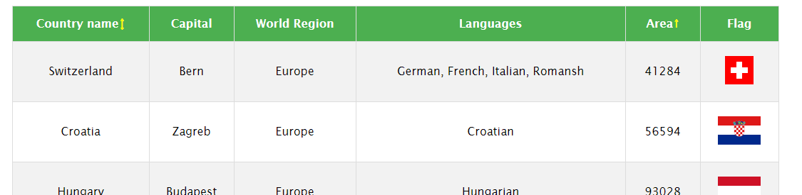
    - Feel free to use a table’s design that you prefer (colors)

RESTRICTIONS

* Editing index.html and external-service.js are forbidden.
* Adding **task/** folder is forbidden. Do not push it to repository. (Only **homework/** folder should be pushed)
* External libraries usage is forbidden

## BEFORE SUBMIT

* Code should be clean, without comments, readable, and tested
* Make sure your GitLab folder structure meets folder structure from this document (without **task** folder)

## SUBMIT

* The **FL17_HW8** folder without **task** folder should be uploaded to GitLab repository “**FL-17**” into **main** branch.

## USEFUL LINKS

* <https://developer.mozilla.org/uk/docs/Web/API/Document>