Supply Chain Analytics
A Data-Driven Investigation into Delays, Profitability & Prediction
Dataset: DataCo Supply Chain (Kaggle) | Tools: Python, Pandas, Scikit-learn, XGBoost
Analysis by: Rohan Maharana

1. Introduction
This report presents an end-to-end analysis of the DataCo Supply Chain dataset sourced from Kaggle. The dataset contains 172,765 orders (after removing cancelled shipments) spanning global regions, multiple shipping modes, customer segments, and product categories. The goal was to go beyond surface-level summaries and ask harder business questions: where is the supply chain losing money, what is driving delays, and can a machine learning model predict a late delivery before it happens?
The analysis was structured across five stages: data preparation, exploratory analysis, bottleneck detection, time series analysis, and machine learning. Each section includes the exact charts generated during the investigation, with explanations written for a non-technical reader.

Headline Numbers: 172,765 orders. 54.71% arrived late. Profit margin: 10.81%. 18.7% of orders ran at a loss. First Class shipping has a 100% global delay rate. An XGBoost model can predict late deliveries with 88% precision.

2. Data Preparation
The raw dataset had 180,519 rows and 53 columns. Many columns were redundant, sensitive, or analytically useless — including customer passwords, free-text product descriptions, zip codes with near-universal missing values, and IDs that were duplicated elsewhere. Category ID inconsistencies were resolved (the Electronics category had two conflicting IDs). Cancelled shipments were filtered out to focus on completed operational data, bringing the dataset to 172,765 rows and 38 columns.
Two engineered columns formed the backbone of the entire analysis:
- Delay — the difference in days between actual delivery and scheduled delivery. Negative values mean early; positive values mean late.
- Is_Delayed — a true/false flag (Delay > 0). This became the target variable for all machine learning models.
After cleaning: 172,765 rows, 38 columns, zero imputation required.

3. Key Metrics at a Glance
Before diving into the charts, here are the headline numbers extracted from the dataset:

Metric | Value | Share
Total Orders | 172,765 | —
Late Deliveries | 94,523 | 54.71%
On-Time Deliveries | 78,242 | 45.29%
Profitable Orders | 139,354 | 80.7%
Loss-Making Orders | 32,295 | 18.7%
Total Revenue | $35,214,430 | —
Total Profit | $3,806,421 | —
Profit Margin | 10.81% | —
Avg Delay (delayed orders) | 1.65 days | —

The most striking figure is the delay rate: more than half of all orders were late. And while 80.7% of orders were profitable, nearly 1 in 5 ran at a loss — over 32,000 loss-making transactions that represent real, addressable financial leakage.

4. Exploratory Analysis

4.1 Profitability Distribution
The pie chart below shows the split between profitable, loss-making, and breakeven orders. 80.7% of orders generate a positive profit. However, 18.7% run at a loss — representing over 32,000 transactions. The chart establishes the baseline: the business is broadly profitable, but a significant tail of loss-making orders deserves investigation.

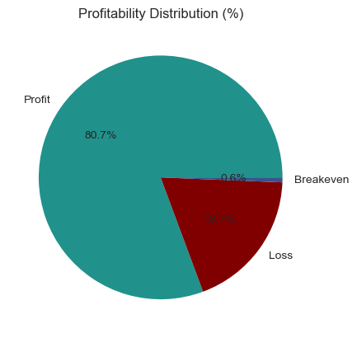
Profitability distribution across all orders: 80.7% profitable, 18.7% at a loss, 0.6% breakeven

4.2 How Delay Directly Affects Profit Per Order
The line chart below plots average profit per order against each exact delay value in days. Negative delay values mean early delivery; positive values mean late. Orders arriving 2 days early (Delay = -2) earn the highest average profit at approximately $23.36. As delay increases into positive territory, average profit falls. Orders delayed by 3 days average only $20.05 per order. The relationship is clear and consistent — every extra day of delay quietly erodes margin.

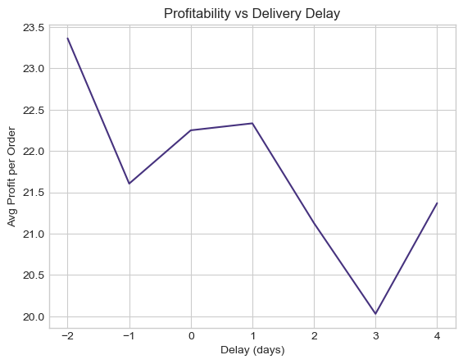
Average profit per order at each exact delay value. Delay = -2 means 2 days early; Delay = +3 means 3 days late.
To make this easier to read, orders were grouped into three delay buckets: On Time (Delay <= 0), 1-2 Days Late, and 3-5 Days Late. The two bar charts below show average profit per order and total profit for each bucket.

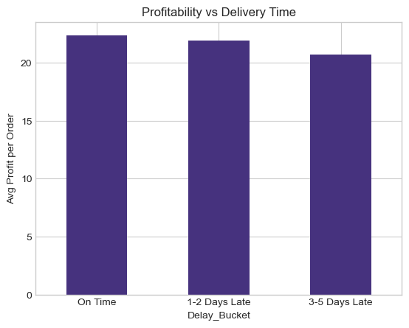 | 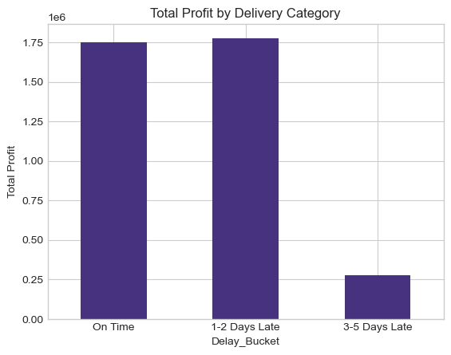
Left: Average profit per order by delay bucket | Right: Total profit volume by delay bucket
On-time orders average ~$22.60 per order. Orders delayed 1-2 days drop to ~$22.00. Orders delayed 3-5 days fall to ~$20.80. The total profit chart (right) shows that most profit volume sits in the on-time and 1-2 day late buckets, simply because those groups contain the most orders — but the per-order gap still represents meaningful margin leakage at the scale of 94,523 delayed orders.

5. Bottleneck Detection
With over half of all orders delayed, the analysis focused on pinpointing exactly which parts of the operation were most affected — and quantifying the financial cost. Two types of charts are used in this section: profit charts (showing how much delayed-order profit is at stake in each category) and delay rate charts (showing what percentage of orders in each category are late).

5.1 Delay vs Profit: The Combined View
The chart below combines two views: total profit (bars) and mean profit per order (line) for each exact delay value. The bars show that most transaction volume is concentrated at 0 and +1 day delay. The falling line confirms that average profit per order erodes as delay grows — from $23.36 at -2 days down to $20.05 at +3 days.

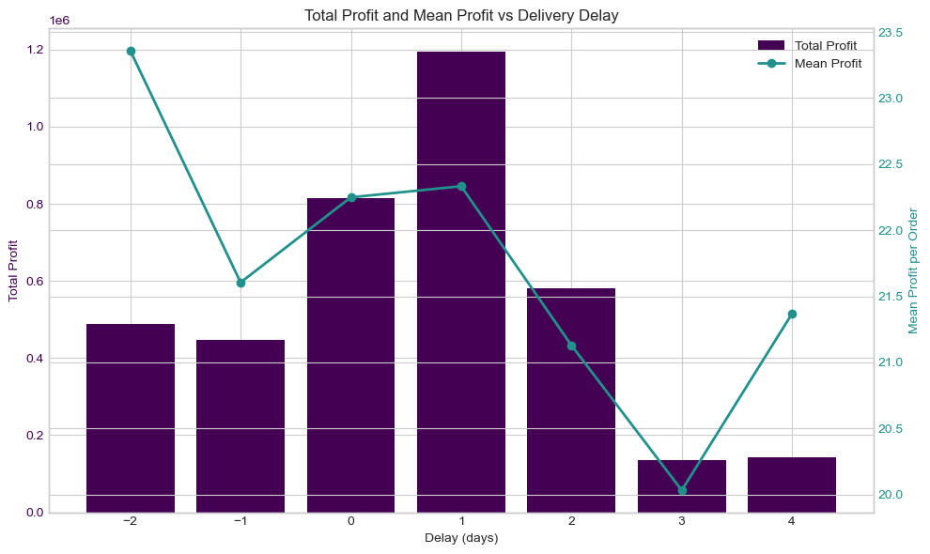
Combined view: total profit (bars, left axis) and mean profit per order (line, right axis) by exact delay in days
The chart below shows the distribution of orders across each delay value. A striking finding: 31% of all orders arrive exactly 1 day late — the single largest group by far. This strongly suggests a systemic scheduling or last-mile logistics issue, rather than isolated failures.

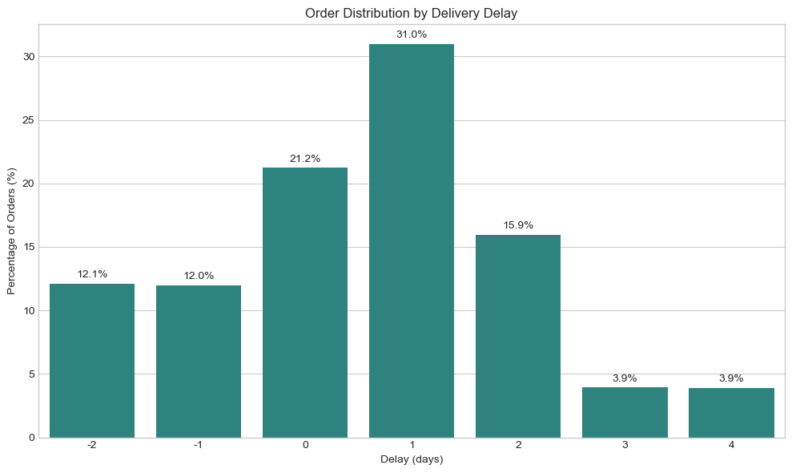
Distribution of orders by delay in days. 31% of all orders arrive exactly 1 day late.

5.2 Profit Exposure by Region, Segment, Shipping Mode, Status, Type & Department
The next six charts show total delayed-order profit broken down across six dimensions. These are filtered to delayed orders only (Delay >= 1), so they reveal where late deliveries are most financially significant — not just most frequent.

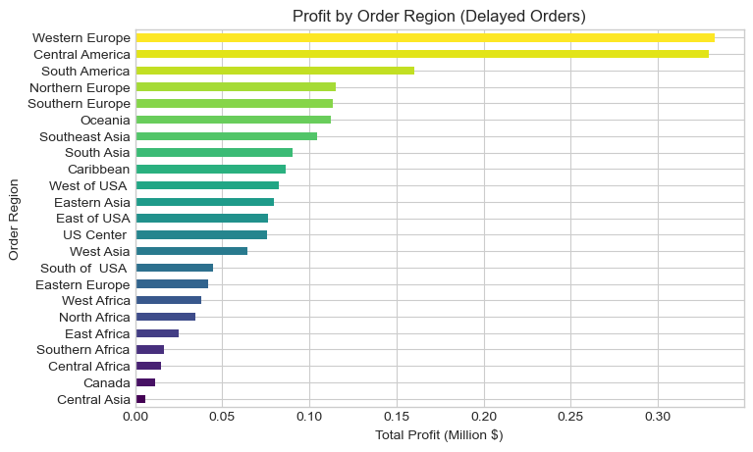
Total profit from delayed orders by region. Western Europe ($0.33M) and Central America ($0.32M) lead.
Western Europe and Central America account for the largest share of delayed-order profit — meaning these are not just the regions with the most orders, but the delays are happening on high-value transactions. South America is third at $0.16M. These three regions should be the highest operational priority for delay reduction.

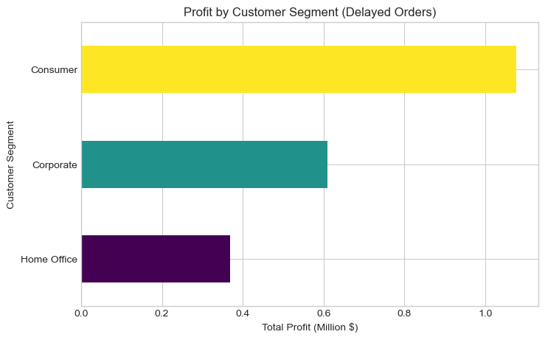
Total profit from delayed orders by customer segment. Consumer segment has the largest exposure at ~$1.08M.
The Consumer segment accounts for roughly $1.08M of delayed-order profit — nearly double Corporate (~$0.60M) and far above Home Office (~$0.37M). This reflects Consumer's larger order volume, but it also means delays are most concentrated in the segment that typically has the highest expectations for on-time delivery.

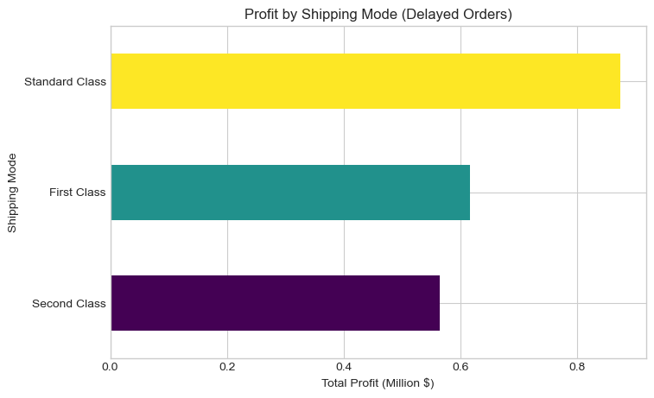
Total profit from delayed orders by shipping mode. Standard Class carries the most delayed profit at ~$0.87M.
Standard Class accounts for the most delayed-order profit (~$0.87M) due to its high volume. But First Class (~$0.61M) is operationally concerning — it is a premium shipping option customers pay more for and expect to be faster. As the delay rate chart later confirms, First Class has a 100% global delay rate, making it both a high-volume and universally late mode.
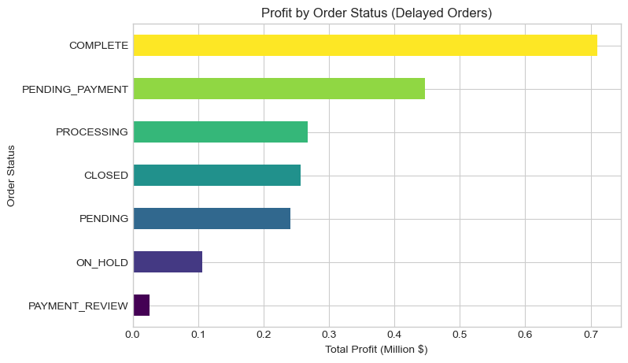
Total profit from delayed orders by order status. COMPLETE orders dominate at ~$0.71M.
COMPLETE orders account for ~$0.71M of delayed-order profit, followed by PENDING_PAYMENT at ~$0.44M. PAYMENT_REVIEW orders sit at the bottom with only ~$0.02M of delayed profit — but not because they are rarely delayed. As the root cause analysis shows, PAYMENT_REVIEW orders have an extremely high delay rate; they simply do not generate much total profit due to low volume.
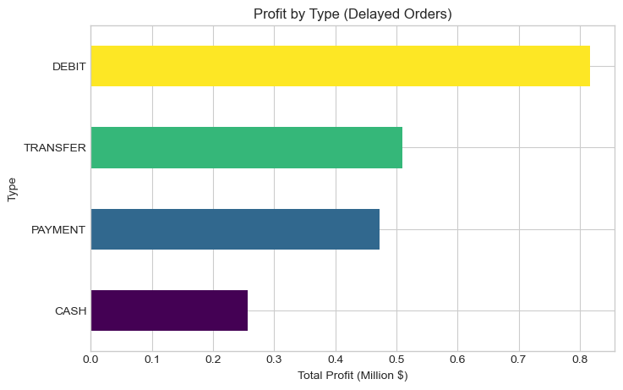 | 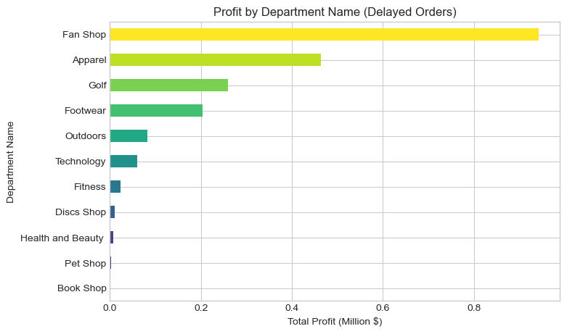
Left: Delayed-order profit by payment type | Right: Delayed-order profit by department name
Payment type: Debit leads at ~$0.82M, followed by Transfer (~$0.51M), Payment (~$0.48M), and Cash (~$0.25M). Department: Fan Shop dominates with ~$0.95M in delayed-order profit, followed by Apparel (~$0.46M), Golf (~$0.25M), and Footwear (~$0.20M). Fan Shop's lead is striking — it generates almost double the delayed-order profit of the next department.

5.3 Root Cause: What Is Actually Causing the Delays?

The next analysis shifts from 'how much profit is delayed' to 'what percentage of orders are actually late'. These charts show delay rates — not profit volumes — so they reveal the structural causes of delay across the operation.

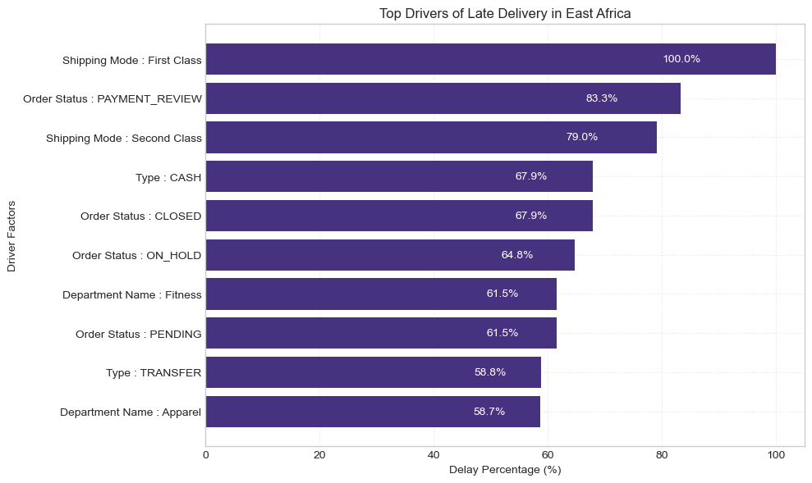
Top delay drivers in East Africa. First Class shipping has a 100% delay rate; PAYMENT_REVIEW orders: 83.3%.
The regional deep-dive into East Africa reveals the starkest finding in the entire analysis: every single First Class shipment in East Africa is delayed — a 100% delay rate. PAYMENT_REVIEW orders are delayed 83.3% of the time. Second Class shipping runs at 79% delay in this region. These are not statistical anomalies; they represent structural process failures at specific intersections of shipping mode, order status, and geography.

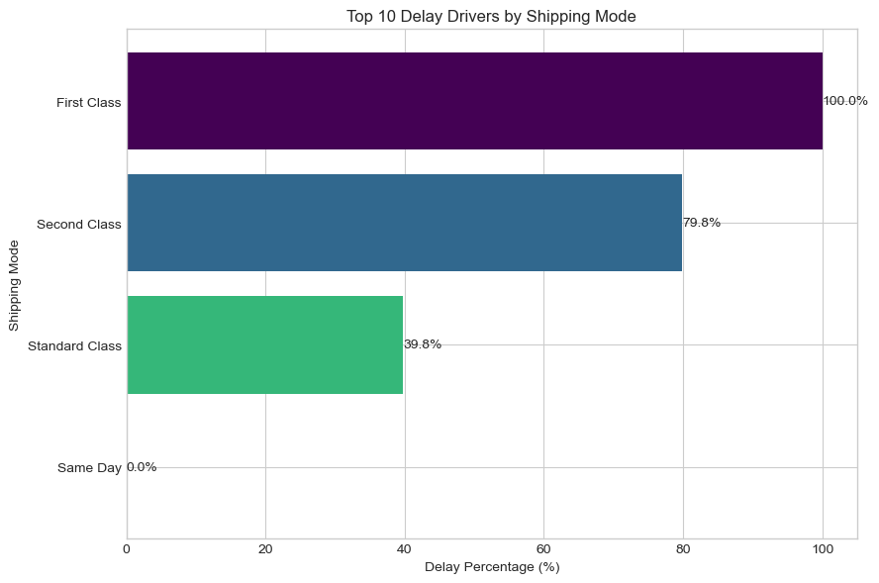
Delay rate by shipping mode (global). First Class: 100% delayed. Second Class: 79.8%. Standard Class: 39.8%. Same Day: 0%.
Globally, First Class shipping has a 100% delay rate — every single First Class order in the dataset arrives late. Second Class follows at 79.8%. Standard Class, despite carrying the highest volume, has the lowest delay rate at 39.8%. Same Day delivery is perfect at 0%. This is the clearest operational finding in the report: First Class is the worst-performing shipping mode for on-time delivery, which directly contradicts its premium positioning.

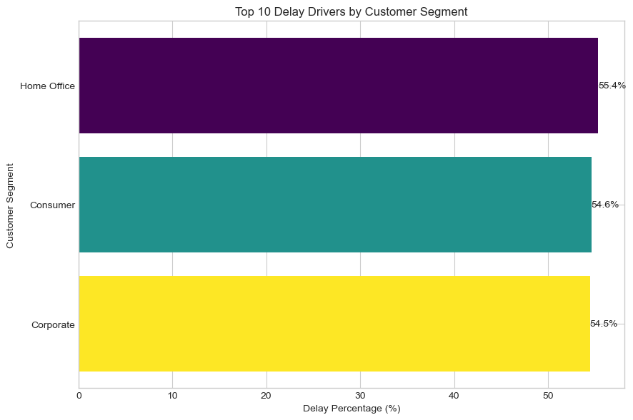
Delay rate by customer segment. All three segments are almost identical: 54.5% to 55.4%.
All three customer segments experience essentially the same delay rate, ranging from 54.5% (Corporate) to 55.4% (Home Office). The difference between best and worst is under 1 percentage point. This tells us the delay problem is not segment-specific — it affects all customers equally regardless of who they are or how much they spend.
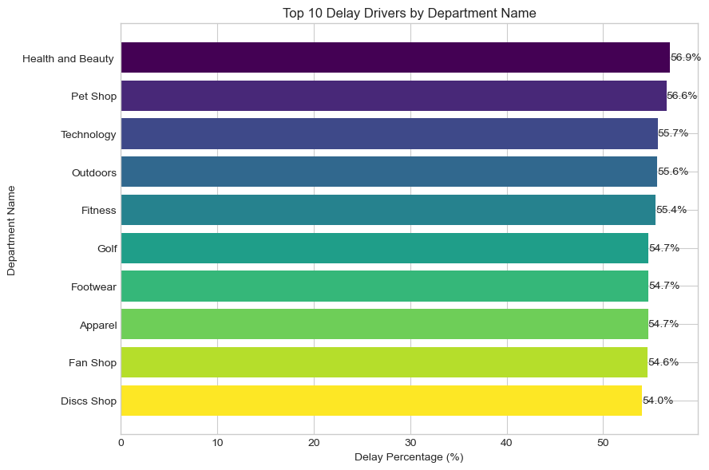
Delay rate by department. Health & Beauty leads at 56.9%; all departments exceed 54%.
Health and Beauty has the highest delay rate at 56.9%, followed by Pet Shop (56.6%) and Technology (55.7%). But the range across all 10 departments is only about 3 percentage points. Like the segment chart, this confirms the delay problem is systemic and not isolated to any particular product department.

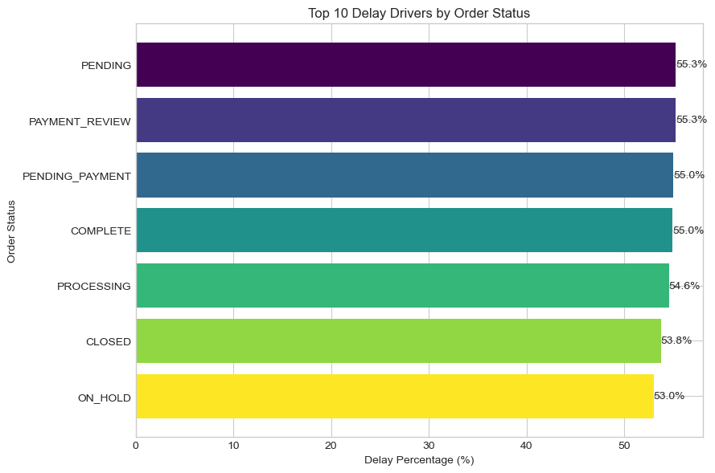
Delay rate by order status. PENDING and PAYMENT_REVIEW are highest at 55.3%; ON_HOLD is lowest at 53%.
PENDING and PAYMENT_REVIEW orders share the highest delay rate at 55.3%. ON_HOLD orders are lowest at 53%. The spread is only 2.3 percentage points. PAYMENT_REVIEW is notable because while globally it is close to the average, in specific regions like East Africa it spikes to 83.3% — suggesting payment friction compounds with geographic logistics challenges.

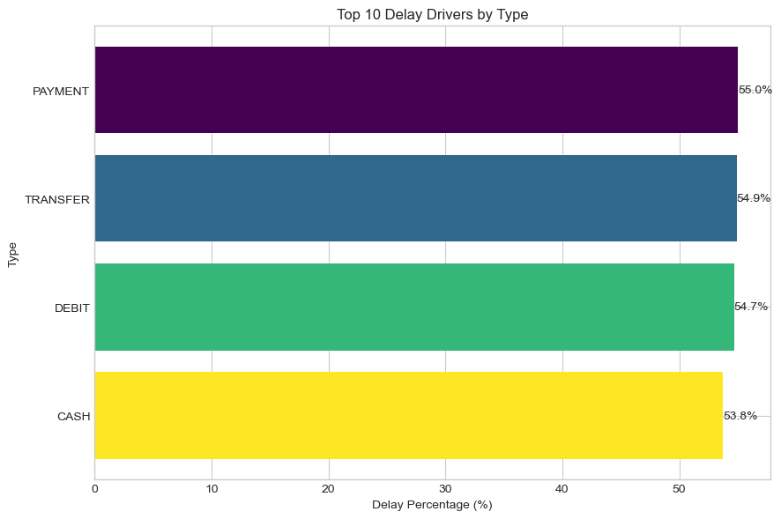
Delay rate by payment type. All four types cluster tightly between 53.8% (Cash) and 55.0% (Payment).
Payment type has almost no effect on delay rate. All four types — Payment, Transfer, Debit, Cash — fall within a 1.2 percentage point range. This is a useful negative finding: how a customer pays is essentially irrelevant to whether their order arrives on time. The supply chain bottleneck is not at the payment stage.

6. Time Series Analysis — Is This a Seasonal Problem?
A natural hypothesis is that delays follow seasonal patterns — peak periods around holidays, end-of-quarter rushes, or staffing cycles. The time series analysis tested this across three dimensions: month of year, day of week, and hour of day.

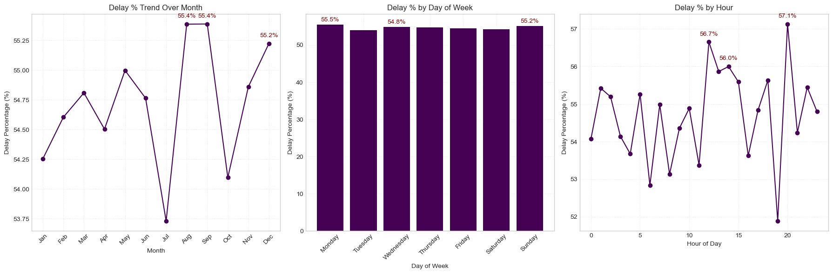
Delay percentage by month of year (left), day of week (centre), and hour of day (right)
Month-by-month, delay rates range from 53.75% in July to 55.4% in August and September — a variation of less than 2 percentage points across the entire year. Day-of-week is even flatter: Monday through Sunday all sit between 54.8% and 55.5%, with no day meaningfully worse than another. Hour of day shows the most movement, peaking at 57.1% around hour 20 (8pm), but the overall range is still only about 5 percentage points.
The conclusion is significant: this is not a seasonal problem. The supply chain is not overwhelmed at Christmas, under-resourced on weekends, or particularly struggling in the evening. The delay rate is structurally elevated and remains that way all year. That makes it harder to address with targeted short-term interventions — but easier to study, because the problem is always present.

Key Insight: A delay rate that barely changes across months, days, or hours is the signature of a structural process failure, not a seasonal one. The fix requires operational redesign — not calendar management.

7. Machine Learning — Can We Predict a Late Delivery?
The final stage shifted from describing the problem to predicting it. The question: given an order's characteristics at the time of placement, can a model reliably flag which orders are at high risk of arriving late — before they actually do?

7.1 Setup
Features used as model inputs: payment type, scheduled shipping days, product category, customer segment, department, order region, shipping mode, and time-based variables (month and hour of order). The target variable was Is_Delayed (true/false).
Because the dataset had slightly more delayed than on-time orders (54.71% vs 45.29%), the training set was balanced using SMOTE — Synthetic Minority Oversampling Technique — which generates synthetic examples of the minority class to prevent models from taking the lazy route of always predicting 'delayed'.

7.2 The Five Algorithms, in Plain English
- Logistic Regression — learns a weighted formula that scores each order. Fast and transparent, but assumes delay patterns are linear, which they are not in this dataset.
- Decision Tree — builds a flowchart of yes/no rules (e.g. 'Is shipping mode First Class? Yes → predict delayed'). Easy to explain but prone to memorising training data.
- Random Forest — trains hundreds of decision trees on random data samples and takes a majority vote. More reliable and resistant to noise than a single tree.
- Gradient Boosting — builds trees one at a time, each correcting the previous one's mistakes. Stronger than Random Forest on structured data, though slower to train.
- XGBoost — a highly optimised gradient boosting implementation with built-in regularisation (which controls overfitting). Consistently strong on real-world tabular datasets.

7.3 Results

Model | Accuracy | Precision | Recall | F1 Score
Decision Tree | 74.50% | 79.97% | 74.03% | 76.89%
Random Forest | 74.68% | 80.61% | 73.48% | 76.88%
Gradient Boost | 72.45% | 89.33% | 58.95% | 71.03%
Logistic Reg. | 68.48% | 83.51% | 56.05% | 67.08%
XGBoost (Best) | 72.69% | 88.14% | 60.46% | 71.72%

Decision Tree and Random Forest achieved the best F1 Scores (0.769) — a balanced measure of precision and recall. XGBoost delivered the highest Precision at 88.14%, meaning when it predicts a late delivery, it is right approximately 9 times out of 10. The trade-off is lower Recall (60.46%) — it misses some late orders, but rarely raises false alarms. Logistic Regression performed weakest, confirming delay patterns here are non-linear.

Practical Implication: XGBoost's 88% precision makes it suitable for operational use. If the model flags an order as high-risk, a logistics team can act on that flag with high confidence — knowing the alert will be accurate roughly 9 times in 10.

8. Conclusions
This analysis turned a 172,765-row dataset into a set of specific, actionable findings. Here is what the data revealed:

- More than half of all orders are late — and this is not a seasonal issue. Delay rates are consistent across every month, every day of the week, and most hours of the day. The supply chain has a structural problem, not a calendar one.
- Every day of delay costs margin. On-time orders earn ~$22.60 per order on average; orders delayed 3-5 days earn only ~$20.80. At 94,523 delayed orders, this difference compounds into material financial leakage.
- First Class shipping has a 100% global delay rate — the most operationally critical finding. A premium shipping tier that never arrives on time is a direct contradiction of its value proposition.
- Western Europe and Central America are the highest-priority regional bottlenecks in terms of delayed-order profit exposure. East Africa shows the most extreme delay rates for specific shipping modes and order statuses.
- Customer segment, department, payment type, and order status all have essentially the same delay rate (~54-55%). No single group is insulated — the problem is systemic across the entire operation.
- XGBoost can predict a late delivery with 88.1% precision. This opens the door to proactive interventions: flagging high-risk orders at placement rather than reacting after the fact.

Suggested next steps: investigate why First Class shipping has a 100% delay rate and whether it can be fixed or should be discontinued; conduct a region-specific logistics audit for Western Europe, Central America, and East Africa; and consider deploying the XGBoost model as a real-time order-risk scoring tool integrated into the order management system.

