Grammars

1)

T = {$, #, *, @, X}

N = {<expr>, <term>, <factor>}

S = <expr>

|  |  |
| --- | --- |
| P = {<expr> ::= | <term> |
| | | <term> $ <term> |
| | | <term> $ <expr> |
| <term> ::= | <factor> |
| | | <factor> # <factor> |
| | | <factor> # <term> |
| <factor> ::= | X |
|  | *X |
|  | @X |
|  | <expr> |
|  | *<expr> |
|  | @<expr>} |

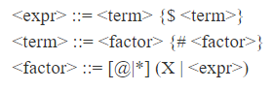

2) $ and # are both right associative.

|  |
| --- |
| @ * |
| # |
| $ |

4) Parse tree for *X$X$@*X#X#*X

5) This language is ambiguous. I will prove this by finding 2 different parse trees for *X$X$@*X#X#*X. I already found one parse tree for it in #4 so here I will find a different one.

Syntax Charts

Chart A EBNF

T = {0, 1}

N = {<A>}

S = <A>

P = {<A> ::= 0 { 0 0 } 1 { 0 { 0 0 } 1 }}

Justification: An <A> is a least 0 followed by a 1. There can be any even number of zeros between the 0 and 1. This can be followed by any number of repetitions of a 0 followed by a 1 with any even number of zeros between the zero and one

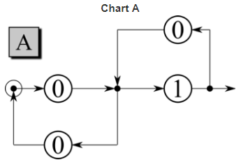

Chart B EBNF

T = {0, 1}

N = {<A>, <B>}

S = <B>

|  |  |
| --- | --- |
| P ={<A> ::= | 0 { 0 0 } 1 { 0 { 0 0 } 1 } |
| <B> ::= | 0 { 0 0 } { <A> 0 { 0 0 } } <A>} |

Justification: I justified <A> in the previous chart. <B> is at least a 0 followed by an <A>. Between them can be any even number of zeros followed by any number of repetitions of <A> followed by 0 with any even number of zeros after it.

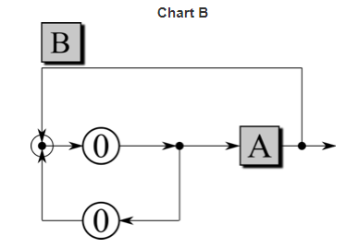

Syntactic Ambiguity

Syntax Tree 1 for “a x b x c”

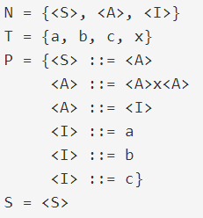

There are 2 different syntax trees for the same expression “a x b x c” in this BNF grammar. This proves that this BNF grammar is ambiguous.

Syntax Tree 2 for “a x b x c”