Assignment 3
Team: BirXbet
Topic: Bet company
Students: Li Denis, Yevgeniy Averyanov, Ivan Kuznetsov, Zhakayev Mukhammad
- Project relevance
Our team chose the Bet Company theme because bookmakers are currently in high demand due to the popularity and awareness of sports. We, for our part, offer a way to increase interest in watching sports matches by offering the opportunity to bet on various outcomes (win, loss, draw), allowing participants to receive corresponding dividends in the event of a successful prediction and a favorable outcome. Our project is not a way to generate regular income but rather aims to increase viewer interest and engagement in watching sports matches.

Competitor analysis
We chose 1xbet (even the name is similar) as our main competitor. 1xbet is an international online bookmaker registered in Cyprus in 2007. They are one of the leading bookmakers in the CIS countries due to their aggressive marketing. 1xbet offers a wide range of match bets. We have chosen a similar approach to our competitors and will offer a wide range of bets on various sporting outcomes.

Target users
Our target audience will be people interested in sports and willing to increase their interest in the match with cash bets.

Planned features
In our project, we want to implement:
- A fully functional Web Interface
- The ability to log in to a personal account
- Developing REST API for adding bets, allowing users to place bets on outcomes, and receiving winnings
- A relational database with all CRUD operations

- Architecture & Design
In our backend we use three-layered architecture that includes:
- Handler layer – responsible for entry points for client requests for HTTP handling, routing and input validation
- Service layer – responsible for business logic and rules. It interacts between handler and data layer.
- Repository layer – responsible for all interactions with database or storage system. It is isolated from direct access from handler layer.
Our frontend stack: React, CSS.
- Use cases:
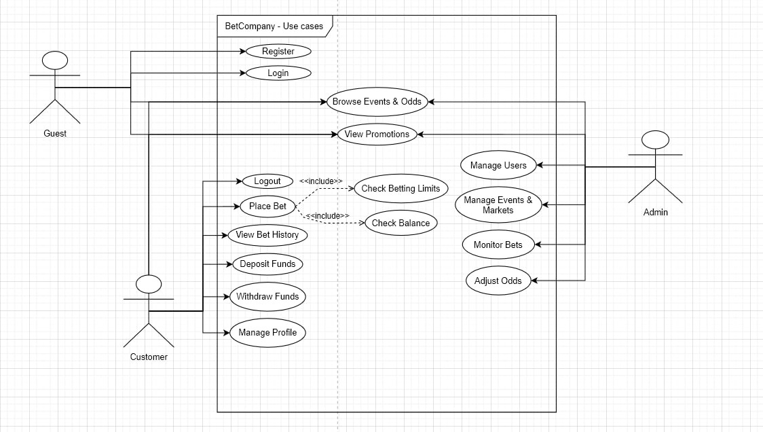
- ERD diagram
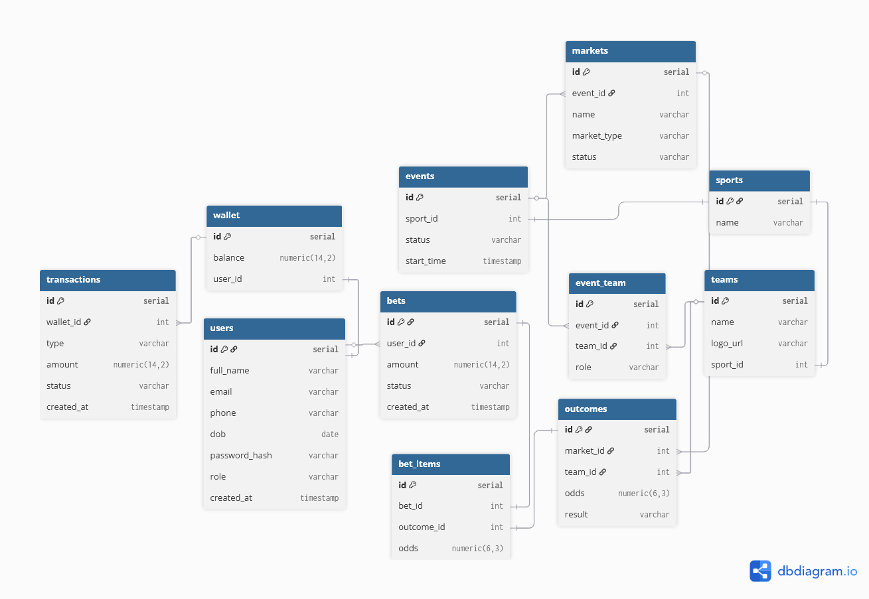
- UML workflow
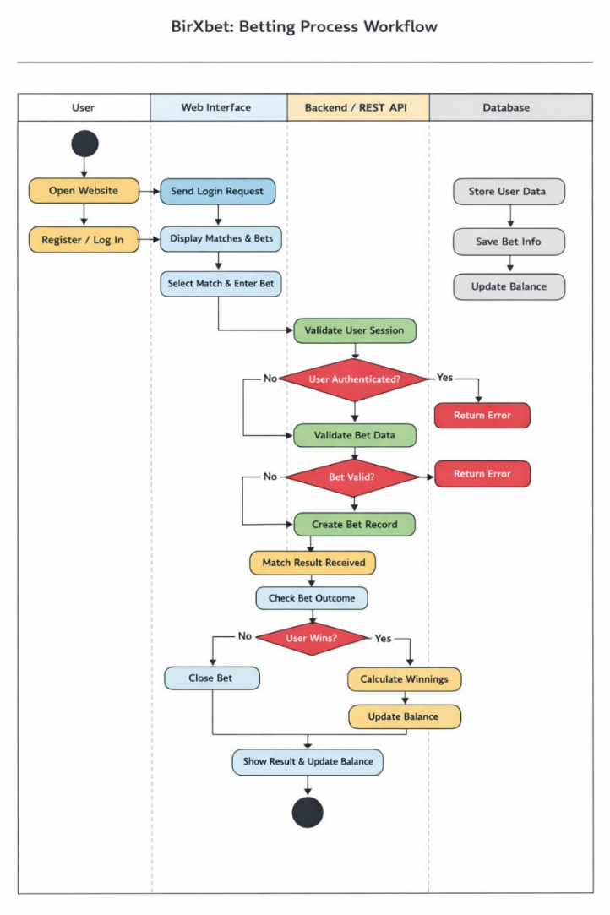

- Project Plan
We use the YouTrack website to add and track tasks that we will implement over time.
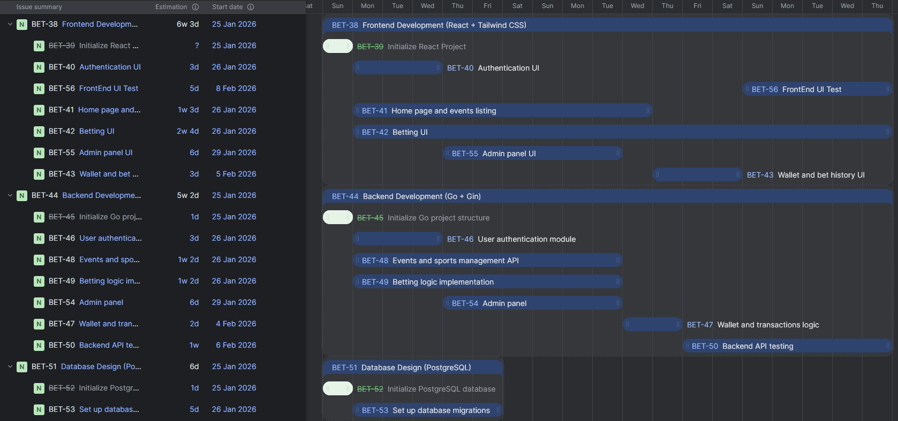
- Repository Setup
Repository Skeleton:
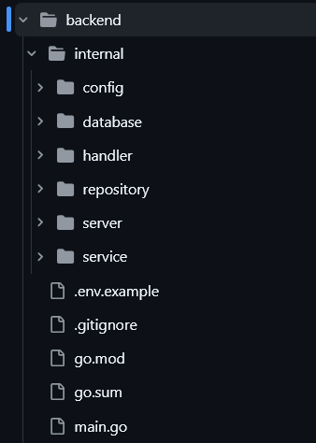 | 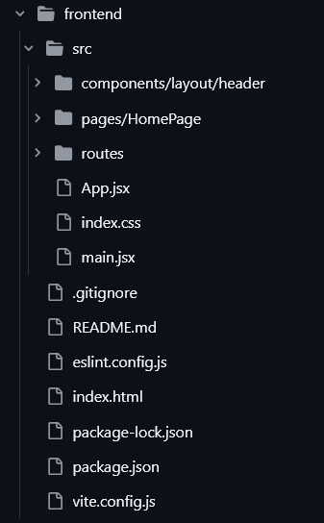

A git repository branch for each member: | At least one commit per member:
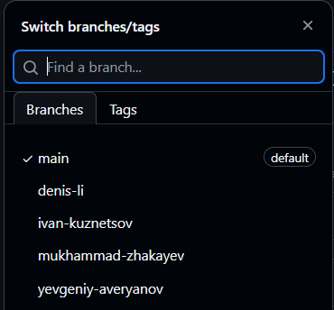 | 