**Лабораторна робота 4**

Верстка Web-сторінки за допомогою flex

Завдання

**index.html**

<!DOCTYPE html>

<html lang="en">

<head>

    <meta charset="UTF-8">

    <meta http-equiv="X-UA-Compatible" content="IE=edge">

    <title>lr4</title>

    <meta name="viewport" content="width=device-width, initial-scale=1.0">

    <link rel="stylesheet" href="styles.css/css/style.css">

    <link rel="preconnect" href="https://fonts.googleapis.com">

    <link rel="preconnect" href="https://fonts.gstatic.com" crossorigin>

    <link href="https://fonts.googleapis.com/css2?family=Barlow+Condensed:wght@500;600;700&family=Barlow:wght@100;200;300;400&display=swap" rel="stylesheet">

</head>

<body>

    <header>

        <img src="https://raw.githubusercontent.com/steminist-ua/dstu/1a3da1753da104ed7a28e5c3fcda4c14a492ebba/pzs/internet_programming/l4/images/logo.svg" alt="error" class="logo">

        <nav>

            <a href=""><p>Product</p></a>

            <a href=""><p>Features</p></a>

            <a href=""><p>Pricing</p></a>

            <p id="dot">•</p>

            <a href=""><p id="login">Login</p></a>

        </nav>

        <a id="hamburger" href=""><img src="https://raw.githubusercontent.com/steminist-ua/dstu/1a3da1753da104ed7a28e5c3fcda4c14a492ebba/pzs/internet_programming/l4/images/icon-hamburger.svg" alt="error"></a>

    </header>

    <main>

        <section id="leading">

            <p id="outlined">NEW</p>

            <p id="thin_text">MONOGRAPH DASHBOARD</p>

        </section>

        <section id="text">

            <div id="title">

                <p>POWERFUL INSIGHTS</p>

                <p>INTO YOUR TEAM</p>

            </div>

            <div id="subtitle">

                <p>Project planning and time tracking</p>

                <p>for agile teams</p>

            </div>

        </section>

        <section id="buttons">

            <a href=""><p id="main_button">SHEDULE A DEMO</p></a>

            <a href=""><p id="secondary_button">TO SEE A LIVE PRVIEW</p></a>

        </section>

    </main>

    <img id="devices" src="https://raw.githubusercontent.com/steminist-ua/dstu/1a3da1753da104ed7a28e5c3fcda4c14a492ebba/pzs/internet_programming/l4/images/illustration-devices.svg" alt="error">

</body>

</html>

**style.css**

*,

*::before,

*::after {

  -webkit-box-sizing: border-box;

          box-sizing: border-box;

}

ul[class],

ol[class] {

  padding: 0;

}

a {

  text-decoration: none;

}

body,

h1,

h2,

h3,

h4,

p,

ul[class],

ol[class],

li,

figure,

figcaption,

blockquote,

dl,

dd {

  margin: 0;

}

body {

  min-height: 100vh;

  scroll-behavior: smooth;

  text-rendering: optimizeSpeed;

  line-height: 1.5;

}

ul[class],

ol[class] {

  list-style: none;

}

img {

  max-width: 100%;

  display: block;

}

article > * + * {

  margin-top: 1em;

}

input,

button,

textarea,

select {

  font: inherit;

}

@media (prefers-reduced-motion: reduce) {

  * {

    -webkit-animation-duration: 0.01ms !important;

            animation-duration: 0.01ms !important;

    -webkit-animation-iteration-count: 1 !important;

            animation-iteration-count: 1 !important;

    -webkit-transition-duration: 0.01ms !important;

            transition-duration: 0.01ms !important;

    scroll-behavior: auto !important;

  }

}

main #leading #thin_text {

  letter-spacing: 4px;

  font-family: "Barlow", sans-serif;

  font-weight: 400;

  font-size: 14px;

  color: #5B5F71;

}

body {

  height: 100vh;

  width: 90%;

  margin: 0 auto;

  overflow-x: hidden;

}

header {

  position: relative;

  display: -webkit-box;

  display: -ms-flexbox;

  display: flex;

  -webkit-box-pack: justify;

      -ms-flex-pack: justify;

          justify-content: space-between;

  margin-top: 60px;

  margin-bottom: 100px;

}

@media only screen and (min-width: 601px) {

  header #hamburger {

    display: none;

  }

  header #hamburger img {

    display: inherit;

  }

  header nav {

    position: relative;

    display: -webkit-box;

    display: -ms-flexbox;

    display: flex;

  }

  header nav a {

    font-family: "Barlow Condensed", sans-serif;

    font-weight: 700;

    font-size: 16px;

    color: #242942;

  }

  header nav #login, header nav #dot {

    color: #A0A1AC;

  }

  header nav p {

    display: inline-block;

    margin-left: 40px;

  }

}

@media only screen and (max-width: 600px) {

  header nav {

    display: none;

  }

  header #hamburder {

    display: inline-block;

  }

}

main {

  width: 60%;

  position: relative;

  z-index: 1;

}

main #leading {

  position: relative;

  display: -webkit-box;

  display: -ms-flexbox;

  display: flex;

  margin-bottom: 60px;

}

main #leading p {

  display: inline-block;

  margin-right: 16px;

}

main #leading #outlined {

  padding: 8px;

  border-radius: 15px;

  background-color: #242942;

  letter-spacing: 0px;

  font-family: "Barlow", sans-serif;

  font-weight: 700;

  font-size: 14px;

  color: white;

}

main #leading #thin_text {

  left: 80px;

  position: absolute;

  top: 50%;

  -webkit-transform: translate(0, -50%);

          transform: translate(0, -50%);

}

main #text {

  margin-bottom: 60px;

}

main #text #title {

  margin-bottom: 30px;

}

main #text #title p {

  line-height: 50px;

  font-family: "Barlow Condensed", sans-serif;

  font-weight: 700;

  font-size: 50px;

  color: #242942;

}

main #text #subtitle p {

  font-family: "Barlow", sans-serif;

  font-weight: 500;

  font-size: 16px;

  color: #5B5F71;

}

@media only screen and (min-width: 601px) {

  main #buttons p {

    display: inline-block;

    margin-right: 30px;

  }

  main #buttons {

    position: relative;

    display: -webkit-box;

    display: -ms-flexbox;

    display: flex;

  }

  main #buttons #secondary_button {

    position: absolute;

    top: 50%;

    -webkit-transform: translate(0, -50%);

            transform: translate(0, -50%);

    letter-spacing: 4px;

    font-family: "Barlow", sans-serif;

    font-weight: 400;

    font-size: 14px;

    color: #5B5F71;

  }

}

@media only screen and (max-width: 600px) {

  main #buttons p {

    display: block;

  }

  main #buttons {

    position: relative;

  }

  main #buttons #secondary_button {

    letter-spacing: 4px;

    padding: 18px;

    font-family: "Barlow", sans-serif;

    font-weight: 400;

    font-size: 14px;

    color: #5B5F71;

  }

}

main #buttons #main_button {

  padding: 18px;

  border-radius: 15px;

  background-color: #FF5C5C;

  letter-spacing: 2px;

  font-family: "Barlow Condensed", sans-serif;

  font-weight: 700;

  font-size: 14px;

  color: white;

}

#devices {

  position: absolute;

  -webkit-transform: translate(-50%, -50%);

          transform: translate(-50%, -50%);

  top: 50%;

  left: 100%;

  max-height: 100vh;

}

**style.scss**

@import "nulling.scss";

$red: #FF5C5C;

$verydarkblue: #242942;

$darkgrayishblue: #5B5F71;

$grayishblue:  #A0A1AC;

$lightgrayishblue: #EEF3F6;

@mixin extra_font($size, $weight, $color) {

    font-family: 'Barlow Condensed', sans-serif;

    font-weight: $weight;

    font-size: $size;

    color: $color;

}

@mixin regular_font($size, $weight, $color) {

    font-family: 'Barlow', sans-serif;

    font-weight: $weight;

    font-size: $size;

    color: $color;

}

%letter_spaced{

    letter-spacing: 4px;

    @include regular_font(14px, 400, $darkgrayishblue);

}

body{

    height: 100vh;

    width: 90%;

    margin: 0 auto;

    overflow-x: hidden;

}

header{

    position: relative;

    display: flex;

    justify-content: space-between;

    margin-top: 60px;

    margin-bottom: 100px;

    @media only screen and (min-width: 601px) {

        #hamburger{

            display: none;

            img{

                display: inherit;

            }

        }

        nav{

            position: relative;

            display: flex;

            a{

                @include extra_font(16px, 700, $verydarkblue);

            }

            #login, #dot{

                color: $grayishblue;

            }

            p{

                display: inline-block;

                margin-left: 40px;

            }

        }

    }

    @media only screen and (max-width: 600px) {

        nav{

            display: none;

        }

        #hamburder{

            display: inline-block;

        }

    }

}

main{

    width: 60%;

    position: relative;

    z-index: 1;

    #leading{

        position: relative;

        display: flex;

        margin-bottom: 60px;

        p{

            display: inline-block;

            margin-right: 16px;

        }

        #outlined{

            padding: 8px;

            border-radius: 15px;

            background-color: $verydarkblue;

            letter-spacing: 0px;

            @include regular_font(14px, 700, white);

        }

        #thin_text{

            left: 80px;

            position: absolute;

            top: 50%;

            transform: translate(0, -50%);

            @extend %letter_spaced;

        }

    }

    #text{

        margin-bottom: 60px;

        #title{

            margin-bottom: 30px;

            p{

                line-height: 50px;

                @include extra_font(50px, 700, $verydarkblue);

            }

        }

        #subtitle{

            p{

                @include regular_font(16px, 500, $darkgrayishblue);

            }

        }

    }

    #buttons{

        @media only screen and (min-width: 601px) {

            p{

                display: inline-block;

                margin-right: 30px;

            }

            &{

                position: relative;

                display: flex;

            }

            #secondary_button{

                position: absolute;

                top: 50%;

                transform: translate(0, -50%);

                letter-spacing: 4px;

                @include regular_font(14px, 400, $darkgrayishblue);

            }

        }

        @media only screen and (max-width: 600px) {

            p{

                display: block;

            }

            &{

                position: relative;

            }

            #secondary_button{

                letter-spacing: 4px;

                padding: 18px;

                @include regular_font(14px, 400, $darkgrayishblue);

            }

        }

        #main_button{

            padding: 18px;

            border-radius: 15px;

            background-color: $red;

            letter-spacing: 2px;

            @include extra_font(14px, 700, white);

        }

    }

}

#devices{

    position: absolute;

    transform: translate(-50%, -50%);

    top: 50%;

    left: 100%;

    max-height: 100vh;

}

**nulling.scss**

*,

*::before,

*::after {

  box-sizing: border-box;

}

ul[class],

ol[class] {

  padding: 0;

}

a{

  text-decoration: none;

}

body,

h1,

h2,

h3,

h4,

p,

ul[class],

ol[class],

li,

figure,

figcaption,

blockquote,

dl,

dd {

  margin: 0;

}

body {

  min-height: 100vh;

  scroll-behavior: smooth;

  text-rendering: optimizeSpeed;

  line-height: 1.5;

}

ul[class],

ol[class] {

  list-style: none;

}

img {

  max-width: 100%;

  display: block;

}

article > * + * {

  margin-top: 1em;

}

input,

button,

textarea,

select {

  font: inherit;

}

@media (prefers-reduced-motion: reduce) {

  * {

    animation-duration: 0.01ms !important;

    animation-iteration-count: 1 !important;

    transition-duration: 0.01ms !important;

    scroll-behavior: auto !important;

  }

}

https://github.com/Coffin69/Web

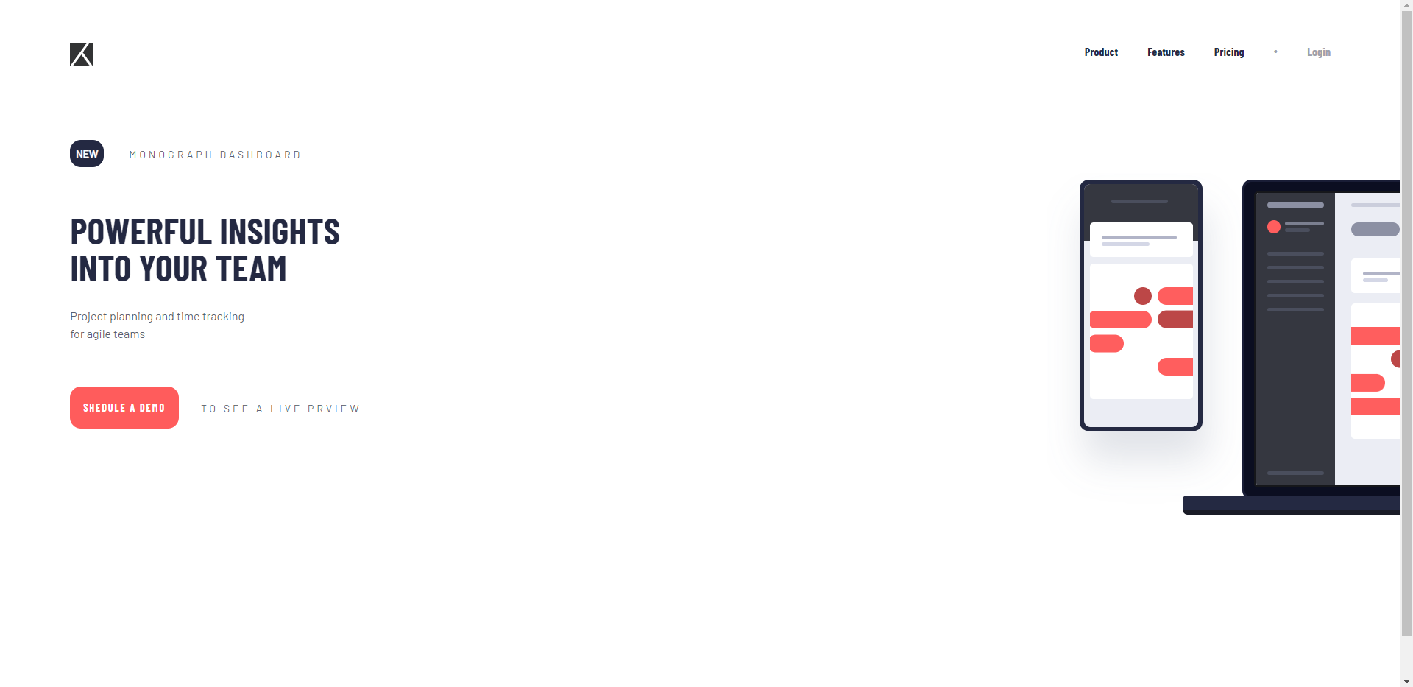

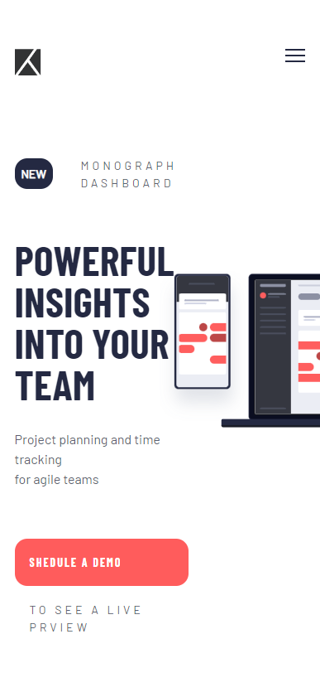

Скріншоти результату