Business Requirement Document Ecommerce Portal

Business Requirements Document (BRD)

Project No.: Cogent_Training_Java_Spring_Hibernate01
Production Priority: Medium
Target Date: 02/05/2015

Approved by:
______________________________ ______________________________
Name of user, department Date
______________________________ ______________________________
Name of user, department Date

Prepared by:
Godwin Mathew George 02/05/2015
Cogent InfoTech Corp Date

Filename: BRD_Ecommerce.doc
Version No. : Draft 1.0

Table of Contents
Version Control 6
Revision History 6
RACI Chart for This Document 6
Codes Used in RACI Chart 6
RACI Chart 7
Executive Summary 7
Overview 7
Background 7
Objectives 7
Requirements 7
Proposed Strategy 7
Next Steps 8
Scope 8
Included in Scope 8
Excluded from Scope 8
Constraints 8
Impact of Proposed Changes 8
Risk Analysis 9
Technological Risks 9
Skills Risks 9
Political Risks 9
Business Risks 9
Requirements Risks 9
Other Risks 9
Business Case 9
Timetable 10
Business Use Cases 10
Business Use-Case Diagrams 10
Business Use-Case Descriptions 10
Actors 10
Workers 10
Business Actors 10
Other Systems 11
Role Map 11
User Requirements 11
System Use-Case Diagrams 11
System Use-Case Descriptions 11
State-Machine Diagrams 14
Nonfunctional Requirements 14
Performance Requirements 14
Stress Requirements 14
Response-Time Requirements 14
Throughput Requirements 15
Usability Requirements 15
Security Requirements 15
Volume and Storage Requirements 15
Configuration Requirements 15
Compatibility Requirements 15
Reliability Requirements 15
Backup/Recovery Requirements 15
Training Requirements 15
Business Rules 15
State Requirements 16
Testing State 16
Disabled State 16
Structural Model 16
Class Diagrams: Entity Classes 16
Entity Class Documentation 16
Test Plan 17
Implementation Plan 18
Training 18
Conversion 18
Scheduling of Jobs 18
Rollout 18
End-User Procedures 18
Post-Implementation Follow-Up 19
Other Issues 19
Sign-Off 19

Revision History
Version # | Date | Authorization | Responsibility (Author) | Description
Draft_1.0 | 02/05/2015 |  | Godwin | Initial

RACI Chart

Codes Used in RACI Chart
* Authorize Has ultimate signing authority for any changes to the document.
R Responsible Responsible for creating this document.
A Accountable Accountable for accuracy of this document
(for example, the project manager)
S Supports Provides supporting services in the production of this document
C Consulted Provides input (such as an interviewee).
I Informed Must be informed of any changes.

RACI Chart
Name | Position | * | R | A | S | C | I
Godwin Mathew George | Programmer Analyst |  | Y |  |  |  | Y
Saran | Training Head | Y |  | Y | Y | Y | Y

Executive Summary

Overview
This business requirement is for an online commerce portal which is used for buying products on a competitive price. This system is loosely coupled so that any change in the technology in the future is possible at low cost/no cost. The proposed system is a web based application and the front end is designed in HTML5/Jsp/JQuery. The middle ware technologies include spring and hibernate. Oracle is the backend database. Oracle Web logic Application Server is used for deploying this web application.

Background
The project is being considered mainly for helping technical training in order to meet the gap between training and real time industry experience that helps the trainees for getting good placement in their journey.

Objective
The proposed Ecommerce portal should have the following modules which are loosely coupled which are to be used in the future in other projects.

Requirements

The proposed system should have the following independent modules described below.
- Login: - User can able to register / login to the system by giving user name and password.
There is a forget username / password link is needed in case if the user is not know his credentials.
- Searching the products: - User can able to search the system by using a keyword such as washer or Dryer and the system will display the result in a list view/gallery view. If we click on each product, it will go to the product details page.
- Product Details: - Product details will show the attribute of each product such as color, size, full description, rating and user comment of the product, different pictures, different pickup options such as Take with, Delivery, Store Pickup. This page is also having added to cart button which adds this product to the cart. The cart is maintained as global.
- Add to Cart: - In this module, different ways of add to cart is supported such as Take with (User takes the product after payment), Delivery (In this the product is shipped to his address later), Store Pickup (In this user needs to go to warehouse and pickup his product.).
- Checkout: - This module will do a checkout functionality in which he has two options. Checkout as guest/checkout as logged in user.
- Payment: - The payment module will accept different payment methods such as debit card/credit card/prepaid card and cash.
- Receipt: - Once the payment is made, this module will print the invoice so that user can able to take his product.
- Audit: - In this module, the super user or administrator can see and control the transactions and products.
- Logging Module: - In this, all the user activities are logged in. Every user will get a unique session id for each login so that the administrator can trace each user.

Proposed Strategy
The execution of this project is carried out in agile-scrum method so that after every sprint, end user will get a functional product. The proposed sprint length is 1 week.

Next Steps

- Action: Environment Setup and Business use cases creation
- Responsibility: Godwin/Saran
- Expected Date:02/06/2015

Scope

Included in Scope

Excluded from Scope

Constraints
Software Environment and its issues.

Impact of Proposed Changes

Business Use Case | New? | Desired Functionality | Current Functionality (if a Change) | Stakeholders / Systems | Priority

Risk Analysis

- Avoid: Do something to eliminate the risk.
- Mitigate: Do something to reduce damage if risk materializes.
- Transfer: Pass the risk up or out to another entity.
- Accept: Do nothing about the risk. Accept the consequences.

Technological Risks

Skills Risks
N/A

Political Risks
N/A

Business Risks
N/A

Requirements Risks
N/A

Other Risks
N/A

Timetable

Task No | Description | Completion Date
1 | BRD and Use cases creation | 02/05/2015
2 | Environment setup | 02/06/2015
3 | Sprint 1:Login Module
4 | Sprint 2:Search Module
5 | Sprint 3: Product Details
6 | Sprint 4:Add to cart
7 | Sprint 5:Checkout
8 | Sprint 6:Payment
9 | Sprint: Receipt
10 | Sprint 8: Audit
11 | Sprint 9: Logging

Business Use Cases

High-level Diagram

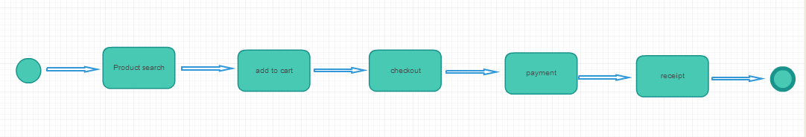

Workers

Department / Position | General Impact on Project

Business Actors

Actor | General Impact on Project

Other Systems

System | General Impact on Project

Role Map
The stakeholders in this project will do multiple roles such as requirement analysis, use cases creation, design, coding, testing and implementation.

User Requirements

- Use Case: Login module
Perspective: system use case
Type: Base use case
  - Use-Case Brief: This use case is for logging into the ecommerce application. First time users can register and create their login and login to the system. If the authentication fails, then he will be asked to reenter the username/password again. If the user forgets the username/password, through a security question, he can reset his password.
  - Business Goals and Benefits: Login module is used to handle the login functionalities. This module will ensure only authenticated user can use the system.
  - Actors
    - Primary Actors: End users
    - Secondary Actors: Admin
    - Off-Stage Stakeholders: N/A
  - Rules of Precedence
    - Triggers: User unable to log into the system.
    - Pre-Conditions: For first time users, a register process is needed. If the user is already registered, then system allows logging in after successful authentication.
  - Post-Conditions
    - Post-Conditions on Success: User successfully entered into the system.
    - Post-Conditions on Failure: If the username/password does not match, he will ask to try again. Also he can try to recover the password.
  - Priority : Medium
  - Status: Under Design
Use-case brief complete: 02/09/2015
Basic flow + risky alternatives complete: 02/11/2015
All flows complete: 02/11/2015
Coded: 2012/07/20
Tested: 2012/08/10
internally released: 02/11/2015
Deployed: 02/11/2015
  - Expected Implementation Date 2/11/2015
  - Actual Implementation Date 2/11/2015
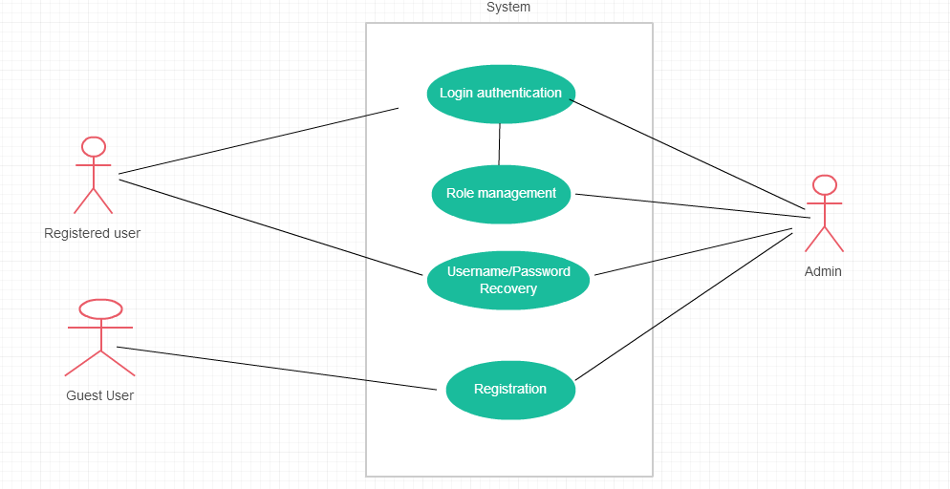
- Flow of Events
Basic Flow
New User registers his credentials with the system
User gives his username/password and clicks the login button
Authentication initiated in the middleware.
If the authentication is success, then user granted to go to the home page. So that he can search the products.
If the authentication fails, user redirected to try again.
If any system/Connectivity issue occurs, then an error page will display with message “We are experiencing technical problems now, Please try again later”.
.
Alternate Flows
N/A
Exception Flows
If the Username/Password is not correct, the user will get the same login page with a message “Try again”.
If any system issue occurs during the authentication process, an error page with message “We are experiencing technical problems now, Please try again later” will display.
- Special Requirements: For authentication, use LDAP or any third party authentication frameworks.
  - Non-Functional Requirements:
  - Constraints:
- Activity Diagram:
- User Interface:
- Class Diagram:
- Assumptions:
- Information Items
- Prompts and Messages:
- Business Rules:
- External Interfaces: Ldap.
- Related Artifacts

State-Machine Diagrams

Nonfunctional Requirements

Performance Requirements

Stress Requirements

Response-Time Requirements

Throughput Requirements

Usability Requirements

Security Requirements

Volume and Storage Requirements

Configuration Requirements

Compatibility Requirements

Reliability Requirements

Backup/Recovery Requirements

Training Requirements

Business Rules

State Requirements

Testing State

Disabled State

Structural Model

Class Diagrams: Entity Classes

Entity Class Documentation

Attribute | Derived? | Derivation | Type | Format | Length | Range | Dependency

Test Plan

Implementation Plan

Training

Conversion

Scheduling of Jobs

Rollout

End-User Procedures

Post-Implementation Follow-Up

Other Issues

Sign-Off
.

