COGETO
Technical Architecture and Implementation Plan
Architecture, technology selection, runtime topology, key mechanisms, libraries, implementation phases, and ways of working for the v1 build.
Prepared July 2026 | Binding companions: v1 Specification, v1 Scope, Verifiable Memory Addendum

1. Introduction and How to Read This Document
This document translates the Cogeto product specification and the Verifiable Memory Addendum into a concrete engineering plan: which technologies are used and why, how the runtime is composed, how the critical mechanisms work, which libraries are selected, in what order the system is built, and how the team (human and AI agents alike) works day to day. Where this document names a specific library or version approach, it is a committed default: change requires a decision record, not a silent substitution.
Three principles govern every choice below. First, production posture from the first commit: idempotent jobs, transactional ingestion, verified deletion, and enforced module boundaries are built now, because they are rewrites later. Second, the smallest honest footprint: each customer runs a dedicated instance, so every container and every megabyte is multiplied across the fleet and priced into margin. Third, boring technology, novel product: differentiation lives in verifiable memory (receipts, history, published accuracy), not in exotic infrastructure. The stack is chosen to be mature, well documented, and unsurprising.

2. Architecture Overview
Cogeto is a modular monolith: one codebase, strict internal module boundaries, and exactly two deployable application processes per tenant. The app process serves the chat API, the dashboard API, the connectors, and the approval endpoints. The worker process runs everything asynchronous: the ingestion pipeline, reconciliation and consolidation, the deletion saga, reminders, and the execution of approved actions. Both are built from the same image; only the entrypoint differs. This is the architecture that keeps a dedicated-instance business profitable: the per-tenant footprint stays at six or seven containers instead of fifteen.
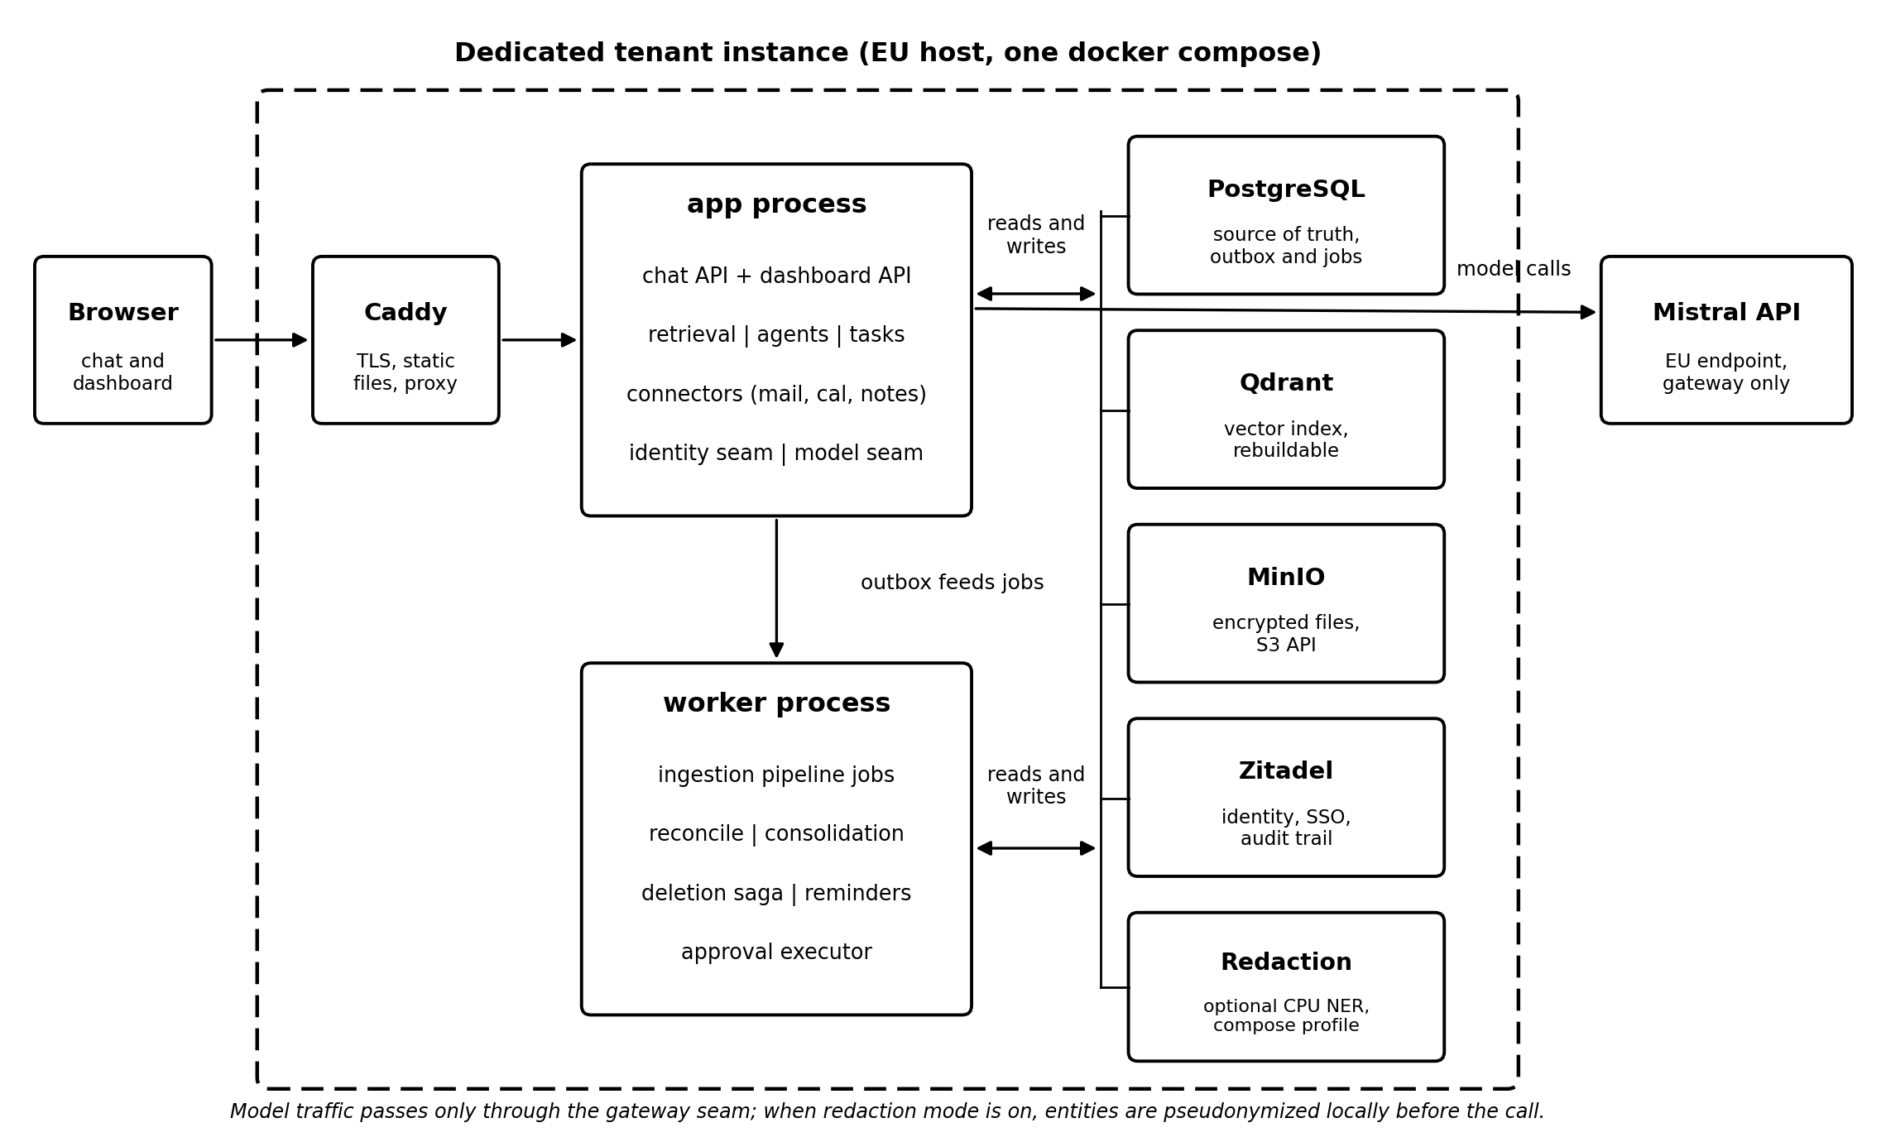
Figure 1. Per-tenant runtime topology. One compose file, two application processes, four infrastructure services, one optional redaction profile, one external EU model endpoint.

2.1 The two hard separations
- Fast path versus slow path. Answering the user is synchronous and touches only retrieval. Extraction, verification, deduplication, contradiction detection, consolidation, and deletion run as background jobs after the response is delivered. Nothing heavy ever executes inside a request handler; this is enforced in code review and by the module dependency rules, not by convention.
- Source of truth versus index. PostgreSQL owns all facts: memories, statuses, scopes, provenance, validity intervals, tasks, receipts, and the job queue itself. Qdrant holds vectors plus a payload copy of the filterable fields and is rebuildable at any time with a single reindex command. Losing Qdrant loses nothing; it is rebuilt from Postgres. This asymmetry is what makes true deletion provable and disaster recovery trivial.

2.2 Bounded contexts (modules)
The codebase is organized as domain-driven bounded contexts. Each module exposes exactly one public interface; internals, including tables, are private to the module. Cross-module communication happens through domain events on the Postgres outbox, the same mechanism that feeds the job queue. These rules are enforced mechanically in CI (dependency linting), because unenforced modularity erodes within months.
Module | Owns | Key invariants it guards
memory | Memory aggregate, statuses, scopes, provenance, validity intervals, deletion saga, receipts | Seven-state status machine; only reconciliation sets contradicted; only the user sets user-approved; provenance is never null
ingestion | Ingest, chunk, extract, verify, embed, store pipeline | Facts, never raw documents, enter the vector store; every fact passes independent verification before becoming active
retrieval | Hybrid search, fusion, ranking | Scope and sensitive are hard filters inside the query; statuses are score multipliers; no app-side post-filtering
agents | Drafting, proposals, approval state machine | Consequential actions execute only from a server-side approved state, only in the worker
connectors | Email, calendar, notes sync; OAuth token custody | Tokens encrypted at rest; incremental sync; ingestion via outbox only
tasks | Todos, open loops, reminders, digests, dreaming card | Derived from memory; never mutates memory directly
identity (seam) | Authenticated principal, org, roles; wraps Zitadel | No other module calls Zitadel; scope filtering is Cogeto logic, not identity-provider logic
model-gateway (seam) | All model and embedding calls; prompt registry | No other module calls a model API; prompts are versioned artifacts with eval scores

3. Technology Stack and Rationale
Layer | Technology | Why this and not the alternative
Language | TypeScript (Node.js 22 LTS) | One language across API, worker, and frontend; a single toolchain, shared types end to end, and the widest agent-assisted-coding support. Go was the runner-up; TS wins on full-stack unification for a small team
Backend framework | NestJS 11 | First-class module system that maps one-to-one onto DDD bounded contexts; dependency injection makes the identity and model seams natural interfaces; mature ecosystem
Frontend | React 19 + Vite, TanStack Query, Tailwind CSS | SPA built to static files and served by Caddy; no server-side rendering needed for an authenticated tool; smallest operational surface
Database | PostgreSQL 17 | Source of truth for everything including the job queue and outbox; one backup captures the entire system state
DB access | Drizzle ORM + drizzle-kit migrations | SQL-first and type-safe without a query-engine black box; migrations are plain, reviewable SQL, which matters when schema decisions are contractual (scope, provenance, statuses)
Job queue | Graphile Worker | Runs on Postgres itself: transactional enqueue in the same commit as the ingested event, no Redis, one fewer container per tenant, exactly the outbox semantics the architecture requires
Vector store | Qdrant | Production-grade filtered HNSW; payload indexes on owner, scope, and status make pre-filtering native; pluggable behind the memory module
Object storage | MinIO (S3 API) | EU-controlled encrypted file storage; the S3 client code also targets Scaleway, OVHcloud, or Hetzner object storage per deployment without change
Identity | Zitadel | Registration, login, SSO, organizations, roles, tamper-evident audit trail; AGPL like the core; wrapped by the identity seam
Model | Mistral API (EU) | Only model in v1, called exclusively through the gateway seam; DPA and EU processing stated on the privacy page
Edge | Caddy 2 | Automatic TLS, static file serving for the SPA, reverse proxy to app and Zitadel; one small container replaces three concerns
Redaction (optional) | Presidio-based NER service (Python, CPU) | Local entity detection and pseudonymization before external model calls; isolated as its own small container behind a compose profile precisely because it is Python in a TypeScript stack
Validation | Zod | Runtime validation at every boundary: API input, connector payloads, model outputs, job payloads
Packaging | Docker + docker compose | One command brings up a complete instance; profiles switch demo seeding and redaction on and off

3.1 Choices worth defending in one paragraph each
Why a Postgres job queue instead of Redis or RabbitMQ. The single most important correctness property in Cogeto is that nothing can be ingested and silently unprocessed. Graphile Worker jobs are enqueued inside the same database transaction that records the source event, which makes that guarantee structural rather than aspirational. It also removes an entire stateful service from every tenant, and at Cogeto's per-tenant volumes (thousands of jobs per day, not millions per second) Postgres queueing is far below its performance ceiling.
Why Drizzle instead of Prisma. Cogeto's schema is contractual: scope on every row, provenance never null, seven-state status enums, validity intervals. Migrations must be reviewable SQL that an audit can read, and queries must be inspectable for the one bug class that is unacceptable (a memory read without a scope filter). Drizzle keeps the SQL visible and the types strict; nothing is generated behind a proprietary engine.
Why the frontend is a static SPA. The product is an authenticated tool, not a public content site, so server-side rendering buys nothing. Building to static files served by Caddy means the frontend adds zero runtime processes per tenant, and the app process remains a pure API.
Why the redaction service is a separate container. The best local NER tooling is Python. Rather than polluting the TypeScript monolith, redaction is a tiny internal HTTP service with one endpoint (detect and pseudonymize), enabled by a compose profile only for tenants who switch redaction mode on. It holds no state and needs roughly one gigabyte of memory on CPU.

4. Runtime Topology and Containers
One tenant equals one compose project. Every service carries a healthcheck, and startup ordering uses health conditions, not sleep timers. Migrations run as a one-shot init container before the app starts; MinIO bucket creation and Zitadel bootstrap (first organization, first admin, OIDC application) are also one-shot init jobs, so a fresh instance reaches a usable login with a single command and zero clicks.
Container | Image basis | Purpose | Indicative RAM
caddy | caddy:2 | TLS termination, SPA static files, reverse proxy | 30 to 60 MB
app | Cogeto image, node entrypoint app | API: chat, dashboard, connectors, approvals | 250 to 400 MB
worker | Cogeto image, node entrypoint worker | All background jobs via Graphile Worker | 250 to 400 MB
postgres | postgres:17 | Source of truth, outbox, job queue | 300 to 600 MB
qdrant | qdrant/qdrant | Vector index with payload filtering | 200 to 500 MB
minio | minio/minio | Encrypted object storage, S3 API | 150 to 300 MB
zitadel | zitadel/zitadel | Identity, SSO, audit trail (shares Postgres) | 100 to 200 MB
redaction (profile) | Cogeto NER image (Python, CPU) | Local PII detection and pseudonymization | 700 MB to 1 GB
init jobs (one-shot) | Cogeto image / mc / zitadel setup | Migrations, bucket creation, identity bootstrap | transient
Fleet math: a baseline tenant without redaction fits comfortably in 2 GB of RAM and one shared vCPU, which maps to the smallest instances at European providers and preserves the target margin at the planned per-instance pricing. Compose profiles: demo seeds the Ana sandbox persona; redaction adds the NER service. Self-hosters run exactly the same file, which is the transparency promise kept literally.

5. Data Architecture

5.1 PostgreSQL: the contractual core (migration 0001)
memory(id, owner_id NOT NULL, scope enum(private, shared) NOT NULL,
source_type NOT NULL, source_id NOT NULL, -- provenance, never null
status enum(active, outdated, contradicted, uncertain,
replaced, user_approved, sensitive) NOT NULL DEFAULT active,
valid_from, valid_until, -- time-travel intervals
content, embedding_ref, created_at, updated_at)
file_metadata(object_key, owner_id, scope, sensitive, upload_date, checksum)
deletion_receipt(id, source_ref, counts_json, status enum(pending, confirmed),
prev_hash, hash, signed_at) -- hash-chained, tamper evident
approval(id, action_type, payload, status enum(draft, pending_approval,
approved, rejected, expired, executed), decided_by, decided_at)
Supporting tables: users and org mapping (thin, identity lives in Zitadel), tasks and reminders, connector accounts with encrypted tokens, prompt registry (version, text hash, eval score), golden-set records for the evaluation harness, and the Graphile Worker job tables. Status transitions are enforced in the memory aggregate, not scattered across services: the set of legal transitions is a single reviewed function.

5.2 Qdrant: one collection, strict payload
A single collection holds memory vectors. Each point carries the payload fields owner_id, scope, status, source_type, source_id, and valid_until, with payload indexes on the first three. Every search request includes the scope filter and the sensitive gate as native Qdrant filter clauses; the application never fetches broadly and filters afterwards. The reindex command streams all memories from Postgres, re-embeds if the embedding model version changed, and rebuilds the collection; it is exercised in CI so it can never rot.

5.3 MinIO: scoped keys, signed access
{org_id}/{user_id}/{scope}/file-{uuid}
The first key segment is the Zitadel organization id, keeping keys stable if small tenants are ever consolidated. Server-side encryption is on; user downloads use short-lived signed URLs; the sensitive flag gates who may generate a URL at all. An optional extract-and-discard mode (a per-upload flag with a per-user default) keeps derived memories and deletes the original bytes immediately after the pipeline confirms extraction.

6. Key Mechanisms
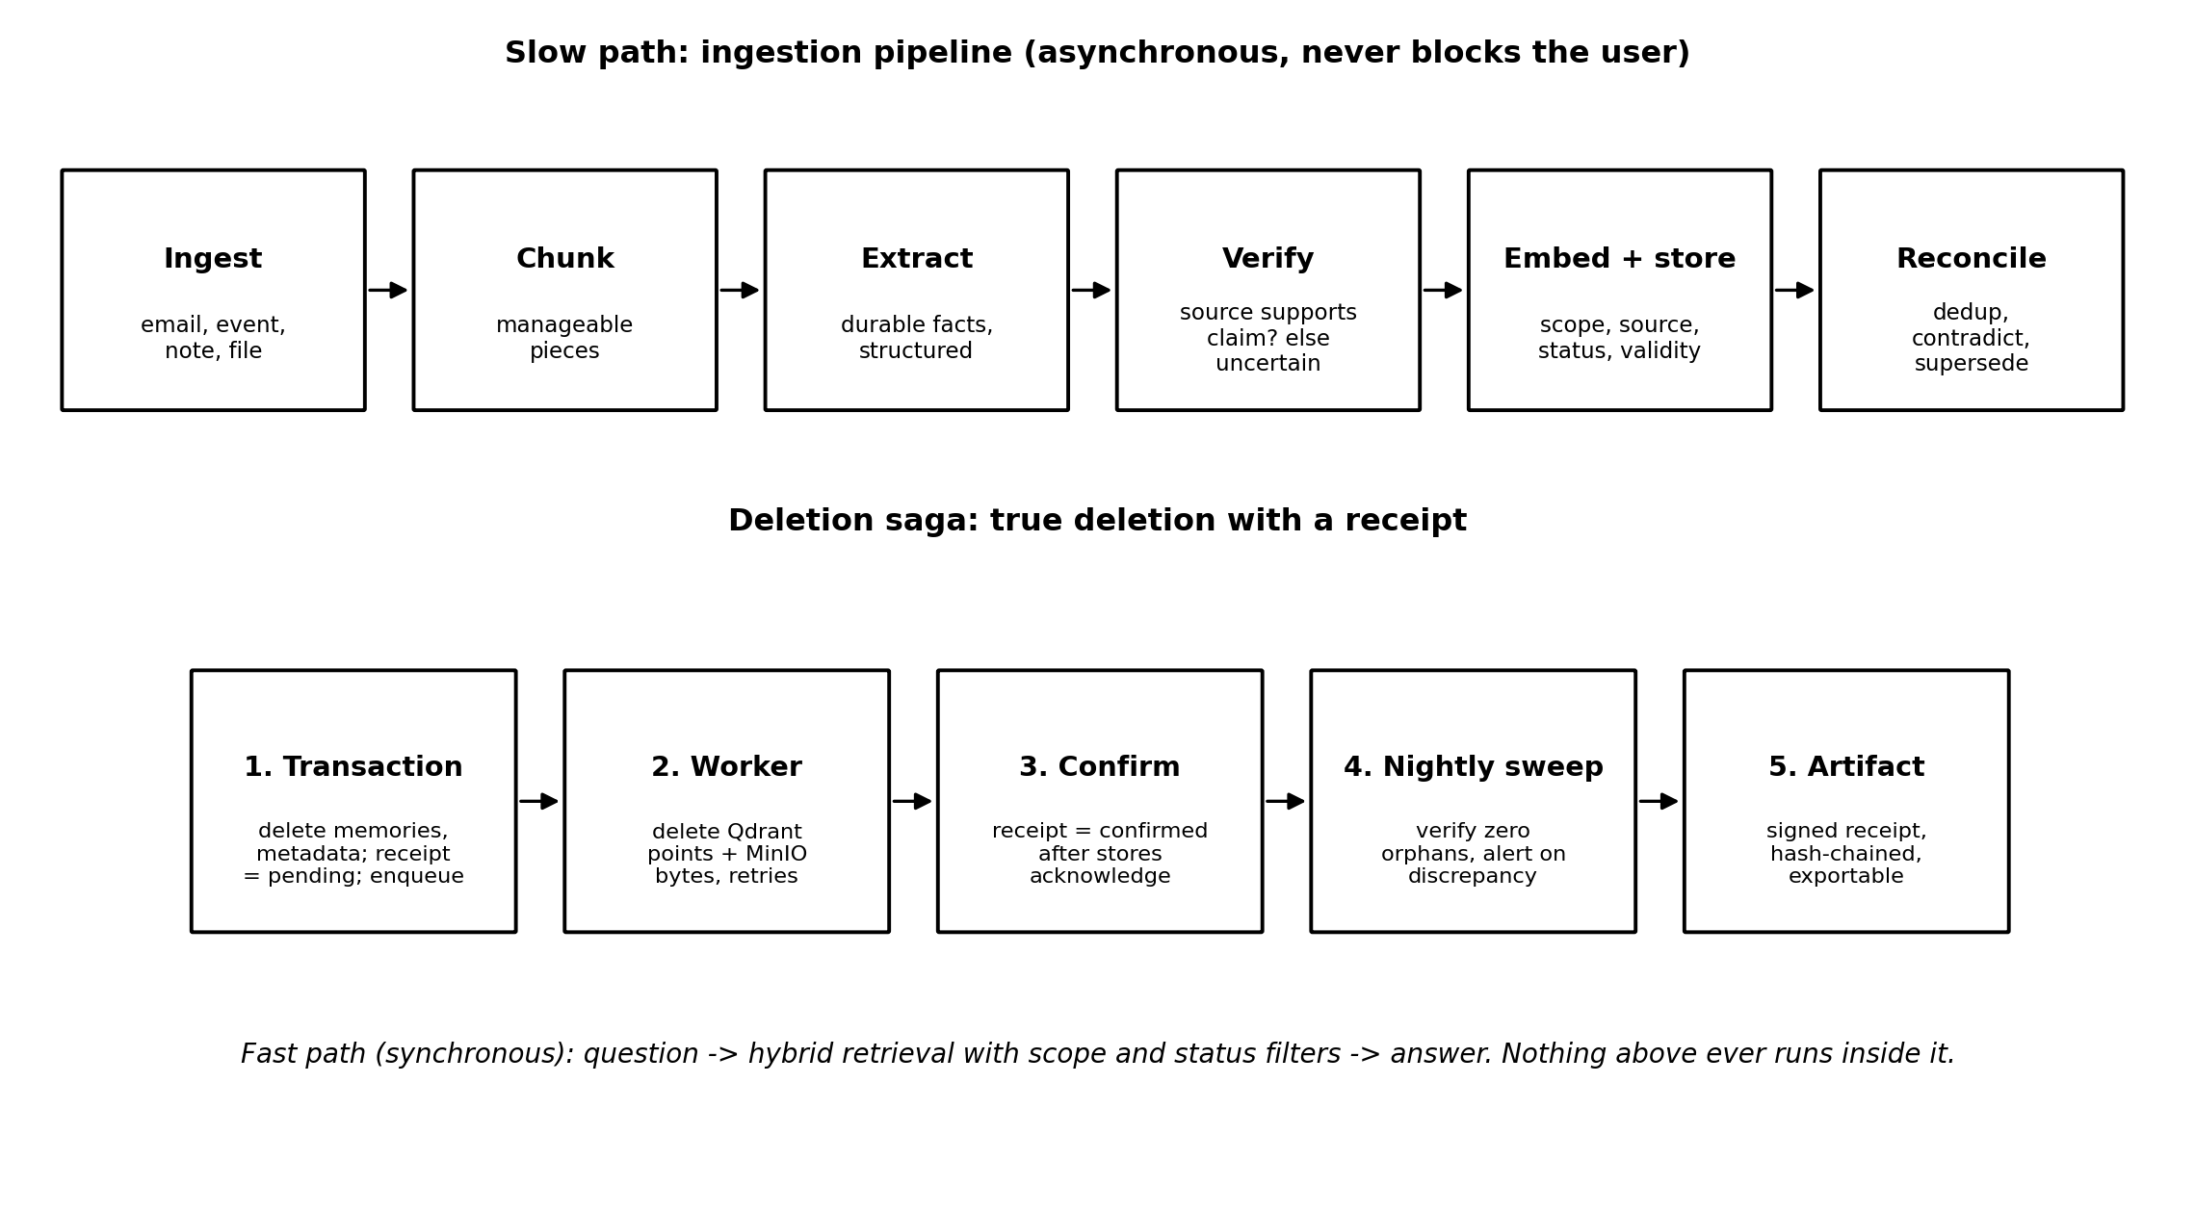
Figure 2. The slow-path ingestion pipeline and the deletion saga. Both run entirely in the worker; the fast path only ever performs filtered retrieval.

6.1 Outbox and jobs
Every state change that must trigger downstream work (a new email ingested, a document uploaded, a deletion requested, an action approved) writes a domain event and its job in the same Postgres transaction as the change itself. Workers claim jobs with row locking, execute idempotently under the key (source_type, source_id, job_type), retry with exponential backoff, and park permanent failures in a dead-letter state visible in the dashboard. A crashed worker loses nothing; a duplicate delivery changes nothing.

6.2 Retrieval: hybrid, fused, filtered
A user question fans out to three signals: semantic vector search in Qdrant, full-text search in Postgres, and trigram matching on entity names (people, projects). Results are fused with reciprocal rank fusion, then status multipliers are applied. Scope and the sensitive flag are hard filters inside each underlying query and are never expressible as score penalties, because a demoted leak is still a leak.
Status | Multiplier | Behavior
active / user_approved | 1.0 | Full weight
uncertain | 0.6 | Retrievable, visibly marked as unconfirmed
contradicted | 0.4 | Retrievable with an explicit warning and both sources shown
outdated | 0.2 | Strongly demoted; surfaced by temporal queries
replaced | 0.0 | Excluded by default; visible in history and time-travel views

6.3 Self-verifying extraction
Extraction produces candidate facts; a second, independent model pass receives each fact plus its source excerpt and answers supported, partial, or unsupported. Only supported facts become active; everything else is stored as uncertain and queued for user review. The verifier uses a different prompt than the extractor, and both prompts are versioned artifacts whose accuracy against the golden set is recorded in the prompt registry. This mechanism is what makes the seven statuses earned rather than decorative, and its outcomes feed the published trust score.

6.4 Deletion saga and receipts
Deletion follows the five steps in Figure 2: a single Postgres transaction removes memories and metadata, writes a pending receipt, and enqueues the external deletions; the worker removes Qdrant points and MinIO bytes with retries; the receipt flips to confirmed only after both stores acknowledge; a nightly sweep proves the absence of orphans; and the resulting receipt is signed, hash-chained to its predecessor, and exportable. The full cascade is covered by an automated test that is part of the definition of done for the memory module.

6.5 Approval state machine
Consequential actions (sending a message, bulk memory changes, external writes) are rows, not intentions: draft, pending_approval, approved, rejected, expired, executed. The confirm endpoint is authenticated and audited; execution happens only in the worker and only from the approved state. A front-end confirmation dialog is a courtesy, never the control.

6.6 Evaluation harness
A golden set of 50 to 100 hand-labeled notes, emails, and events (per supported language) defines expected memories. CI runs extraction, verification, deduplication, and contradiction detection against it on every change to prompts, models, or pipeline code, and fails the build below thresholds. The same numbers, published per release, are the public trust score. The harness is built alongside the extractor in the first implementation phase, not retrofitted, because extraction quality is the product.

7. Library Selection
Library | Role | Note
@nestjs/core and friends | Application framework, DI, module system | Modules map to bounded contexts; seams are injected interfaces
drizzle-orm, drizzle-kit, pg | Typed SQL and migrations | Migrations are reviewable SQL files, numbered from 0001
graphile-worker | Postgres job queue | Transactional enqueue; cron-style scheduling for digests and the nightly sweep
@qdrant/js-client-rest | Vector store client | Wrapped entirely inside the memory module
@aws-sdk/client-s3, s3-request-presigner | Object storage via S3 API | Targets MinIO and EU S3 clouds identically
openid-client | OIDC against Zitadel | Used only inside the identity seam
@mistralai/mistralai | Model API client | Used only inside the model gateway; embeddings included
zod | Boundary validation | API DTOs, connector payloads, job payloads, and model output parsing
pino | Structured logging | Redaction rules forbid memory content and tokens in logs
react, vite, @tanstack/react-query, tailwindcss | Dashboard and chat frontend | Static build served by Caddy
vitest, supertest, @testcontainers/postgresql | Unit and integration testing | Integration tests run against real Postgres, Qdrant, and MinIO containers
playwright | End-to-end tests | Login through Zitadel, chat round trip, deletion receipt flow
dependency-cruiser, eslint, prettier | Boundary enforcement and hygiene | CI fails on any cross-module import that violates the context map
presidio-analyzer / presidio-anonymizer (Python) | Redaction service | Isolated container; single internal endpoint
Rule for additions: any new dependency requires a one-paragraph decision record naming the alternative considered and the reason. Dependency sprawl is a fleet-maintenance cost multiplied by every tenant instance.

8. Implementation Plan
Phases are sequential and each ends in something demonstrable. The connector order (notes first, calendar second, email last) is deliberate: it exercises the full pipeline with zero OAuth friction, produces the public demo early, and defers the one external dependency (email scope verification) that can stall a launch.
Phase | Scope | Exit criterion
0. Skeleton | Repo structure per context map; compose with all services healthy; Zitadel bootstrap; CI with lint, type check, boundary check | docker compose up reaches a usable login on a fresh clone
1. Contractual core | Migration 0001 (memory, file_metadata, receipts, approvals); outbox and Graphile Worker wiring; identity and model seams as interfaces with first implementations | Integration tests prove transactional enqueue and scope-filtered reads
2. Notes vertical slice | Manual note capture; full pipeline ingest to reconcile; self-verifying extraction; embedding and Qdrant storage; hybrid retrieval; chat answer with sources; dashboard list, edit, statuses | A note becomes a correct, source-linked, verified memory answerable in chat
3. Trust machinery | Deletion saga with receipts and cascade test; approval state machine end to end; eval harness with golden set gating CI; prompt registry | Delete a document, receive a confirmed signed receipt; CI fails on eval regression
4. Ana sandbox | Demo compose profile with seeded persona; public sandbox deployment; compliance one-pager | A visitor asks what Ana promised Marko and watches a live deletion receipt
5. Calendar connector | Google and Microsoft calendar OAuth, incremental sync, meeting prep | Calendar facts flow through the same pipeline with correct provenance
6. Email connector | Microsoft Graph and IMAP first; Gmail per the scope-assessment decision; drafts through approval | The day-one question is answerable across all three sources
7. Productization | Instance provisioning and teardown automation, trial lifecycle, backups, monitoring, upgrade playbook across the fleet | A trial instance is created, used, converted or destroyed without manual steps
8. v1.x expansion | Time-travel diff view, Memory Passport export, dreaming digest card, local embeddings and reranker | Each ships as an independent increment on the same schema
The one decision to make before Phase 6 begins, not during it: the Gmail restricted-scope question. Either budget for the third-party security assessment immediately (months of lead time) or launch email via Microsoft and IMAP and add Gmail when the assessment clears. This dependency gates the launch date more than any engineering task in this plan.

9. Ways of Working

9.1 Repository and process conventions
- Trunk-based development. Short-lived branches, small reviewable pull requests, main always releasable. Feature flags are compose profiles or config, not long-lived branches.
- Decision records. Every notable choice (new dependency, schema change beyond additive, deviation from this document) gets a short numbered record in docs/decisions. The record names the alternative and the reason; ten lines is usually enough.
- Agent-assisted engineering with guardrails. AI coding agents work from CLAUDE.md and AGENTS.md, which encode the non-negotiables as a checklist. The research documents in docs/research are required reading before touching memory, retrieval, agents, or pipeline code. Agents propose; CI and the boundary rules dispose.
- Definition of done. Code, tests at the right level, migration if schema changed, decision record if a choice was made, docs updated, boundary check green, eval harness green when prompts or pipeline changed, and for the memory module specifically: the deletion cascade test passes.

9.2 Testing strategy
Level | Tooling | What it must cover
Unit | Vitest | Status transition function, fusion scoring, key derivations, validators
Integration | Vitest + Testcontainers | Transactional enqueue, scope-filtered queries (including proving unscoped reads are impossible through the public interface), pipeline steps against real Postgres, Qdrant, MinIO
End to end | Playwright | Login via Zitadel, note to memory to chat answer, approval round trip, deletion receipt flow
Quality | Eval harness in CI | Extraction precision and recall, verification agreement, dedup and contradiction accuracy against the golden set

9.3 Prompts as engineering artifacts
Every prompt that decides what Cogeto remembers (extraction, verification, deduplication, contradiction, consolidation) lives in the repo, is numbered and immutable once released, carries a changelog entry, and records its golden-set score in the prompt registry. Because the core is open source, these prompts are public, which extends the verifiable-memory posture into the model layer.

10. Security and Operations
- Secrets: environment variables injected per instance from the provisioning system; nothing secret in the repo or the image; connector OAuth tokens encrypted at the application layer before storage; log redaction enforced in the pino configuration.
- Encryption at rest: MinIO server-side encryption plus full-disk encryption on the host. Application-level envelope encryption is deliberately deferred; single-tenant isolation plus disk and object encryption answers the v1 threat model without gold-plating.
- Backups: nightly Postgres dumps and MinIO bucket sync to EU object storage in a second location; Qdrant is intentionally not backed up because reindex rebuilds it from Postgres; restore is rehearsed as part of Phase 7, not assumed.
- Monitoring: structured logs shipped per instance, uptime checks on Caddy and app health endpoints, job-queue depth and dead-letter alerts, and the nightly deletion sweep alerting on any orphan. Fleet dashboards aggregate per-tenant signals without aggregating tenant data.
- Upgrades across the fleet: one versioned image; instances upgrade by pulling the new tag and running pending migrations through the init container; canary on internal and demo instances first; rollback is the previous tag plus, when needed, reindex. The upgrade playbook is written and tested in Phase 7, because fleet operations is the second product.

11. Risks and Mitigations
Risk | Mitigation
Extraction quality below trust threshold | Golden set and CI gates from Phase 2; self-verification demotes unsupported facts to uncertain instead of asserting them; published score keeps the team honest
Email scope verification delays launch | Decision forced before Phase 6; Microsoft and IMAP path exists regardless of the Gmail outcome
Scope-filter regression leaks a memory | Filters live inside queries and Qdrant payload filters; integration tests assert the public interface cannot express an unscoped read; dependency rules keep raw table access inside the memory module
Vector store and source of truth drift | Qdrant is rebuildable by design; nightly sweep detects deletion orphans; reindex exercised in CI
Per-tenant costs erode margin | Two-process monolith, Postgres-based queue, no Redis, redaction only as an opt-in profile; footprint reviewed as a release metric
Fleet operations overwhelm a small team | Provisioning, teardown, backup, and upgrade automation are an explicit phase with exit criteria, not an afterthought
Dependency sprawl | Decision record required for every new library; the fleet multiplies every maintenance cost
Closing note. Nothing in this plan is speculative technology. Every mechanism (outbox, saga, state machine, hybrid retrieval, evaluation gates) is a well-understood pattern applied with discipline to one novel end: memory whose trustworthiness can be inspected, corrected, and proven. Build the contractual core first, keep the boundaries enforced, and the rest of the roadmap is increments on a foundation that never needs to be revisited.

