Game Play and Mechanics

Game Play

UI
Game Loading (Splash Screen)
The first image the player will see is the 'game loading' splash screen. This is a generic screen with game's name, game's logo, and 'Loading..." text. Usually, this will be just a flash until the game start screen displays.
Game Start
This screen is displayed when the game has been loaded/reloaded and is ready to play. It be a splash screen displaying 'Start Game', 'Exit Game', and 'Game Credits' buttons. When the player clicks the 'Start Game' button, then the game starts by loading and displaying the Level-1 Scene. When the player clicks the 'Exit Game' button, then the game immediately exits to the hardware's operation system.
Game End
The game ends whenever the hero defeats the boss on the final level, or the hero's health points fall to zero or less. When this happens the game will display the Game Over screen, then after a short time (seconds), the screen will fade to the Game Start screen. The game end screen will display whether the Hero was successful or died.
Credits Screen
The Game Credits screen will display all accreditation due either by good will or license requirement. If needed, the credits will scroll to accommodate their number.
Current credits can be found in Game Credits
Level Screens
During game play each level will display a UI containing critical stats. They are:
- Maximum health,
- Current health,
- Challengers Defeated,
- Coins collected,
- Gems collected,
- Shield counts,
- Primary weapon ammo count, and
- Secondary weapon ammo count.

Levels
The game play consists of 5 levels. When the player starts game play (Start Screen), SMC displays the first level (Level 1). Levels are larger than the game viewport. At the beginning of a level the viewport contains the portion of the level the Hero will start from. SMC blocks the player's input at this time.
The Hero character is not visible when the level loads and displays. At a preset time the game shows the Hero in the viewport using an effect akin to using a teleport. When the Hero character finishes with the teleport, then SMC enables the player's controls so the player can interact with the game.
The player controls the Hero to move around the level (exploring). While doing this the player encounters Containers (which contain items), Power-ups, and Challengers. The player can:
- Open containers,
- Collect the contents of open containers,
- Collect power-ups, and
- Fight challengers.
The final goal of each level is to defeat the Boss character (Skull of Death). The player cannot move to the next level until the Boss is defeated. When the player defeats the boss, then SMC will fade to the next level. On the last level, then SMC will display the Game End screen.
If at any time a Challenger defeats the Hero, then the player loses and the game is over and SMC will display the Game End screen.

Level Difficulty
This game is not meant to be difficult to play or win. It is a demonstration of what can be done. However, the last 3 levels will have more Challengers and more difficult bosses. More difficult. Not ridiculous.

Options
This game has no options the player can select.

Characters
- The Hero (Protagonist)
  - Primary Weapon: Crossbow Bolt
  - Secondary Weapon: Bomb
  - Defense:
    - Short Shield
    - Long Shield
- Vampire (Challenger) : Easy
  - Primary Weapon: Bite
  - Secondary Weapon: Automatically draws Hero to the Vampire in a helpless state
- Skeleton Warrior (Challenger) : Moderately easy
  - Primary Weapon: Throwing Knife
- Skeleton Grim Reaper (Challenger) : Medium
  - Primary Weapon: Fireball
  - Secondary Weapon: Scythe
- Skull of Death (Challenger) : Hard (Level Boss)
  - Primary Weapon: Laser
  - Secondary Weapon: Leap and Fire blast

Containers
These objects contain items. The game developer/coder and the designer statically place these during level design and development. The contents of each container are handled the same. They are closed when the player starts a new level.
The player opens a container by shooting it with the Hero's primary weapon. When the weapon hits the container, then the container opens by displaying an animation of it opening, and SMC shows the items on the screen. SMC displays the items such that the are a short distance from the container and the player can easily pick them up by moving the Hero graphic so that it collides with the items.
- Large Chest
- Medium Chest
- Small Chest

Items
Items only appear in containers. Gems and coins serve no purpose other than giving the player a sense of accomplishment by collecting them. Collecting gems and coins only increases their respective counters in the UI.
- Increase maximum health by 10 and fill set health to maximum health,
- Gems, and
- Coins.

Power-ups
SMC generates power-ups randomly. SMC randomly generates a power-up between 1 and 10 seconds.
The following list shows each power-up, the probability of SMC generating it, and its value.
- Extra life points
  - 25% probability
  - 5 to 10 life points
- Primary weapon refill of 5 units
  - 30%
  - 5 units
- Secondary weapon refill of 1 unit
  - 15% probability
  - 1 unit
- Short Shield
  - 20% probability
  - 1 unit
- Long Shield refill
  - 10% probability
  - 1 unit

Level Layout and Decorations

Level 1
Content
- Challengers
  - 2 Skeleton Warriors
  - 0 Skeleton Grim Reapers
  - 1 Vampire
  - 1 Skull of Death
- Containers
  - 1 Small Chest
    - 1 Short Shield
    - 1 Coin
    - 1 Primary Weapon
  - 1 Medium Chest
    - 2 Primary Weapons
    - 1 Life Potion
  - 2 Large Chests
    - 5 Primary Weapons
    - 3 Secondary Weapons
    - 2 Life Potions
    - 1 Long Shield
Layout
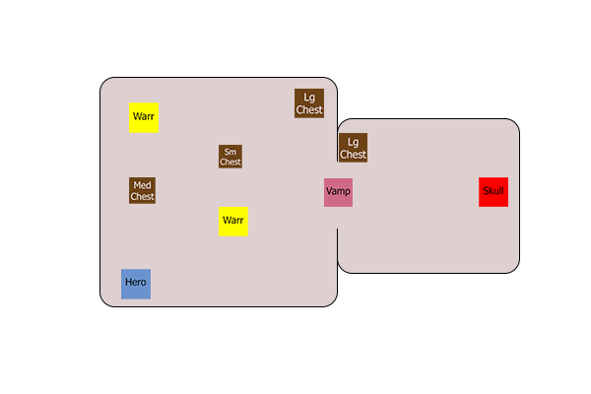
The Front Room has 2 Skeleton Warriors, 1 Vampire, 1 Small Chest, 1 Medium Chest, and 1 Large Chest. The Vampire blocks the doorway between both rooms so that the player must defeat the Vampire to get to the boss.
The Back room has the Skull of Death and 1 Large Chest. The Skull of Death is at the back of the room and Large Chest is near the front of the room so that the player can retreat and open the Large Chest if needed.

Levels 2 & 3
Content
Same as Level 1.
Layout
Same as Level 1 with different positions for the containers, items and Skeleton Warriors.

Level 4
Content
- Challengers
  - 6 Skeleton Warriors
  - 1 Skeleton Grim Reapers
  - 2 Vampires
  - 1 Skull of Death
- Containers
  - 3 Small Chests
    - 2 Short Shield
    - 2 Small Coin
    - 2 Primary Weapon
    - 1 Gem
  - 3 Medium Chests
    - 2 Primary Weapons
    - 1 Small Life Potion
    - 1 Large Coin
    - 2 Gems
  - 2 Large Chests
    - 1 Increase Maximum Life
    - 5 Primary Weapons
    - 3 Secondary Weapons
    - 2 Large Life Potions
    - 2 Long Shield

Layout
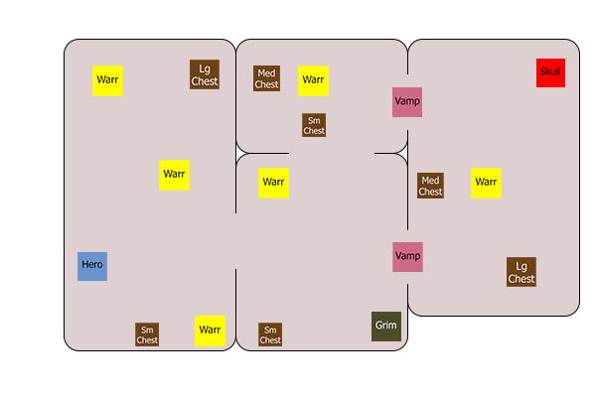

Level 5
Content
- Challengers
  - 12 Skeleton Warriors
  - 2 Skeleton Grim Reapers
  - 4 Vampires
  - 1 Skull of Death
- Containers
  - 8 Small Chests
    - 1 Life Potion
    - 2 Short Shield
    - 2 Small Coin
    - 2 Primary Weapon
    - 1 Gem
  - 4 Medium Chests
    - 2 Primary Weapons
    - 2 Secondary Weapons
    - 1 Small Life Potion
    - 1 Increase Maximum Life
    - 1 Large Coin
    - 2 Gems
  - 4 large Chests
    - 1 Increase Maximum Life
    - 2 Life Potions
    - 10 Primary Weapons
    - 5 Secondary Weapons
    - 3 Large Life Potions
    - 2 Long Shield

Layout
