Mechanics

Physics
Levels differ in size and area. Each level will have a boundary wall to prevent the player from moving the Hero out of the level's area, and to prevent game controlled characters and objects from leaving the level's area.
Since this is a top down game, gravity is not used, nor can the Hero or any computer controlled character jump. Nor do projectiles fall to the floor.
The Hero moves about the area in response to the player's inputs on the controls. Hero's speed is constant. No power-ups exist to boost or retard speed.
Any object that would be solid in-real-life is also solid in SMC. Hero, NPCs, projectiles and weapons cannot 'pass through' solid objects.
Weapons and projectiles travel in straight lines from point of release.
Bombs remain where they are placed.
Notice Range - Some Challengers do not engage with the Hero until the Hero enters their notice range. This is an area (usually circular) around the challenger that causes the Challenger engage with Hero for combat. The Challenger moves towards the Hero until the Hero is in range of the Challenger's weapon(s). The notice range is greater than the crossbow's projectile range. The player can choose to fight the Challenge, or try to run away from it, or try to put an object between the Hero and Challenger.

Movement
The player controls the Hero's movements. NPCs movements are controlled by the game logic.
The AI controls movement for the Challengers.

Objects
These include:
- Containers,
- Items, and
- Power-ups.
Only the Hero can collect items and power-ups. The player collects items by firing the primary weapon at a container. The container 'opens' and displays the items it contains. The player then collects the items by colliding with them.
The player collects power-ups by colliding the Hero into them. Items (Containers) that contain other items such as prizes and power-ups cannot be opened by Challenger weapons.

Actions
SMC will support keyboard/mouse and a game controller. The player can interact with the UI and controls the Hero with these input devices.

UI Interaction
The sole interaction with the UI is clicking buttons on the Start, End, and Credits screens. When using the keyboard/mouse the player uses the left mouse button to click on buttons. When the player is using a game controller then the following buttons select buttons:
- Game Start
  - Start Game - A button
  - Exit Game - X Button
  - Credits - B Button
- Game Exit
  - Return to Start - A button
- Credits
  - Return to Start - A button

Hero Control
Keyboard/Mouse
- Move Left - A or Left-arrow
- Move Right - D or Right-Arrow
- Move Up - W or Up-Arrow
- Move Down - S or Down-Arrow
- Primary Weapon - Left Mouse Button
- Secondary Weapon - Right Mouse Button
- Shields - Q
Game Controller
- Movement - Left Joystick
- Primary Weapon - Right Trigger
- Secondary Weapon - Left Trigger
- Shields - Left Button or Right Button

Viewport
The levels are larger than the viewport for the game. The Hero is always at the center of the viewport. As the player moves the Hero the level scrolls to keep the Hero in the center of viewport. (I. E. The camera is always above the Hero.)

Combat
Cool Down Period - The game limits combatants to how often they can fire their weapons. This is referred to as the cool down period. When a combatant fires a weapon, then it cannot fire that weapon again until the cool down period has expired.
Damage Immunity Period - The game limits how often a combatant can be hit by an opponent's weapon. When a weapon inflicts damage on a combatant, then that combatant cannot be damaged again until the damage immunity period has expired.

Hero
Movement - Controlled by player. SMC has four (4) sprite images for the Hero; North, East, South and West. SMC determines the general direction of the Hero's movement and displays the appropriate image.
Damage Immunity Period - The Hero has a preset damage immunity period.
Primary Weapon - Crossbow. This is a traditional distance, projectile weapon. When fired at an Challenger it inflicts a preset amount of damage. When a crossbow projectile hits a container, then the container opens to reveal its contents. This weapon is subject to a preset cool down period.
Secondary Weapon - Bomb. This is a stationary weapon placed by the Hero. It detonates 2 seconds after being placed. The detonation inflicts a preset amount of damage. The projectile has a preset range after which it is removed from the scene. This weapon is subject to a preset cool down period.
Short Shield - This makes the Hero immune from damage for a preset amount of time. This shield cancels any damage immunity period that may be active. No other shields can be used while this one is active.
Long Shield - This makes the Hero immune from damage for a preset amount of time which is longer than the short shield. This shield cancels any damage immunity period that may be active. No other shields can be used while this one is active.

Vampire
Movement - None.
Damage Immunity Period - None.
Primary Weapon - The stare and bite. When the Hero comes within a preset range (notice range) of the vampire, then the Hero comes under the vampire's control (the stare). This causes the Hero to move to the vampire's position. When they collide, the vampire bites the Hero inflicting a preset amount of damage. At this point the vampire's control over the Hero ends and the vampire cannot control the Hero until the cool down period expires. This allows the Hero to plant a bomb and back out of range. NOTE: The preset range of the stare is greater than the range of the crossbow projectile. This forces the Hero to have to place a bomb to destroy the vampire.

Skeleton Warrior
Movement - When the Hero enters it's notice range, then the Skeleton Warrior moves towards the Hero in order to use its primary weapon. If the Hero leaves the notice range, then the challenger stops moving and remains where it is. The Skeleton Warrior is pretty brain-dead. It it encounters an obstacle (solid object) directly in the path to the Hero, then the object stops the Skeleton Warrior and it cannot proceed along that path. It can only move if the Hero moves so that no objects are between the Hero and the Skeleton Warrior, and the Hero is still in the Skeleton Warrior's notice range.
Damage Immunity Period - A preset amount of time, but is relatively short.
Primary Weapon - Throwing Knife. The Skeleton Warrior throws a knife at the Hero when it is within a preset distance from the Hero (throwing range). The knife has a cool down period of one (1) second. This weapon is subject to a preset cool down period. If the knife hits the Hero, then it inflicts a preset amount of damage. The knife has a preset range. If it does not hit the Hero, then it is removed from the scene if it exceeds this range.

Skeleton Grim Reaper
Movement - This Challenger is a hunter. By this we mean that it seeks out the Hero whenever the Hero enters its domain (as defined by a navigation region). When the Hero moves into this region, then the Skeleton Grim Reaper moves towards the Hero. However, unlike the Skeleton Warrior, objects (solid objects) do not deter it. The Skeleton Grim Reaper will move around obstacles to reach the Hero. If the Hero leaves the Skeleton Grim Reaper's domain, then it will stop moving.
Damage Immunity Period - A preset amount of time, but longer than the Skeleton Warrior.
Primary Weapon - Fireball. When the Hero is in range of this weapon, then the Skeleton Grim Reaper will throw a fireball at the Hero. The range is such that the Hero will be hit at least once by the fireball. When the fireball leaves its range, then it is removed from the scene. The fireball is subject to a preset cool down period. The fireball inflicts a preset amount of damage. The speed of the fireball is such that the Player will have difficulty dodging it.
Secondary Weapon - Scythe. When the Hero becomes closer to the Challenger, then the challenger switches to its secondary weapon. This weapon has a higher damage value than the primary weapon, and it is subject to a preset cool down period.

Skull of Death
Movement - This Challenger does not move more than a preset distance from where it starts in the scene. No obstacles are in this diameter of movement, so that the Challenger always has a clear path towards the Hero. When the Hero enters this area, then the Challenger attacks the Hero immediately.
Weapon Selection - The game logic randomly determines which weapon will be used. A preset value determines the probability of which weapon is used. The primary weapon has a higher probability of being used than the secondary weapon. Because of this the secondary weapon inflicts a higher amount of damage.
Damage Immunity Period - A preset amount of time to make it challenging for the player. The last few levels have a longer preset time.
Primary Weapon - Laser. When the Hero is in range of the Challenger, then the Challenger fires this weapon. It is fast. So the Hero cannot dodge it. The laser has a preset amount of damage. The laser is subject to a longish preset cool down period.
Secondary Weapon - Fire blast. When the secondary weapon is selected, then the Challenger lunges (moves quickly, very quickly) towards the Hero. It then sends a fire blast at the Hero. The fire blast has a higher preset amount of damage than the laser. This weapon is subject to the same cool down period as the laser.

Economy
No real economy exists in SMC. Although the player can collect gems and coins, they have no value in the game other than bragging rights.
The only reason we included them is in case we develop this game further and include a real economy.

Screen Flow
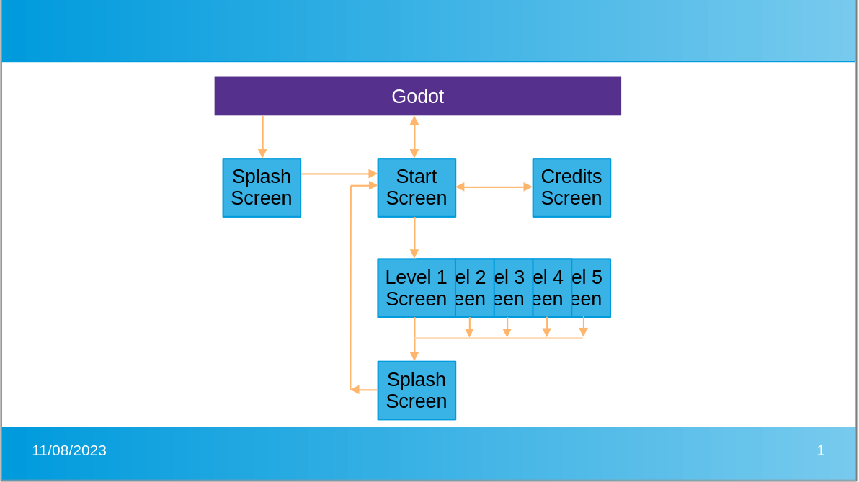
When the player activates the game, then SMC displays the splash screen. Once the game is loaded, SMC displays the Game Start screen.
From the Game Start screen the user can choose start a game, exit the application to the O/S, or display the game credits.
Game Credits display all the credits for the games. If all credits do not fit on the screen, then the screen will scroll. The screen has a "Return" button to go back to the Game Start screen.
SMC displays the Game End screen when the player either wins or dies. It has a "Continue" button to go back to "Game Start".

Other Gameplay Aspects
- SMC has no pause capability

Gameplay Options
SMC has no options for the player to choose from.

Saving and Replaying
SMC does not include saving games. Reply consists of starting the game over.

Easter Eggs and Cheats
N/A at this time.

