**COGNIGRADE – Application Guide**

To ensure the correct use of the Cognigrade app, the following instructions must be followed by both students and teachers.

**Instructions followed by the student while writing exams-**

* Ensure your handwriting is neat and legible, with sufficient spacing between lines and words.
* Clearly indicate question numbers using a standard format, such as “Q1” or “Question 1.”
* Avoid using arrows or non-linear formats to connect parts of your answer; responses must be written sequentially, in a line-by-line manner.
* Please note that any rough work done within the answer space will be included in the extracted response and assessed accordingly. Therefore, it is advised to perform all rough work separately.
* If you need to strike through any content, do so clearly and completely to ensure the text is no longer visible.

Example:

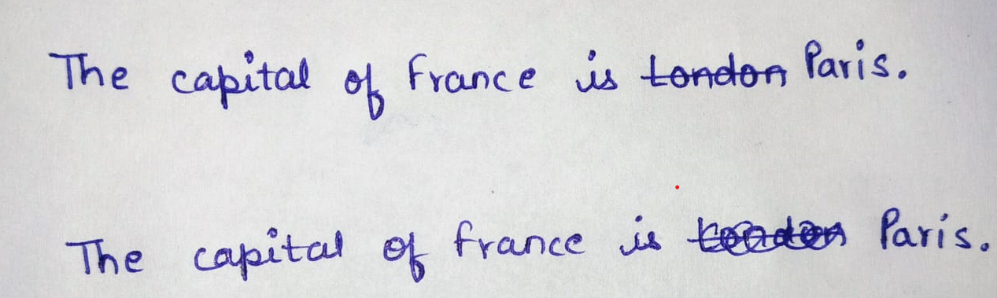





**Instructions followed by the teacher while creating exams-**

**1. Answer Script Based Examination**

* Ensure that question numbers are clearly distinguishable and presented in a sequential manner.

** **

**Q1. What is a computer? Q1. What is a computer?**

**Q2. Who is the father of the computer? Q1. Who is the father of the computer?**

* For questions that contain diagrams or any non-text content, manual evaluation is required. Please make sure to **deselect** these questions from the automatic grading process in the UI before beginning the evaluation process.

**2. Inbox Type Examination**

* Do not ask students to mark answers within the question itself. Instead, instruct them to **rewrite** the selected answer clearly in the answer space.

Avoid-

*Tick the correct answer.*

*Match the answers.*

*Encircle the incorrect statements and write the corrected forms.*

Recommended-

*Write the complete corrected answer clearly in the space provided.*

**NOTE:** Users will be charged based on the total number of API calls made during grading. Please check the pricing details before starting the evaluation to avoid any unexpected charges.