# GenieCart User Guide

## Table of Contents

1. Introduction  
  
2. For Real Users  
 - Signing Up  
 - Logging in  
 - Managing Your Profile  
 - Receiving Your Recommendations  
  
3. For Machine Customers  
 - Accessing the RESTful API Endpoint  
 - Sending Data Requests  
 - Interpreting Responses

## 1. Introduction

Welcome to GenieCart, an intelligent platform for personalized shopping experiences. This guide provides instructions for real users and machine customers on how to interact with GenieCart’s features.

## 2. For Real Users

### Signing Up

- If you are a new user, visit the GenieCart homepage and click **Sign Up**..

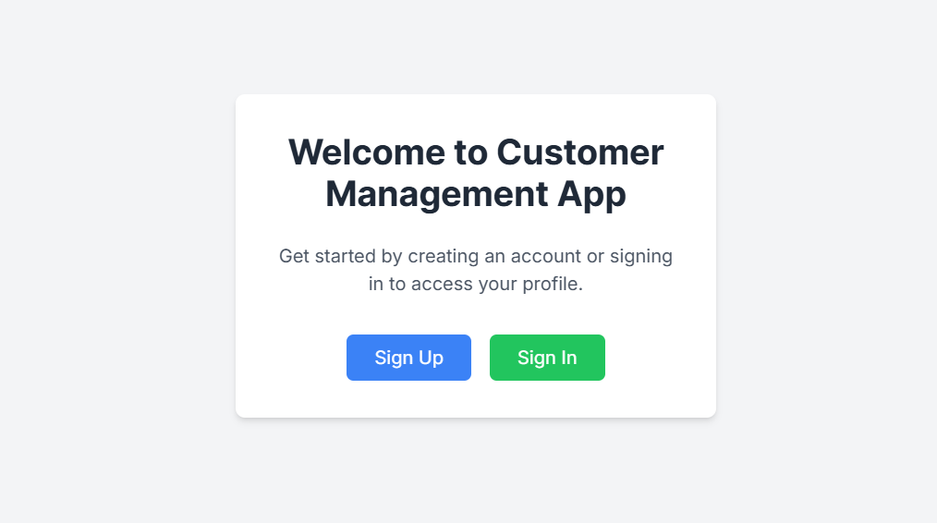

- Enter your name, email, and a secure password.  
- Click **Sing up** to create your account.

### Logging In

- Click on **Sign in** option.  
- Enter your email and password, then press **Sign in**.

### Managing Your Profile

- After logging you will be Navigate to the **Profile** section.  
- Here, you will receive a **secret key** upon signing up. Keep it safe and do not share it with anyone except trusted machine customers.  
- Machine customers will use this key to make authenticated requests on your behalf.

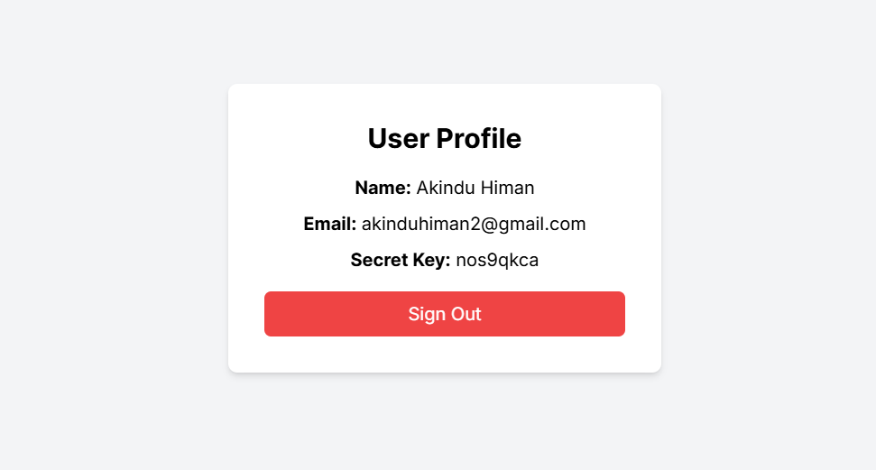

### Receiving Your Recommendations

- You will receive recommendations via email when your machine customers make a request.  
- Ensure the email you provided during signup is active and accessible.  
- The email will include a summary of the recommended products.

## 3. For Machine Customers

### Accessing the RESTful API Endpoint

- Use the endpoint. (As currently running locally something like http://125.1.1.1:5000/recommend)  
- Ensure you have a secret key to authenticate requests.

### Sending Data Requests

- Format your request in JSON, as shown below:  
{  
 "secret_key": "your_api_key",  
 "item_name": "example_item",  
 "custom_domains": ["https://domain1.com", "https://domain2.com"],  
 "price_level": 2,  
 "tags": ["tag1", "tag2"]  
}  
- Send POST requests using any HTTP client.

### status Responses

- GenieCart returns response is it success of fail.

