# [**Call Tracing: Unlock New Dimensions in VUX Optimization**](https://www.cognigy.com/blog/call-tracing)

In the burgeoning field of voice technology, optimizing Voice User Experience (VUX) is a sophisticated endeavor fraught with unique challenges. VUX designers confront intricate variables from timing nuances and intonation accuracy to the unpredictability of human speech and environmental interference.

These factors often present hurdles that can transform an otherwise fluid dialogue into a disjointed exchange. For enterprises aiming to scale and perfect their voice-enabled services, these are not mere technicalities but critical pivots on the customer experience journey.

Recognizing this complex landscape, at Cognigy, we’re excited to introduce the ultimate tool for developers and VUX designers in their quest for voice excellence: [**Call Tracing**](https://en.wikipedia.org/wiki/Call_tracing)**.**

### **Visualizing the Unseen: How Call Tracing Changes the Game**

Traditionally, understanding and monitoring voice interaction requires painstaking analysis of transcriptions, user feedback, and basic audio playback. Now, Cognigy’s Call Tracing feature offers an actionable visualization of all activities taking place during the call, such as speech recognition and connections, together with the call recording waveforms. This powerful tool grants VUX designers an unparalleled view of the dynamics of voice interactions.

Event and soundwave visualization provides an analytical perspective that goes beyond the audio, giving professionals the ability to dissect and understand voice experiences at a granular level. It brings critical elements to the forefront that might not be immediately evident in transcriptions or basic audio playback.

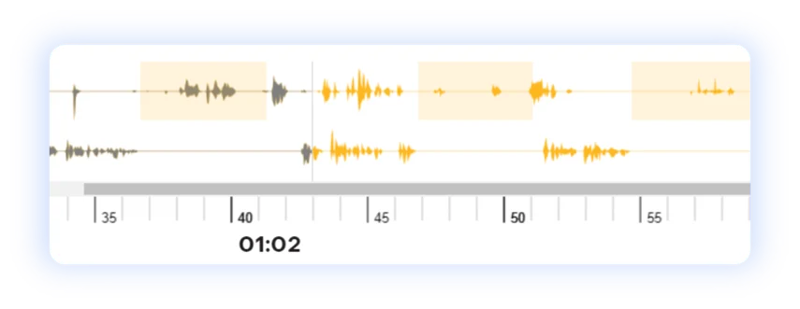

### **Key Topics**

| **Topic** | **Description** |
| --- | --- |
| Optimizing Response Timings | Identify silence and pauses; analyze call duration; uncover speech recognition latency. |
| Detecting and Resolving Overlapping Speech | Resolve speech overlaps; fine-tune settings for seamless interaction. |
| Monitoring Speech Quality | Highlight inconsistencies; troubleshoot for service quality. |
| Fine-tuning the ASR Model | Optimize speech recognition models; enhance recognition accuracy. |

#### **Conclusion**

* Cognigy’s Call Tracing uncovers nuanced expressions, crucial for enhancing user experiences.
* Explore our documentation for insights on the [Voice Gateway Self-Service Portal](https://docs.cognigy.com/voicegateway/webapp/overview/) and [Call Tracing](https://docs.cognigy.com/voicegateway/webapp/recent-calls/#call-tracing).