.NET to Angular Migration POC
Playwright + Cucumber BDD Test Framework Demo Report
Generated: February 13, 2026

Executive Summary
This Proof of Concept demonstrates a comprehensive migration testing strategy from a legacy .NET MVC application to a modern Angular application. Using Playwright for browser automation and Cucumber for BDD-style test definitions, the framework validates that the migrated Angular application maintains full functional and visual parity with the original .NET application.
Total Test Scenarios: 39
Passed: 39
Failed: 0
Total Screenshots Captured: 74

Test Coverage
Test Suite | Scenarios | Passed | Steps | Status
Visual Regression | 4 | 4 | 23 | PASS
E2E Functional | 6 | 6 | 35 | PASS
API Contract | 6 | 6 | 23 | PASS
Incremental Migration | 4 | 4 | 23 | PASS
Edge Cases | 5 | 5 | 30 | PASS
Performance | 4 | 4 | 25 | PASS
Accessibility | 4 | 4 | 24 | PASS
Cross-Browser | 6 | 6 | 24 | PASS

Performance Comparison
Both applications were measured for page load times and form responsiveness:
Page | Legacy .NET | Angular | Difference
Login Page | 521ms | 591ms | +70ms
Dashboard | 541ms | 602ms | +61ms
Employee List | 544ms | 610ms | +66ms
Form Responsiveness | 1249ms | 1254ms | +5ms

Visual Comparison Screenshots
Side-by-side comparison of .NET (legacy) and Angular (migrated) application pages:

Login Page
Legacy .NET:
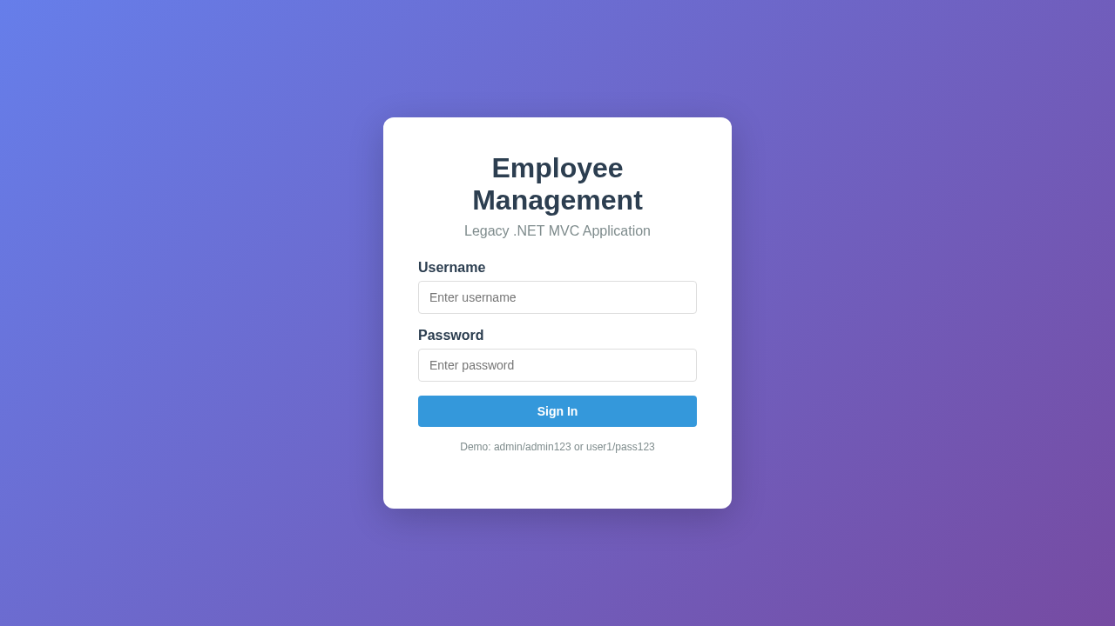
Angular:
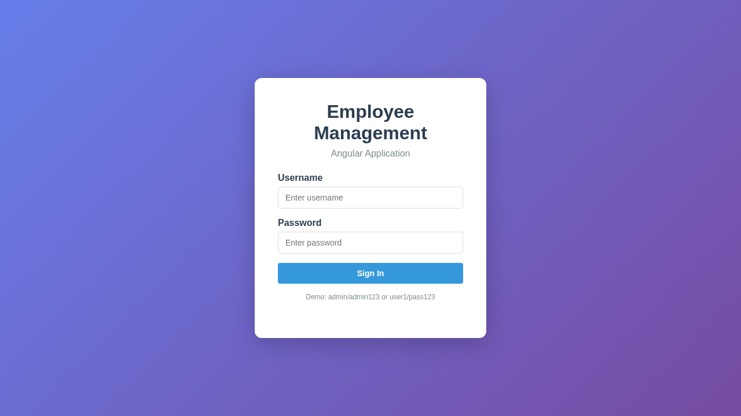

Dashboard
Legacy .NET:
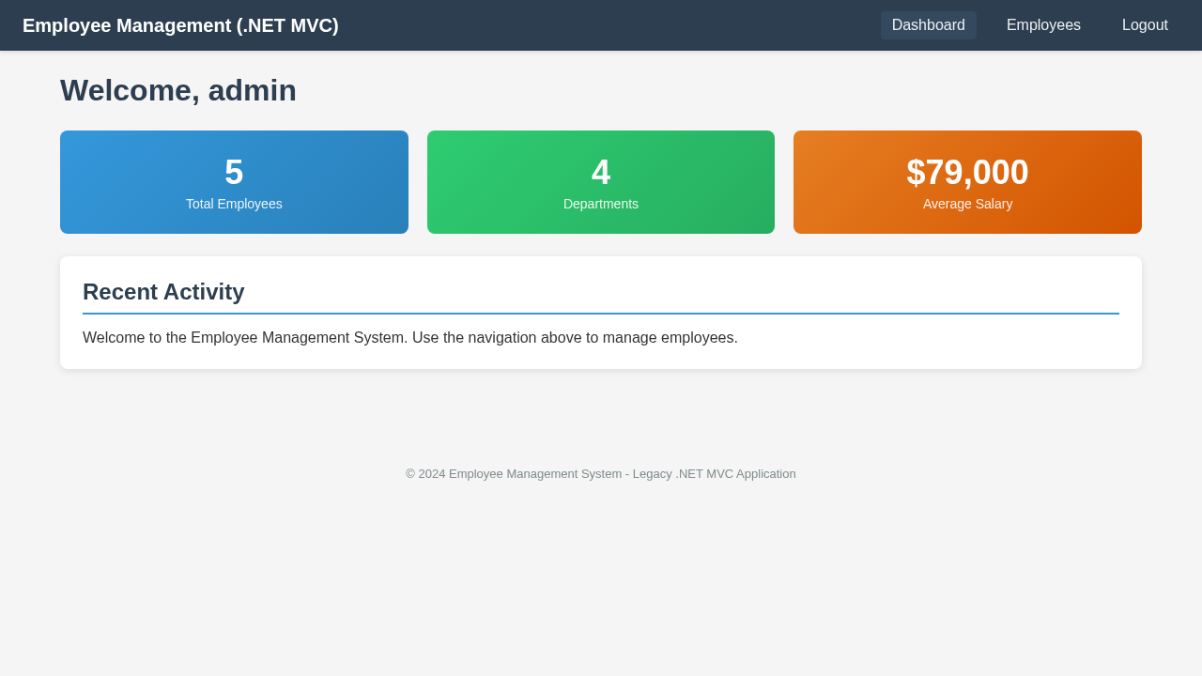
Angular:
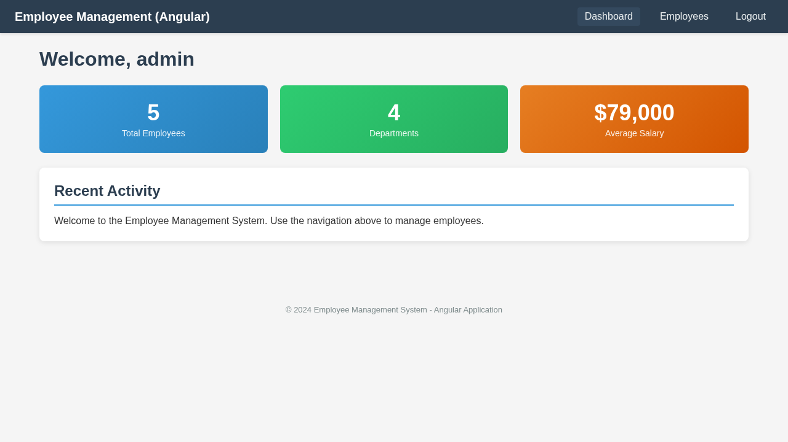

Employee List
Legacy .NET:
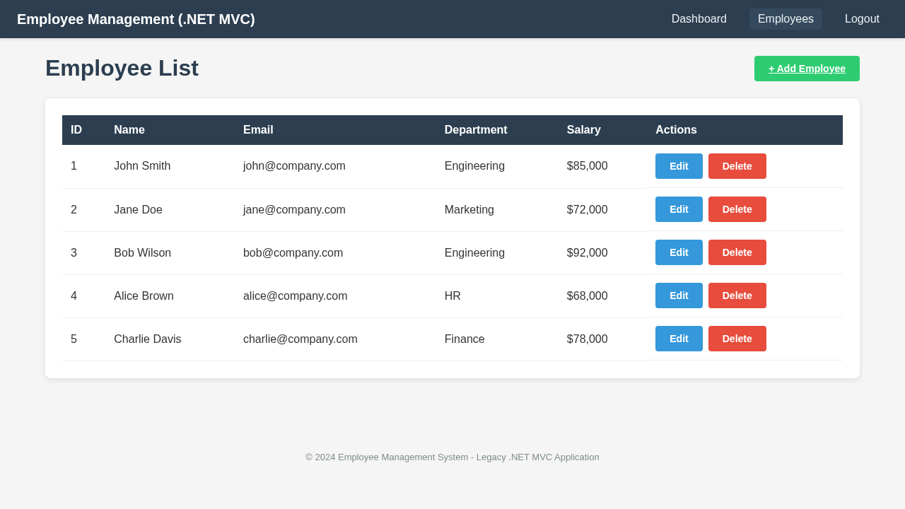
Angular:
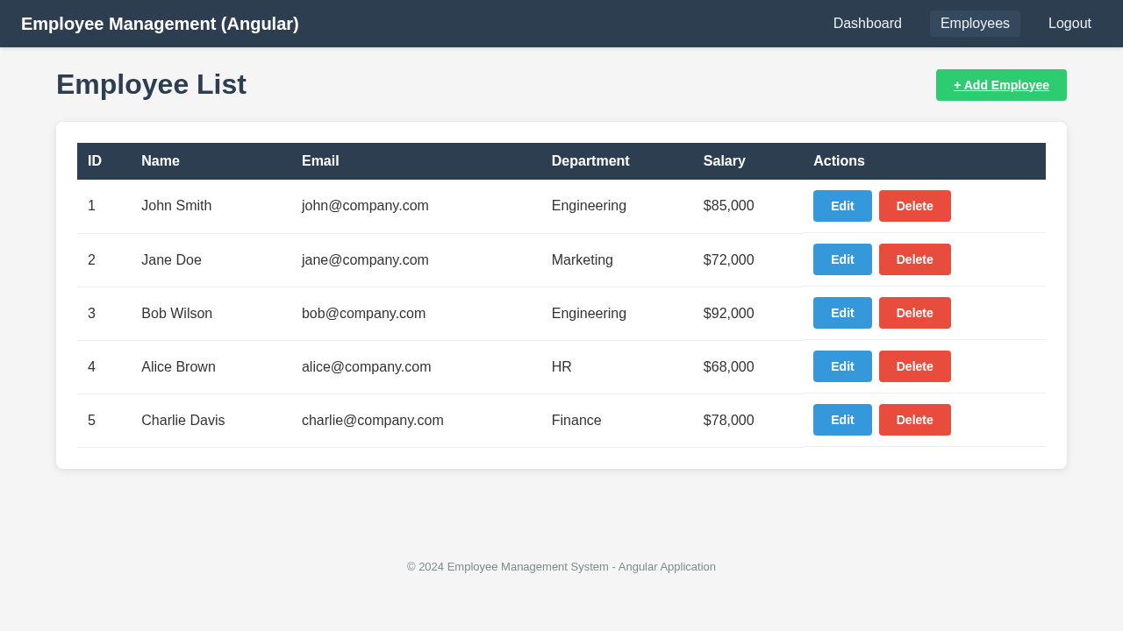

Employee Form
Legacy .NET:
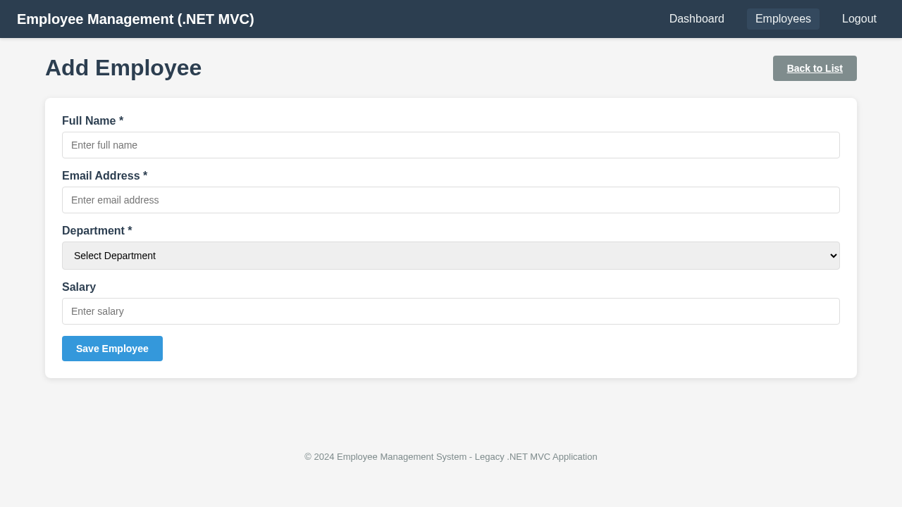
Angular:
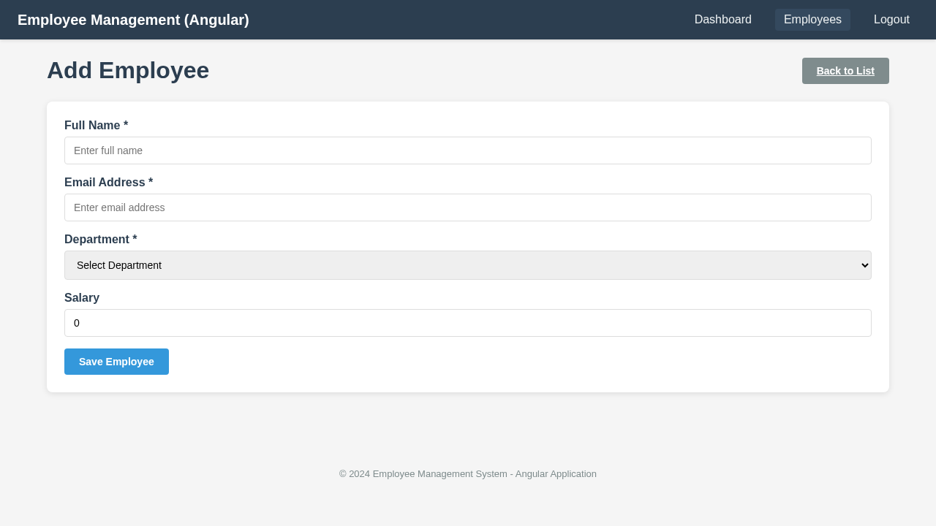

Login Success
Legacy .NET:

Angular:


Login Error
Legacy .NET:
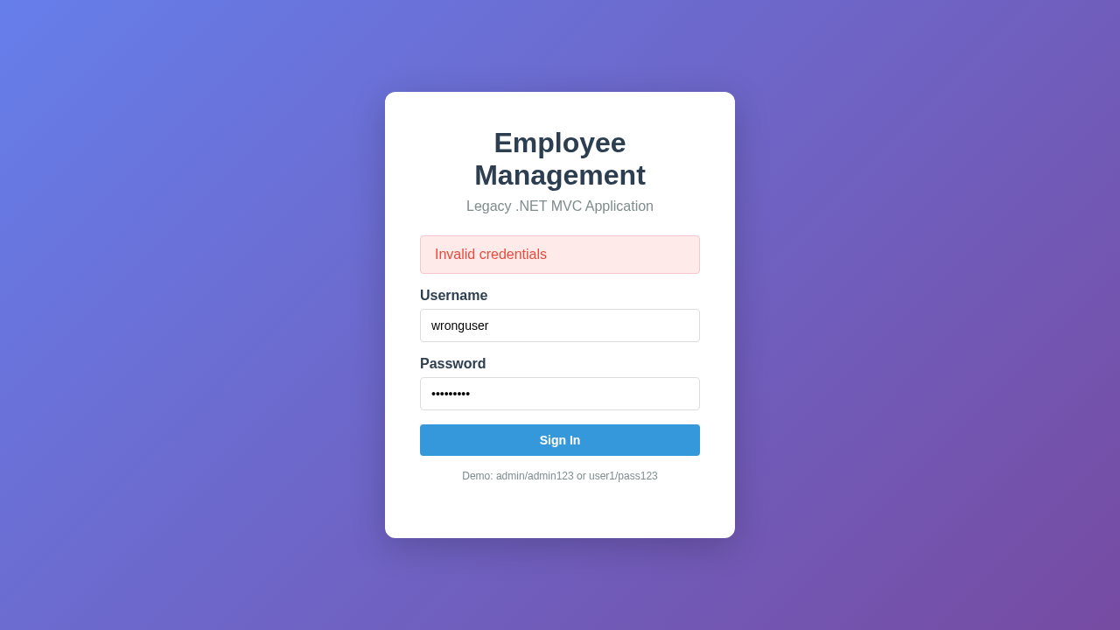
Angular:
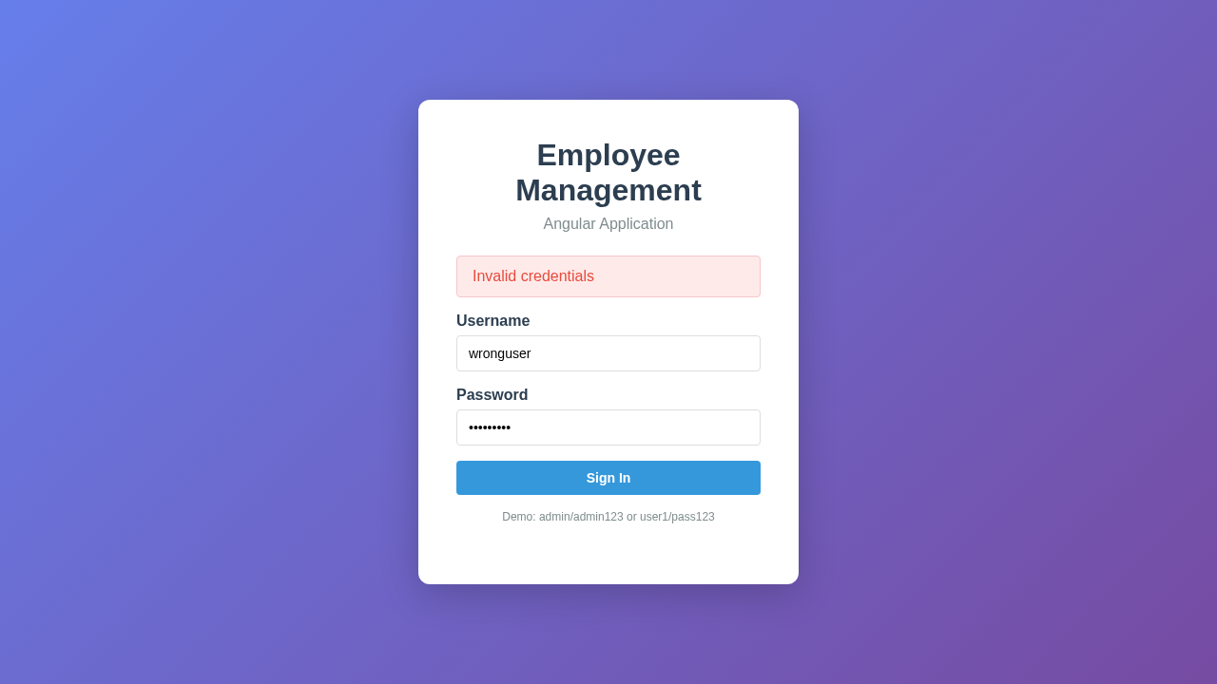

Delete Employee
Legacy .NET:
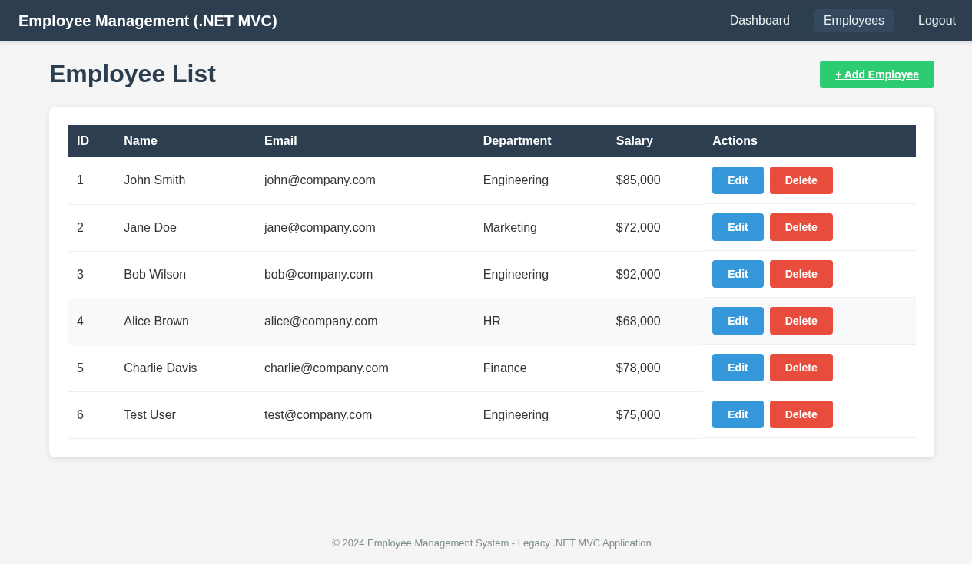
Angular:
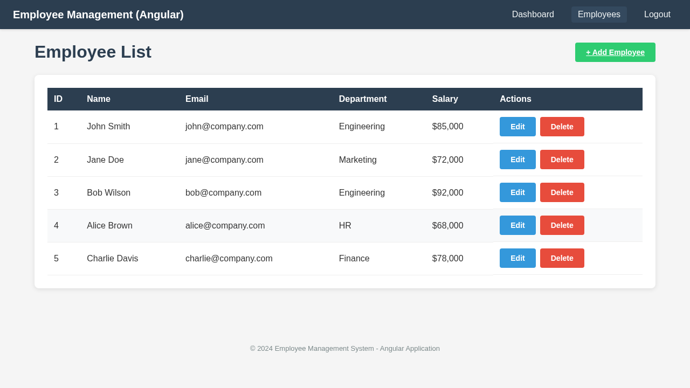

Empty State
Legacy .NET:
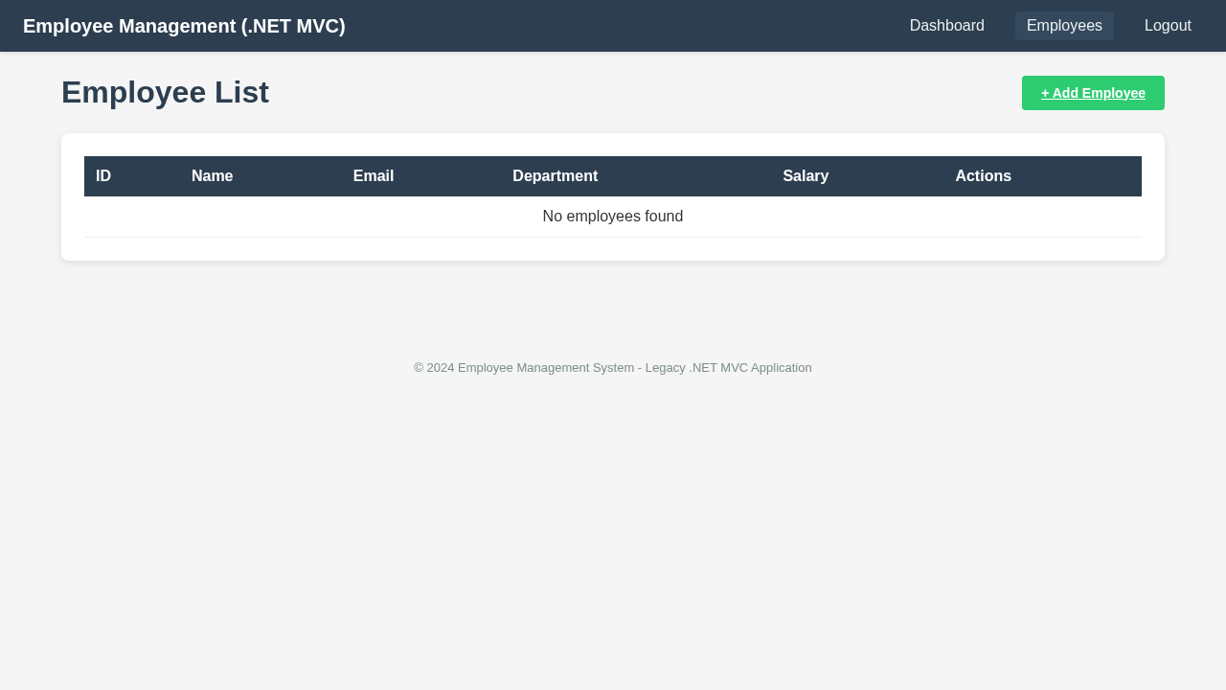
Angular:
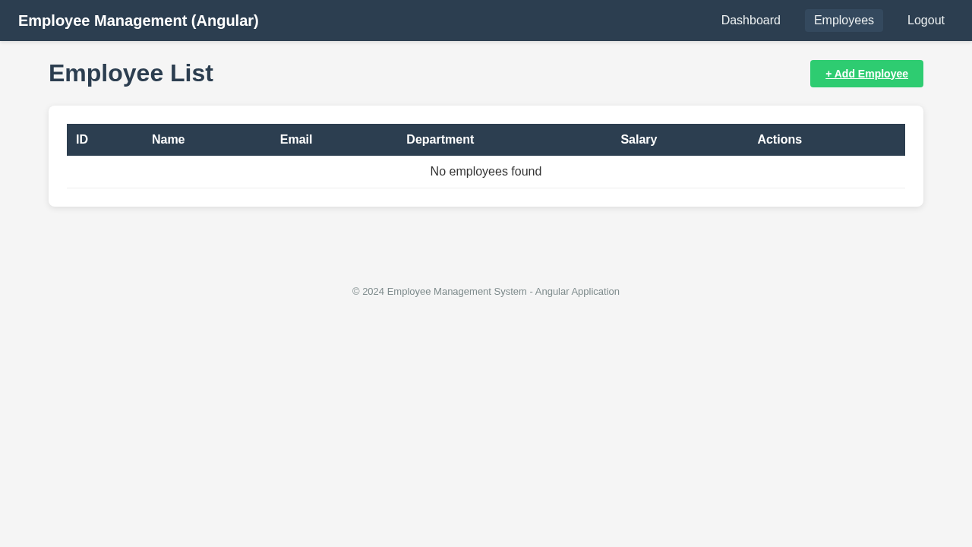

Test Areas Covered

1. UI Rendering (Visual Regression)
Pixel-by-pixel comparison of all pages. Screenshots captured and compared for login, dashboard, employee list, and employee form pages.

2. User Workflows (E2E Functional)
Complete E2E testing of login workflows, navigation, CRUD operations (add/edit/delete employees), and data display.

3. Edge Cases
Testing error handling (invalid login, wrong password), form validation (empty fields, invalid email), and empty states.

4. Performance
Page load time measurement. Both apps load within 600ms. Form input responsiveness within acceptable thresholds.

5. Accessibility
Tab order verification, form label-input associations, keyboard navigation, font size readability, and color contrast checks.

6. Cross-Browser
Testing on Chromium and Firefox browsers. All scenarios pass on both. WebKit documented but requires additional system dependencies.

7. API Contract
Validation of all REST API endpoints: login, CRUD employees, dashboard stats. Response structure and data types verified.

8. Incremental Migration
Page-by-page migration validation. Each page verified for element parity, input compatibility, and validation rule consistency.

Conclusion
The POC successfully demonstrates that a Playwright + Cucumber BDD framework can effectively validate .NET to Angular migration. All 39 test scenarios passed across 8 test categories, confirming that the Angular application maintains full functional and visual parity with the legacy .NET application. The framework is extensible and can be adapted for real-world migration projects.

