Optimizing Intelligent Agent’s Constraint Satisfaction with Neural Networks
Arpad Kelemen, Yulan Liang, Robert Kozma, Stan Franklin
Department of Mathematical Sciences
The University of Memphis
Memphis TN 38152
kelemena@msci.memphis.edu
Abstract. Finding suitable jobs for US Navy sailors from time to time is an important and ever-changing process. An Intelligent Distribution Agent and particularly its constraint satisfaction module take up the challenge to automate the process. The constraint satisfaction module’s main task is to assign sailors to new jobs in order to maximize Navy and sailor happiness. We present various neural network techniques combined with several statistical criteria to optimize the module’s performance and to make decisions in general. The data was taken from Navy databases and from surveys of Navy experts. Such indeterminate subjective component makes the optimization of the constraint satisfaction a very sophisticated task. Single-Layer Perceptron with logistic regression, Multilayer Perceptron with different structures and algorithms and Support Vector Machine with Adatron algorithms are presented for achieving best performance. Multilayer Perceptron neural network and Support Vector Machine with Adatron algorithms produced highly accurate classification and encouraging prediction.
1 Introduction
IDA, an Intelligent Distribution Agent [4], is a “conscious” [1], [2] software agent being designed and implemented for the U.S. Navy by the Conscious Software Research Group at the University of Memphis. IDA is intended to play the role of Navy employees, called detailers, who assign sailors to new jobs from time to time. To do so IDA is equipped with ten large modules, each of which is responsible for one main task of the agent. One of them, the constraint satisfaction module, is responsible for satisfying constraints in order to satisfy Navy policies, command requirements, and sailor preferences. To better model humans IDA’s constraint satisfaction is done through a behavior network [6] and “consciousness”, and employs a standard linear functional approach to assign fitness values for each candidate job for each candidate sailor one at a time. There is a function and a coefficient for each of the soft-constraint, which are constraints that can be violated, and the job may still be valid. Each of these functions measures how well the given constraint is satisfied for the given sailor and the given job. Each of the coefficients measures how important is the given constraint in relative to the others. There are hard constraints too which can not be violated and they are implemented as Boolean multipliers for the whole functional. A violation of a hard constraint yields 0 value for the functional. The functional yields a value on [0,1] where higher values mean higher degree of “match” between the given sailor and the given job at the given time. Tuning the coefficients and the functions to improve the performance is a continuously changing, though critical task. Using neural networks and statistical methods to enhance decisions made by IDA’s constraint satisfaction module and to make better decisions in general are the aim of this paper.
Using data from time to time coming from human detailers, a neural network may learn to make human-like decisions for job assignments. On the other hand human detailers, though have some preferences in judging jobs for sailors, can’t give specific functions and numeric coefficients to be applied in a constraint satisfaction model. Different detailers may have different views on the importance of constraints, which view may largely depend on the sailor community they handle and may change from time to time as the environment changes. However, setting up the coefficients in IDA such a way that decisions reflect those made by humans is important. A neural network may give us more insight in what preferences are important to a detailer and how much. Moreover inevitable changes in the environment will result changes in the detailer’s decisions, which could be learned with a neural network with some delay.
In this paper, we present several approaches in order to achieve optimal decisions. Feed-Forward Neural Network (FFNN) without and with one hidden layer for training a logistic regression model were applied for searching for optimal coefficients. For better generalization performance and model fitness we present the Support Vector Machine (SVM) method. Sensitivity analysis through choosing different network structures and algorithms were used to assess the stability of the given approaches.
In Section 2 we describe how the data was attained and formulated into the input of the neural networks. In Section 3 we discuss FFNNs with Logistic Regression Model and the performance function and criteria of Neural Network Selection for best performance including learning algorithm selection. After this we turn our interest to Support Vector Machine to see if better performance can be achieved with it. Section 4 presents some comparison study and numerical results of all the presented approaches along with the sensitivity analysis.
2 Preparing the Input for the Neural Networks
The data was extracted from the Navy’s Assignment Policy Management System’s job and sailor databases. For the study one particular community, the Aviation Support Equipment Technicians community was chosen. Note that this is the community on which the current IDA prototype is being built. The databases contained 467 sailors and 167 possible jobs for the given community. From the more than 100 attributes in each database only those were selected which are important from the viewpoint of the constraint satisfaction: 18 attributes from the sailor database and 6 from the job database. The following four hard constraints were applied to these attributes complying with Navy policies:
Table 1. The four hard constraints applied to the data set

Function | Policy name | Policy
c₁ | Sea Shore Rotation | If a sailor's previous job was on shore then he is only eligible for jobs at sea and vice versa
c₂ | Dependents Match | If a sailor has more than 3 dependents then he is not eligible for overseas jobs
c₃ | Navy Enlisted Classification (NEC) Match | The sailor must have an NEC [trained skill] what is required by the job
c₄ | Paygrade Match (hard) | The sailor’s paygrade can't be off by more than one from the job's required paygrade

Note that the above definitions are simplified. Long, more accurate definitions were applied on the data.
1277 matches passed the above four hard constraints, which were inserted into a new database.

Four soft constraints were applied to the above matches, which were implemented with functions. The function values after some preprocessing served as inputs to the neural networks and were computed through knowledge given by Navy detailers. Each of the function’s range is [0,1]. The functions were the following:
Table 2. The four soft constraints applied to the data set

Function | Policy name | Policy
f₁ | Job Priority Match | The higher the job priority, the more important to fill the job
f₂ | Sailor Location Preference Match | It is better to send a sailor to a place he wants to go
f₃ | Paygrade Match (soft) | The sailor’s paygrade should exactly match the job’s required paygrade
f₄ | Geographic Location Match | Certain moves are more preferable than others

Again, the above definitions are simplified. All the f_{i} functions are monotone but not necessarily linear. Note that monotony can be achieved in cases when we assign values to set elements (such as location codes) by ordering.

Every sailor along with all his possible jobs satisfying the hard constraints were assigned to a unique group. The numbers of jobs in each group were normalized into [0,1] and were also included in the input to the neural network, which will be called f5 in this paper. This is important because the output (decisions given by detailers) were highly correlated: there was typically one job offered to each sailor.
Output data (decision) was acquired from an actual detailer in the form of Boolean answers for each match (1 for jobs to be offered, 0 for the rest). Therefore we mainly consider supervised learning methods.
3 Design of Neural Network
3.1 FFNN with Logistic Regression
One issue we are interested in is to see the relative importance of f₁-f₄ and the estimation of the conditional probability for the occurrence of the job to be offered. This can be done through a logistic model.
In a logistic regression model the predicted class label, “decision” is generated according to
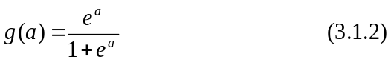
Where g is a logistic function, a is the activation, w is a column vector of weights, and f is a column vector of inputs “f₁-f₅“.

The weights in a logistic regression model (3.1.1) can be adapted using FFNN topology [26]. In the simplest case it is only one input layer and one output logistic layer. This is equivalent to the generalized linear regression model with logistic function. The initial estimated weights were chosen from [0,1], so the linear combination of weights with inputs f₁-f₄ will fall into [0,1]. It is a monotone function of conditional probability, as shown in (3.1.1) and (3.1.2), so the conditional probability of job to be offered can be monitored through the changing of the combination of weights. The classification of decision can be achieved through the best threshold with the largest estimated conditional probability from group data. The class prediction of an observation x from group y was determined by
The setup of the best threshold employed Receiver Operating Characteristic (ROC), which provides the percentage of detections classified correctly and the percentage of non-detections incorrectly classified giving different threshold as presented in [27]. The range of the threshold in our case was [0,1].
To improve the generalization performance and achieve the best classification, the FFNN with one hidden layer and one output layer was employed. Network architectures with different degrees of complexity can be obtained through choosing different types of sigmoid functions, number of hidden nodes and partition of data which provides different size of examples for training, cross-validation and testing sets.
3.2 Performance Function, Neural Network Selection and Criteria
The performance function commonly used in neural networks [11], [12], [13] is a loss function plus a penalty term:

We propose an alternative function, which includes a penalty term as follows:
Where SSE is the Sum Square Error, λ is penalty factor, n is the number of parameters in the network decided by the number of hidden nodes and N is the size of the input examples’ set.
Through structural learning with minimizing the cost function (3.2.2), we would like to find the best size of samples included in the network and also the best number of hidden nodes. In our study the value of λ in (3.2.2) ranged from 0.01 to 1.0. Normally the size of input samples should be chosen as large as possible in order to keep the residual as small as possible. Due to the cost of a large size of input examples, it may not be chosen as large as desired. In the other hand if the sample size is fixed then the penalty factor combined with the number of hidden nodes should be adjusted to minimize (3.2.2). For better generalization performance we need to consider the size of testing and cross-validation sets. We designed a two-factorial array to find the best partition of data into training, cross-validation and testing sets with the number of hidden nodes given the value of λ.
Several criteria were applied in order to find the best FFNN:
- Mean Square Error (MSE) defined as the Sum Square Error divided by the degree of freedom
- The Correlation Coefficient (r) of the model shows the agreement between the input and the output
- The Akaike Information Criterion (AIC) defined as

- Minimum Description Length (MDL) defined as

Where L_{ml} is the maximum likelihood of the model parameters and K_{a} is the number of adjustable parameters. N is the size of the input examples’ set.

More epochs generally provide higher correlation coefficient and smaller MSE for training. To avoid overfitting and to improve generalization performance training was stopped when the MSE of the cross-validation set started to increase significantly. Sensitivity analysis were performed through multiple test runs from random starting points to decrease the chance of getting trapped in a local minimum and to find stable results.
Note that the difference between AIC and MDL is that MDL includes the size of the input examples which can guide us to choose appropriate partition of the data into training, cross-validation and testing sets. The choice of the best network structure is finally based on the maximization of predictive capability, which is defined as the correct classification rate and the lowest cost given in (3.2.2).
3.3 Learning Algorithms for FFNN
Back propagation with momentum, conjugate gradient, quickprop and delta-delta learning algorithms were applied for comparison study [10], [11]. The Back-propagation with momentum algorithm has the major advantage of speed and is less susceptible to trapping in local minima. Back-propagation adjusts the weights in the steepest descent direction in which the performance function is decreasing most rapidly but it does not necessarily produce the fastest convergence. The search of the conjugate gradient is performed along conjugate directions, which produces generally faster convergence than steepest descent directions. The Quickprop algorithm uses information about the second order derivative of the performance surface to accelerate the search. Delta-delta is an adaptive step-size procedure for searching a performance surface.

The performance of best MLP with one hidden layer network obtained from above was compared with popular classification method Support Vector Machine (SVM) and Single-Layer Perceptron (SLP).
3.4. Support Vector Machine
Support Vector Machine is a method for finding a hyperplane in a high dimensional space that separates training samples of each class while maximizes the minimum distance between the hyperplane and any training samples [20], [21], [22]. SVM approach can apply any kind of network architecture and optimization function. We employed Radial Basis Function (RBF) network and Adatron algorithms. The advantage of RBF is that it can place each data sample with Gaussian distribution so as to transform the complex decision surface into a simpler surface and then use linear discriminant functions. The learning algorithm employed Adatron algorithm [23], [24], [25]. Adatron algorithm substitutes the inner product of patterns in the input space by the kernel function of the RBF network. The performance function used as presented in 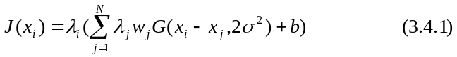[27]:
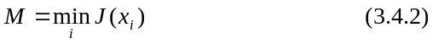
Where λ_{i} is multiplier, w_{i} is weight, G is Gaussian distribution and b is bias.

We chose a common starting multiplier (0.15), learning rate (0.70), and a small threshold (0.01). While M is greater than the threshold, we choose a pattern x_{i} to perform the update. After update only some of the weights are different from zero (called the support vectors), they correspond to the samples that are closest to the boundary between classes. Adatron algorithm uses only those inputs for training that are near the decision surface since they provide the most information about the classification, so it provides good generalization and generally yields no overfitting problems, so we do not need the cross-validation set to stop training early. The Adatron algorithm in [27] can prune the RBF network so that its output for testing is given by
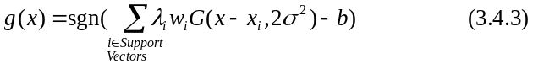

so it can adapt an RBF to have an optimal margin [25]. Various versions of RBF networks (spread, error rate, etc.) were also applied but the results were far less encouraging for generalization than with SVMs with the above method [10], [11].
4 Data Analysis and Results
FFNN with back-propagation with momentum without hidden layer gives the weight estimation for the four coefficients: Job Priority Match, Sailor Location Preference Match, Paygrade Match,
Geographic Location Match as follows: 0.316, 0.064, 0.358, 0.262 respectively. Simultaneously we got the conditional probability for decisions of each observation from (3.1.1). We chose the largest estimated logistic probability from each group as predicted value for decisions equal to 1 (job to be offered) if it was over threshold. The threshold was chosen to maximize performance and its value was 0.65. The corresponding correct classification rate was 91.22% for the testing set.
Multilayer Perceptron (MLP) with one hidden layer was tested using tansig and logsig activation functions for hidden and output layers respectively. Other activation functions were also used but their performance was worse. Four different learning algorithms were applied for comparison studies. For reliable results and to better approximate the generalization performance for prediction each experiment was repeated 10 times with 10 different initial weights. The reported values are averaged over the 10 independent runs. Training was confined to 5000 epochs, but in most cases there were no significant improvement in the MSE after 1000 epochs. The best FFNNs were chosen by modifying the number of hidden nodes ranging from 2 to 20, while the training set size was setup as 50%, 60%, 70%, 80% and 90% of the sample set. The cross-validation and testing sets each took the half of the rest. We used 0.1 for the penalty factor λ, which has better generalization performance then other values for our data set. Using MDL criteria we can find out the best match of percentage of training with the number of hidden nodes in a factorial array. Table 3 reports MDL/AIC values for given number of hidden nodes and given testing set sizes. As shown in the table for 2, 5 and 7 nodes 5% for testing, 5% for cross validation, and 90% for training provides the lowest MDL. For 9 nodes the lowest MDL was found for 10% testing, 10% cross validation, and 80% training set sizes. For 10-11 nodes the best MDL was reported for 20%-20% cross-validation and testing and 60% training set sizes. For 12-20 nodes the best size for testing set was 25%. There appears to be a trend that by increasing the number of hidden nodes the size of the training set should be increased to lower the MDL and the AIC. Table 4 provides the correlation coefficients between inputs and outputs for best splitting the data with given number of hidden nodes. 12–20 hidden nodes with 50% training set provides higher values of the Correlation Coefficient than other cases. Fig. 1 gives the correct classification rates given different numbers of hidden nodes assuming the best splitting of data. The results were consistent with Tables 3 and 4. The best MLP network we chose was 15 nodes in the hidden layer and 25% testing set size. The best MLP with one hidden layer, SLP and the SVM were compared. Fig. 2 shows how the size of the testing set affects the correct classification rate for three different methods (MLP, SLP, SVM). The best MLP with one hidden layer gives highly accurate classification. The SVM performed a little better, which is not surprising because of its properties. Early stopping techniques were employed to avoid overfitting and better generalization performance. Fig. 3 shows the MSE of the training and the cross-validation data with the best MLP with 15 hidden nodes and 50% training set size. The MSE of the cross validation data started to significantly increase after 700 epochs, therefore we use 700 for future models. Fig. 4 shows performance comparison of back-propagation with momentum, conjugate gradient descent, quickprop, and delta-bar-delta learning algorithms for MLP with different number of hidden nodes and best cutting of the sample set. As it can be seen their performance were relatively close for our data set, and delta-delta performed the best. MLP with momentum also performed well around 15 hidden nodes.
MLP with 15 hidden nodes and 25% testing set size gave approximately 6% error rate, which is a very good generalization performance for predicting jobs to be offered for sailors. Some noise is naturally present when humans make decisions in a limited time frame. An estimated 15% difference would occur in the decisions even if the same data would be presented to the same detailer at a different time. Different detailers are also likely to make different decisions even under the same circumstances. Moreover environmental changes would also further bias decisions.
Conclusion
A large number of neural network and statistics criteria were applied to either improve the performance of the current way IDA handles constraint satisfaction or to come up with alternatives. IDA’s constraint satisfaction module, neural networks and traditional statistics methods are complementary with one another. MLP with one hidden layer with 15 hidden nodes and 25% as testing set using back-propagation with momentum and delta-delta learning algorithms provided good generalization performance for our data set. SVM with RBF network architecture and Adatron algorithm gave even more encouraging prediction performance for decision classification. Coefficients for the existing IDA constraint satisfaction module were also obtained via SLP with logistic regression. However, it is important to keep in mind that periodic update of the coefficients as well as new neural network trainings using networks and algorithms we presented are necessary to comply with changing Navy policies and other environmental challenges.
Acknowledgement
This work is supported in part by ONR grant (no. N00014-98-1-0332). The authors thank the “Conscious” Software Research group for its contribution to this paper.
References
1. Baars, B. J.: A Cognitive Theory of Consciousness, Cambridge University Press, Cambridge, 1988.
2. Baars, B. J.: In the Theater of Consciousness, Oxford University Press, Oxford, 1997.
3. Franklin, S.: Artificial Minds, Cambridge, Mass.: MIT Press, 1995.
4. Franklin, S., Kelemen, A., McCauley, L.: IDA: A cognitive agent architecture, In the proceedings of IEEE International Conference on Systems, Man, and Cybernetics ’98, IEEE Press, pp. 2646, 1998.
5. Kondadadi, R., Dasgupta, D., Franklin, S.: An Evolutionary Approach For Job Assignment, Proceedings of International Conference on Intelligent Systems-2000, Louisville, Kentucky, 2000.
6. Maes, P.: How to Do the Right Thing, Connection Science, 1:3, 1990.
7. Liang T. T., Thompson, T. J.: Applications and Implementation – A large-scale personnel assignment model for the Navy, The Journal For The Decisions Sciences Institute, Volume 18, No. 2 Spring, 1987.
8. Liang, T. T., Buclatin, B.B.: Improving the utilization of training resources through optimal personnel assignment in the U.S. Navy, European Journal of Operational Research 33, pp. 183-190, North-Holland, 1988.
9. Gale D., Shapley, L. S.: College Admissions and stability of marriage, The American Mathematical monthly, Vol 60, No 1, pp. 9-15, 1962.
10. Bishop, C. M.: Neural Networks for Pattern Recognition. Oxford University Press, 1995.
11. Haykin, S.: Neural Networks, Prentice Hall Upper Saddle River, New Jersey, 1999.
12. Girosi, F., Jones, M., Poggio, T.: Regularization theory and neural networks architectures, Neural Computation, 7:219--269, 1995.
13. Biganzoli, E., Boracchi, P., Mariani, L., Marubini, E.: Feed Forward Neural Networks for the Analysis of Censored Survival Data: A Partial Logistic Regression Approach, Statistics in Medicine 17, pp. 1169-1186, 1998.
14. Akaike, H.: A new look at the statistical model identification, IEEE Trans. Automatic Control, Vol. 19, No. 6, pp. 716-723, 1974.
15. Rissanen, J.: Modeling by shortest data description. Automat., Vol. 14, pp. 465-471, 1978.
16. Ripley, B.D.: Statistical aspects of neural networks, in Barndorff-Nielsen, O. E., Jensen, J. L. and Kendall, W. S. (eds), Networks and Chaos – Statistical and Probabilistic Aspects, Chapman & Hall, London, pp. 40-123, 1993.
17. Ripley, B. D.: Statistical ideas for selecting network architectures, in Kappen, B. and Gielen, S. (eds), Neural Networks: Artificial Intelligence and Industrial Applications, Springer, London, pp. 183-190, 1995.
18. Stone, M.: Cross-validatory choice and assessment of statistical predictions (with discussion), Journal of the Royal Statistical Society, Series B, 36, pp. 111-147, 1974.
19. Vapnik, V. N.: Statistical Learning Theory, Springer, 1998.
20. Cortes C., Vapnik, V.: Support vector machines, Machine Learning, 20, pp. 273-297, 1995.
21. Cristianini, N., Shawe-Taylor, J.: An Introduction to Support Vector Machines (and other kernel-based learning methods), Cambridge University Press, 2000.
22. Brown, M. P. S., Grundy, W. N., Lin, D., Cristianini, N., Sugnet, C., Ares, M., Haussler, D.: Support Vector Machine Classification of Microarray Gene Expression Data, University of California Technical Report USCC-CRL-99-09, 1999.
23. Friess, T. T., Cristianini N., Campbell, C.: The kernel adatron algorithm: a fast and simple learning procedure for support vector machine, In Proc. 15th International Conference on Machine Learning, Morgan Kaufman Publishers, 1998.
24. Anlauf, J. K., Biehl, M.: The Adatron: an adaptive perceptron algorithm, Europhysics Letters, 10(7), pp. 687--692, 1989.
25. Boser, B., Guyon, I., Vapnik, V.: A Training Algorithm for Optimal Margin Classifiers, In Proceedings of the Fifth Workshop on Computational Learning Theory, pp. 144-152, 1992.
26. Schumacher, M., Rossner, R., Vach, W.: Neural networks and logistic regression: Part I’, Computational Statistics and Data Analysis, 21, pp. 661-682, 1996.
- Principe, J., Lefebvre, C., Lynn, G., Fancourt C., Wooten D.: Neurosolutions User’s Manual, Release 4.10, Gainesville, FL: NeuroDimension, Inc., 2001
- Matlab User Manual, Release 6.0, Natick, MA: MathWorks, Inc., 2000
Table 3. Factorial array for guiding the best model selection with correlated group data: values of MDL/AIC up to 1000 epochs

# hidden nodes Size of testing set
H | 5% | 10% | 15% | 20% | 25%
2 | -57.2/-58.3 | -89.9/-96.3 | -172.3/181.7 | -159.6/-171.1 | -245.3/-258.5
5 | -12.7/-15.3 | -59.5/-74.7 | -116.4/-138.9 | -96.5/-124.3 | -188.0/-219.7
7 | 13.9/10.3 | -48.9/-27.8 | -93.5/-62.2 | -62.3/-100.9 | -161.0/-116.9
9 | 46.0/41.5 | 7.4/-21.6 | -22.1/-62.2 | -15.1/-64.4 | -91.7/-148.1
10 | 53.7/48.6 | -15.1/-64.4 | 63.4/19.0 | 10.3/-41.9 | -64.9/-127.6
11 | 70.1/64.5 | 41.1/8.3 | 152.4/103.6 | 29.2/-30.8 | -52.4/-121.2
12 | 85.6/79.5 | 60.5/24.6 | 39.9/-13.2 | 44.5/-21.0 | -27.7/-102.7
13 | 99.7/93.1 | 73.4/34.5 | 66.0/8.4 | 80.8/9.9 | -14.2/-95.4
14 | 120.4/113.3 | 90.8/49.0 | 86.6/24.6 | 101.4/25.1 | 20.8/-67.6
15 | 131.5/123.9 | 107.0/62.7 | 95.6/29.2 | 113.9/32.2 | 38.5/-58.4
17 | 166.6/158.0 | 138.0/87.4 | 182.4/107.2 | 149.4/56.9 | 62.2/-26.6
19 | 191.2/181.7 | 181.5/124.9 | 166.1/109.5 | 185.8/82.6 | 124.0/5.7
20 | 201.2/191.1 | 186.6/127.1 | 231.3/143.0 | 193.2/84.5 | 137.2/12.8

Table 4. Correlation Coefficients of inputs with outputs for given number of hidden nodes and the corresponding (best) cutting percentages

Number of Hidden Nodes | Correlation Coefficient  (Percentage of training)
2 | 0.7017 (90%)
5 | 0.7016 (90%)
7 | 0.7126 (90%)
9 | 0.7399 (80%)
10 | 0.7973 (60%)
11 | 0.8010 (60%)
12 | 0.8093 (50%)
13 | 0.8088 (50%)
14 | 0.8107 (50%)
15 | 0.8133 (50%)
17 | 0.8148 (50%)
19 | 0.8150 (50%)
20 | 0.8148 (50%)

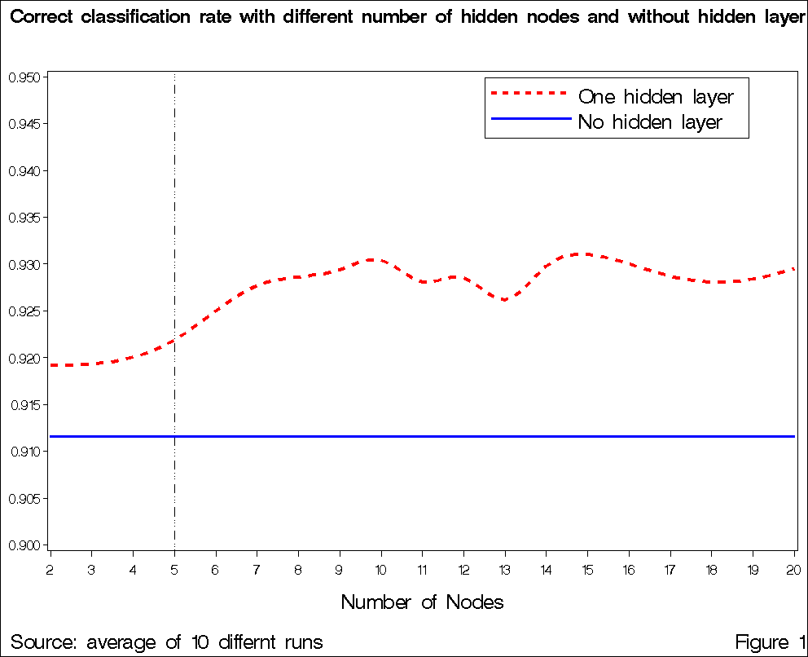Fig. 1. The dotted line shows the correct classification rates for MLP with one hidden layer with different number of hidden nodes. The solid line shows results of SLP projected out for comparison. Both lines assume the best splitting of data for each node as reported in Table 4
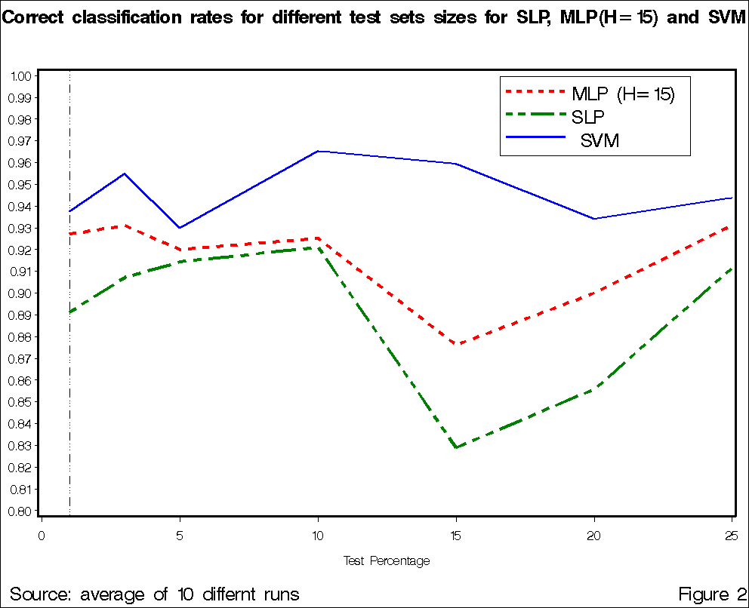
Fig. 2. Different sample set sizes give different correct classification rates. Dotted line: MLP with one hidden layer and 15 hidden nodes. Dash-2dotted line: SLP. Solid line: SVM

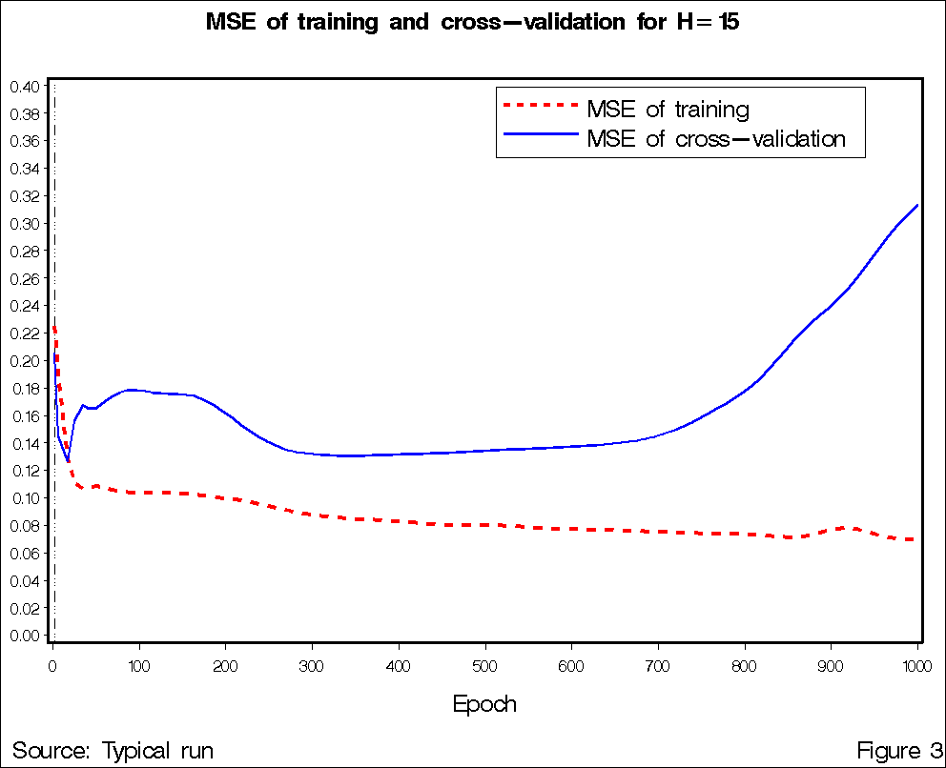Fig. 3. Typical MSE of training (dotted line) and cross-validation (solid line) with the best MLP with one hidden layer (H=15, training set size=50%)
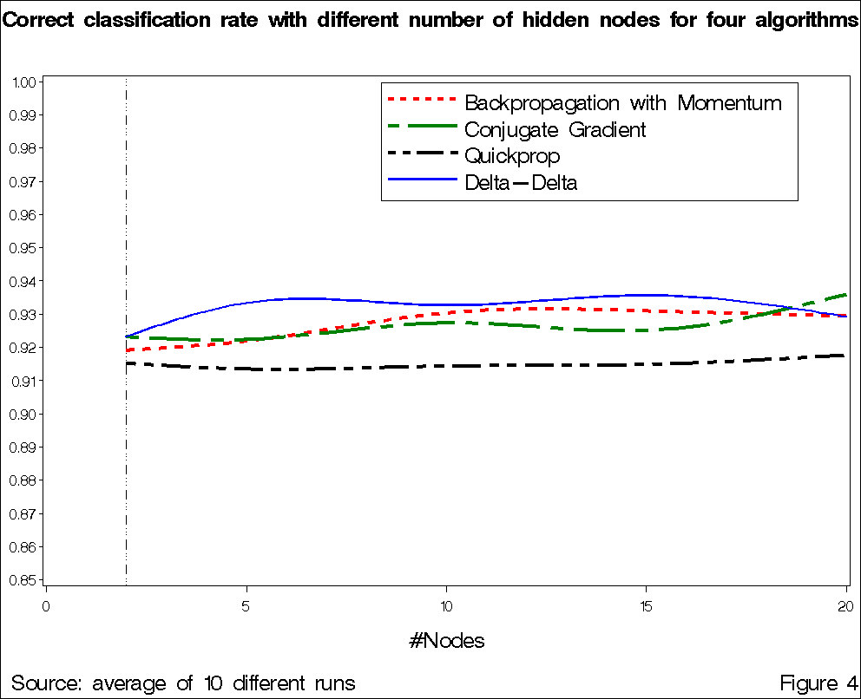
Fig. 4. Correct classification rates with different number of hidden nodes using 50% training set size for four different algorithms. Dotted line: Back-propagation with Momentum. Dash-dotted line: Conjugate Gradient Descent. Dash-2dotted line: Quickprop. Solid line: Delta-Delta algorithm

