IDA: A Cognitive Agent Architecture,

Stan Franklin Arpad Kelemen2, and Lee McCauley

Institute for Intelligent Systems

The University of Memphis

For most of its four decades of existence artificial intelligence has devoted its attention primarily to studying and emulating individual functions of intelligence. During the last decade, researchers have expanded their efforts to include systems modeling a number of cognitive functions (Albus, 1991, 1996; Ferguson, 1995; Hayes-Roth, 1995; Jackson, 1987; Johnson and Scanlon, 1987; Laird, Newall, and Rosenbloom, 1987; Newell, 1990; Pollack, ????; Riegler, 1997; Sloman, 1995). There’s also been a movement in recent years towards producing systems situated within some environment (Akman, 1998; Brooks, 1990; Maes, 1990b). Some recent work of the first author and his colleagues have combined these two trends by experimenting with cognitive agents (Bogner, Ramamurthy, and Franklin to appear; Franklin and Graesser forthcoming; McCauley and Franklin, to appear; Song and Franklin , forthcoming; Zhang, Franklin and Dasgupta, 1998; Zhang et al, 1998). This paper briefly describes the architecture of one such agent.

By an autonomous agent (Franklin and Graesser 1997) we mean a system situated in, and part of, an environment, which senses that environment, and acts on it, over time, in pursuit of its own agenda. It acts in such a way as to possibly influence what it senses at a later time. That is, the agent is structurally coupled to its environment (Maturana 1975, Maturana and Varela 1980). Biological examples of autonomous agents include humans and most animals. Non-biological examples include some mobile robots, and various computational agents, including artificial life agents, software agents and computer viruses. Here we’ll be concerned with autonomous software agents ‘living’ in real world computing systems.

Such autonomous software agents, when equipped with cognitive (interpreted broadly) features chosen from among multiple senses, perception, short and long term memory, attention, planning, reasoning, problem solving, learning, emotions, moods, attitudes, multiple drives, etc., will be called cognitive agents (Franklin 1997). Such agents promise to be more flexible, more adaptive, more human-like than any currently existing software because of their ability to learn, and to deal with novel input and unexpected situations. But, how do we design such agents?

On way is to model them after humans. We’ve chosen to design and implement such cognitive agents within the constraints of the global workspace theory of consciousness, a psychological theory that gives a high-level, abstract account of human consciousness and broadly sketches it architecture (Baars, 1988, 1997). We’ll call such agents “conscious” software agents.
Global workspace theory postulates that human cognition is implemented by a multitude of relatively small, special purpose processes, almost always unconscious. (It's a multiagent system.) Coalitions of such processes find their way into a global workspace (and into consciousness). This limited capacity work space serves to broadcast the message of the coalition to all the unconscious processors, in order to recruit other processors to join in handling the current novel situation, or in solving the current problem. All this takes place under the auspices of contexts: goal contexts, perceptual contexts, conceptual contexts, and/or cultural contexts. Each context is, itself a coalition of processes. There's much more to the theory, including attention, learning, action selection, and problem solving. Conscious software agents should implement the major parts of the theory, and should always stay within its constraints.
IDA (Intelligent Distribution Agent), is to be such a conscious software agent developed for the Navy. At the end of each sailor’s tour of duty, he or she is assigned to a new billet. This assignment process is

Figure 1
.
called distribution. The Navy employs some 200 people, called detailers, full time to effect these new assignments. IDA’s task is to facilitate this process, by playing the role of detailer as best she can.
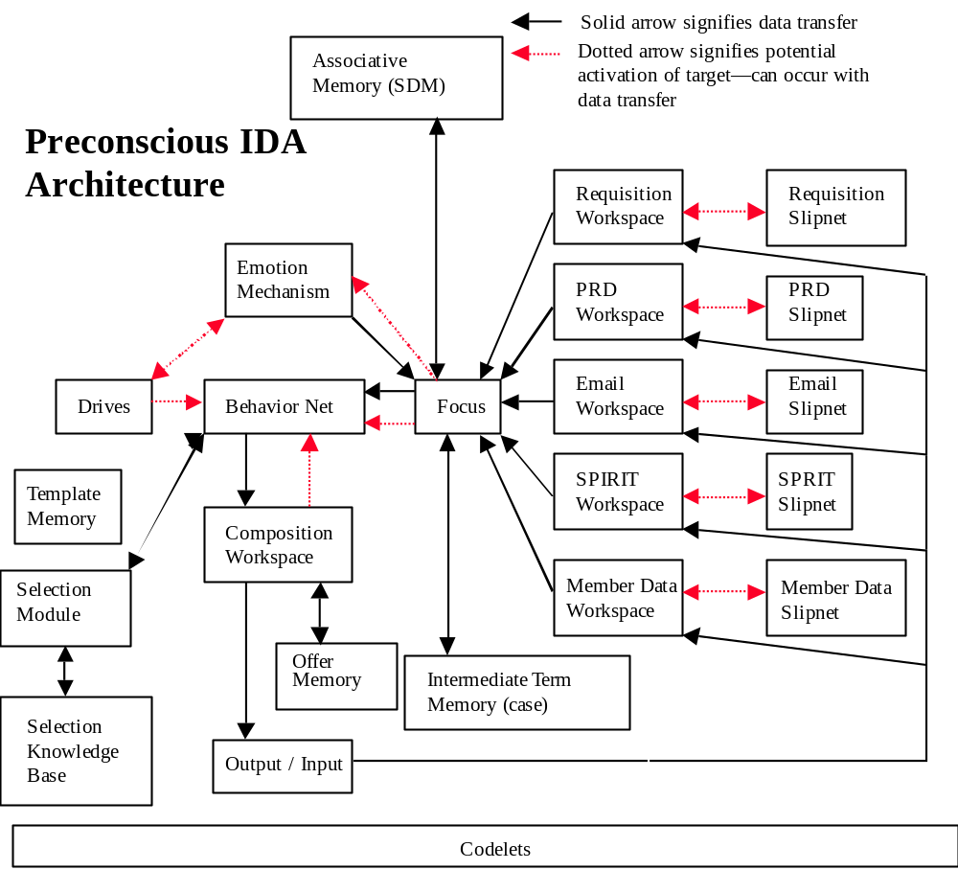
Designing IDA presents both communication problems and constraint satisfaction problems. She must communicate with sailors via email and in natural language, understanding the content. She must access a number of databases, again understanding the content. She must see that the Navy’s needs are satisfied, for example, the required number of sonar technicians on a destroyer with the required types of training. She must hold down moving costs. And, she must cater to the needs and desires of the sailor as well as is possible.
Here we’ll briefly describe a design for IDA including a high level architecture and the mechanisms by which it’s to be implemented. With the help of diagrams we’ll describe a preconscious version of IDA, and then discuss the additional mechanisms needed to render her conscious.
IDA will sense her world using three different sensory modalities. She’ll receive email messages, she’ll read database screens and, eventually, she’ll sense via operating system commands and messages. Each sensory mode will require at least one knowledge base and a workspace. The mechanism here will be based losely on the Copycat Architecture (Hofstadter1995; Hofstadter and Mitchell 1994; Zhang et al 1998). Each knowledge base will be a slipnet, a fluid semantic net. The workspace (working memory) will allow perception (comprehension), a constructive process. See the right side of Figure 1 for five such pairs. Each, other than the email, will understand material from a particular database, for example personnel records, a list of job openings, a list of sailors to be assigned. Sensing the operating system isn’t present in Preconscious IDA.
Note that each of IDA’s senses is an active sense, like our vision rather than our hearing. They require actions on IDA’s part before sensing can take place, for example reading email or accessing a database. IDA selects her actions by means of a enhanced version of the behavior net (Maes 1990a; Song and Franklin forthcoming). See Figure 1. The behavior net is a directed graph with behaviors as verticies and three different kinds of links along which activation spreads. Activation originates from internal, explicitly represented drives, from IDA’s understanding of the external word through the Focus, and from internal states. The behavior whose activation is highest among those with all prerequisites satisfied becomes the next goal context as specified in global workspace theory. The several small actions typically needed to complete a behavior are taken by codelets, of which more later.
IDA’s behaviors are partitioned into streams, the connected components of the digraph, each in the service of one or more drives. Streams of behaviors are like plans, except that the may not be linear, and might well be interrupted during their execution or possibly not completed. Examples of IDA’s streams include Access EAIS, Access Personnel Record, Send Acknowledgement, Offer Assignments, Produce Orders.
IDA is very much a multi-agent system, the agents being the codelets that underlie all the higher level constructs and that ultimately perform all of IDA’s actions. We’ve mentioned the codelets that underlie behaviors. Others underlie slipnet nodes and perform actions necessary for constructing IDA’s understanding of an email message or of a database screen (Zhang et al 1998). Still other codelets will play a vital role in consciousness, as we’ll see below. The codelets are represented in Figure 1 by a long box at the bottom, since they underlie essentially everything else.
Having gathered all relevant information, IDA must somehow select which assignments she’ll offer a given sailor. See the lower left of Figure 1. Being a constraint satisfaction problem, considerable knowledge will be required to make these selections. This knowledge could be in the form of a traditional, rule-based expert system, but more likely will be implemented as a classifier system (Holland 1986) in order to facilitate learning at a later stage. The constraint satisfaction mechanism will be housed in the selection module. The choice of mechanism for it is currently being researched.
IDA’s emotion module (McCauley and Franklin 1998), like a human’s, provides a multi-dimensional method for ascertaining how well she’s doing. We’ll experiment with building in mechanisms for emotions, such as anxiety at not understanding a message, guilt at not responding to a sailor in a timely fashion, and annoyance at an unreasonable request from a sailor. Emotions in humans and in IDA influence all decisions as to action (Damasio 1994). IDA’s action selection will be influenced by emotions via their effect on drives. Including emotional capabilities in non-biological autonomous agents is not a new idea (Bates, Loyall, and Reilly 1991, Sloman and Poli 1996, Picard 1997). Some claim that truly intelligent robots or software agents can’t be effectively designed without emotions
As a glance at Figure 1 shows, IDA has a number of different memories. The offer memory is a traditional database that keeps track of the assignments IDA has offered various sailors. The template memory is another that holds the various templates that IDA uses compose commands to access databases or issue orders, and to compose messages to sailors. IDA’s intermediate term memory acts as an episodic memory, providing context for email messages and for the contents of database screens. It’ll be implemented as a case-based memory to facilitate case-based learning at a later stage. IDA’s associative memory does what you’d expect. It associates memories, emotions and actions with incoming percepts. It’s implemented by an extension of sparse distributed memory (Kanerva 1988).
The operation of these last two, more complex, memory systems deserves more explanation. As IDA’s most recent percept reaches the perception register (See Figure 2) having been constructed (comprehended)
by one of the perception modules, several events occur in simulated parallel. Activation is sent to the behavior net, that is, the environment influences action selection. The associative memory is read using the percept as the cue. Since sparse distributed memory is content addressable, associations with the percept, including an emotional overtone and an action previously taken in a similar situation are typically returned into an expanded copy of the perception registers (see Figure 2). These associations also activate the behavior net and the emotion module. Associations influence action selection. At the same time intermediate term memory is read with the same cue. The most similar case is returned, again with emotion and action, into yet another copy of the expanded perception registers. In the full version consciousness will come into play at this point. Now, an action and an emotion are selected into the two remaining copies of the expanded perception registers along with the current percept. Each is then written to its appropriate memory. IDA has been processed a single percept.

FOCUS

Emotion Perception Register Action
From Intermediate Term Memory
Most Recent Percept

Emotion Perception Register Action
From Associative Memory

Perception Register Contents

Emotion Perception Register Action
To Associative Memory

Emotion Perception Register Action
To Intermediate Term Memory

Figure 2.

Our brief description of the preconscious form of IDA is as complete as it’s going to be in this short paper. She could well be implemented as described, and should be expected to work reasonably well. She would not, however, show the kind of flexibility and more human-like behavior in the face of novel ro problematic situations that was claimed in the third paragraph of this paper. To accomplish this, and to implement global workspace theory, will require a fair amount more machinery.
Global workspace theory postulates the contents of consciousness to be coalitions of codelets shined on by a spotlight. Imagine a codelet workspace populated by many active codelets each working, unconsciously and in parallel, on its own agenda. The spotlight seeks out coalitions of codelets that arise from novel or problematic situations. When the spotlight picks out some coalition of codelets, the information contained therein is broadcast to all the codelets, active or not. The idea is to recruit resources, that is relevant codelets, to help in dealing with the situation. It seems that in humans almost any resource may be relevant depending on the situation. The global workspace method attacks the problem of finding the relevant resources by brute force. Broadcast to them all. IDA will use this method. To do so, she’ll need a coalition manager, a spotlight controller, and a broadcast manager (Bogner, Ramamurthy, and Franklin to appear).

References:

Akman V. (1998) (guest ed.) Minds and Machines (Special Issue: Situations and AI.
Albus, J.S. (1991), "Outline for a Theory of Intelligence," IEEE Transactions on
Systems, Man and Cybernetics, Vol. 21, No. 3, May/June.
Albus, J.S. (1996). "The Engineering of Mind," Proceedings of the Fourth International Conference on Simulation of Adaptive Behavior: From Animals to Animats 4, Cape Cod, MA, September.
Baars, B. J. (1988). A Cognitive Theory of Consciousness. Cambridge: Cambridge University Press.
Baars, B. J. (1997). In the Theater of Consciousness. Oxford: Oxford University Press.
Bates, Joseph, A. Bryan Loyall, and W. Scott Reilly (1991). "Broad Agents," Proceedings of the AAAI Spring Symposium on Integrated Intelligent Architectures, Stanford University, March. These proceedings are available in SIGART Bulletin, Volume 2, Number 4, August 1992.
Bogner, Myles, Uma Ramamurthy, and Stan Franklin (to appear), Modeling Global Workspace Perception In A Socially Situated Agent, in Kerstin Dautenhahn ed. Human Cognition and Social Agent Technology
Brooks, Rodney A. (1990), "Elephants Don't Play Chess," In Pattie Maes, ed., Designing Autonomous Agents, Cambridge, MA: MIT Press
Damasio, A. R. (1994), Descartes’ Error, New York: Gosset/Putnam Press.
Ferguson, I. A. (1995). "On the role of DBI modeling for integrated control and coordinated behavior in autonomous agents." Applied Artificial Intelligence, 9(4).
Franklin, Stan (1997). Autonomous Agents as Embodied AI, Cybernetics and Systems' Special issue on Epistemological Aspects of Embodied AI, 28:6 499-520.
Franklin, Stan and Graesser, Art (1997) “Is it an Agent, or just a Program?: A Taxonomy for Autonomous Agents,” Intelligent Agents III, Berlin: Springer Verlag, 21-35,
Franklin, Stan and Graesser, Art (forthcoming), “Models of Consciousness”
Hayes-Roth, B. (1995). "An architecture for adaptive intelligent systems." Artificial Intelligence, 72 329-365.
Hofstadter D. R. (1995), Fluid Concepts and Creative Analogies, Basic Books.
Hofstadter, D. R. and Mitchell, M. (1994), "The Copycat Project: A model of mental fluidity and analogy-making." In Holyoak, K.J. & Barnden, J.A. (Eds.) Advances in connectionist and neural computation theory, Vol. 2: Analogical connections. Norwood, N.J.: Ablex.
Holland, J. H. (1986), “A Mathematical Framework for Studying Learning in Classifier Systems.” In D., Farmer et al, Evolution, Games and Learning: Models for Adaption in Machine and Nature. Amsterdam: North-Holland
Jackson, John V. (1987), "Idea for a Mind," SIGGART Newsletter, no. 181, July, 23-26.

Johnson, M. and Scanlon, R. (1987) "Experience with a Feeling-Thinking Machine", Proceedings of the IEEE First International Conference on Neural Networks, San Diego.71-77.
Kanerva, Pentti (1988), Sparse Distributed Memory, Cambridge MA: The MIT Press.
Kolodner, Janet (1993), Case-Based Reasoning , Morgan Kaufman

Laird, John E., Newall, Allen, and Rosenbloom, Paul S. (1987). "SOAR: An Architecture for General Intelligence." Artificial Intelligence, 33: 1-64.

Maes, Pattie (1990a), 'How to do the right thing', Connection Science, 1:3.

Maes, Pattie (1990b) ed., Designing Autonomous Agents, Cambridge, MA: MIT Press
Maturana, H. R. (1975). “The Organization of the Living: A Theory of the Living Organization. ”International Journal of Man-Machine Studies, 7:313-32.
Maturana, H. R. and Varela, F. (1980). Autopoiesis and Cognition: The Realization of the Living. Dordrecht, Netherlands: Reidel.
McCauley, Thomas L. and Stan Franklin (to appear) “An Architecture for Emotion,” ????
Picard, Rosalind (1997), Affective Computing, Cambridge MA: The MIT Press.
Newell, Allen (1990), Unified Theories of Cognition, Cambridge, Mass: Harvard University Press.
Pollack, ????;
Riegler, A. (1997) Ein kybernetisch-konstruktivistisches Modell der Kognition. In: Müller, A, Müller, K. H. & Stadler, F. (eds.) Konstruktivismus und Kognitionswissenschaft. Kulturelle Wurzeln und Ergebnisse. Wien, New York: Springer.
Sloman, Aaron (1995). "Exploring Design Space and Niche Space." Proceedings 5th Scandinavian Conf on AI, Trondheim May 1995, Amsterdam: IOS Press.
Sloman, Aaron and Poli, Riccardo (1996). "SIM_AGENT: A toolkit for exploring agent designs in Intelligent Agents," Vol. II (ATAL-95), Eds. Mike Wooldridge, Joerg Mueller, Milind Tambe, Springer-Verlag, pp. 392--407.
Song, Hongjun and Stan Franklin (forthcoming), “Action Selection Using Behavior Instantiation”
Zhang, Zhaohua, Stan Franklin and Dipankar Dasgupta (1998), Metacognition in Software Agents using Classifer Systems, Proc AAAI 98,
Zhang, Zhaohua, Stan Franklin, Brent Olde, Yun Wan and Art Graesser (1998) “Natural Language Sensing for Autonomous Agents,” Proc. IEEE Joint Symposia on Intelligence and Systems, Rockville, Maryland, 374-81.

With indispensable help from the other members of the Conscious Software Research Group including Ashraf Anwar, Miles Bogner, Scott Dodson, Art Graesser, Derek Harter, Aregahegn Negatu, Uma Ramamurthy, Hongjun Song, and Zhaohua Zhang.
Supported in part by ONR grant N00014-98-1-0332.
2

