Experiment Objektbeschreibungen:

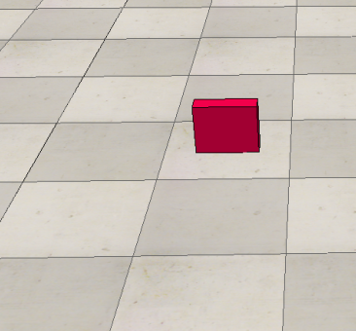

*Beispielaufgabe:*

Do the following attributes describe the above object accurately?

* large yes | no
* flat yes | no
* broad yes | no
* green yes | no
* orange yes | no
* dark yes | no

Experiment Objektkonstellationen

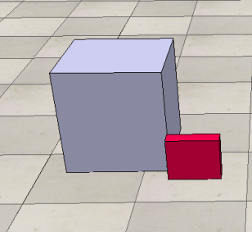

*Beispielaufgabe:*

Do the following attributes describe the spatial relationship accurately?

* red block **in front of** gray block yes | no
* red block **underneath** gray block yes | no
* red block **to the left of** gray block yes | no
* red block **higher than** gray block yes | no