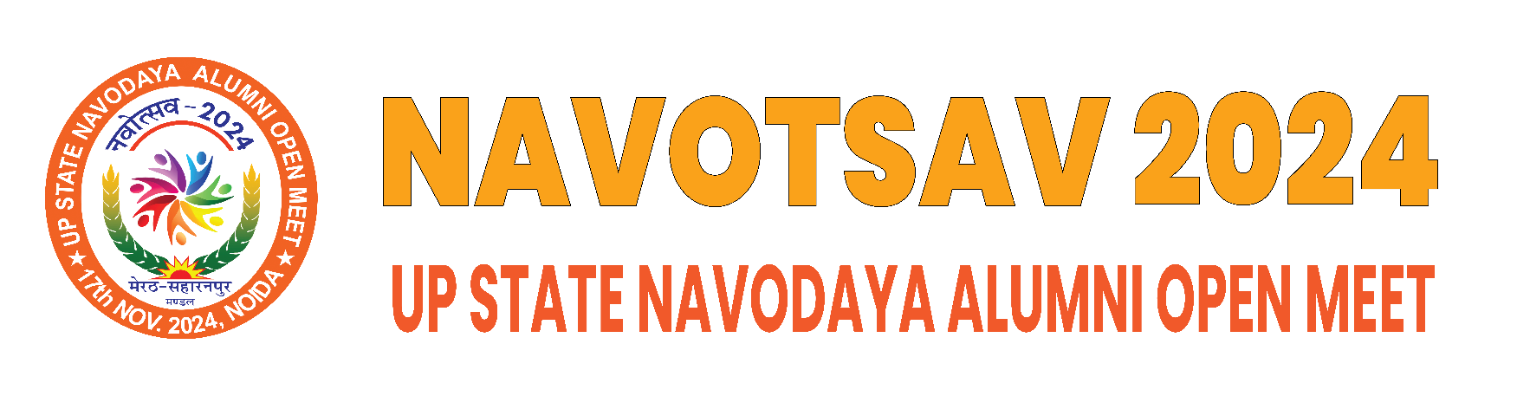

**Navodaya Ratna Award Form**

|  |
| --- |
| **Please indicate your award category (highlight or bold it):** |

|  |  |
| --- | --- |
| * Professional Excellence | * Business Excellence |
| * Social & Community Service | * Art, Cultural & Literature |
| * Sports & Athlete | * Distinguish Alumni |
| * Alumni Choice Award | * Emerging Professional Excellence |
| * Emerging Business Excellence |

|  |  |
| --- | --- |
| **1. Personal details** | |
| Full name: |  |
| Date of birth: |  |
| Nationality: |  |
| Navodaya name: |  |
| Year of study(e.g. 1986-93) |  |
| Mobile: |  |
| Email: |  |
| Address: |  |
|  |  |

|  |  |  |  |  |  |
| --- | --- | --- | --- | --- | --- |
| **2. Education:** (please list all academic qualification(s)). For each qualification, please indicate if you studied for the full duration of the course or whether you gained advanced entry to the course. If you gained advanced entry, which year of the course did you enter at (e.g. year 3 of a possible 5)? | | | | | |
| **University/institution**  **(please include country)** | Degree/diploma name | **Type of study (full time, part time, placement year, flexible study)** | **Full course or advanced entry** | **Date started (and year of course if not year 1)** | **Date completed** | |
|  |  |  |  |  |  | |
|  |  |  |  |  |  | |
|  |  |  |  |  |  | |

|  |  |  |  |
| --- | --- | --- | --- |
| **3. Member of any other professional organisation(s):** (if it applies) | | | |
| **Name of organisation** | **Grade** | **How membership was achieved (e.g. examination)** | **Year gained** |
|  |  |  |  |
|  |  |  |  |
|  |  |  |  |

|  |  |  |  |
| --- | --- | --- | --- |
| **4. Professional experience(last 2 years):** | | | |
| Period | Job title | **Employer** | **Type and scope of responsibilities**  **(in detail)** |
|  |  |  |  |
|  |  |  |  |

|  |
| --- |
| **5. Awards & Recognition** |
| 1.  2.  3. | |

|  |
| --- |
| **6. Write-up in support of Nomination (details in support of nomination, key achievement, accomplishments etc.)** |
| 1.  2.  3. | |

**Note:** If any additional paper is needed, please mark clearly the section it refers to, and attach it securely to this document. Alumni can also submit videos, audio clips, link of LinkedIn profile, detailed resume in own template or any other relevant document/material (all optional) in support of their nomination to

**Please forward completed nomination to:**

[awards@navotsava.in](mailto:adutt@rics.org)