Hydra
developer guide

Hardware consists of the database server and the render node computers. The database server, Hydra.cogswell.edu, is a server machine that runs MySQL. The render nodes run some special Hydra software, as well as Maya and other CG software.

The database consists of six tables. Use MySQL Workbench or mysql.exe to examine the structure of these tables.

- Hydra_rendernode records describe the render nodes.
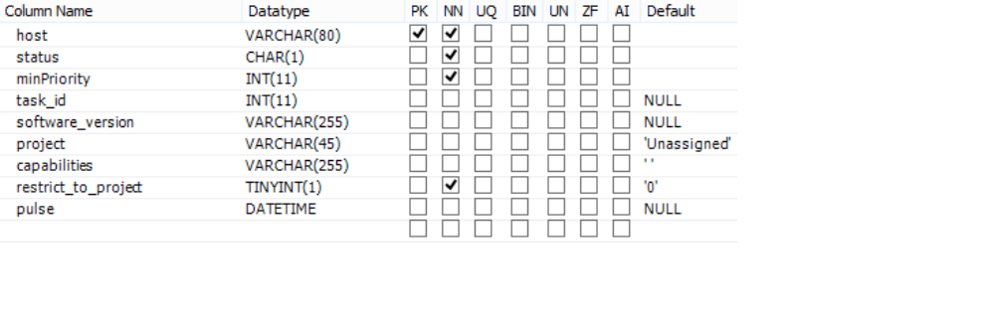
host is the name of the render node, with the domain .cpc.local appended.
status is the 1-character abbreviation for the node's status (Idle, Started, etc.)
minPriority is the lowest priority a task can have and still be run by this node.
task_id is the id of the task currently running, if any.
software_version is the version of the RenderNodeMain.exe currently running.
project is the render node's assigned project.
capabilities lists the node's capabilities (VRay, etc.) in alphabetical order.
restrict_to_project determines whether project is a restriction or a preference.
pulse is the last time RenderNodeMain.exe was known to be running.

- Hydra_job records describe submitted render jobs, which contain one or more render tasks.
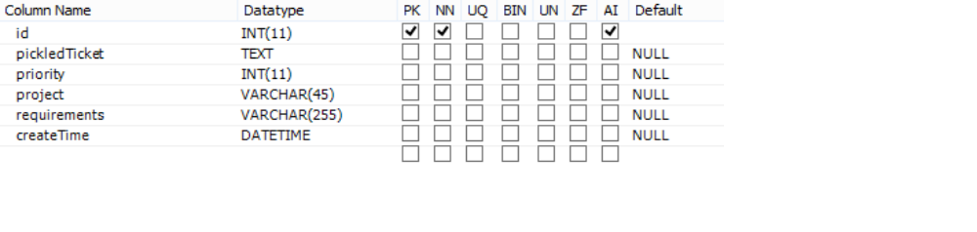
id is the ID number of the job.
pickledTicket is a text representation of the job's JobTicket object.
priority is the job's priority, inherited by its tasks.
project is the job's project, inherited by its tasks.
requirements is the job's requirements, inherited by its tasks.
createTime is the time at which the job record was created.

- Hydra_rendertasks describe the actual rendering commands to be executed along with their command-line arguments.
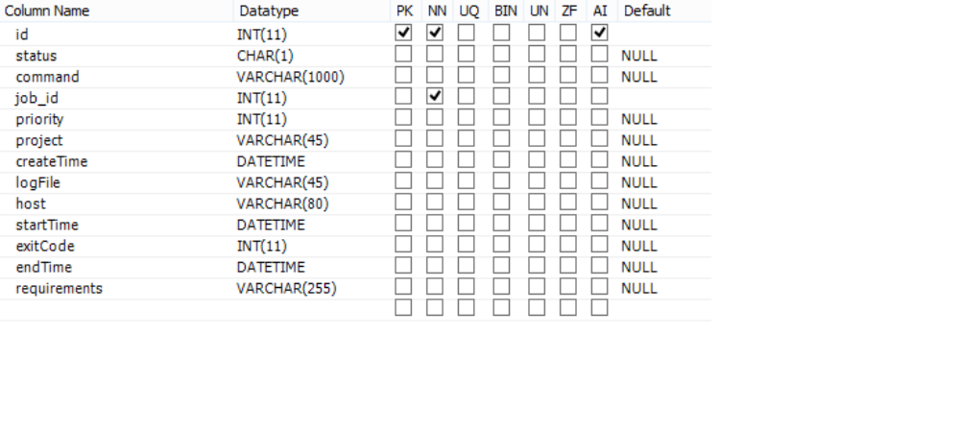
id is the ID of the task.
Status is the 1-character abbreviation for the task's status (Ready, Finished, etc.)
command is the actual command to be executed to perform the task.
job_id is the id number of the task's job.
priority is the task's priority.
project is the task's assigned project.
createTime is the time at which the task was created.
logFile is the name of the render log file on the task's render node.
host is the name of the render node that ran the task.
startTime is the time at which the task started running.
exitCode is the status code the render program returned (should be 0).
endTime is the time at which the task finished running.
requirements is the wildcard string that a render node's capabilities must match
in order to run the task.

- Hydra_projects lists all of the current projects. Render nodes are assigned to a project, and submitted jobs are assigned to a project. Render nodes prefer to work on tasks from their assigned projects.
- Hydra_capabilities lists specific capabilities (software) render nodes can have: Maya2014, VRay, Shave, etc. When a job is submitted the user specifies which capabilities the job needs, and a render node only runs a task if it has all the capabilities the task needs.
- Hydra_executables lists all the rendering programs that can be executed by the render farm. An executable is specified when a job is submitted.
Setup

Before a render node can render, it needs to have a record in Hydra_rendernode. Running register.exe creates this record. Cababilities, projects, etc. have to be added to the Hydra_rendernode records manually using SQL. Normally the properties of a room full of render nodes are set or changed all at once. (In fact, one can set up machines in bulk using SQL without bothering to run register.exe, as long as the records come out right. Caveat scriptor.)

Render nodes are set up by IT to run the RenderNodeMain.exe software automatically. Developers can run the software manually on their own machines.

The Hydra_projects, Hydra_capabilities, and Hydra_executables tables are maintained manually.

Rendering life cycle

Jobs are usually submitted by dragging and dropping a Maya file onto SubmitterMain.exe. The submitter GUI lets the user specify a frame range, the number of frames per render task, a project, an executable, and any requirements the job has (corresponding to render node capabilities). When the user clicks OK, a Hydra_job record is created and serveral Hydra_rendertask records are created and each is marked 'Ready'.

When a render node isn't actually rendering, i.e., it's in the 'Idle' state, it searches the database for a render task to work on. (Please see RenderNodeMain.py for details.) If it finds one, it marks itself and the task 'Started' and runs the task's rendering command. Eventually the render finishes and the task is marked 'Finished' and the render node becomes 'Idle' again.

FarmView.exe should be used to track the progress of render jobs and tasks, check their status, and chase down log files if anything goes wrong.

What could possibly go wrong?

The network is used to read and write most of the files involved in rendering, and it is used to communicate with the database. A network interruption can cause a failure anywhere in the rendering process. Such failures can appear as intermittent I/O errors: unable to find a file, unable to write to a file, etc. A process that fails due to a network error is worth restarting or trying again because network failures are random and hopefully not very common.

Submission failures occur when RenderNodeMain.exe crashes, at job submission time. Any error messages will be in the DOS window that opens when you submit. Submission failures may keep the job from being created, or some of the tasks may not be created. Partial jobs resulting from submission failures should be killed.

Render failures occur because of system or software failures, or because there's something wrong with the scene being rendered or the files it uses. Each task has a log file that contains all of the output and error messages written by the rendering program, as well as any error messages from Hydra itself. FarmView.exe shows each task's render node and the name of its log file on the render node's C: drive. The Hydra log file folders are always shared, so you can navigate to the task's log file on the render node and read it to see what went wrong.

Render node failures can keep a render node from rendering. FarmView.exe shows each render node's last heartbeat; if the heartbeat is old, the render node has failed and should be rebooted.

Render tasks can fail to run for several reasons when a render node is available. If RenderNodeMain.exe is failing or throwing errors, error messages will appear on the node's log file c:\Hydra\logs\RenderNodeMain.txt. If it's not throwing errors, but not picking up a task, then it's not finding a compatible task.
For the node to pick up the task, all of the following must be true:

- The node must be Idle.
- The task must be Ready.
- If the node is restricted to a project, the task must have the same project.
- The task's priority must be at least the node's minPriority.
- The node's capabilities string must match the task's requirements wildcard.

