C-3-3 – Design Efficiency and Effectiveness Evaluation
Student Name: _Cohen Nicholls___________
Class: _Software Development____________
Date: _22 / 6 / 2026________________________
📌 Purpose
The purpose of this task is to evaluate your design alternatives using functional and non-functional requirements from your SRS. You will complete a detailed evaluation of each design based on efficiency and effectiveness factors, and justify which design is the best choice.

🖼️ Design Ideas
Sketch 1
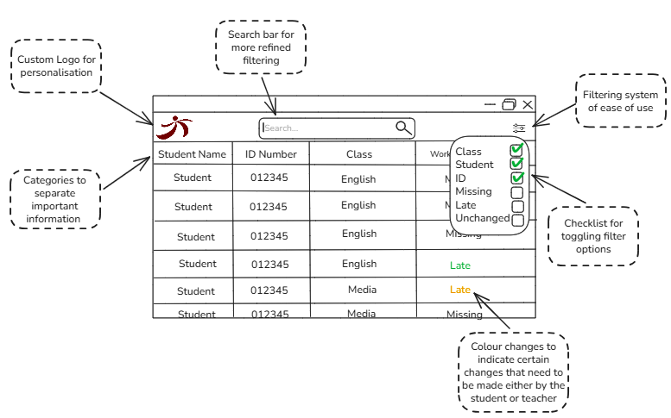
Sketch 2
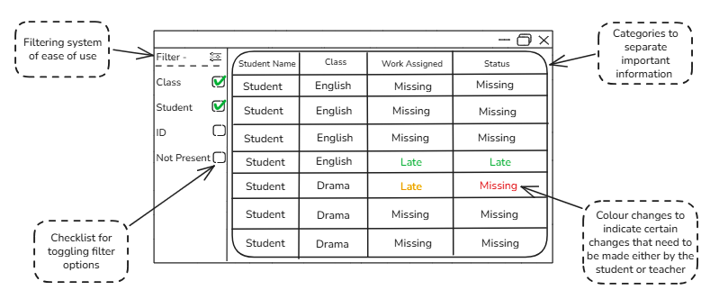

Functional Requirements Checklist
ID | Requirement Name | Covered by Design 1 (✓/✗) | Covered by Design 2 (✓/✗) | Notes
FR1 | View Missing Assignments | ✗ | ✗
FR2 | Update Assignment Status | ✓ | ✓
FR3 | Mark Work as Late | ✓ | ✓
FR4 | Mark Work as Submitted | ✓ | ✓
FR5 | Filter Assignments | ✓ | ✓
FR6 | Search Assignments | ✓ | ✗
FR7 | Save and Load Assignment Data | ✗ | ✗

Non-Functional Requirements Checklist
ID | Requirement Name | Covered by Design 1 (✓/✗) | Covered by Design 2 (✓/✗) | Notes
NFR1 | Response Time | ✓ | ✓
NFR2 | Usability | ✓ | ✓
NFR3 | Security | ✗ | ✗
NFR4 | Reliability | ✓ | ✓
NFR5 | Maintainability | ✓ | ✓
NFR6 | Portability | ✓ | ✓
NFR7 | Accessibility | ✓ | ✓

⚙️ Efficiency Evaluation Table
Rate each design from 1 (Very Poor) to 5 (Excellent) on each factor.
Efficiency Factor | Design 1 Rating (1–5) | Design 2 Rating (1–5) | Notes / Evidence
Speed of Processing | 5 | 5
Cost of Data Manipulation | 4 | 4
Functionality Implementation | 4 | 3
Hardware Requirements | 5 | 5
Bandwidth Usage (if applicable) | 5 | 5

🎯 Effectiveness Evaluation Table
Rate each design from 1 (Very Poor) to 5 (Excellent) on each factor.
Effectiveness Factor | Design 1 Rating (1–5) | Design 2 Rating (1–5) | Notes / Justification
Accessibility | 5 | 5
Accuracy | 5 | 5
Attractiveness | 4 | 2
Clarity | 4 | 3
Communication of Message | 4 | 4
Completeness | 5 | 3
Maintainability | 5 | 5
Readability | 4 | 3
Relevance | 5 | 5
Timeliness | 5 | 5
Usability | 3 | 2

