LeongLaiYing

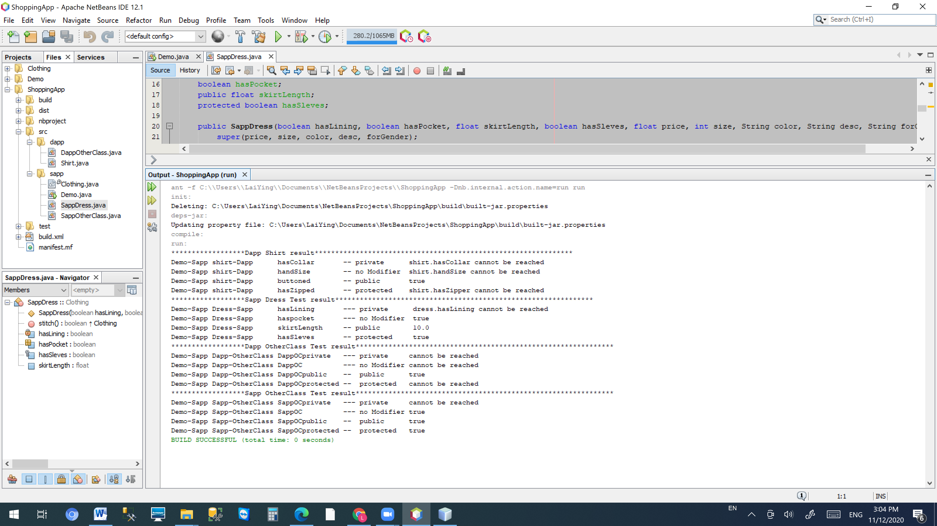

|  |  |  |  |
| --- | --- | --- | --- |
| **Demo Package** | **Shirt Package (subclass of Clothing)** | **Modifier** | **Accessible** |
| Sapp | Dapp | Private | No |
|  |  | No Modifier | No |
|  |  | public | Yes |
|  |  | protected | No |
|  |  |  |  |
| **Demo Package** | **Dress Package (subclass of Clothing)** | **Modifier** | **Accessible** |
| Sapp | Sapp | Private | No |
|  |  | No Modifier | Yes |
|  |  | public | Yes |
|  |  | protected | Yes |
|  |  |  |  |
| **Demo Package** | **SOtherClass Package** | **Modifier** | **Accessible** |
| Sapp | Sapp | Private | No |
|  |  | No Modifier | No |
|  |  | public | Yes |
|  |  | protected | No |
|  |  |  |  |
| **Demo Package** | **DOtherClass Package** | **Modifier** | **Accessible** |
| Sapp | Dapp | Private | No |
|  |  | No Modifier | Yes |
|  |  | public | Yes |
|  |  | protected | Yes |