# Load Bank

Tianshu Hou

## LCD description

**Keyes 3.5英寸TFT LCD Shield 扩展板**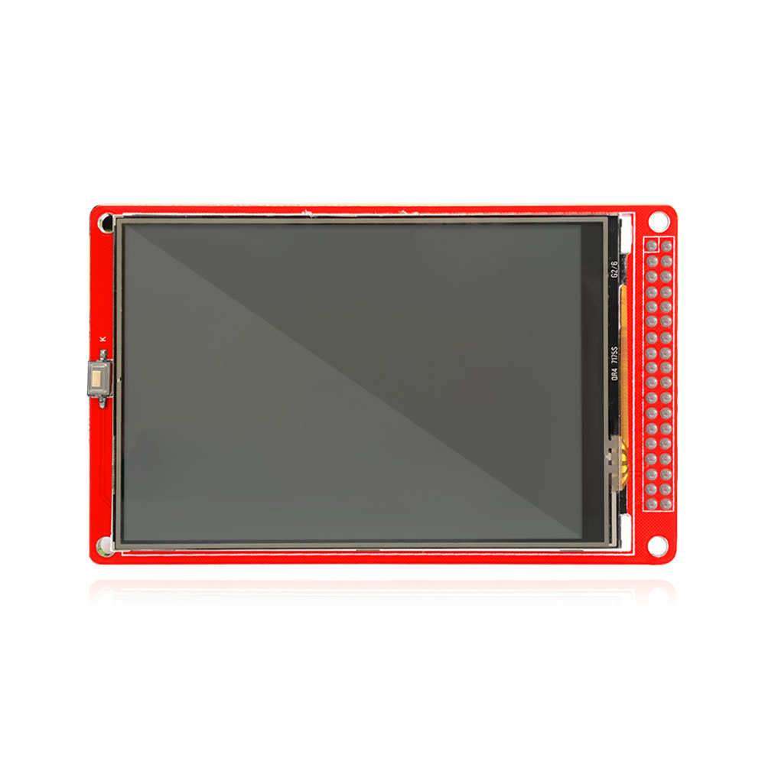

**1.说明**

LCD 面板尺寸：3.5英寸•

视角方向:9:00 O’Clock

LCD 驱动芯片：ILI9481

逻辑电平:2.8V-3.3V •

数据接口:16总线接口

扩展板模式:16位总线模式

供电电压:DC 5V

触感控制板

白色背光

1. **技术参数**

**参数**   **规格**  **单位**

**色彩**  262K

**有效面积**  48.96*73.44  mm2

**玻璃面积**   52.96 ×81.44  mm2

**分辨率**   W/H 320×480 Dot

**模组功耗**   90-120  mW

**LCD 类型**  TFT   -

1. **连接图**

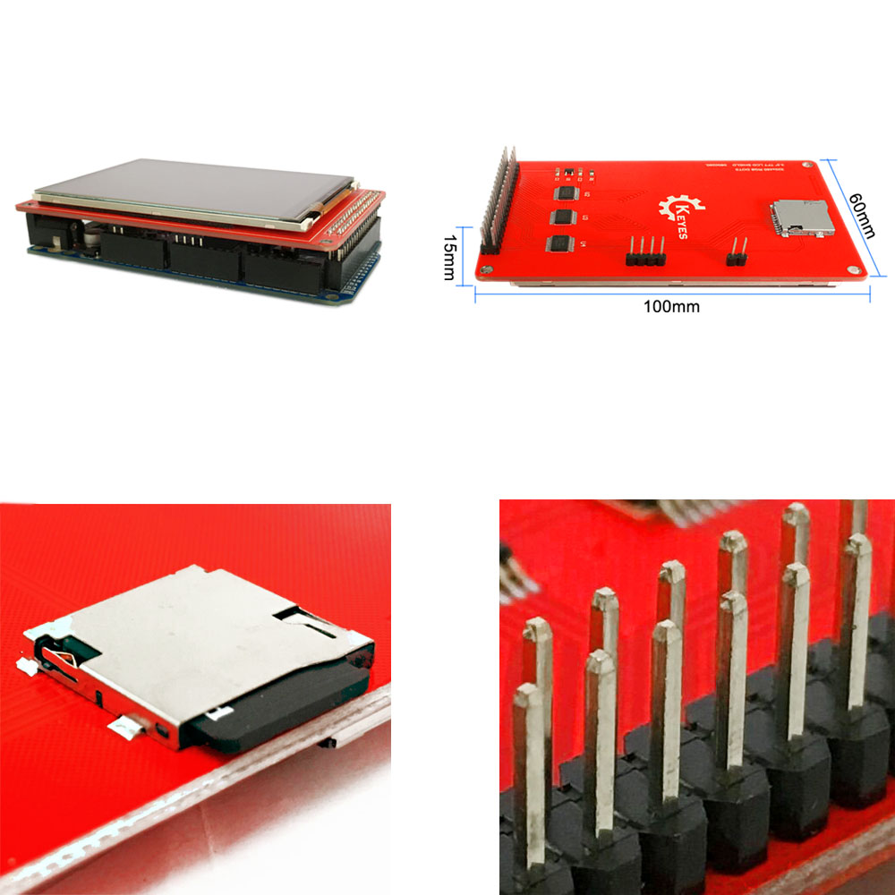

## Schematic

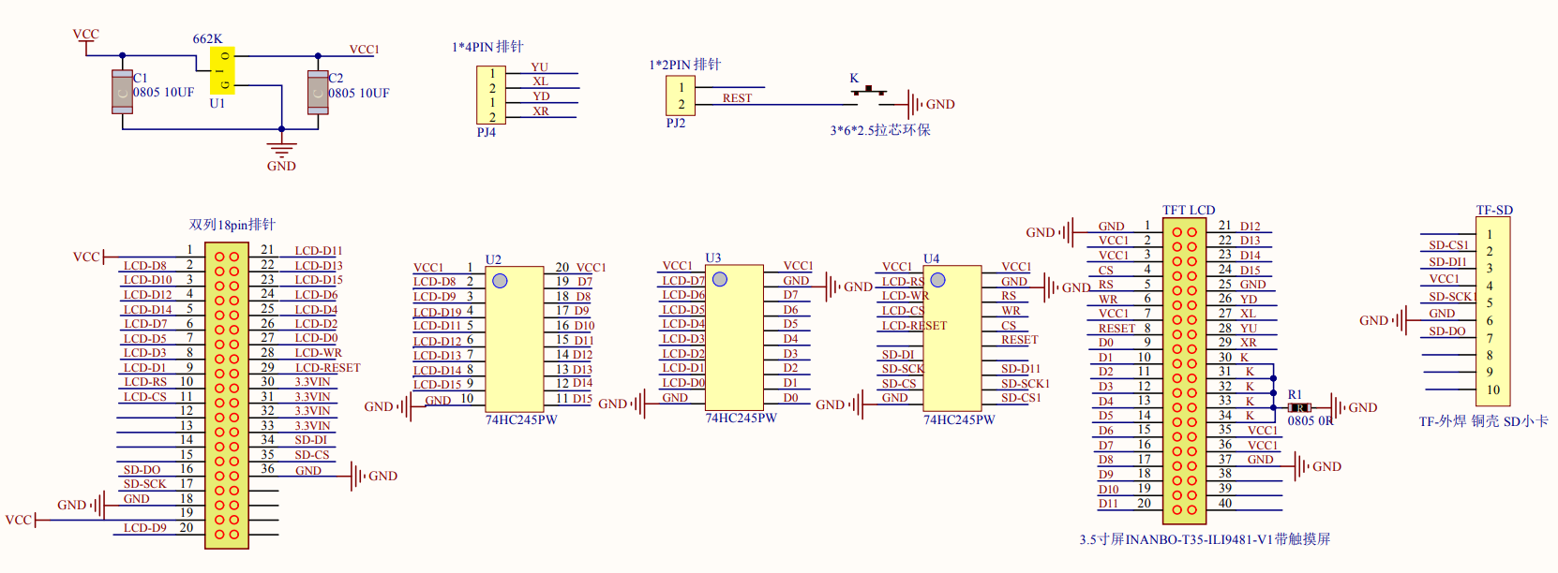

## Load Bank Project

### Experiment

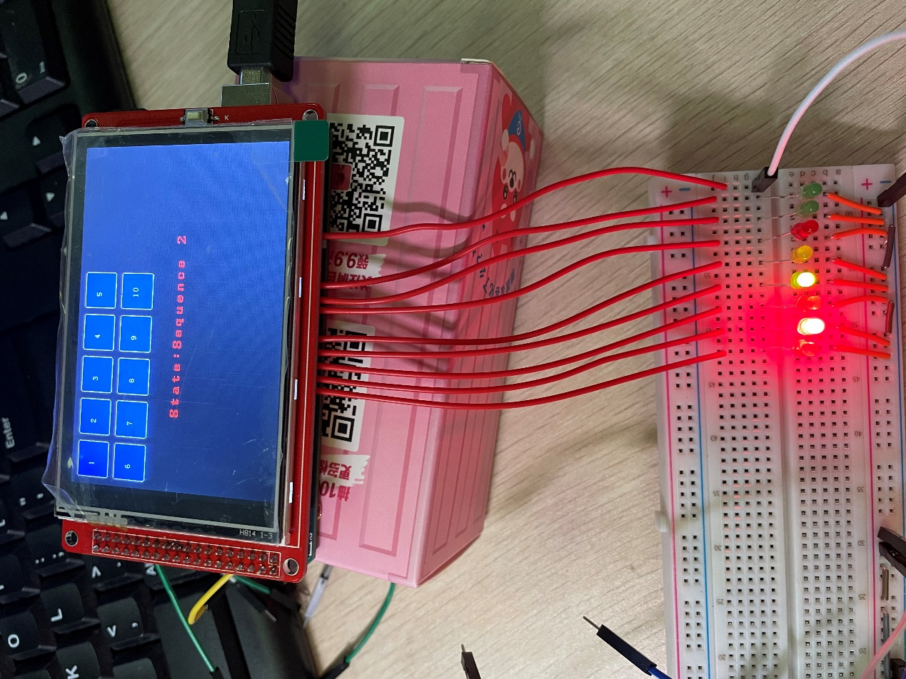

### Function

The Arduino uploaded with new code can achieve the functions in amp profiles

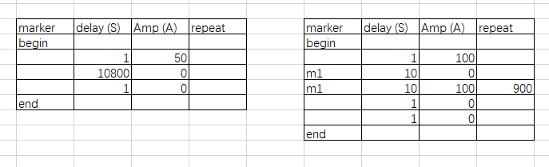

The look-up table of amp value vs. amp/bit in by-current(2) is coded as two arrays

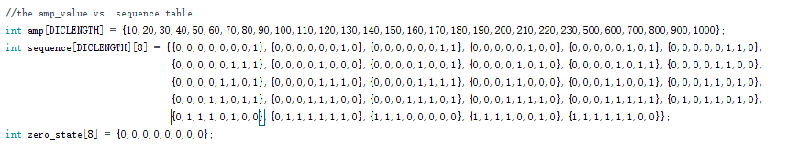

so that when we code a new load bank, we can directly input the amp value, then the code can find the running load bank matrix by looking up the arrays.

## How to Run?

### Library Install

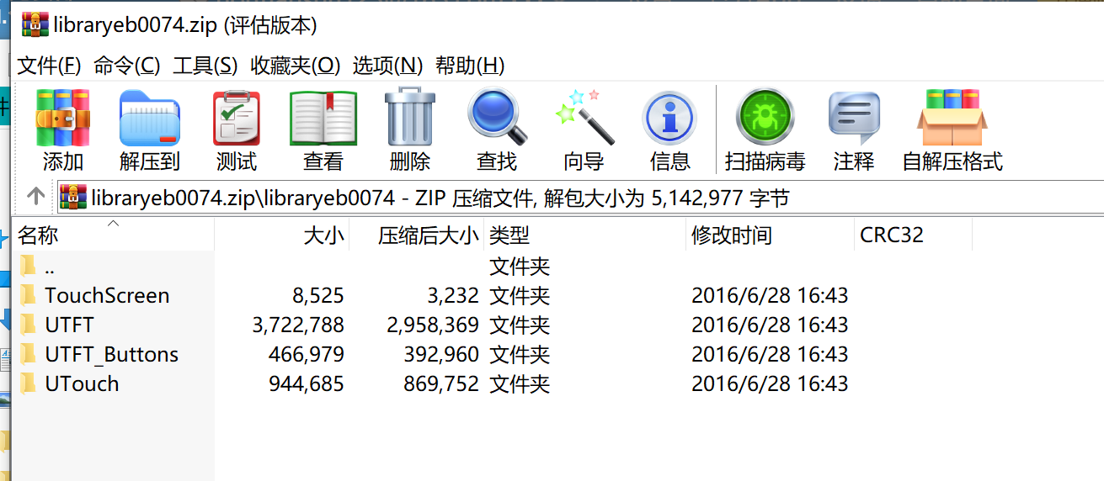

Requirement:

* TouchScreen.h
* UTFT.h

Please convert file in LCD library/libraryeb0074.zip to zip format respectively, then install the needed libraries in Arduino IDE as:

<https://www.arduino.cc/en/guide/libraries?setlang>

### Demo process

Please see ***demo.mp4***