PROJECT ON

**Jean Station**

**DEVELOPED BY：** **COORDINATOR：**

|  |  |  |
| --- | --- | --- |
| ZHANGYUFENG | EDWARD | 2014141222 |
| XUYI | Danborad | 2014141241 |
| WANGXIANG | Kevin | 2014141230 |

**SANA MAHERU**



PROJECT TITLE

NAME OF THE COORDINATOR ：SANA MAHERU

NAME OF THE DEVELOPER  **：**ZHANGYUFENG EDWARD

XUYI DANBOARD

WANGXIANG KEVIN



CERTIFICATE

This is to certify that this report titled Jean Station。Embodies the original work done by ,Edward George Jeff Benedict and Sam in partial fulfillment of the course requirements at NIIT。

COORDINATOR：**Sana Maheru**

ACKNOWLEDGEMENT

We have benefited a lot from the feedback and suggestions given to us by SANA MAHERU and other faculty members. Meanwhile, Thanking to friends for their help.

SYSTEM ANALYSIS

■The application should be accessible over the Internet.

■The system should allow a customer to perform the following operation:

○Browse the store to view products.

○Add and remove products from an online shopping basket.

○Place a shopping order by providing delivery information.

■The system should allow an authorized administrator to perform the following

operations:

○Add new products. ○Edict information of products.

○Delete products. ○View status of placed orders.

○Update the status of an order to be delivered.

■Bolg is take the network as the carrier,fast,easy,easy to release their own experience,timely and effective to easily communicate with others,and then set of rich and colorful personalized display in an integrated platform. NIIT Bolg for students to create a note to share collaboration platform for the sharing,learing,teaching.

MORE SPECIFICATIONS

■Application should be designed in ASP.NET MVC.

■ The design,layout, and navigation of the application should be uniformed across all Web pages.

■ Shopping activities of customers should be tracked across a user’s session through a shopping cart.

■ User authentication should be form-based.

■ User authorization should be role-based.

■ The data provided by the user must be validated.

■ Discount notifications should be easily configured through an XML file.

■ Static views of the application should be cached .

■ The application should provide information on the company’s profile and its

contact details.

INTERFACE DESIGN FOR

Jean Station Corp

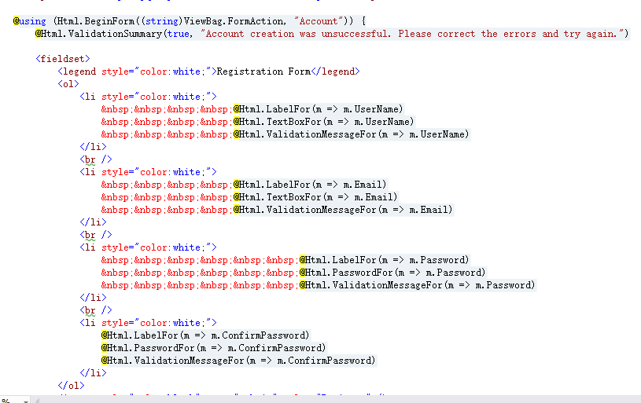

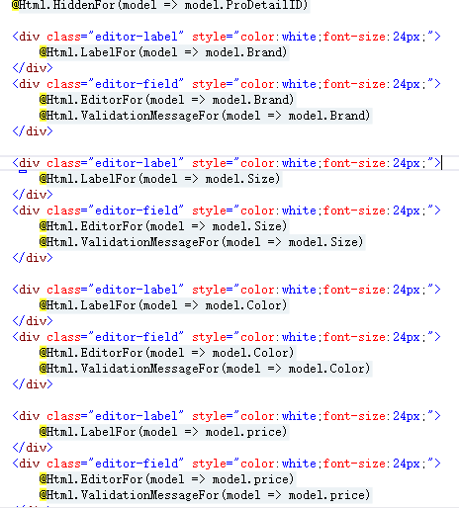

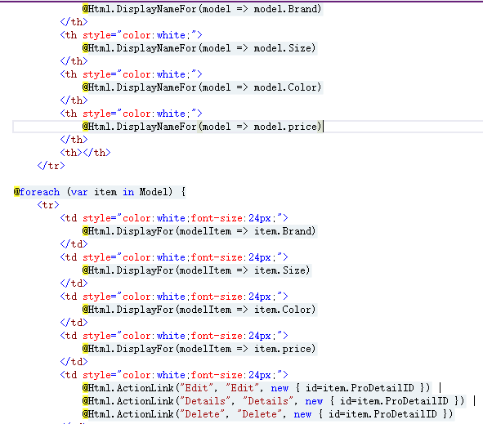

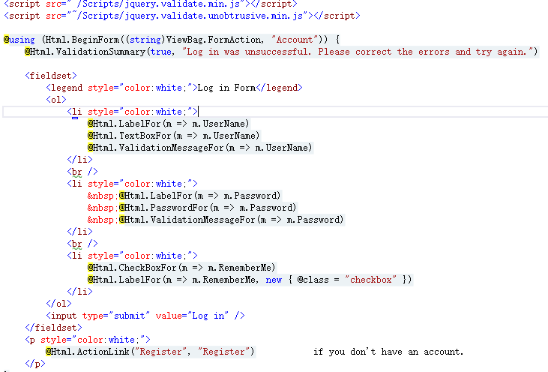

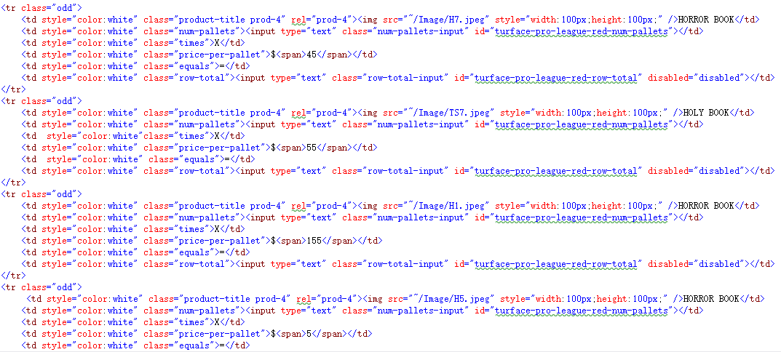

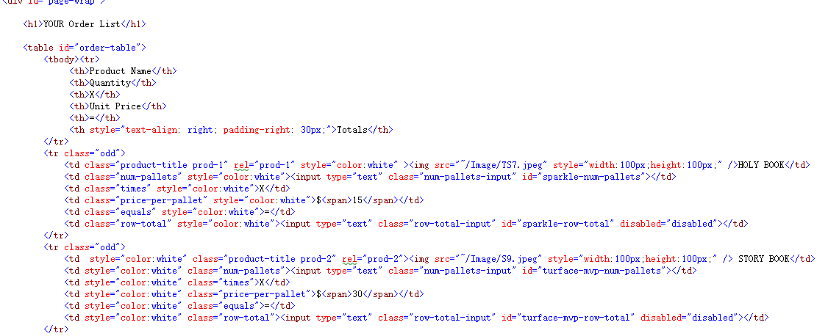

CONFIGURATION

**Hardware**  : PIV-3.0 GHz 865/915 Chipset 800 MHz FSB

512 MB RAM ( 2*256 MB)

80 GB 7200 RPM Hard Drive

CD ROM Drive

10/100 NIC

Optical Wheel Mouse

Keyboard

17 ” Color Monitor

**Operator system** : Window 7,8,10

**Software**  : Visual Studio 2012 Professional