**CoinHarbour Pty Ltd**

**Investment Memorandum**



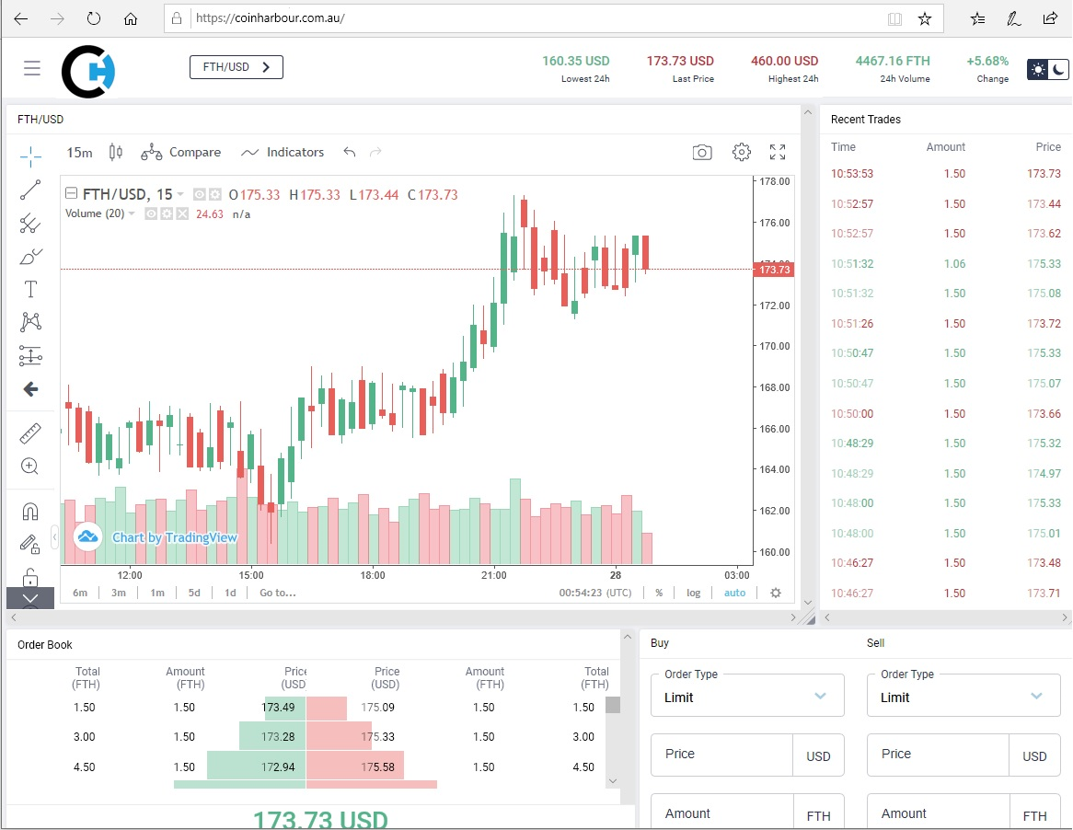

Table of Contents

Overview 3

CoinHarbour Service Offering 3

Market Opportunity 4

Past year 5

Current Status 5

Next year 5

CoinHarbour Utility Token (CHR) 6

Austrac Registration 6

Market Making 7

Revenue Model 8

Key Staff 9

ESIC Tax Benefits 9

Seed Round A Funding 10

Round B Funding 10

Investor Exit 10

Offer Terms 11

Contact Details 11

# Overview

CoinHarbour is a financial services provider focused on crypto currencies and digital assets. CoinHarbour services include Investments, Payments and Trading. *Better Than Any Bank Account*

The first generation of crypto currencies started slowly with Bitcoin in 2009. The second generation took off with the Ethereum Blockchain in 2015 and the subsequent popular adoption of Blockchain technology and crypto currencies.

Now, after ten years, the next wave of Blockchain technology and mainstream acceptance of digital assets is leading to a more mature and long-term boom.

The Internet started in 1989, Google ten years later in 1999. Now, ten years after Bitcoin emerged, CoinHarbour is being launched as a platform to make digital assets accessible to the public.

# CoinHarbour Service Offering

The emergence of Blockchain technology to support distributed and trusted digital assets has created the next wave of technology dishevel. It has coincided with a time of rapid change in financial technology (Fintech). Fintech is a natural application of Blockchains and digital assets, creating the type of opportunity that occurs once a decade.

CoinHarbour seeks to capitalise on this opportunity by providing these crypto-asset services:

* Investments – CoinHarbour supports the accounting, administration and management of digital assets on a convenient, safe and secure platform.
* Trading – CoinHarbour is a comprehensive, flexible and sophisticated platform for trading a wide range of digital assets. CoinHarbour has been designed to easily add support for new Blockchain networks as they emerge.
* Payments – Integrating convenient, efficient and frictionless transfers between a variety of fiat and crypto currencies is the next big challenge. CoinHarbour thinks we can solve this by issuing credit and debit cards linked to customer deposits in fiat and crypto currencies. Key to this is the smart transfer between currencies to facilitate customer payments.
* Loans – once the three customer functions above are available, CoinHarbour intends to expand into crypto and fiat loans and deposits. Initially this will be loans secured against crypto assets. We also hope to offer credit cards with debt facilities and interest that can span various crypto and fiat currencies.

Recently the Australian Prudential Regulatory Authority (APRA) expanded the Banking License regime to add Restricted ADI “Digital Banking License” for tech start-ups to increase competition and innovation in the banking sector.

We see a limited form of APRA Banking License as the future for Coin Harbour and hope to pursue this path after the third capital raising round.

# Market Opportunity

It is estimated the total value of crypto/digital assets is USD 0.25 Trillion. This compares with Stock markets worth 75 Trillion, or Apple with a market cap of USD 1 Trillion. This suggests there is still enormous growth potential in the future for digital assets.

As negative interest rates in the advanced world economies become normal, depositors will avoid leaving funds in bank accounts to avoid paying interest. Digital assets will be an attractive alternative to negative returns on fiat currencies in banks.

It is estimated that there is USD 70 Trillion in uninvested funds globally. These are funds in excess of available investments, leading to downward pressure on interest rates.

If only 2% of these funds were invested in digital assets, the total market capitalisation of crypto currencies would increase by 560% ($70t * 0.02 / 0.25).

The future growth prospects for the digital assets class is exciting.

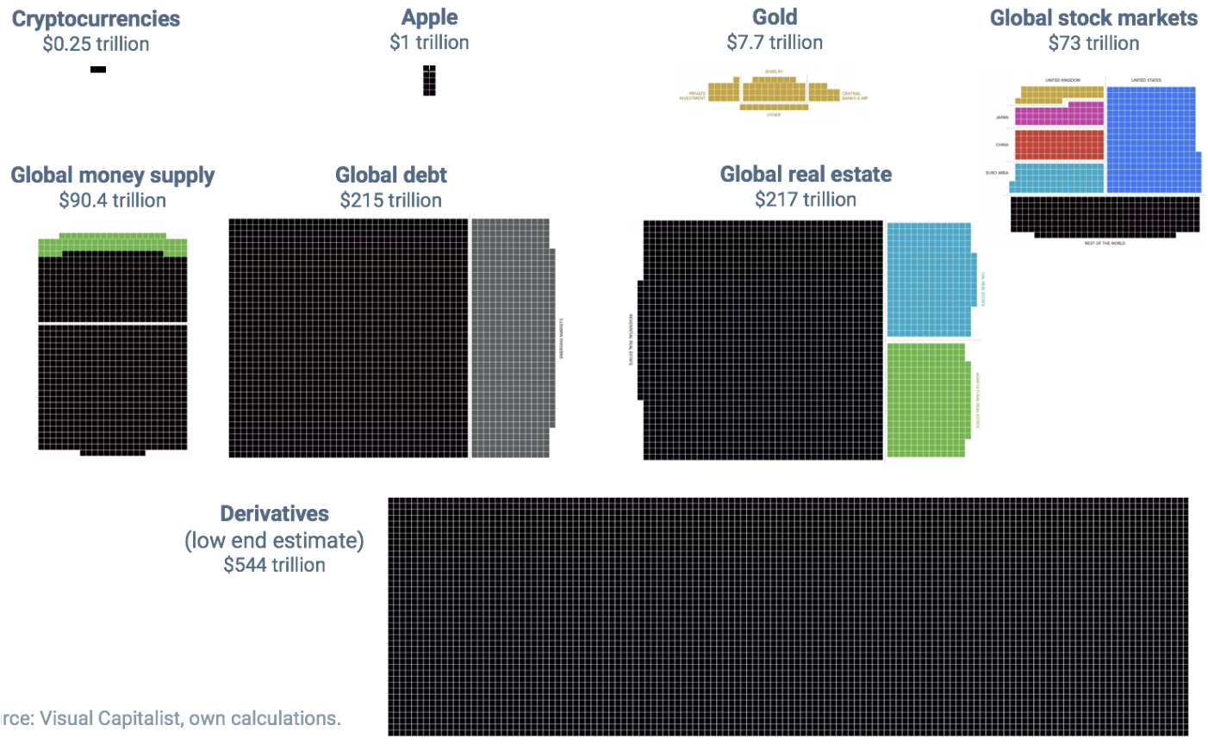

The emergence of Blockchain technology to support distributed and trusted digital assets is happening at the same time as rapid changes in Fintech and innovation in financial services such as Banking.

We can’t predict the future, but we can say the future for digital assets is bright and exciting.

# Past year

Since 2018 CoinHarbour has been focused on developing the Blockchain trading and payments systems that are the centre of the platform. This has taken longer and cost more than envisaged because the market is evolving so quickly and several technology upgrades have been necessary to keep up with current trends.

CoinHarbour has developed a professional relationship with Helios (Ukraine), who develop the *Peatio* system used by 99% of all crypto exchanges.

One competitive advantage CoinHarbour now has is a much more modern, flexible and feature-rich technology platform than other market participants. We feel CoinHarbour will deliver a much better customer experience, adapt faster to market changes, as well as provide a broader range of digital assets and services.

# Current Status

Being able to trade digital assets on Blockchains is an essential link in the business equation. The CoinHarbour platform is currently trading live with Bitcoin, Ethereum, Bitcoin Cash, Doge Coin, Monero and Litecoin. This provides good coverage of the most popular digital assets.

This means is that CoinHarbour can now offer a crypto exchange service which includes the ten most popular digital assets.

The AusPost PoliPay service is being used to process deposits of client funds. At present only AUD fiat deposits and payments are available.

Bank reconciliations are being done manually. This is a labour-intensive process which will be automated, however in the short-term it has the advantage of being a good form of fraud prevention.

# Next year

Our range of digital asset offerings will be expanded to 100 most popular coins

Full Market-making system with liquidity pools implemented to increase trade margins and reduce transaction fees.

Straight thru processing (STP) of bank accounts for deposits and payments in multiple fiat currencies will be implemented to automate cashflows and enable large transaction volumes.

Integrated Visa Debit Cards are planned to allow clients to use their CoinHarbour crypto and fiat assets for retail spending. We are considering Heritage Bank to facilitate this.

Dedicated Marketing resources will be employed and a priority will be Loyalty and Affiliate programs to improve marketing reach.

# CoinHarbour Utility Token (CHR)

Writing transactions to the various blockchains involves paying a fee, typically to reward “Miners” who operate the Blockchain. These fees are usually adjusted from the actual transfer quantity.

CoinHarbour plans to operate a small-scale Blockchain Mining facility which is powered by renewable energy.

This will solve two problems:

* Mining operations are heavy consumers of electricity and public concerns have been raised about this environmental impact of this. Coin Harbour will build an ecologically-friendly crypto-mining operation powered by renewable energy to generate crypto coins.
* CoinHarbour will receive crypto coins for running these Blockchain “Nodes”. These coins will be used to cover client blockchain transaction fees.

Coin Harbour customers who hold the CHR tokens will be able to used the mined coins to save having to pay these Blockchain transaction fees.

The CoinHarbour utility token (CHR) will be used to fund this Blockchain Mining operation once an Initial Coin Offering is complete.

CoinHarbour utility tokens (CHX) will be listed on the exchange to allow trading of the token.

To incentivise Investors in the first Seed funding round, an equivalent amount of CHR tokens will be issued without charge at a nominal price of 1 cent each.

19% of the ICO CoinHarbour Coin (CHR) is reserved for Team and Ambassadors; part of this allocation will be used for Investors.

The CoinHarbour CHR Token has no equity rights or ownership entitlement.

# Austrac Registration

The business model of Coin Harbour is to be a full-service, fully-regulated provider of Financial Services in the digital and fiat currency markets. Coin Harbour holds the following registrations:

* COIN HARBOUR PTY LTD is registered with AUSTRAC to provide Digital Currency Exchange services, Provider number: DCE100633359-001
* COIN HARBOUR PTY LTD is registered with AUSTRAC as an Independent Remittance Dealer, Registration number: IND100633359-001

During 2020 Coin Harbour plans to obtain an Australian Financial Services License (AFSL) from ASIC.

Once the AFSL is obtained and the second round of capital raising has been completed Coin Harbour plans to apply for a Digital Banking License from the Australian Prudential Regulatory Authority (APRA).

# Market Making

CoinHarbour is developing an advanced and unique model for Making Markets of crypto currencies.

Many crypto exchanges simply take retail orders and back these off against a wholesale exchange. The flaw with this is that either the net margin received by the exchange is too small to be profitable, or the resulting spread is too high to be competitive in the market.

CoinHarbour will operate a Liquidity Pool for each traded commodity, with upper and lower levels for holdings. Clients will trade against this Liquidity Pool. When the upper or lower level is breached a single larger order will be placed against a wholesaler to balance the book.

This will enable CoinHarbour to keep most orders on the exchange so that both sides of the spread can be captured.

The downside of running Liquidity Pools for each of the traded assets is that a much more working capital is required.

We expect that the Traded Margin model will behave as follows:

|  |  |  |  |  |  |  |  |  |  |
| --- | --- | --- | --- | --- | --- | --- | --- | --- | --- |
| **Customers** | 1,000 | 10,000 | 20,000 | 50,000 | 60,000 | 70,000 | 80,000 | 90,000 | 100,000 |
| **Margin %** | 0.60% | 0.60% | 0.70% | 1.00% | 1.10% | 1.20% | 1.30% | 1.40% | 1.50% |

Coin Harbour has been developing the most advanced crypto Market Making software that will:

* Connect to many other crypto exchanges for quoted prices and trade execution
* Find the best execution path
* Automatically evaluate combinations of both major commodity pairs and thirds, including the ability to Make Markets in thirds from a combination of other commodities
* Automatically adjust quoted spreads according to market volatility

Given that the crypto market is highly fragmented and some parts thinly traded, our Market Making algorithms should be a unique competitive advantage.

We feel our decades of experience in the financial markets, especially OTC Foreign Exchange, will bring a new and more profitable approach to operating a crypto exchange.

# Revenue Model

The key to profitability for a crypto exchange is reaching a critical-mass of active customers.

Coinbase, one of the largest crypto exchange, has around 30 million customers. According to Bloomberg, Coinbase had USD $1.3 billion in revenue and $456 million in profits in 2018. Last year, Coinbase generated $923 million in revenue and $380 million in profit.

One of the characteristics of our business model is smart Market Making to both meet customer transaction needs and maximise traded margins for the exchange. We feel that our Market Making model will be very successful once sufficient scale in customer numbers is reached.

For the initial stage of Coin Harbour there are two sources of revenue:

* Traded Margins – that is, the difference between what the exchange buys and sells digital assets.
  + As turnover increases and efficiencies in the Market Making model have effect, the margin will grow with customer numbers and turnover.
  + CoinHarbour plans to expand the number of digital assets traded on the exchange to over 100. Many of the less popular crypto coins trade with a higher bid/ask spread, meaning a greater margin for the exchange.
* Listing Fees – CoinHarbour will be able to charge fees to the issuers of some digital assets to have them listed and traded on the exchange.
  + As CoinHarbour grows in customers and profile, it can charge higher listing fees.
  + Our Market Making ability will mean being able to quote a constant market for these digital assets. This is important because often the lesser know crypto currencies are thinly traded, which in turn diminishes their value.

|  |  |  |  |  |  |  |  |  |  |  |  |  |  |  |  |  |  |  |  |  |  |  |  |  |  |  |  |  |  |  |
| --- | --- | --- | --- | --- | --- | --- | --- | --- | --- | --- | --- | --- | --- | --- | --- | --- | --- | --- | --- | --- | --- | --- | --- | --- | --- | --- | --- | --- | --- | --- |
| |  |  |  |  |  |  |  | | --- | --- | --- | --- | --- | --- | --- | | Customers | 1,000 | 10,000 | 20,000 | 50,000 | 60,000 | 70,000 | | Volume | $500,000 | $5,000,000 | $10,000,000 | $25,000,000 | $30,000,000 | $35,000,000 | | Margin | $3,000 | $30,000 | $70,000 | $250,000 | $330,000 | $420,000 | |  |  |  |  |  |  |  |  |  |
|  |  |  |  |  |  |  |  |  |  |

Note: Volume is based on an average $500 per client per month. Gross margin is explained above.

# Key Staff

The CoinHarbour business has been under development since 2018 and until now has been self-funded by the founders:

* Peter Cooney - 30 years’ experience in banking, broking and treasury sectors – specifically in Fintech. Former ANZ Bank Australian Treasury. More than 70 Fintech IT projects over eight countries. Specialist in Quantitive Finance and Algorithmic Trading.
  + <https://www.linkedin.com/in/petercooney/>
* Kent Kingsley history of web design and ecommerce businesses
* Jack Cooney infrastructure and Network Support and Cloud Computing Engineer

Peter and Kent have collaborated on business ventures together for about twenty years.

# ESIC Tax Benefits

ESIC is an Early Stage Innovation Company. In order for a company to qualify as an ESIC via the principals-based assessment a company must have high growth potential, be able to scale, address a broader than local market, and have competitive advantages

More details about the ESIC scheme can be found here:

<https://www.ato.gov.au/Business/Tax-incentives-for-innovation/In-detail/Tax-incentives-for-early-stage-investors/>

<https://treasury.gov.au/national-innovation-and-science-agenda/tax-incentives-for-early-stage-investors>

The main benefit of investing in an ESIC is that a 20% non-refundable carry-forward tax offset is available.

Tax offsets directly reduce the amount of tax you have to pay, with each dollar of tax offset reducing your tax payable by the same amount. This means an immediate 20% tax rebate on the investment amount.

Capital Gains in the investment would be tax free, but a deduction could not be claimed for a Capital Loss in the first ten years.

An ESIC structure would only be available for first round investors.

# Seed Round A Funding

We envisage opening Seed Round A Funding on 4th February 2020.

Seed Round A seeks to raise $500,000 for an equity stake of 25% in Coin Harbour Pty Ltd, based on an initial valuation of $2m. This round will include 100 CHX Coins for every dollar invested.

Proceeds of the fund raising will be used for:

* Operations ~$200,000
* Systems development ~$100,000
* Marketing ~$100,000
* Working capital ~$100,000

While we are not expecting operations to be profitable or cashflow positive for at least 12 months, some funds will be earned which will slow the cash burn rate.

Part of the first round of funding will be used by Coin Harbour to obtain an Australian Financial Services License (AFSL).

Our objective is to use funds from this capital raising to acquire the first 2,000 active clients.

# Round B Funding

We envisage Seed Round B during Q3 2020.

Round B Funding is envisaged to be an equity-based capital raising of potentially $2m based on a valuation of $10m

Our objective is to use funds from this capital raising to expand the business to 10,000 active clients, $500m to p.a. in turnover and $5m revenue.

The main use of these funds will be marketing for customer acquisition and systems development to improve the customer experience and automate business processes to facilitate scaling of the business.

# Investor Exit

This type of Financial Services company, operating in a new market and technical genre, would appeal to established Financial Institutions seeking to both acquire innovation and expand their product offerings.

It is likely that once the Coin Harbour business is established and proven, that it would be an attractive acquisition for Forex Brokers, Stock Brokers or possibly a Bank.

An IPO and ASX listing is another possible path, which would be driven by the need for substantial capital if Coin Harbour did even move towards some form of APRA Banking License.

# Offer Terms

All investments are for the sale of new Ordinary Shares with unrestricted voting rights, which will be issued full-paid at $1 each in Round A.

Coin Harbour Pty Ltd only has a single class of Shares and this is not envisaged to change.

Existing shareholders will participate in the fund-raising. No existing shares are being sold.

The intention of company founders is to hold their investments in the long term.

To comply with the requirements as an Early Stage Innovation Company, all new Shares in Coin Harbour Pty Ltd will need to be issued at the same time. This means that there may be a delay between an investment subscription and the issue of shares.

Funds for the subscription of new Shares should be deposited to:

Coin Harbour Pty Ltd Operating Account:

BSB: 063858

Account: 10271179

# Contact Details

COIN HARBOUR PTY LTD

ABN: 12 624 879 223

[www.coinharbour.com.au](http://www.coinharbour.com.au)

Level 2, 696 Bourke St, Melbourne VIC 3000

Contact: [kent@coinharbour.com.au](mailto:kent@coinharbour.com.au) or [peter@coinharbour.com.au](mailto:peter@coinharbour.com.au)