**CoinHarbour Pty Ltd**

**Investment Memorandum**

**April 2024**





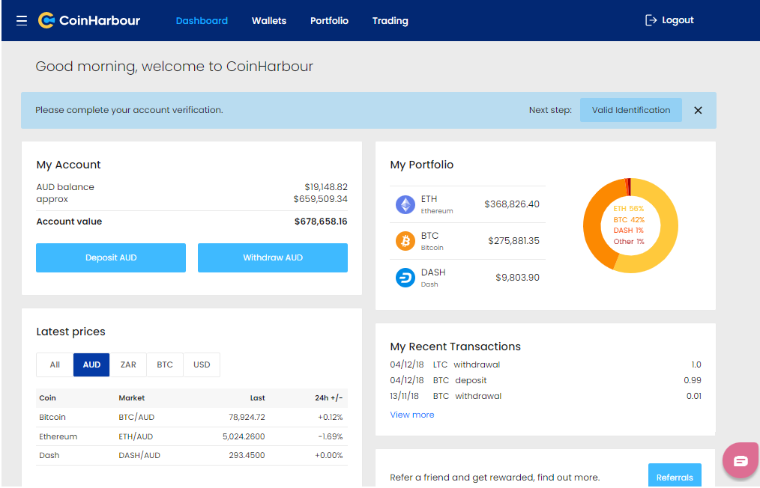

Table of Contents

Welcome 3

Overview 3

CoinHarbour Service Offering 4

Market Opportunity 5

Development 5

Technology Upgrades 6

Functionality 6

Fraud and threat protection 6

Automation and customer-experience 6

KYCAid 7

Fiat Transactional Banking Facility 7

Current Status 8

Year 2024 8

Regulatory Compliance 11

Austrac Registration 11

ASIC and AFSL 11

Market Making 12

Revenue Model 13

Key Staff 14

ESIC Tax Benefits 15

Funding Round 16

Investor Exit 17

Offer Terms 18

Contact Details 18

# Welcome

We have prepared this Confidential Investment Memorandum with the goal of providing the reader with a good general overview of what is on offer.

While this document will not explore every detail of the business and investment offer, it is our hope that it will provide the reader with sufficient information so they can decide whether or not to progress to the next stage of this process, which would be a visit to the business and an informal meeting with the principals.

In any event, I hope you enjoy reading this document and we look forward to hearing from you.

Yours sincerely,

Kent Kingsley Peter Cooney

**Kent Kingsley Peter Cooney**

CEO CFO

# Overview

CoinHarbour is a financial services provider focused on cryptocurrencies and digital assets. The Coin Harbour exchange provides an *easy, fast and safe* user experience.

The first generation of cryptocurrencies started slowly with Bitcoin in 2009. The second generation took off with the Ethereum Blockchain in 2015 and the subsequent popular adoption of Blockchain technology and cryptocurrencies.

Now, the third generation of Blockchain technology and mainstream acceptance of digital assets is leading to a more mature and long-term boom.

The third wave of Blockchain technology includes:

* Web3 technology
* Non-Fungible Tokens (NFT)
* Distributed Finnace (DeFi)

Coin Harbour is well-positioned and ready to catch the third wave of blockchain technology and build a profitable and sustainable business.

# CoinHarbour Service Offering

CoinHarbour is a “full-service” digital asset exchange that services the “private client” or sophisticated investor segment of the market. This is forecast to continue to be an expanding and lucrative market this decade.

CoinHarbour seeks to capitalise on this opportunity by providing these crypto-asset services:

* **Investments** – CoinHarbour supports the accounting, administration and management of digital assets on a convenient, safe and secure platform.
* **Trading** – CoinHarbour is a comprehensive, flexible and sophisticated platform for trading a wide range of digital assets. CoinHarbour has been designed to easily add support for new Blockchain networks as they emerge.
* **Payments** – Integrating convenient, efficient and frictionless transfers between a variety of fiat and crypto currencies is the next big challenge. CoinHarbour thinks we can solve this by issuing credit and debit cards linked to customer deposits in fiat and cryptocurrencies. Key to this is the smart transfer between currencies to facilitate customer payments.
* **NFTs** – CoinHarbour intends to expand into the Non-Fungible Token (NFT) sector. We foresee rapid and sustained growth in NFTs for gaming, the Metaverse and collectibles.
* **Smart Market-Making** - rather than being a “broker” of “exchange”, Coin Harbour operates as a smart Market Maker that provides continuous liquidity to customers.

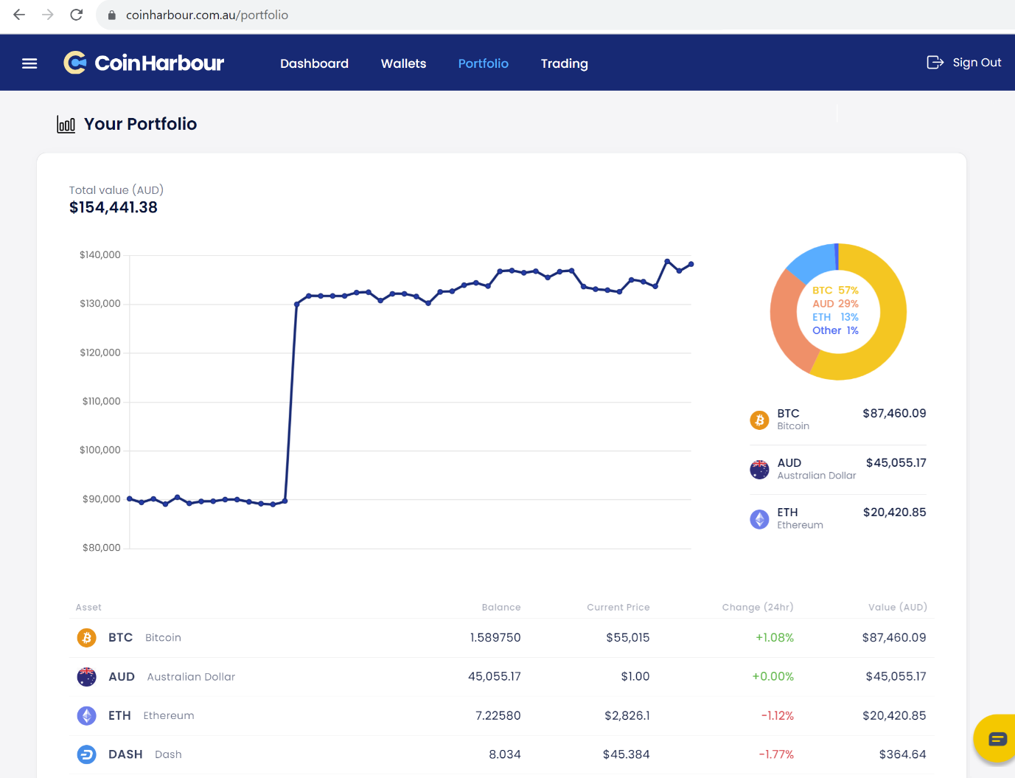

# Market Opportunity

Revenue for Australian exchanges in the Cryptocurrencies market is projected to reach US$807m in 2023.

Revenue is expected to show an annual growth rate (CAGR 2023-2027) of 14% resulting in a projected total amount of US$1,375m by 2027.

The average revenue per user in the cryptocurrency market amounts to US$142.7 in 2023.

From a global comparison perspective, it is shown that the highest revenue is reached in the United States (US$17,960m in 2023).

In the Cryptocurrencies market, the number of users is expected to amount to 7.4m users by 2027.

User penetration will be 21% in 2023 and is expected to hit 27% by 2027.

<https://www.statista.com/outlook/fmo/digital-assets/cryptocurrencies/australia>

**Definition**:

Cryptocurrencies are digital currencies that use an online ledger with strong cryptography to secure online transactions. Generally, cryptocurrencies are decentralized networks based on blockchain technology – a distributed ledger technology that autonomously records peer-to-peer transactions across decentralized computers without a central authority. Cryptocurrencies are predominantly traded and exchanged on cryptocurrency exchanges, neobrokers, and neobanks.

# Development

Since 2020 CoinHarbour has been focused on developing the Blockchain trading and payments systems that are the centre of the platform. This has taken longer and cost more than envisaged because the market is evolving so quickly and several technology upgrades have been necessary to keep up with current trends.

CoinHarbour has developed a professional relationship with Helios (Ukraine), who developed the *Peatio* system used by 60% of all crypto exchanges.

One competitive advantage CoinHarbour now has is a much more modern, flexible, and feature-rich technology platform than other market participants. We feel CoinHarbour will deliver a much better customer experience, adapt faster to market changes, as well as provide a broader range of digital assets and services.

## Technology Upgrades

The CoinHarbour project has been delayed and taken much longer than originally planned because of five major upgrades to the technology platform that pushed the go-live date back.

### Functionality

Most of these upgrades were for new functionality that reflects the fast-paced rate of change in the crypto blockchain industry. For instance, several new blockchains have emerged and need to be integrated into our systems.

### Fraud and threat protection

As the crypto blockchain sector matures, more is known of security threats and measures have been developed to deal with these risks.

The CoinHarbour platform is now protected by the Cloudflare firewall system, which also provides threat detection and advisory functions. Cloudflare is also configured to prevent access from known threat regions, such as North Korea and Nigeria.

We have implemented full end-to-end strict SSL TLS 1.3 encryption for all of our infrastructure. Measures such as Cross-Site Request Forgery (CSRF) protection have been added.

All sensitive data, such as customer data and API Keys are stored in encrypted form using the Hashicorp “Vault” system.

### Automation and customer-experience

Since the project commenced the crypto market and customer expectations have changed and expanded.

In response to this, a lot of development effort has been spent improving the customer experience and automating functions. An example of this is the customer “sign up” or acquisition process. In the past this would be done manually, where customers would send their identification documents, which would then be manually verified against an identity database, such as Dunn and Bradstreet.

Now this process is automated, typically with no intervention by staff, and new customers can be on-boarded and verified in a few minutes. A new client can sign up, be verified, deposit funds and start trading in a single session.

### KYCAid

Coin Harbour now uses the KYCAid identity verification service. KYCAid verifies the customer identity documents against national identity databases, detects fraudulent identities and flags Politically Exposed Persons (PEPs).

The KYCAid services satisfy the Austrac Anti-Money Laundering (AML) and Know Your Client (KYC) requirements.

Coin Harbour interfaces automatically end-to-end with KYCAid, and there is an ability for staff to log into the KYCAid portal to review customer details.

### Fiat Transactional Banking Facility

It is extremely difficult for Australian crypto exchanges to obtain an AUD fiat transactional banking facility. Since Austrac prosecuted banks for Anti-Money-Laundering breaches they have been averse to activities perceived to be risky, including crypto exchanges.

Coin Harbour has had business bank accounts arbitrarily closed by CommBank and Westpac.

This has significantly delayed business commencement by Coin Harbour.

**Monoova Payments.**

Coin Harbour has contracted with **Monoova Payments** for AUD fiat transactional banking services. Monoova is part of Moneytech and interfaces to the New Payments Processing (NPP) system via Cuscal.

To complete the extensive due diligence and sign a contract with Monoova took almost a year. The effort has been worthwhile and has given Coin Harbour direct API access to the various banking systems in Australia, including NPP, RTGS and BPay. This should enable Coin Harbour to offer a very comprehensive and feature-rich service to our customers.

Currently Coin Harbour can directly send and receive NPP payments for customers. We are also working to implement RTGS, BPay and Polipay.

Later in 2022 Monoova should introduce branded debit cards, which is a product we are very keen to add to Coin Harbour.

# 

# Current Status

The CoinHarbour platform is currently trading live, trading 65 of the most popular cryptocurrencies, including Bitcoin, Ethereum, Bitcoin Cash, Doge Coin, Monero and Litecoin. This provides good coverage of the most common digital assets.

Nine different blockchain networks are connected to Coin Harbour for settlement.

Market-making robots “bots” are running to give customers access to instant market liquidity.

New client onboarding is fully automated and instant using KYCAid.

Customers can instantly deposit and withdraw AUD funds via NPP (Osko). Monoova Payments is our transactional banking partner.

Clients have signed up, deposited funds and are actively trading.

The technical challenges have been met, and Coin Harbour is now focused on marketing, customer acquisition and operational cashflows.

# Year 2024

**Q1: Mobile App Release**

Launch a user-friendly iOS and Android mobile app to provide convenience and accessibility to a wider audience.

We continue to focus on delivering a great user experience. Our goal is to build an addictive app that keeps users tethered to our platform.

**USDT Markets** - In addition to quoting markets in AUD, we will offer markets in USDT to attract more sophisticated customers.

**Additional Fiat Gateways**. In addition to the existing NPP bank transactions, BPay and RTGS will be added in Q1 2024.

**Q2: AI Market-Making**

We have started a project to use Artificial Intelligence for "smart" market-making software "bots" (robots).

This will automate exchange liquidity and risk management.

Market-making is our profit engine and we will be the best.

**NFTs** - Development work has been started to launch Initial Coin Offerings (ICOs) and Initial Exchange Offerings (IEOs) and Non-Fungible Tokens (NFTs) on Coin Harbour.

**Q3: Partnerships**

Form strategic partnerships with upcoming blockchain projects to drive user adoption and increase liquidity.

Our model is to list tokens from these projects on Coin Harbour, in exchange for a supply of free or discounted tokens for distribution to our customers.

During Q3 we estimate this will lift customer numbers past 10,000.

**Visa Debit Cards** - Integrated Visa Debit Cards are planned to allow clients to use their CoinHarbour crypto and fiat assets for retail spending. We have had discussions with a few card providers, including Monoova and EML, and anticipate that Coin Harbour will be able to offer customers branded cards in Q3 2024. Debit cards only become financially viable when we pass 10,000 customers.

**Q4: Marketing**

Before the end of 2024, we predict CoinHarbour will pass 15,000 customers, and at this stage, the business will be strongly profitable and cashflow positive.

This is less than 1% of the market and readily achievable. We plan for much more.

**DeFi** - We have been exploring the Distributed Finance (DeFi) market for sometime, but have reluctant to participate in DeFi and the regulatory requirements are more certain. We will re-evaluate DeFi once an AFSL has been obtained.

**Additional Fiat Currencies**

During 2024 we hope to add support for CNY, IDR, NZD, THB and USD fiat currencies. The Coin Harbour platform is capable of supporting an unlimited number of currencies and spot foreign exchange.

The limiting factors are regulatory compliance and obtaining transactional banking facilities,

**Marketing**

The biggest challenges will be marketing and customer acquisition. Most of our marketing effort will be directed to social media and various crypto industry forums.

Milestones will be the first 10,000 and 100,000 customers.

For some time Coin Harbour has been building a broad Social Media presence and we have been working with a specialist consultant to run targeted Social Media marketing campaigns once the exchange is live.

The metrics we assume are marketing costs of $50 for each new validated and active customer.

**CoinHarbour Loyalty Token (CHR)**

The Coin Harbour Token (CHR) has been published on the Ethereum blockchain as an ERC20 Smart Contract.

CHR is listed on the Coin Harbour exchange, and we make a market so that it can always be bought or sold.

The Coin Harbour token will be used as an incentive for new customers to signup, and also for existing customers to refer others to Coin Harbour too. We have created a Referral system to accommodate this.

# Regulatory Compliance

## Austrac Registration

The business model of Coin Harbour is to be a full-service, regulated provider of Financial Services in the digital and fiat currency markets. Coin Harbour holds the following registrations:

* COIN HARBOUR PTY LTD is registered with AUSTRAC to provide Digital Currency Exchange services, Provider number: DCE100633359-001
* COIN HARBOUR PTY LTD is registered with AUSTRAC as an Independent Remittance Dealer, Registration number: IND100633359-001

## ASIC and AFSL

During 2024 Coin Harbour plans to obtain an Australian Financial Services License (AFSL).

For the current Coin Harbour business, only the Austrac registration is mandatory, an AFSL is not required. Recently the Federal Treasurer announced that Digital Asset Exchanges will require and AFSL.

There are three reasons for obtaining an AFSL:

1. We feel having an AFSL would give customers more comfort with the business.
2. In future there will be increased regulation of the crypto sector in Australia, and that an AFSL will eventually be required.
3. In the future we plan on expanding our product and service range, requiring an AFSL.

# Market Making

CoinHarbour is developing an advanced and unique model for Making Markets of crypto currencies.

Many crypto exchanges simply take retail orders and back these off against a wholesale exchange. The flaw with this is that either the net margin received by the exchange is too small to be profitable, or the resulting spread is too high to be competitive in the market.

CoinHarbour will operate a Liquidity Pool for each traded commodity, with upper and lower levels for holdings. Clients will trade against this Liquidity Pool. When the upper or lower level is breached a single larger order will be placed against a wholesaler to balance the book.

This will enable CoinHarbour to keep most orders on the exchange so that both sides of the spread can be captured.

The downside of running Liquidity Pools for each of the traded assets is that substantial working capital is required.

We expect that the Traded Margin model will behave as follows:

|  |  |  |  |  |  |  |  |  |  |
| --- | --- | --- | --- | --- | --- | --- | --- | --- | --- |
| **Clients** | 1,000 | 10,000 | 20,000 | 50,000 | 60,000 | 70,000 | 80,000 | 90,000 | 100,000 |
| **Margin %** | 0.90% | 1.20% | 1.50% | 1.70% | 1.80% | 1.90% | 1.90% | 1.90% | 1.90% |

Coin Harbour has been developing the most advanced crypto Market Making software that will:

* Be based on the *Reinforcement Learning Model* (RLM), in collaboration with Microsoft.
* Connect to many other crypto exchanges for quoted prices and trade execution.
* Find the best execution option.
* Automatically evaluate combinations of both major commodity pairs and thirds, including the ability to Make Markets in thirds from a combination of other commodities.
* Automatically adjust quoted spreads and risk positions according to market volatility.

Given that the crypto market is highly fragmented, and some parts thinly traded, our Market Making algorithms should be a unique competitive advantage.

We feel our decades of experience in the financial markets, especially OTC Foreign Exchange, will bring a new and more profitable approach to operating a crypto exchange.

# Revenue Model

The key to profitability for a crypto exchange is reaching a critical mass of active customers.

Coinbase, one of the largest crypto exchanges, has around 30 million customers. According to Bloomberg, Coinbase had USD $1.3 billion in revenue and $456 million in profits in 2018. Last year, Coinbase generated $923 million in revenue and $380 million in profit.

One of the characteristics of our business model is smart Market Making to both meet customer transaction needs and maximise traded margins for the exchange. We feel that our Market Making model will be very successful once sufficient scale in customer numbers is reached.

For the initial stage of Coin Harbour there are two sources of revenue:

* Traded Margins – that is, the difference between what the exchange buys and sells digital assets.
  + As turnover increases and efficiencies in the Market Making model have effect, the margin will grow with customer numbers and turnover.
  + CoinHarbour plans to expand the number of digital assets traded on the exchange to over 100. Many of the less popular crypto coins trade with a higher bid/ask spread, meaning a greater margin for the exchange.
* Listing Fees – CoinHarbour will be able to charge fees to the issuers of some digital assets to have them listed and traded on the exchange.
  + As CoinHarbour grows in customers and profile, it can charge higher listing fees.
  + Our Market Making ability will mean being able to quote a constant market for these digital assets. This is important because often the lesser-known crypto currencies are thinly traded, which in turn diminishes their value.

|  |  |  |  |  |  |  |  |  |  |  |  |  |  |  |  |  |  |  |  |  |  |
| --- | --- | --- | --- | --- | --- | --- | --- | --- | --- | --- | --- | --- | --- | --- | --- | --- | --- | --- | --- | --- | --- |
| |  |  |  |  |  |  |  | | --- | --- | --- | --- | --- | --- | --- | | Clients | 1,000 | 10,000 | 20,000 | 50,000 | 60,000 | 70,000 | | Volume | $500,000 | $5,000,000 | $10,000,000 | $25,000,000 | $30,000,000 | $35,000,000 | | Margin | $5,000 | $50,000 | $150,000 | $600,000 | $720,000 | $900,000 | |
|  |

Note: Volume is based on an average $500 per client per month. Gross margin is explained above.

# Key Staff

The CoinHarbour business has been under development since 2018 and until now has been self-funded by the founders:

* Peter Cooney - 30 years’ experience in banking, broking and treasury sectors – specifically in Fintech. Former ANZ Bank Australian Treasury. More than 70 Fintech IT projects over eight countries. Specialist in Quantitative Finance and Algorithmic Trading.
  + <https://www.linkedin.com/in/petercooney/>
* Kent Kingsley - background in web design and ecommerce businesses
* Jack Cooney - Infrastructure and Network Support and Cloud Computing Engineer

Peter and Kent have collaborated on business ventures together for more than twenty years.

# 

# ESIC Tax Benefits

Investors who buy new shares in a qualifying early stage innovation company (ESIC) may be eligible for tax incentives.

The main benefit of investing in an ESIC is that a 20% non-refundable carry-forward tax offset is available.

Tax offsets directly reduce the amount of tax you have to pay, with each dollar of tax offset reducing your tax payable by the same amount. This means an immediate 20% tax rebate on the investment amount.

Capital Gains in the investment would be tax free, but a deduction could not be claimed for a Capital Loss in the first ten years.

In order for a company to qualify as an ESIC via the principals-based assessment a company must have high growth potential, be able to scale, address a broader than local market, and have competitive advantages.

More details about how the ESIC scheme applies to Coin Harbour Pty Ltd, including refences, can be found here:

<https://doc.coinharbour.com.au/invest/esic/>

# Funding Round

Coin Harbour Pty Ltd envisages opening a sole Funding Round during late 2023 to expand the business.

We seek to raise $1,000,000 for an equity stake of 25% in Coin Harbour Pty Ltd, based on an initial diluted valuation of $8m. Coin Harbour Pty Ltd has a single class of “Ordinary” shares. The shares offered are new shares in the company; no existing shareholder is disposing of their investment.

Proceeds of the fund raising will be used for:

* Operations ~$100,000
* Software and Systems development ~$200,000
* Marketing ~$200,000
* Working capital ~$100,000
* Increased Market-Making liquidity ~$400,000

While we are not expecting operations to be profitable or cashflow positive for at least six months, some funds will be earned which will slow the cash burn rate.

There may be subsequent capital raisings or the sale of new shares in Coin Harbour Pty Ltd once the next milestone on 10,000 customers is achieved.

Our objective is to use funds from this capital raising to acquire the first 10,000 active clients.

# 

# Investor Exit

**Scenario #1 Private Sale**

This type of Financial Services company, operating in a new market and technical genre, would appeal to established Financial Institutions seeking to both acquire innovation and expand their product offerings.

It is likely that once the Coin Harbour business is established and proven, it would be an attractive acquisition for Forex Brokers, Stock Brokers, or possibly a Bank.

With this scenario our preference would be to place the investment with a business that can offer synergies in addition to capital. For example, possibly a stockbroking firm that would offer the potential to see the cryptocurrency asset class into their existing client base.

**Scenario #2 Public Offering**

An IPO and ASX listing is another possible path, which would be driven by the need for substantial capital if Coin Harbour did even move towards some form of APRA Banking License.

In this scenario, we see “crowd-sourced” funding as an opportunity to build a shareholder base that could be used to satisfy the ASX listing rule of a minimum of 200 shareholders.

**Scenario #3 No Exit**

The business will likely have strong earnings and cashflows for several years that can be distributed to shareholders as dividends.

Management and investors might maintain their shareholdings to receive dividends from the business,

This article referring to Coinspot may offer some insight to this strategy:

<https://doc.coinharbour.com.au/competitors/coinspot/CoinSpot_founder_700m_dividend.pdf>

# Offer Terms

All investments are for the sale of new Ordinary Shares with unrestricted voting rights, which will be issued full paid at $1 each.

Coin Harbour Pty Ltd only has a single class of Shares and this is not envisaged to change.

Existing shareholders may participate in the fund-raising. No existing shares are being sold.

The intention of company founders is to hold their investments in the long term.

To comply with the requirements as an Early Stage Innovation Company, all new Shares in Coin Harbour Pty Ltd will need to be issued at the same time. This means that there may be a delay between an investment subscription and the issue of shares.

Funds for the subscription of new Shares should be deposited to:

Coin Harbour Pty Ltd Operating Account:

BSB: 033-047

Account: 806571

# Contact Details

COIN HARBOUR PTY LTD

ABN: 12 624 879 223

[www.coinharbour.com.au](http://www.coinharbour.com.au)

Level 2, 696 Bourke St, Melbourne VIC 3000

Contact: [kent@coinharbour.com.au](mailto:kent@coinharbour.com.au) or [peter@coinharbour.com.au](mailto:peter@coinharbour.com.au)