**ComputationalGeometry _HW2**

**(演算法及證明題並沒有一定解，只要能依題意解出即可)**

**Chap 3**

**3.2** A rectilinear polygon is a simple polygon of which all edges are horizontal or vertical. Let P be a rectilinear polygon with n vertices. Give an example to show that └n/4┘ cameras are sometimes necessary to guard it.

**Answer：**

The rectilinear polygon would contain n/4 parallel ”alleys”. At least n/4 cameras are needed because no camera can see more than one alley.

**3.7** Let P be a simple polygon with n vertices, which has been partitioned into monotone pieces. Prove that the sum of the number of vertices of the pieces is O(n).

**Answer：**

Every triangulation of an n vertex simple polygon has n- 2 triangles, each triangle is a monotone piece, so sum of the number of vertices is 3*(n−2)=O(n)

**3.11** Give an efficient algorithm to determine whether a polygon P with n vertices is monotone with respect to some line, not necessarily a horizontal or vertical one.

**Answer：**

Use sweep plane for testing monotonicity.

將polygon P做一定角度的逆時針旋轉。

將polygon的vertex做排序。

由上往下掃，確認各個頂點是否為split vertex或merge vertx，確認是否為monotone。

重複上述步驟，直至轉完360度為止。

**Chap 4**

**4.2** Consider the casting problem in the plane: we are given polygon P and a 2-dimensional mold for it. Describe a linear time algorithm that decides whether P can be removed from the mold by a single translation.

**Answer：**

對於P的任一面 fi 的法向量 ni ，找到一個移動向量d，使其ni和d夾角大於90度，意即內積<0。

1.給{(n1x,n1y),(n2x,n2y).....(nmx,nmy)}，令dy=1

┌n1x * dx + n1y * dy <= 0

│n2x * dx + n2y * dy <= 0

│…

└nmx * dx + nmy * dy <= 0

解聯立方程式→時間複雜度為O(n)，即為linear time

2.不做假設，僅使用Algorithm **2**D**R**ANDOMIZED**B**OUND**LP**判斷是否有解，時間複雜度亦為O(n)

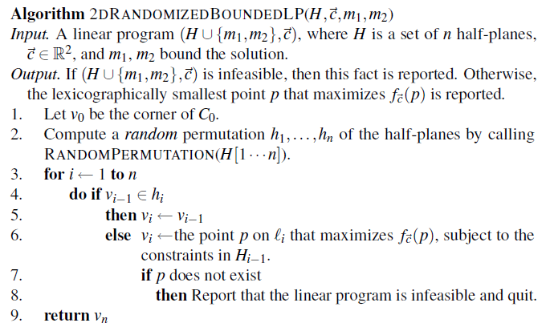

**4.8** The plane z = 1 can be used to represent all directions of vectors in 3- dimensional space that have a positive z-value. How can we represent all directions of vectors in 3-dimensional space that have a non-negative z-value? And how can we represent the directions of all vectors in 3- dimensional space?

**Answer：**

(1) x^2 + y^2 + z^2 =1, z >= 0, we can project any directions of vectors in 3-dimensional space thathave a non-negative z-value onto the surface of half sphere.

(2) x^2 + y^2 + z^2 =1, we we can project any directions of vectors in 3-dimensional space onto thesurface of the whole sphere.

**4.16**

On n parallel railway tracks n trains are going with constant speeds v1,v2, . . . , vn. At time t = 0 the trains are at positions k1, k2, . . . , kn. Give anO ( nlogn ) algorithm that detects all trains that at some moment in timeare leading. To this end, use the algorithm for computing the intersection of half-planes.

**Answer：**

火車i在t時間時的位置pi = ki + vi*t (i = 1,2,3......n)

令yi= pi, x=t

原式改為yi≧ki+vi*x ,  
利用INTERSECT HALFPLANES演算法求這n個半平面相交的區域

Algorithm INTERSECT HALFPLANES (H)

Input. A set H of n half-planes in the plane.

Output. The convex polygonal region C := ∩h H ∈ h.

1. if card(H) = 1

2. then C ← the unique half-plane h H ∈

3. else Split H into sets H 1 and H 2 of size n/2 and n/2 .

4. C 1 ←I NTERSECT HALFPLANES (H 1 )

5. C 2 ←I NTERSECT HALFPLANES (H 2 )

6. C ←I NTERSECT C ONVEX R EGIONS (C 1 ,C 2 )

時間複雜度:O(nlogn)