**实验数据记录**

**BM**

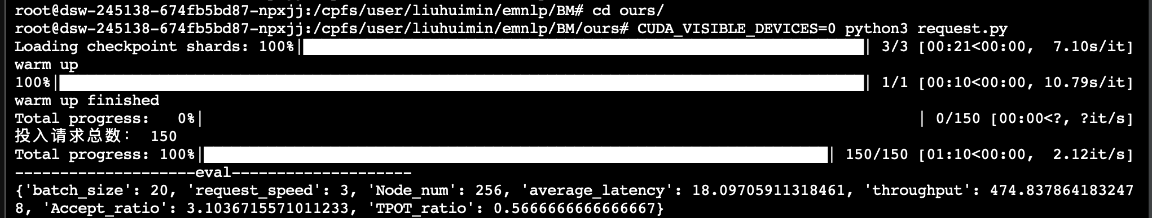

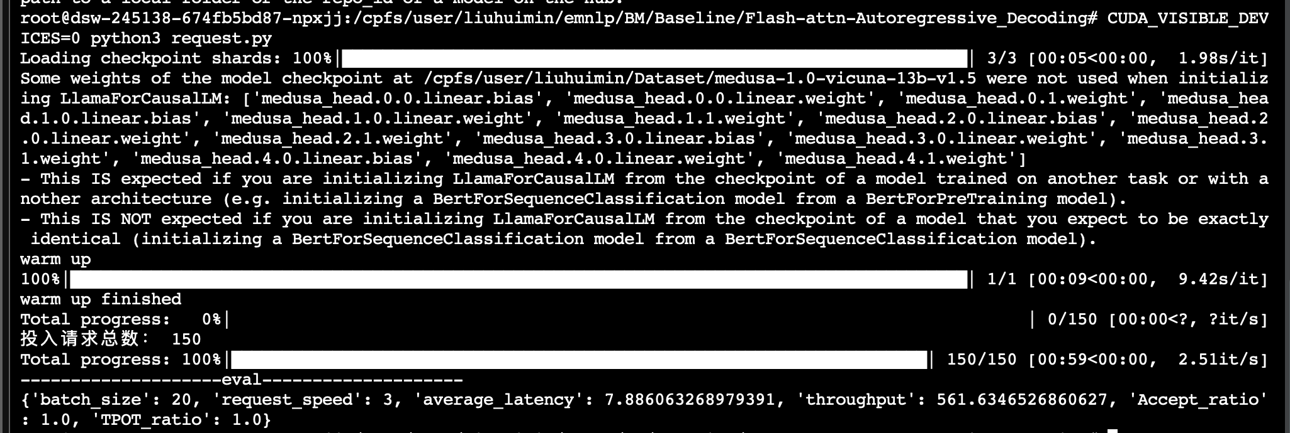

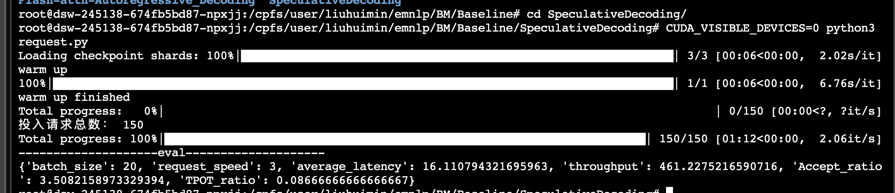

|  |  |
| --- | --- |
| **1** | **{'batch_size': 20, 'request_speed': 1, 'Node_num': 256, 'average_latency': 4.950661750634511, 'throughput': 221.5612271900453, 'Accept_ratio': 3.425135053423042, 'TPOT_ratio': 0.97}** |
| **2** | **{'batch_size': 20, 'request_speed': 2, 'Node_num': 256, 'average_latency': 6.063185020287832, 'throughput': 430.97898432970015, 'Accept_ratio': 3.2402407607650914, 'TPOT_ratio': 0.8666666666666667}** |
| **3** | **{'batch_size': 20, 'request_speed': 3, 'Node_num': 256, 'average_latency': 15.655929709275563, 'throughput': 554.2315442247622, 'Accept_ratio': 3.0697812414873638, 'TPOT_ratio': 0.5466666666666666}** |

**BE**